ECOCLEAN: SMART WASTE REPORTING AND MANAGEMENT SYSTEM

A project report submitted in fulfillment of
the requirements for the award of the degree of

MASTER OF COMPUTER APPLICATIONS
From

APJ Abdul Kalam Kerala Technological University


Submitted By

ATHUL KRISHNA R (MEA25MCA-2007)



MEA Engineering College
Department of Computer Applications
Vengoor P.O, Perinthalmanna, Malappuram, Kerala- 679325 OCTOBER 2026

DEPARTMENT OF COMPUTER APPLICATIONS

MEA ENGINEERING COLLEGE PERINTHALMANNA-679325

CERTIFICATE

This is to certify that the Project report entitled “ECOCLEAN: SMART WASTE REPORTING AND MANAGEMENT SYSTEM” is a bonafide record of the work done by ATHUL KRISHNA R (MEA25MCA-2007) in partial fulfillment of the requirements for the award of the degree of Master of Computer Applications of the APJ Abdul Kalam Technological University during the academic year 2025-2026.

Mr. Sajeesh M
Assistant Professor & Project Guide
Dept. of Computer Applications

Internal Examiner
Mr. Sajeesh M Assistant Professor & Head of the Department
Dept. of Computer Applications

External Examiner

Acknowledgements
First and foremost, I express my humble gratitude to the Almighty God for showering immense blessings, knowledge, courage, and perseverance that guided me in the successful completion of this project.
An academic project of this scope and magnitude requires continuous advice, support, and constructive direction from many well-wishers and educators. I take this opportunity to express my profound gratitude to our respected Principal, Dr. J. Hussain, for providing an inspiring environment and excellent institutional infrastructure for carrying out this project.

I would like to express my sincere and heartfelt gratitude to Mr. Sajeesh M, Assistant Professor and Head of the Department of Computer Applications, and my Project Guide, for his constant encouragement, invaluable suggestions, and technical guidance throughout the project duration. His patience and inspiring mentorship were crucial in shaping this work.

I share my sincere thanks to Project Co-ordinator Mr. Adil Narakkoden, Assistant Professor in Department of Computer Applications, for his wholehearted moral support, insightful suggestions, and co-ordination during all stages of this project work. I also extend my gratitude to all teachers, non-teaching staff, my family members, and friends for their constant cooperation.

ATHUL KRISHNA R (MEA25MCA-2007) DATE: OCTOBER 2026

ABSTRACT
Rapid urbanization, expanding commercial centers, and dense residential clusters have led to a critical surge in municipal solid waste generation, presenting acute public health and operational difficulties for civic authorities. Conventional municipal waste disposal channels often suffer from severe communication bottlenecks, absent geographical tracking, and delayed resolution times, leading to unattended garbage piles, public hygiene hazards, and low citizen participation.

This project presents EcoClean, a comprehensive smart waste reporting and management web application designed to seamlessly interconnect citizens, municipal administrators, and sanitation field squads. Citizens can easily flag overflowing waste spots on an interactive Leaflet OpenStreetMap interface with precision GPS coordinates and captured photographs. The system incorporates a simulated AI waste scanner that assesses image parameters to estimate waste categorization (Plastic, Organic, E-Waste, Hazardous) and urgency severity. To foster sustained community stewardship, a gamification engine awards 'Eco-Points' and tiered badges for verified cleanups. Municipal administrators monitor incident hotspots across an administrative control center, scheduling assignments and analyzing trends. Sanitation workers access a mobile-optimized job portal to navigate to collection points and upload 'after-cleaning' proof photos to certify resolution.

Developed on modern web technologies including Node.js, Express, React, and MongoDB with custom dark-glassmorphic styling, EcoClean delivers an accountable, transparent, and community-driven digital paradigm for urban municipal waste management.

CONTENTS
Page No.

- INTRODUCTION 1
- SYSTEM ANALYSIS 3
  - Existing System 4
  - Proposed System 4
  - Module Description 4
  - Sprint 6
- FEASIBILITY STUDY 8
  - Economical Feasibility 9
  - Technical Feasibility 9
  - Operational Feasibility 9
  - Behavioural Feasibility 9
  - Software Feasibility 10
  - Hardware Feasibility 10
- SOFTWARE ENGINEERING PARADIGM 11
  - Agile Model 12
  - Scrum 12
- SYSTEM REQUIREMENT SPECIFICATION 13
  - Software Requirements 14
  - Hardware Requirements 14
- SYSTEM DESIGN 15
  - Database Design 16
  - Tables 19
  - UML Design 23
  - Use Case Diagram 24
  - Scenario 25
  - Data Flow Diagram 26
- SYSTEM DEVELOPMENT 30
  - Coding 31
- SYSTEM TESTING AND IMPLEMENTATION 34
  - Types of Testing 35
  - Implementation 37
- SYSTEM MAINTENANCE 38
- FUTURE ENHANCEMENT 40
- CONCLUSION 42
- APPENDIX 44
- BIBILIOGRAPHY 59

INTRODUCTION

INTRODUCTION
Solid waste management represents one of the most critical infrastructural and environmental challenges facing modern towns and cities. With exponential population growth and accelerated consumption patterns, urban local bodies struggle to maintain hygienic public spaces using legacy schedules and manual monitoring. Traditional complaint mechanisms—such as physical petitioning or landline complaint cells—suffer from substantial processing latency, lack of geographical precision, and minimal public feedback. Consequently, unattended waste dumps proliferate in residential areas, causing soil contamination, vector-borne disease outbreaks, and severe aesthetic degradation. The aim of EcoClean: Smart Waste Reporting and Management System is to digitalize, streamline, and democratize urban solid waste monitoring by bridging citizens, municipal authorities, and field sanitation workers through a modern, transparent web platform.
EcoClean tackles these operational bottlenecks by integrating geolocated mapping, computer vision simulation, and civic gamification into a unified ecosystem. Citizens report dumps in seconds by dropping precise map pins and uploading photos, which are analyzed through a simulated AI scanner to predict waste category and severity level. Municipal administrators utilize an intelligent control panel equipped with live map markers, automated worker dispatching tools, and analytical dashboards. Sanitation field workers receive clear task sheets on mobile devices, navigate directly to target coordinates, and submit verified 'after-cleaning' photographs to close tickets. By rewarding active contributors with Eco-Points and community achievement badges, EcoClean transforms civic sanitation from a passive complaint process into an engaging, collaborative urban movement.

SYSTEM ANALYSIS

SYSTEM ANALYSIS

Existing system
In existing municipal solid waste management systems, reporting garbage dumps relies heavily on manual complaints, physical visits to municipal ward offices, or generic telephone helplines. These channels lack geographic positioning, making it exceptionally difficult for sanitation drivers to locate dump sites in complex street networks. Furthermore, there is zero status transparency: citizens never know whether their report was reviewed, assigned, or ignored. Sanitation departments also lack digital oversight over field staff, making it impossible to evaluate worker workload distribution or verify if a reported dump was genuinely cleaned. This results in prolonged resolution delays, widespread public dissatisfaction, and mounting municipal operational costs.

Proposed system
The proposed EcoClean system introduces a unified, full-stack, cloud-enabled web application connecting citizens, administrators, and field workers in real-time. Citizens pinpoint exact waste locations on an interactive Leaflet OpenStreetMap canvas and upload photos. An AI waste scanner simulation evaluates image features to classify waste types (Plastic, Organic, Hazardous, E-Waste) and estimate severity. Administrators verify incoming reports on a centralized dark-glassmorphic control map and dispatch individual workers or teams with deadlines. Sanitation workers access a mobile job sheet to view active assignments, navigate to locations, and upload 'after-cleaning' photographic proofs. Upon administrative confirmation, the reporting citizen is automatically awarded 50 Eco-Points, ascending leadership ranks from Novice Reporter to Eco Warrior.

Module description

The EcoClean platform is architected into three tightly integrated functional modules:

Admin Module

    - Authentication (Secure JWT login to administrative glassmorphic portal)
    - Live Geospatial Map Overview with color-coded incident markers (Pending, Assigned, Cleaned)
    - Incident Verification and Priority Assessment (Low, Medium, High severity)
    - Sanitation Worker and Cleanup Squad Fleet Management
    - Task Allocation and Target Deadline Assignment

    - Two-Way Before/After Photographic Verification Inspection
    - Resolution Approval and Automated Citizen Points Disbursement
    - Waste Analytics Dashboard (Ingestion Trends, Waste Composition Charts)
    - Municipality Ward-Wise Resource and Truck Route Optimization
    - Citizen Feedback and Review Moderation
    - Audit Trail and System Activity Logging
    - Monitor Citizen Cleanliness Reviews and Ward Resolution Ratings

Citizen Module

    - Citizen Secure Registration and Authentication (JWT Session Storage)
    - Interactive OpenStreetMap Geolocation Pin Dropping (Accurate Coordinates)
    - Incident Before-Cleaning Photo Upload via Multer / Cloudinary
    - Simulated AI Waste Scanner (Material Recognition & Severity Scoring)
    - Real-Time Incident Lifecycle Tracking (Pending ➔ Assigned ➔ Cleaned ➔ Resolved)
    - Detailed Waste Landmark and Location Address Notes
    - Eco-Points Wallet and Digital Reward Ledger
    - Tiered Achievement Badge System (Novice Reporter up to Eco Warrior)
    - City-Wide Community Leadership Leaderboard
    - Side-by-Side Visual Proof of Completed Cleanups
    - Ward-Level Environmental Impact Statistics
    - User Profile Management and Submission History
    - Sanitation Worker Mobile Workspace and Job Card Navigation
    - Field Photo Capture and Proof Submission Workflow

Sprint

Sprint 1

MODULE | TASK | PENDING TASK IF ANY | HOURS | EXPECTED DATE | ACTUAL DATE | REASON FOR DELAY
ADMIN | MongoDB Schema Modeling (User, Complaint, Team) | - | 6hr | 01/04/2026 | 01/04/2026 | -
ADMIN | JWT Authentication & Role-Based Middleware Setup | - | 5hr | 03/04/2026 | 03/04/2026 | -
ADMIN | REST API Complaint Ingestion & Multer Uploads | - | 7hr | 06/04/2026 | 06/04/2026 | -
ADMIN | Admin Dashboard Dark-Glassmorphic UI Layout | - | 8hr | 08/04/2026 | 08/04/2026 | -
ADMIN | Leaflet OpenStreetMap Layer & Marker Integration | - | 8hr | 10/04/2026 | 10/04/2026 | -
ADMIN | Incident Verification & Prioritization APIs | - | 4hr | 12/04/2026 | 12/04/2026 | -
ADMIN | Sanitation Worker Dispatch & Team Assignment Flow | - | 6hr | 14/04/2026 | 14/04/2026 | -
ADMIN | Resolution Deadline Scheduler & Target Alerts | - | 4hr | 16/04/2026 | 16/04/2026 | -
ADMIN | Worker Active Job Status Tracking Endpoints | - | 5hr | 18/04/2026 | 18/04/2026 | -
ADMIN | Recharts Waste Category Distribution Charts | - | 6hr | 20/04/2026 | 20/04/2026 | -
ADMIN | Monthly Incident Resolution Velocity Analytics | - | 5hr | 22/04/2026 | 22/04/2026 | -
ADMIN | Seed Database Script with Perinthalmanna Geocodes | - | 4hr | 24/04/2026 | 24/04/2026 | -

Sprint 2

MODULE | TASK | PENDING TASK IF ANY | HOURS | EXPECTED DATE | ACTUAL DATE | REASON FOR DELAY
CITIZEN | Citizen Portal Registration & Auth Flow | - | 4hr | 26/04/2026 | 26/04/2026 | -
CITIZEN | Interactive Geolocation Map with Leaflet Pins | - | 7hr | 28/04/2026 | 28/04/2026 | -
CITIZEN | Reverse Geocoding Address Fetching via OSM Nominatim | - | 5hr | 30/04/2026 | 30/04/2026 | -
CITIZEN | Garbage Dump Photo Ingestion & Client Compression | - | 5hr | 02/05/2026 | 02/05/2026 | -
CITIZEN | Simulated AI Waste Scanner Scanning Animation | - | 8hr | 05/05/2026 | 05/05/2026 | -
CITIZEN | Waste Category & Severity Prediction Module | - | 6hr | 07/05/2026 | 07/05/2026 | -
CITIZEN | Incident Submission & Ticket Tracking View | - | 5hr | 09/05/2026 | 09/05/2026 | -
CITIZEN | Sanitation Worker Mobile Dashboard View | - | 6hr | 11/05/2026 | 11/05/2026 | -
CITIZEN | Assigned Job Sheet Cards & GPS Navigation Links | - | 6hr | 13/05/2026 | 13/05/2026 | -
CITIZEN | After-Cleaning Photographic Proof Upload | - | 5hr | 15/05/2026 | 15/05/2026 | -
CITIZEN | Eco-Points Calculation & 50-Points Credit Engine | - | 4hr | 17/05/2026 | 17/05/2026 | -
CITIZEN | Gamification Badges (Novice to Eco Warrior) | - | 4hr | 19/05/2026 | 19/05/2026 | -
CITIZEN | Civic Leaderboard & Top Reporters Ranking Page | - | 5hr | 21/05/2026 | 21/05/2026 | -

FEASIBILITY STUDY

FEASIBILITY STUDY

A feasibility study represents a thorough analysis of the operational, technical, and economic viability of a software system before full deployment. It ensures that the proposed EcoClean architecture satisfies stakeholder objectives within reasonable resource parameters.

Economical Feasibility

The EcoClean platform is economically highly feasible. It is built using modern open-source software libraries (Node.js, Express, React, Leaflet, MongoDB) that incur zero commercial licensing overheads. Compared to traditional manual complaint processing and physical surveillance squads, the system minimizes administrative paperwork and drastically cuts municipal vehicle fuel expenditure by providing exact geolocation pins for collection trucks.

Technical Feasibility

The technical stack consists of established, highly reliable web technologies. React.js powers a responsive client application, Node.js and Express handle high-throughput REST APIs, MongoDB manages flexible NoSQL documents, and Leaflet.js renders lightweight interactive OpenStreetMap tiles without costly commercial map licenses. The entire infrastructure runs efficiently on commodity cloud hosting platforms.

Operational Feasibility

EcoClean is engineered for high operational usability across all user groups. Citizens require no specialized training because dropping a map pin and snapping a photo mirrors familiar consumer mobile apps. Sanitation field workers utilize touch-friendly job cards, and municipal administrators monitor operations seamlessly through an interactive map dashboard.

Behavioural Feasibility

Public apathy has traditionally hindered municipal waste management. EcoClean overcomes this barrier by introducing gamification: citizens earn Eco-Points and prestigious digital badges (Eco Warrior) for confirmed cleanups, transforming waste reporting into a rewarding civic achievement. Photographic proof verification establishes absolute trust between the public and civic workers.

Software Feasibility

The software components are platform-independent and conform to modern W3C web standards. The web application executes smoothly across all modern web browsers including Google Chrome, Mozilla Firefox, Microsoft Edge, and Apple Safari across Windows, Android, macOS, and Linux operating systems.

Hardware Feasibility

No specialized hardware or proprietary IoT sensors are required for deployment. Citizens and sanitation workers utilize existing standard smartphones equipped with cameras and GPS receivers. Municipal administrators operate standard office computers or laptops, making widespread adoption frictionless.

SOFTWARE ENGINEERING PARADIGM

SOFTWARE ENGINEERING PARADIGM
The software engineering paradigm defines the systematic approach and procedural lifecycle followed to design, implement, test, and maintain the software system.

Agile model
The development of EcoClean followed the Agile Software Development Life Cycle (SDLC) model. By partitioning requirements into modular, iterative sprints, the development team was able to rapidly accommodate evolving user feedback, integrate mapping libraries iteratively, and test UI modules incrementally.
In Agile development, software evolves through collaborative effort between cross-functional units, enabling continuous integration, immediate bug identification, and rapid delivery of functional milestones.

Scrum
EcoClean was executed under the Scrum framework, an agile methodology emphasizing iterative cycles called Sprints. Key Scrum ceremonies—Sprint Planning, Daily Stand-Ups, Sprint Reviews, and Retrospectives—ensured high accountability and on-time task delivery.
Artifacts including the Product Backlog, Sprint Backlogs, and Burn-Down Charts allowed the team to track progress accurately across database design, map integration, and verification flows.

SYSTEM REQUIREMENT SPECIFICATION

SYSTEM REQUIREMENTS SPECIFICATION

Software Requirements

Operating System : Windows 10/11, macOS, or Linux
Backend Server : Node.js (v18.x+) & Express.js Framework
Frontend Client : React.js 18 (Vite Engine), HTML5, CSS3, Tailwind / Glassmorphic UI

Database Engine : MongoDB Database (v6.x) with Mongoose ODM

Libraries & APIs : React-Leaflet, OpenStreetMap Tiles, Recharts, Socket.io (Real-Time WebSockets), Axios, Bcrypt.js, JWT, Multer, Cloudinary

Development IDE : Visual Studio Code, Postman API Tester, Git Version Control

Hardware Requirements

A computing device with broadband or 4G/5G mobile internet connectivity

Processor : Intel Core i3 / AMD Ryzen 3 or higher

RAM : Minimum 4 GB (Recommended 8 GB for full-stack build)

Display Monitor : 14" HD Display or mobile screen (responsive minimum 360px width)

Input Devices : Standard Keyboard and Mouse / Touch Screen

Mobile Sensors : Integrated GPS receiver and High-Resolution Camera (for photo proof)

SYSTEM DESIGN

SYSTEM DESIGN

System design is the first in the development phase for many engineered product or system. It may define the process of applying various techniques and principles for the purpose of defining a device, a process or system in sufficient detail to permit its physical realization.

Database Design

Database design is the systematic process of organizing and structuring data to ensure integrity, consistency, and rapid spatial query performance. In the EcoClean project, the database plays a pivotal role in managing core entities such as users, municipal wards, waste dump complaints, sanitation teams, and before/after verification logs. The architecture utilizes MongoDB, a robust document-oriented NoSQL database system, paired with Mongoose ODM in Node.js. Mongoose provides schema validation, type constraints, and virtual population hooks instead of raw manual queries. Core collections—including User, Complaint, Team, WorkerTask, WasteAssessment, and VerificationLog—maintain referential integrity through ObjectId references. This NoSQL architecture supports rapid ingestion of geospatial coordinates, image URI payloads, and dynamic status transitions, enabling real-time administrative oversight and instant gamified reward disbursements.

NoSQL Document Schema Design & Architecture

In the MERN stack architecture, the EcoClean system utilizes MongoDB, a modern distributed NoSQL document-oriented database. Unlike conventional relational database management systems that mandate rigid tabular structures and multi-table relationships to organize entities, MongoDB stores data as flexible, self-contained JSON/BSON documents. This document paradigm allows related data—such as geographic coordinates, incident timestamps, and verification image payloads—to be co-located within the same document, eliminating expensive multi-table JOIN operations and dramatically accelerating read/write query performance.

Schema Flexibility: Dynamic BSON structure accommodates evolving incident attributes without table migrations.
Atomic Document Operations: Updates to embedded subdocuments and ticket statuses occur atomically in a single write.

High-Throughput Spatial Querying: Native support for GeoJSON coordinates and 2dsphere spatial indexing.

Data Modeling Paradigms: Two fundamental design strategies govern MongoDB data modeling: Embedding and Referencing.

Document-Oriented Data Modeling Principles

A document database stores each real-world entity as an independent, self-describing BSON document containing key-value pairs, arrays, and nested structures. In EcoClean, each waste dump complaint encapsulates its title, description, timestamp, status, and severity rating within a single document. This design aligns naturally with JavaScript and React frontend object models, ensuring that data retrieved from the Express backend requires zero translation or complex object-relational mapping.

Embedding vs. Referencing Strategies (Denormalization)

In MongoDB, data modeling balances between embedding subdocuments (denormalization) and referencing documents via ObjectIds (normalization). EcoClean applies both strategies strategically based on system access patterns:
  - Embedding (1-to-Few): Geospatial location coordinates (latitude, longitude, formatted street address) are embedded directly within the Complaint document for instant single-query retrieval.
  - Referencing (1-to-Many): Relationships between Complaints and Users (Citizens, Workers, Admins) are modeled via ObjectId references (ref: 'User') to avoid duplicating user credentials across millions of reports.
  - Two-Way Referencing: Sanitation Squad Teams reference Worker ObjectIds in an array, while Workers reference their assigned Team ID for fast bidirectional querying.

Mongoose Schema Validation & Constraints

Although MongoDB provides a flexible schema at the database layer, enterprise applications require strict data integrity. EcoClean implements Mongoose Object Data Modeling (ODM) to enforce rigorous schema validation at the application tier. Mongoose defines field data types (String, Number, Date, ObjectId), mandatory constraints (required: true), unique constraints (such as unique user emails), and enumerated value restrictions (restricting roles to 'citizen', 'admin', or 'worker' and statuses to 'pending', 'verified', 'assigned', 'cleaned', 'completed'). This ensures that all documents stored in the database conform strictly to application business rules.

Geospatial Indexing & Spatial Queries (2dsphere):

A distinctive requirement of the EcoClean platform is geographic proximity tracking. Traditional relational databases require external GIS extensions or complex trigonometric formulas (such as the Haversine equation) to locate nearby waste dumps. MongoDB natively integrates geospatial indexing through the '2dsphere' index on coordinate pairs ([longitude, latitude]). This enables real-time spatial queries—such as finding all active garbage dumps within a 5-kilometer radius of a sanitation truck—using MongoDB's $near and $geoWithin aggregation operators with sub-millisecond execution times.

Data Consistency, Encryption & Audit Logging:

To maintain operational security and consistency across concurrent mobile and web requests, EcoClean incorporates Mongoose pre-save middleware hooks. Passwords are automatically salted and hashed using Bcrypt before storage. Automatic timestamping (createdAt, updatedAt) provides an immutable audit trail for every status transition (pending ➔ verified ➔ assigned ➔ cleaned ➔ completed). This guarantees total accountability and tamper-proof verification records for municipal sanitation audits.

Collections and Document Schema Definitions

User

FIELD NAME | DATA TYPE | DESCRIPTION
_id | ObjectId (Unique Document ID, Index) | Unique MongoDB auto-generated document identifier
name | String (Required) | Full name of citizen, admin, or worker
email | String (Required, Unique) | Login email address for authentication
password | String (Bcrypt Hashed) | Encrypted password using salt rounds
role | String (Enum: ['citizen', 'admin', 'worker']) | Role-based access control level in portal
points | Number (Default: 0) | Accumulated citizen reward Eco-Points
badge | String (Default: 'Novice Reporter') | Current civic achievement badge tier
isOnline | Boolean (Default: false) | Real-time active field worker tracking flag
team | ObjectId (ref: 'Team', Nullable) | Reference to worker's sanitation squad
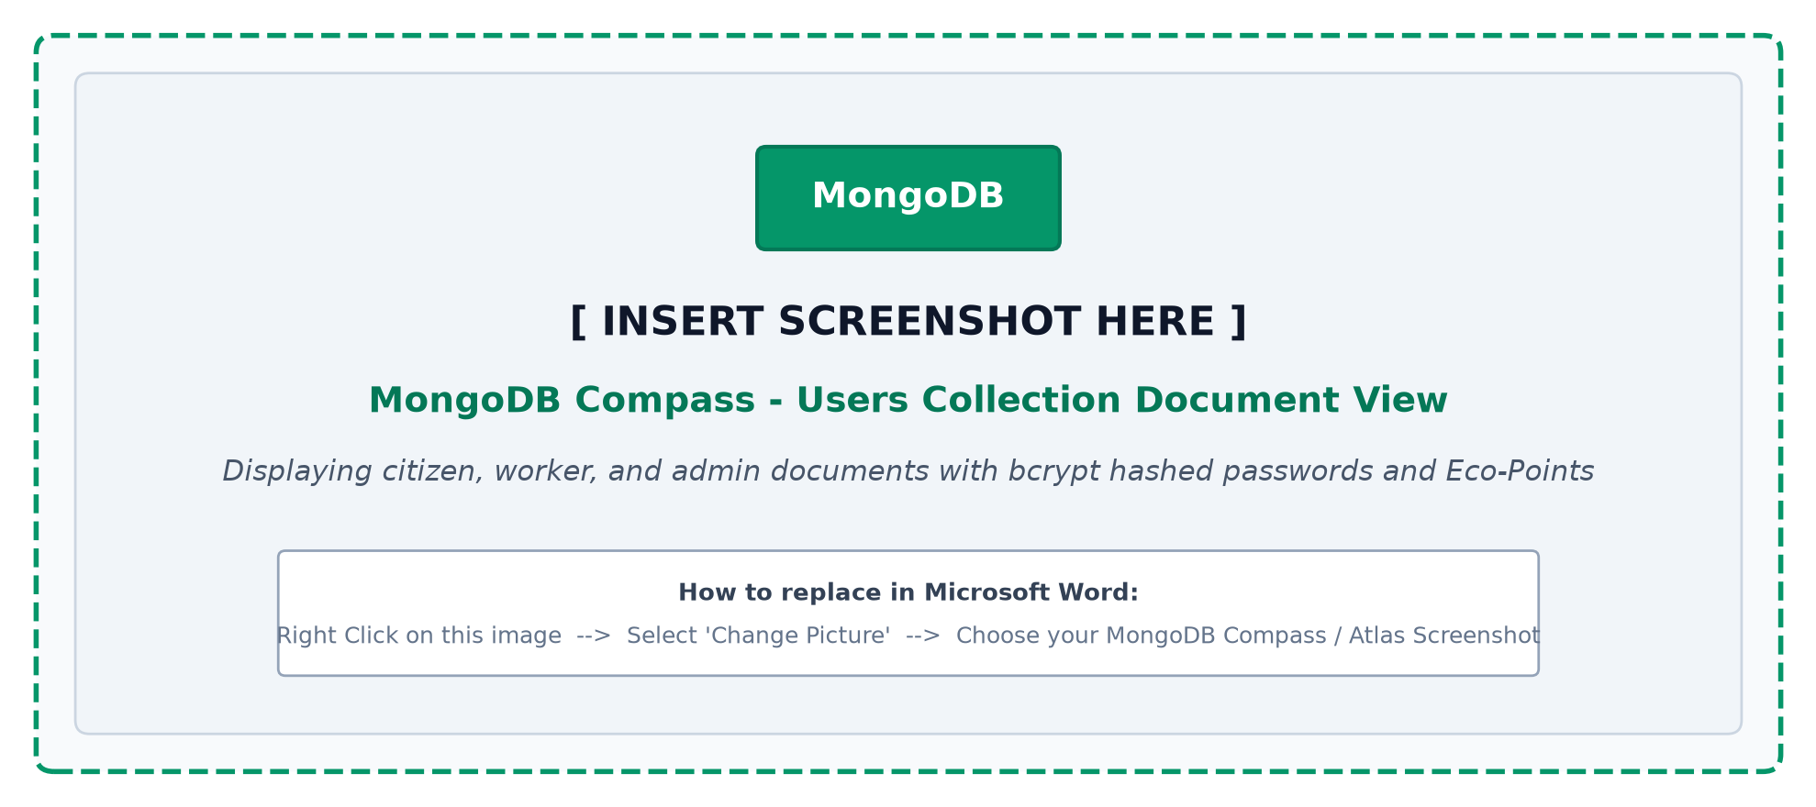
Figure 6.1: MongoDB Compass - Users Collection Document Schema View

CitizenProfile

FIELD NAME | DATA TYPE | DESCRIPTION
_id | ObjectId (Index) | Unique profile document identifier
user | ObjectId (ref: 'User', Unique) | One-to-one reference to User account document
phoneNumber | String (Indexed) | Contact phone number for SMS notices
wardNumber | Number | Residential municipal ward number

WardAddress

FIELD NAME | DATA TYPE | DESCRIPTION
_id | ObjectId (Index) | Unique ward location document identifier
wardName | String (Required) | Name of administrative municipal ward
city | String (Default: 'Perinthalmanna') | Municipality or corporation jurisdiction
supervisor | ObjectId (ref: 'User') | Reference to ward sanitation officer
location.coordinates | [Number] (GeoJSON [lng, lat]) | 2dsphere indexed center coordinate pair
location.type | String (Default: 'Point') | GeoJSON spatial geometry type
pincode | String | Postal area code of the municipal zone
totalDwellings | Number | Estimated count of residential households
activeDumpsters | Number | Registered public waste dumpsters in ward
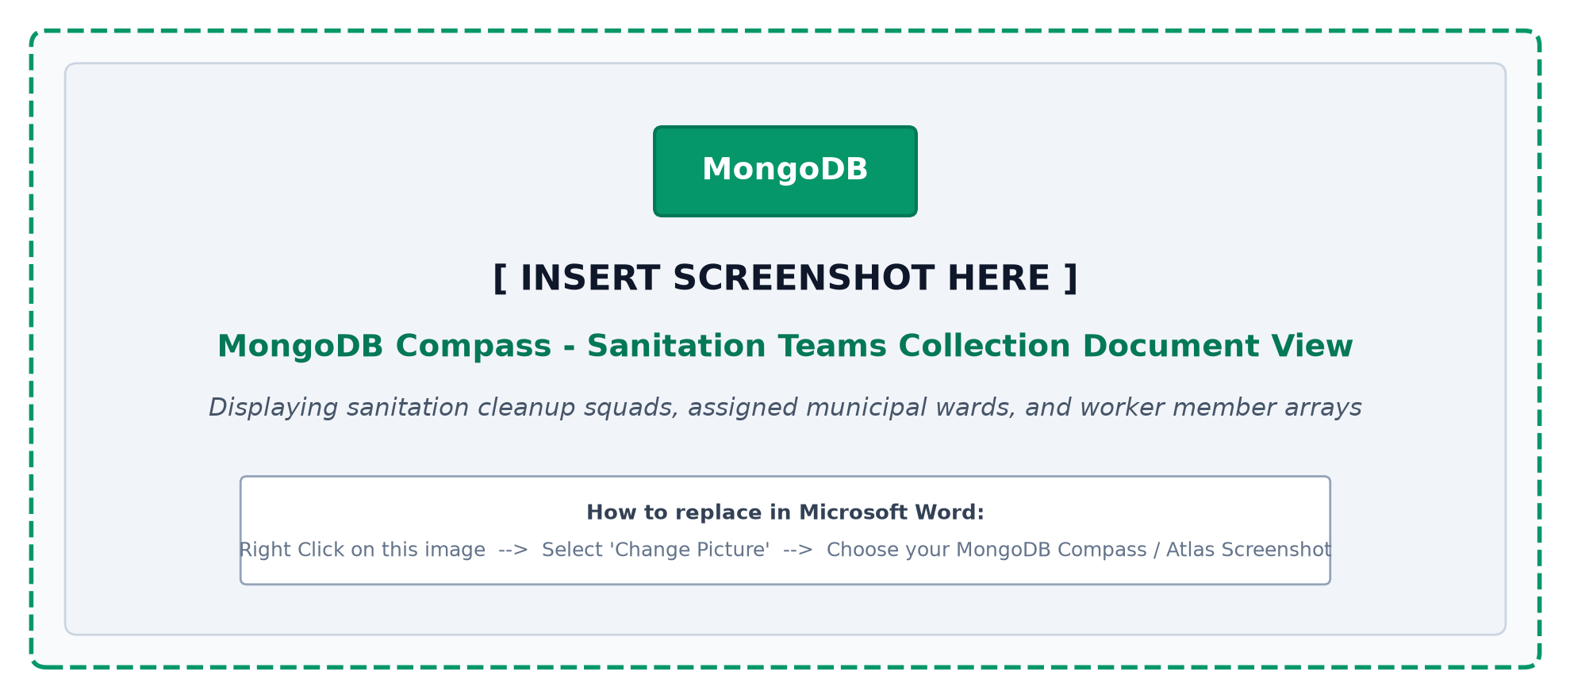
Figure 6.2: MongoDB Compass - Ward Geolocation & Teams Collection View

WasteAssessment

FIELD NAME | DATA TYPE | DESCRIPTION
_id | ObjectId (Index) | Unique AI assessment record identifier
complaint | ObjectId (ref: 'Complaint') | Reference to reported waste dump document
predictedCategory | String (Enum: ['Plastic', 'Organic', 'E-Waste', 'Hazardous']) | Simulated AI classification prediction
confidenceScore | Number (Percentage) | Model certainty rating (e.g., 94.6%)
estimatedVolume | Number (m³) | Estimated physical volume of garbage heap
hazardIndex | String (Enum: ['Low', 'Medium', 'High']) | Toxicity and contagion severity score
recommendedTruck | String | Suggested collection truck category to deploy

CitizenFAQ

FIELD NAME | DATA TYPE | DESCRIPTION
_id | ObjectId (Index) | Unique civic FAQ document identifier
question | String (Required) | Waste disposal or segregation question
answer | String (Long Text) | Official municipal guideline response
category | String | Topic: Segregation, E-Waste, Bulky Items
createdAt | Date | Timestamp of FAQ publication in portal
displayOrder | Number | Frontend rendering sequence number

WorkerJobSheet

FIELD NAME | DATA TYPE | DESCRIPTION
_id | ObjectId (Index) | Unique worker daily job sheet identifier
worker | ObjectId (ref: 'User') | Reference to sanitation field worker
shiftDate | Date | Scheduled duty date for cleaning shift
assignedWard | Number | Ward allocated for garbage collection
totalTasks | Number (Default: 0) | Count of target cleanup sites assigned

TaskItem

FIELD NAME | DATA TYPE | DESCRIPTION
_id | ObjectId (Index) | Unique task dispatch record identifier
jobSheet | ObjectId (ref: 'WorkerJobSheet') | Reference to daily WorkerJobSheet document
complaint | ObjectId (ref: 'Complaint') | Reference to Complaint dump site document
priority | String (Enum: ['Low', 'Medium', 'High']) | Urgency ranking of task item
targetDeadline | Date | Mandatory completion deadline set by admin
status | String (Enum) | Task progress status (assigned, in-progress, completed)
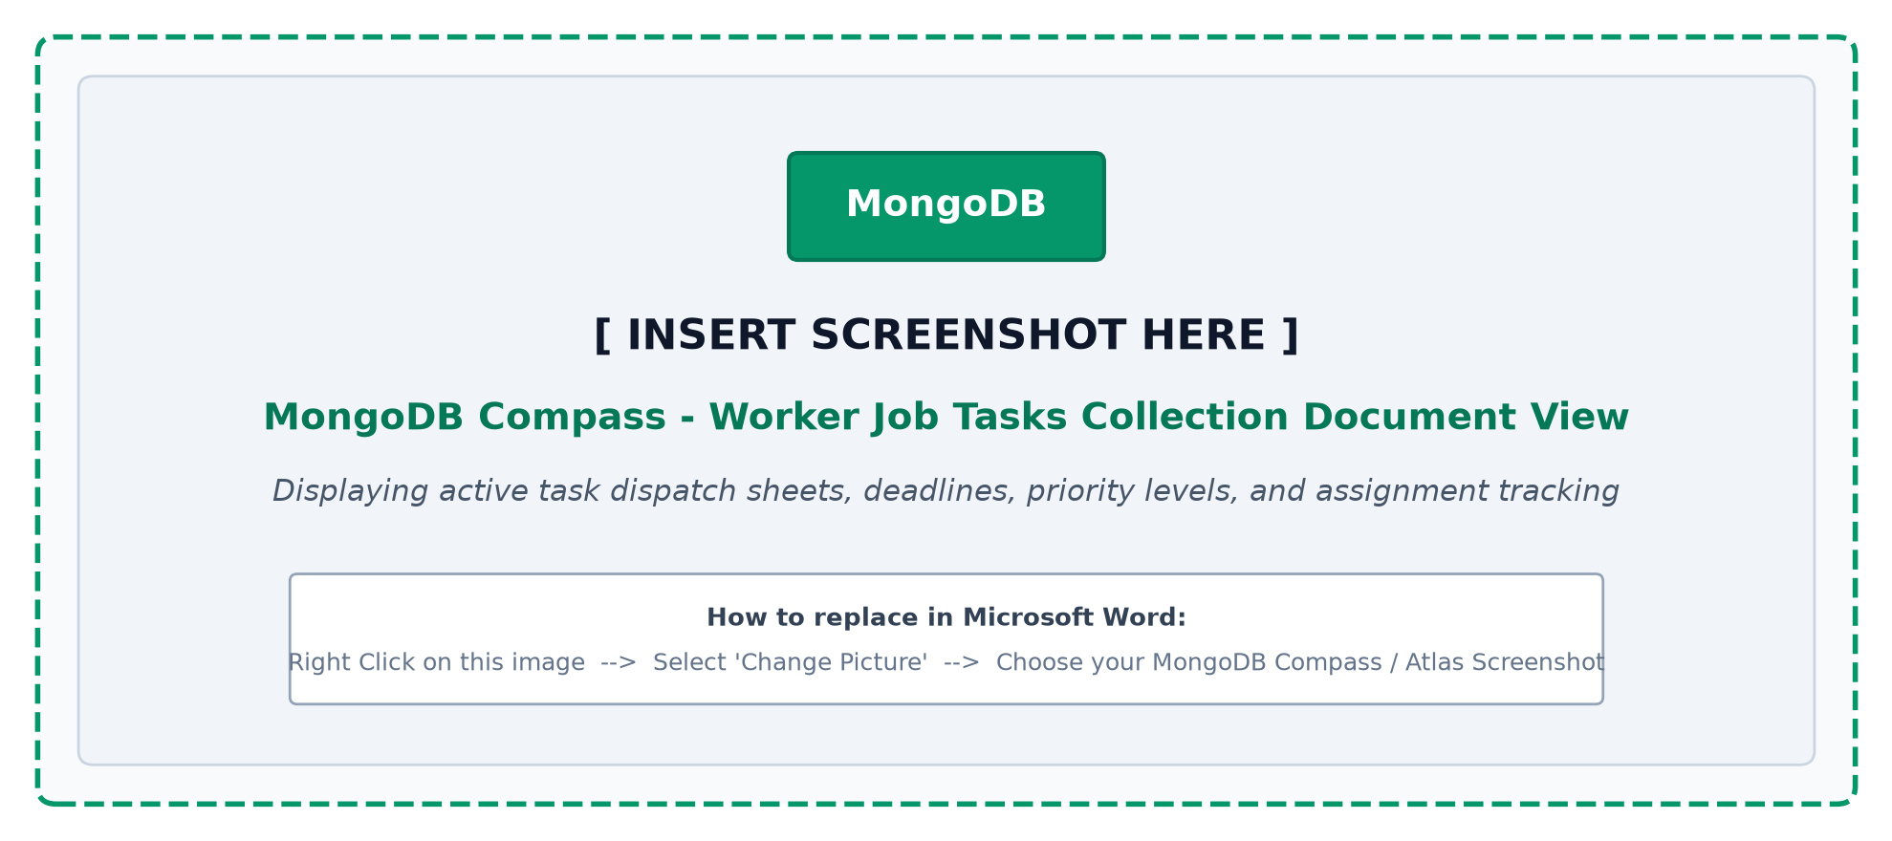
Figure 6.3: MongoDB Compass - Worker Tasks & Job Sheet Collection View

WasteCategory

FIELD NAME | DATA TYPE | DESCRIPTION
_id | ObjectId (Index) | Unique waste category document identifier
categoryName | String (Unique, Required) | Class: Plastic, Organic, E-Waste, Hazard
disposalProtocol | String (Long Text) | Official municipal recycling handling guide

IncidentPhoto

FIELD NAME | DATA TYPE | DESCRIPTION
_id | ObjectId (Index) | Unique photo document identifier
complaint | ObjectId (ref: 'Complaint') | Reference to corresponding Complaint document
imageUrl | String | Cloudinary or local static storage URI path

Complaint

FIELD NAME | DATA TYPE | DESCRIPTION
_id | ObjectId (Unique Document ID, Index) | Unique waste dump incident document identifier
citizen | ObjectId (ref: 'User', Required) | Reference to reporting citizen User document
worker | ObjectId (ref: 'User', Nullable) | Reference to assigned sanitation worker
team | ObjectId (ref: 'Team', Nullable) | Reference to assigned sanitation squad
title | String (Required) | Short descriptive title of waste incident
description | String (Required) | Detailed notes and geographical landmarks
location.latitude | Number (Required) | Precise GPS latitude coordinate (-90 to +90)
location.longitude | Number (Required) | Precise GPS longitude coordinate (-180 to +180)
location.address | String | Reverse geocoded street address from OSM
wasteType | String (Default: 'Mixed') | Waste category (Plastic, Organic, Mixed, etc.)
severity | String (Enum: ['Low', 'Medium', 'High']) | Urgency classification of dump site
photoBefore | String (Required) | Storage URI of initial report photo
photoAfter | String (Nullable) | Storage URI of verification photo by worker
status | String (Enum) | Lifecycle status: pending, verified, assigned, cleaned, completed
pointsAwarded | Number (Default: 0) | Eco-Points credited to citizen upon resolution
deadlineAt | Date (Nullable) | Scheduled deadline timestamp set by admin
createdAt | Date (Default: Date.now) | Auto-generated Mongoose creation timestamp
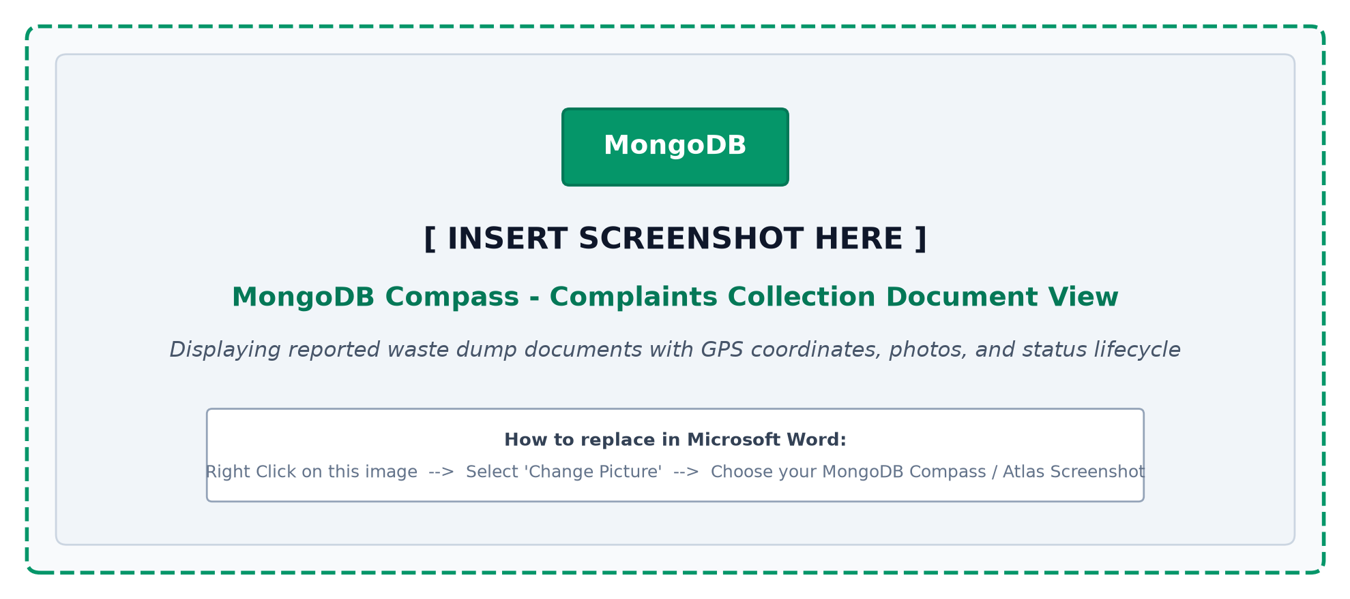
Figure 6.4: MongoDB Compass - Complaints Collection Document Schema View

SeverityScale

FIELD NAME | DATA TYPE | DESCRIPTION
_id | ObjectId (Index) | Unique severity tier document identifier
levelName | String (Unique) | Scale designation: Low, Medium, High, Critical
slaHours | Number | Service Level Agreement response target hours
bonusMultiplier | Number | Multiplier factor for citizen Eco-Points award

EcoPointsVoucher

FIELD NAME | DATA TYPE | DESCRIPTION
_id | ObjectId (Index) | Unique reward voucher redemption identifier
citizen | ObjectId (ref: 'User') | Reference to citizen User document
voucherCode | String (Unique) | Unique alphanumeric coupon redemption code
discountValue | Number | Redemption coupon value in Indian Rupees
partnerStore | String | Partner green merchant / grocery vendor
isRedeemed | Boolean (Default: false) | Redemption status flag
expiresAt | Date | Coupon expiration validity date
issuedDate | Date (Default: Date.now) | Date voucher was redeemed with Eco-Points

CleanupValidationLog

FIELD NAME | DATA TYPE | DESCRIPTION
_id | ObjectId (Index) | Unique validation event document identifier
complaint | ObjectId (ref: 'Complaint') | Reference to Complaint document
worker | ObjectId (ref: 'User') | Sanitation worker who executed field cleanup
verifiedByAdmin | ObjectId (ref: 'User') | Municipal administrator who approved resolution
validationTime | Date | Exact timestamp of after-photo upload
cleanlinessRating | Number (1 to 5 scale) | Audit quality rating score assigned by admin
adminRemarks | String (Long Text) | Notes and observations from municipal inspection
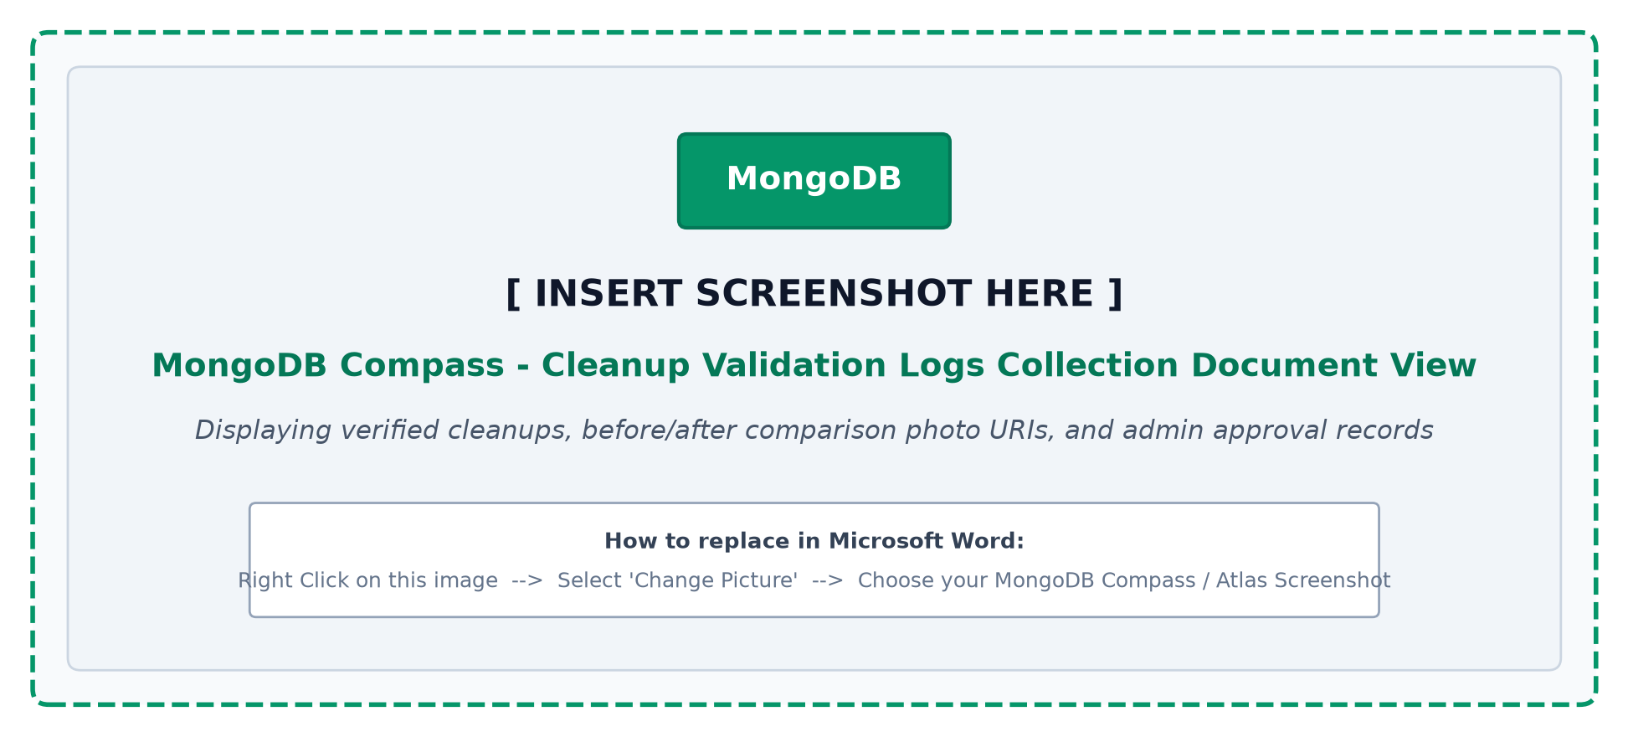
Figure 6.5: MongoDB Compass - Cleanup Validation Logs Collection View

WorkerAssignment

FIELD NAME | DATA TYPE | DESCRIPTION
_id | ObjectId (Index) | Unique task assignment document identifier
complaint | ObjectId (ref: 'Complaint') | Complaint ID allocated to field worker
worker | ObjectId (ref: 'User') | Sanitation field worker assigned to task
assignedBy | ObjectId (ref: 'User') | Administrator who scheduled assignment
assignedAt | Date (Default: Date.now) | Timestamp of ticket dispatch to worker
expectedCompletion | Date | Target resolution completion deadline
actualCompletion | Date (Nullable) | Actual timestamp recorded upon completion
status | String (Enum) | Dispatch status (En Route, In Progress, Done)
workerNotes | String (Long Text) | Field remarks recorded by sanitation worker
verificationFlag | Boolean (Default: false) | Verification flag confirmed by administrator

CitizenReview

FIELD NAME | DATA TYPE | DESCRIPTION
_id | ObjectId (Index) | Unique feedback review document identifier
complaint | ObjectId (ref: 'Complaint') | Reference to resolved Complaint document
citizen | ObjectId (ref: 'User') | Citizen submitting cleanup feedback
rating | Number (1 to 5 Stars) | Citizen rating of cleanup thoroughness
comments | String (Long Text) | Citizen remarks regarding speed and cleanliness
submittedAt | Date (Default: Date.now) | Timestamp of citizen feedback submission

StarredHotspot

FIELD NAME | DATA TYPE | DESCRIPTION
_id | ObjectId (Index) | Unique hotspot bookmark document identifier
admin | ObjectId (ref: 'User') | Municipal administrator bookmarking the zone
wardNumber | Number | Ward flagged as recurrent chronic dump site
notes | String (Long Text) | Surveillance and frequent collection notes

UML Designs
The Unified Modeling Language (UML) is a standardized modeling language used to visualize, specify, construct, and document the software artifacts of an object-oriented and web-based system. UML diagrams facilitate structural and behavioral understanding across stakeholders.
In the EcoClean architecture, Use Case diagrams model user roles and interactions, while Data Flow Diagrams (DFD) trace the movement, transformation, and storage of waste data between citizens, workers, and administrative controllers.

Use case diagram
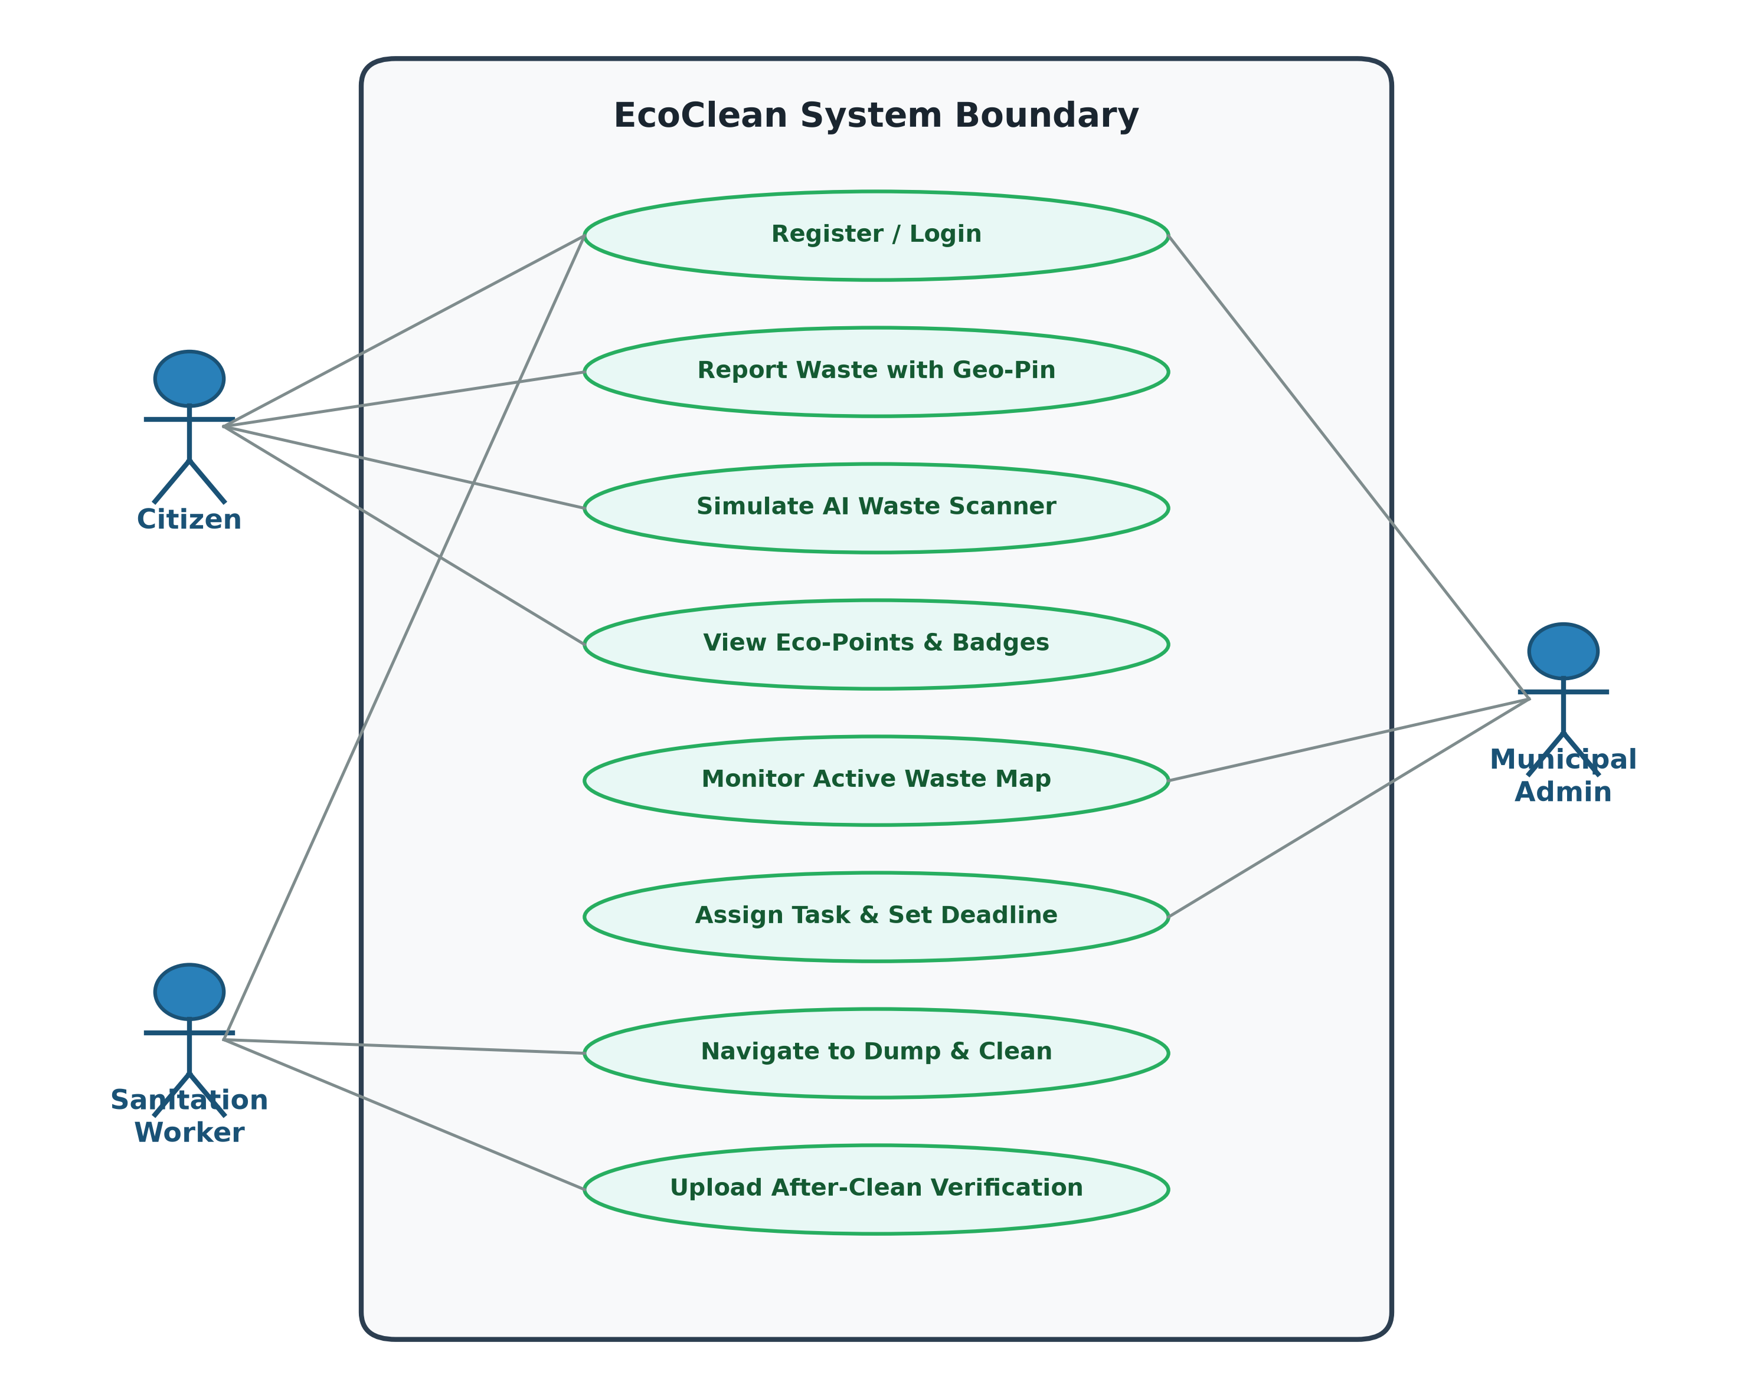

Scenario

Admin

    - Admin Can Login to Customized Glassmorphic Management Portal.
    - Admin Can View Main Real-Time Waste Incident Map.
    - Admin Can Filter Complaints by Ward, Severity, and Status.
    - Admin Can Verify New Reports and Confirm Incident Validity.
    - Admin Can Dispatch Complaints to Individual Sanitation Workers.
    - Admin Can Assign Group Tickets to Sanitation Squad Teams.
    - Admin Can Set Mandatory Cleanup Deadlines and SLAs.
    - Admin Can Track Active Sanitation Workers on Field Duty.
    - Admin Can Inspect Uploaded Before and After Photographic Proofs.
    - Admin Can Approve Completed Cleanups and Trigger Reward Credits.
    - Admin Can Monitor Real-Time Waste Category Breakdown Charts.
    - Admin Can Analyze Monthly Waste Ingestion and Resolution Trends.
    - Admin Can Review Ward-Level Chronic Hotspot Summaries.
    - Admin Can Moderate Citizen Feedback and Cleanliness Ratings.
    - Admin Can Configure Reward Points and Achievement Badge Tiers.
    - Admin Can Export Detailed Municipal Waste Resolution Reports.
    - Admin Can Maintain System Audit Trails and Worker Logs.
    - Admin Can Detect Duplicate Waste Incident Reports using Geospatial Clustering.

User

    - Citizen Can Register with Email, Phone, and Municipal Ward.
    - Citizen Can Securely Login via JWT Authentication.
    - Citizen Can View Personal Profile, Points Balance, and Rank Badge.
    - Citizen Can Open Interactive Map and View Local Incident Pins.
    - Citizen Can Drop Precise GPS Location Pin on Waste Dump.
    - Citizen Can Upload High-Resolution Photograph of Garbage Site.
    - Citizen Can Run Simulated AI Waste Scanner for Material Detection.
    - Citizen Can Enter Descriptive Landmark Notes and Street Details.
    - Citizen Can Submit Incident Report to Local Civic Municipality.
    - Citizen Can Track Lifecycle Status of Submitted Complaints.
    - Citizen Can View Side-by-Side Photographic Proof of Resolved Cleanup.
    - Citizen Can Earn 50 Eco-Points for Every Verified Cleanup.
    - Citizen Can Level Up from Novice Reporter to Eco Warrior.
    - Citizen Can Inspect City-Wide Civic Leadership Leaderboard.
    - Citizen Can Redeem Accumulated Eco-Points for Partner Vouchers.
    - Sanitation Worker Can View Mobile Job Sheet and Active Targets.
    - Sanitation Worker Can Navigate to Coordinates via Maps Integration.
    - Sanitation Worker Can Capture and Submit After-Cleaning Photo Proof.

Data Flow Diagram

Level - 0
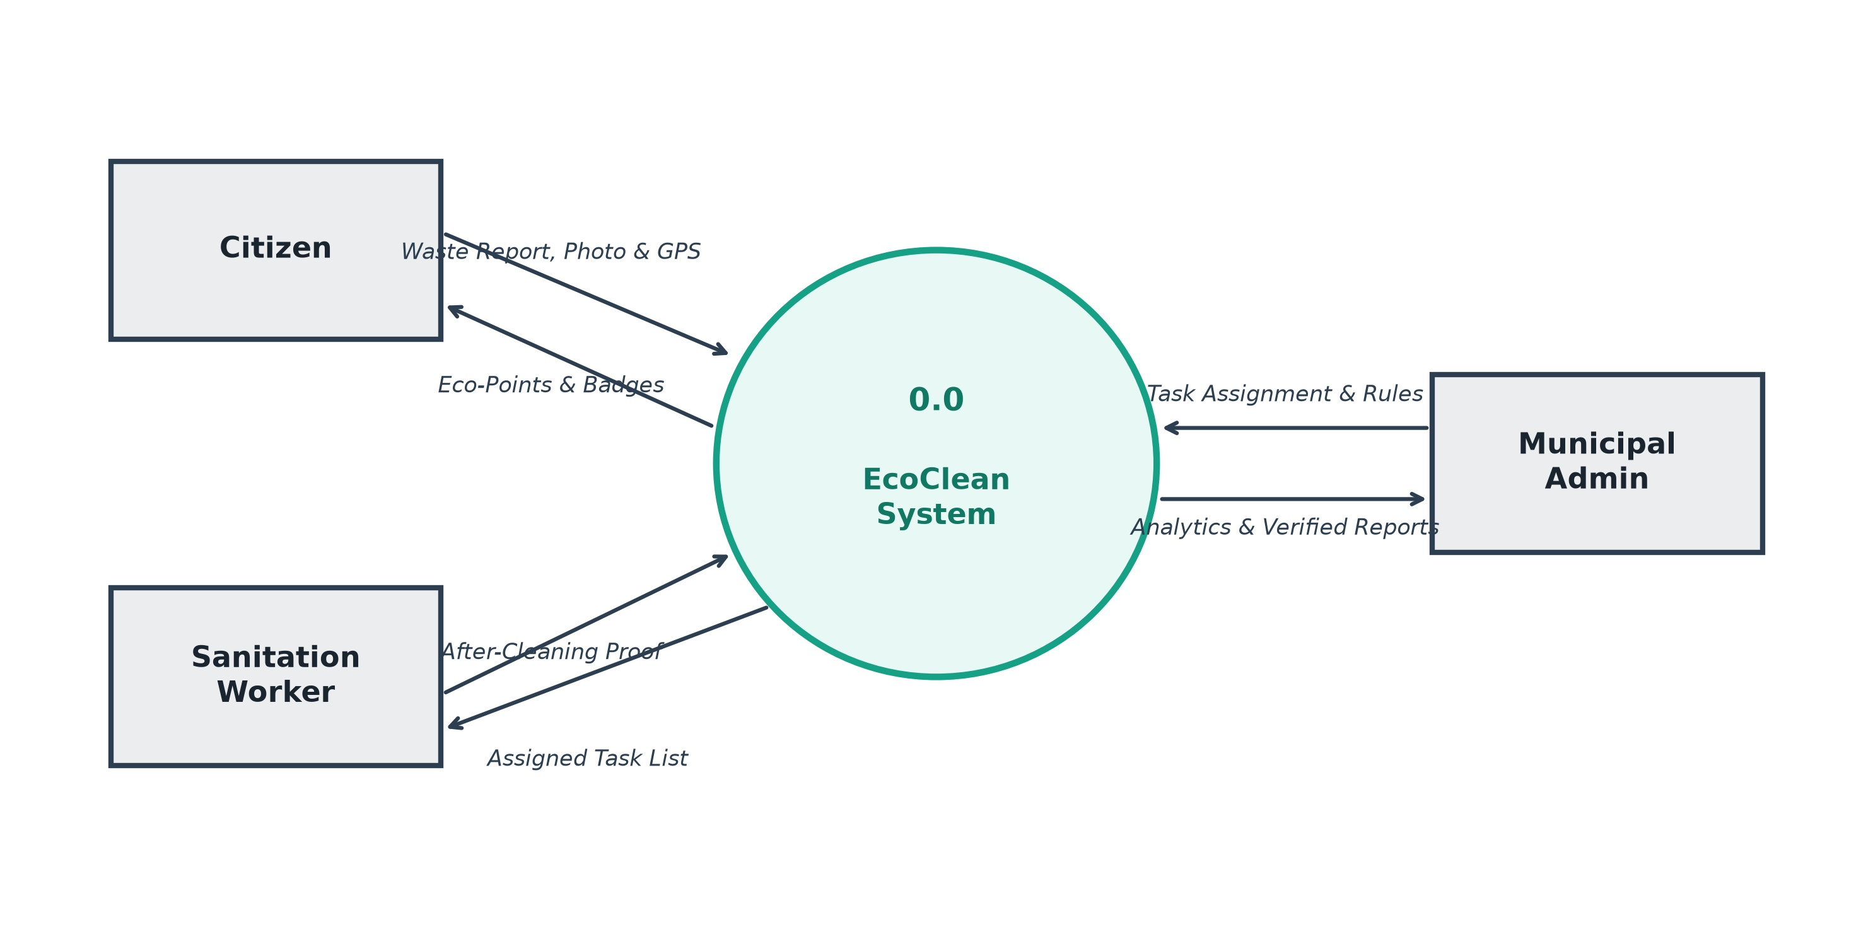

Level - 1 Admin

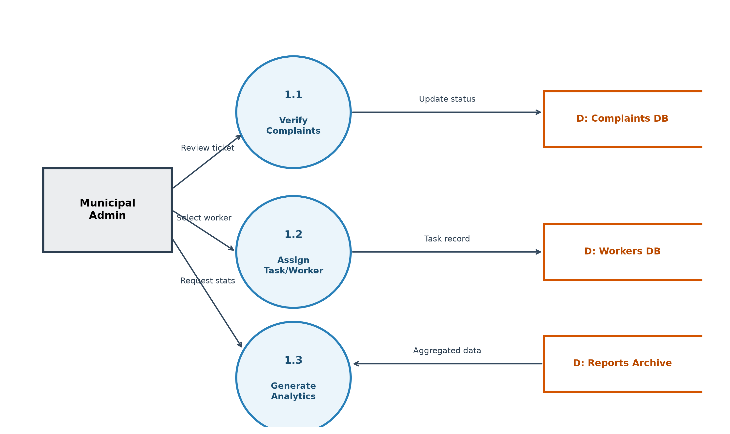

Level - 1 User

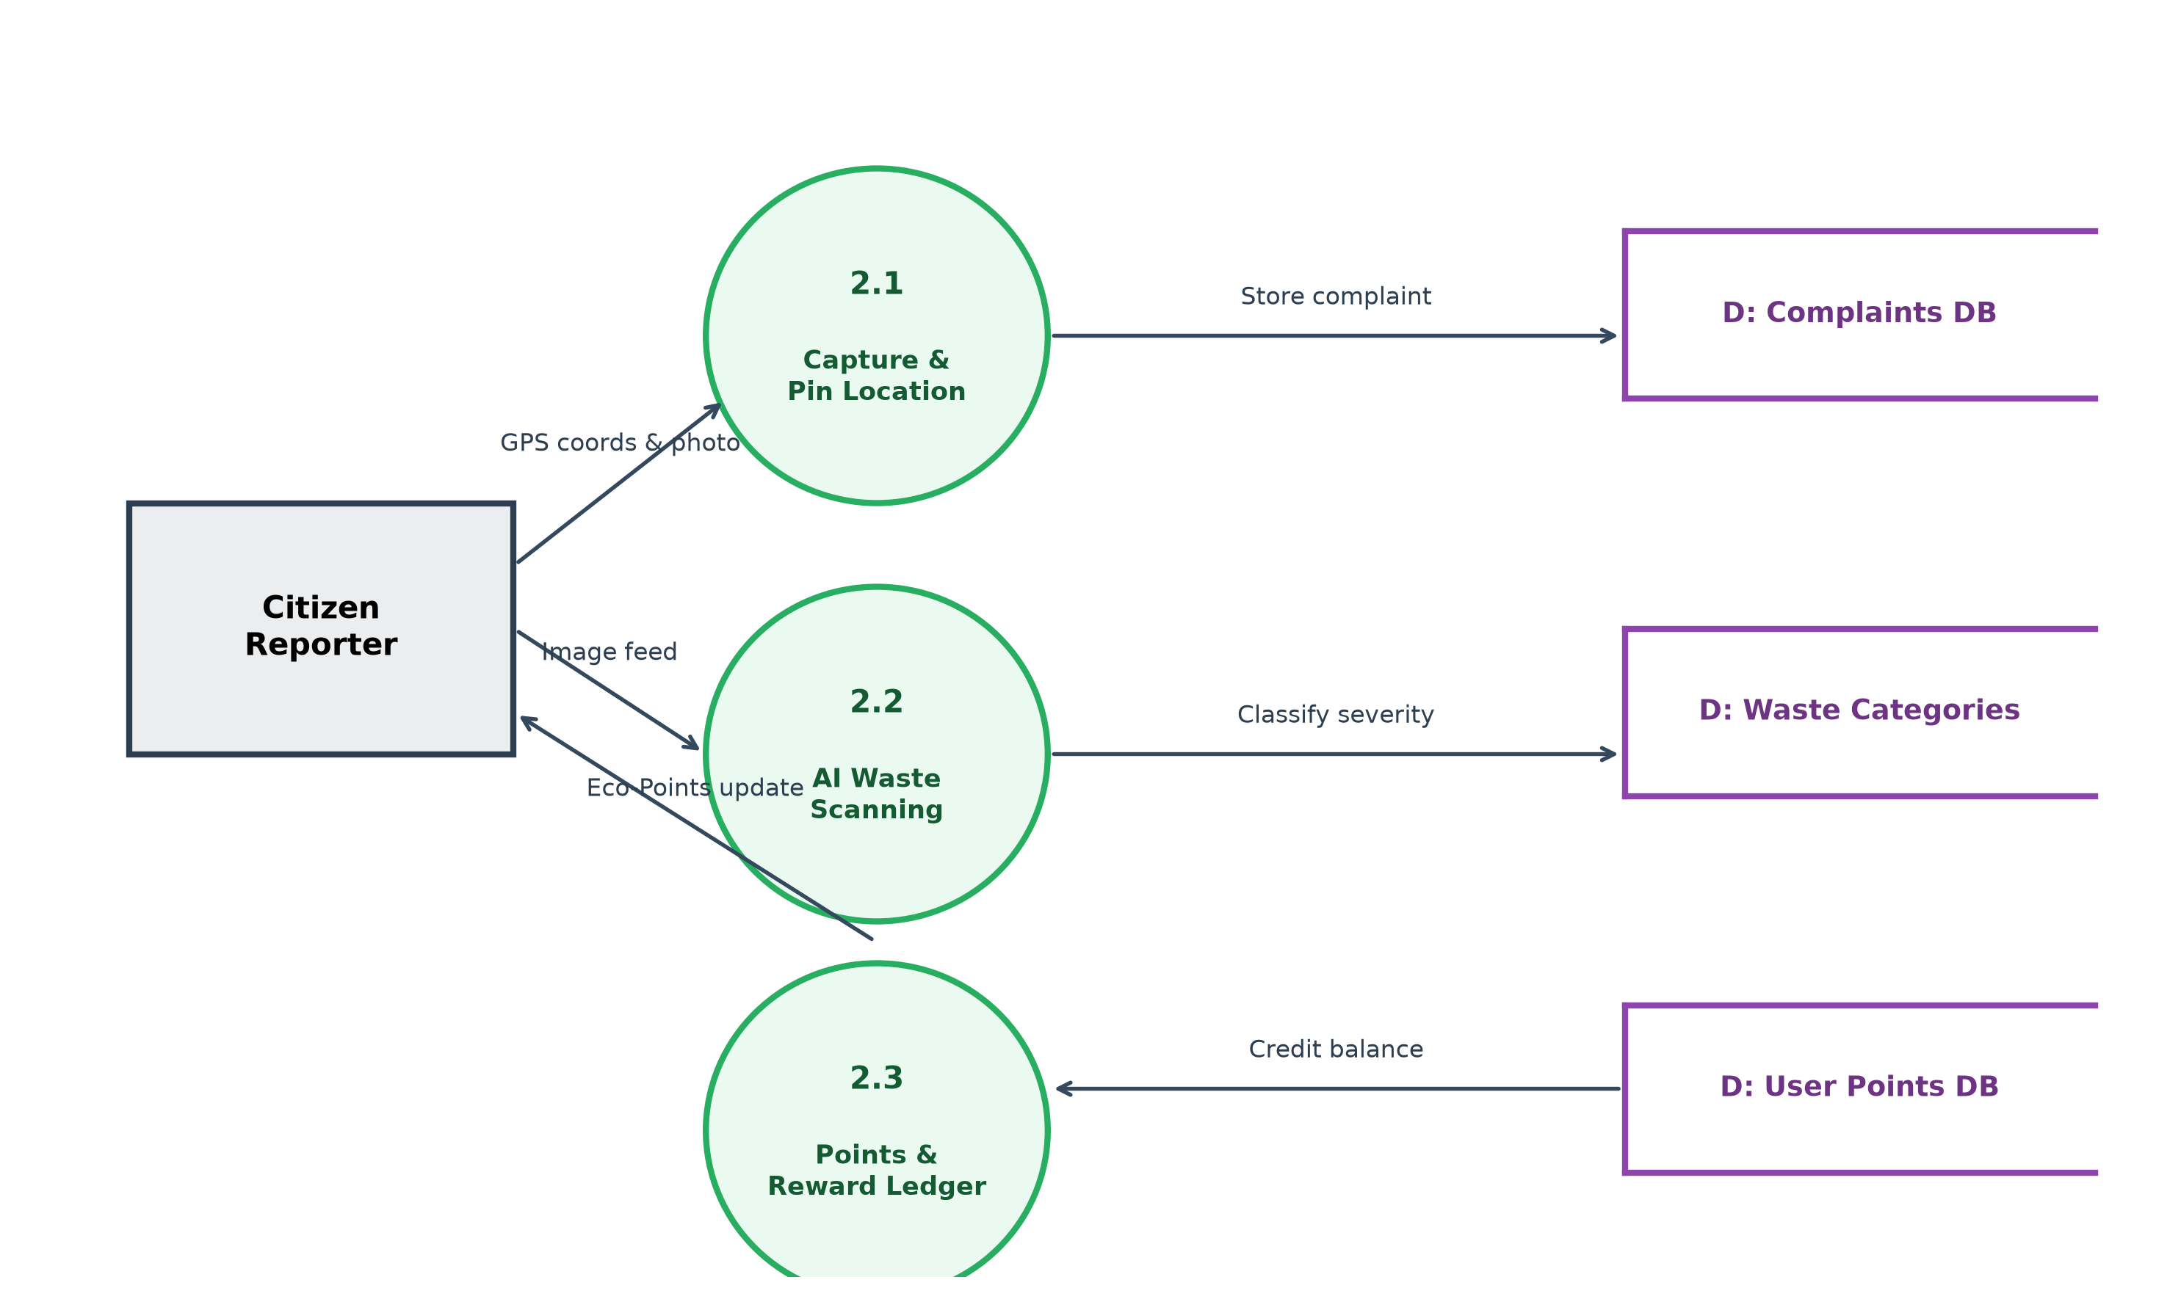

Level - 2 Admin

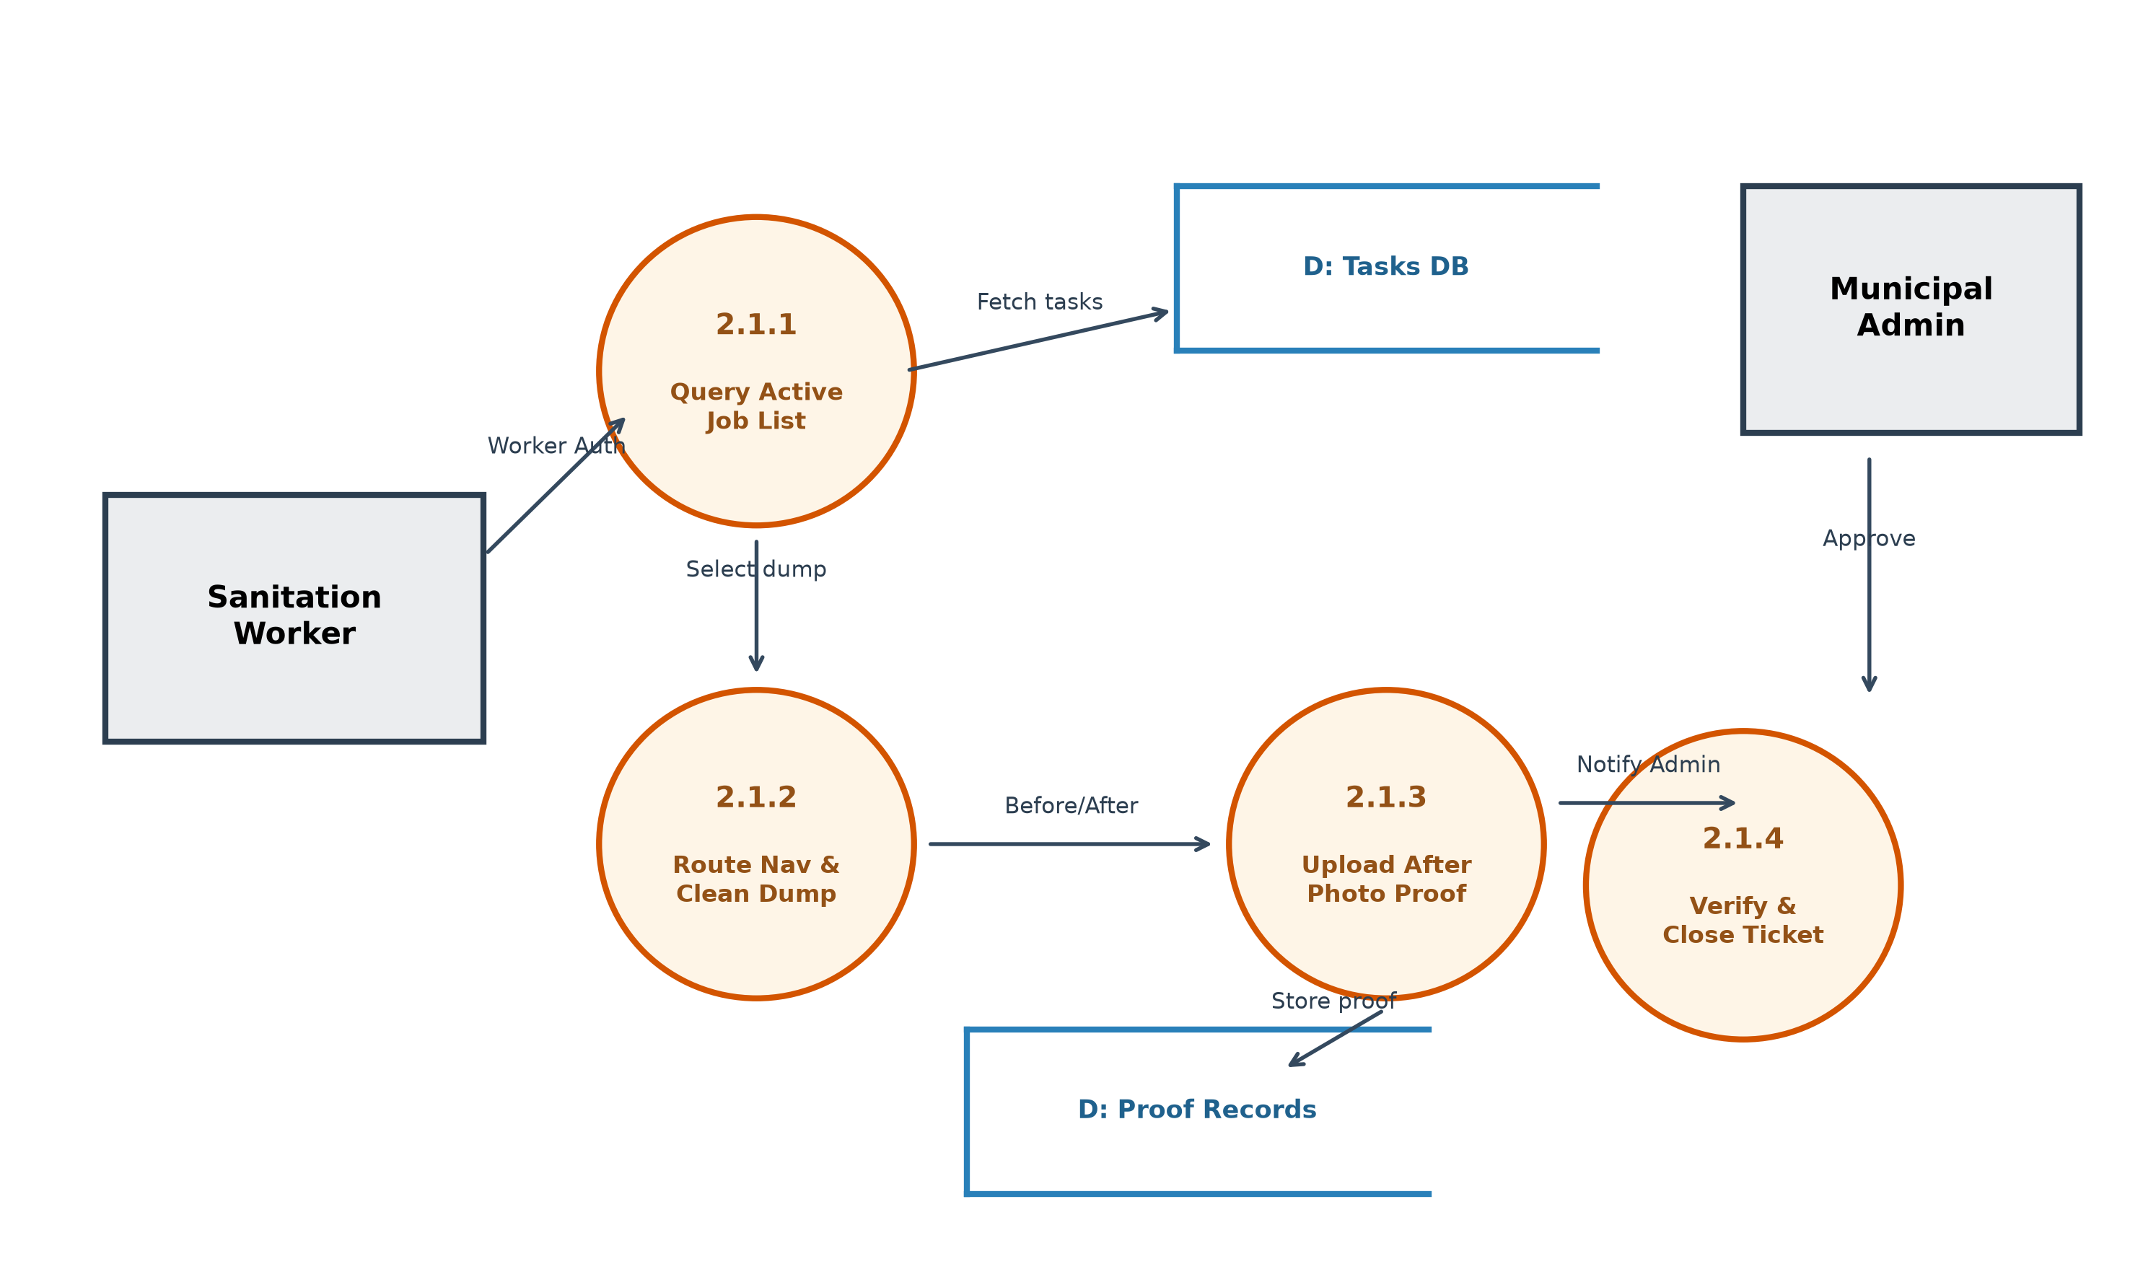

Level - 2 User

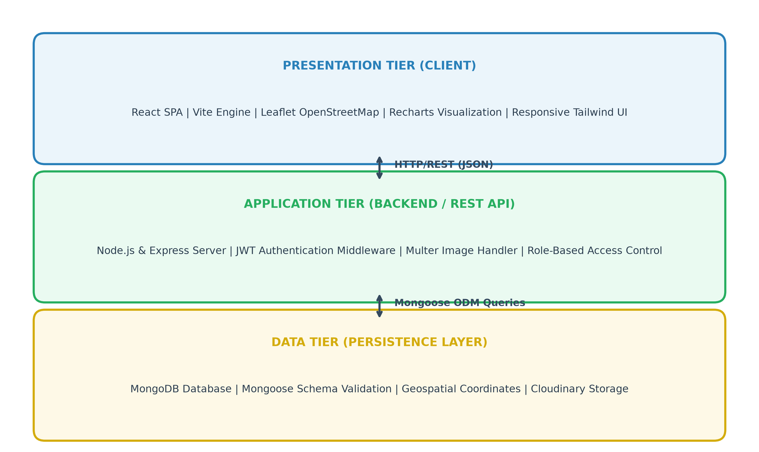

SYSTEM DEVELOPMENT

SYSTEM DEVELOPMENT
System development is series of operations to manipulate data to produce output from computer system. The principal activities performed during the development phase can be divided into two major related sequences.
- System development entails the architectural and procedural execution through which technical design models are translated into a production-grade software solution. EcoClean employs a modular Model-View-Controller (MVC) server pattern integrated with an asynchronous Single Page Application (SPA) client.
- Internal system development
The major external system activities are:
- Implementation
- Planning
- Equipment acquisition
- Installation

Coding
The purpose of code is to facilitate the identification and retrieval of items of information. A code is an ordered collection of symbols designed to provide uniqueidentification of entity or an attribute. Code also show interrelationship among different items. Codes are used to identify, access, sort, matching records. The code ensures that only one value of code with a single meaning is applied to give entity or attribute as described in various ways.

JavaScript & Node.js
JavaScript is used across the entire development stack (client and server), ensuring unified data representations and rapid serialization of JSON models. Node.js provides a high-concurrency, event-driven runtime ideal for simultaneous geo-tracking and API queries.
JavaScript is a versatile, high-level, multi-paradigm programming language that powers modern interactive web applications. Coupled with the Node.js runtime engine, built on Google Chrome's V8 JavaScript engine, it enables event-driven, non-blocking asynchronous I/O execution on the server side. This architecture allows EcoClean to handle concurrent client requests, continuous geolocation telemetry, and real-time report status polling with high throughput and low resource utilization.
In modern full-stack web engineering, Node.js combined with the Express.js framework provides robust middleware pipelines, modular RESTful API routing, and streamlined JSON request/response serializations. Furthermore, asynchronous helper libraries such as Axios, Bcrypt, and Multer facilitate secure password hashing, token verification, and seamless multipart image ingestion.

In the EcoClean project, Node.js and Express act as the core backend engine, managing application business logic, coordinate geofencing, role-based JWT authentication, and database transactions. Its non-blocking architecture ensures that administrative dashboards, worker job cards, and citizen reporting portals receive instantaneous updates across municipal operations.

Libraries

JavaScript and Node.js, alongside modern full-stack web engineering, possess a vast ecosystem of open-source packages via npm that streamline development, spatial calculations, and asynchronous I/O handling.

Express.js
Express.js serves as the backend REST web framework, providing lightweight routing, request payload parsers, and custom middleware for JWT authentication and Multer multipart image streaming.

React.js
React 18 powers the dynamic user interface using modular functional components and state hooks. React facilitates fluid map interactions, live points counter increments, and mobile-friendly task card workflows.
Tailwind CSS and modern dark-glassmorphism styling constitute the front-end presentation layer of EcoClean. Utilizing a utility-first methodology, Tailwind enables responsive, mobile-first layouts, custom frosted-glass navigation bars, and glowing status indicators. This ensures that the user interface remains intuitive, highly aesthetic, and fully responsive across smartphones, tablets, and desktop workstations without requiring bulky UI frameworks.

Leaflet Maps & OpenStreetMap
Leaflet is an open-source JavaScript mapping library used to display raster OpenStreetMap tiles, render custom SVG dump status markers, and allow precise coordinate drag-and-drop placement by citizens.
The AI Waste Scanner simulation incorporates computer vision feature extraction principles to analyze uploaded garbage dump imagery. By evaluating pixel color distributions, contour densities, and material texture patterns, the algorithm estimates waste classifications (such as Plastic Polymers, Biodegradable Organic Matter, or Toxic E-Waste) and assigns an appropriate severity score to prioritize sanitation dispatch.

MongoDB NoSQL Engine
MongoDB handles unstructured complaint schemas, nested geographical coordinate arrays, and historical before/after image records with sub-millisecond query performance.

Mongoose ODM
Mongoose enforces strong schema validation, pre-save hashing hooks, and relationship population between User, Complaint, and Team collections.

Recharts Data Visualization
Recharts renders responsive, animated SVG bar charts and trend lines on the administrative dashboard, visualizing waste composition metrics and monthly resolution velocity.

SYSTEM TESTING AND IMPLEMENTATION

SYSTEM TESTING AND IMPLEMENTATION
Testing is the vital to the success of the system. It makes a logical assumption that if all the parts of the system are correct, the goal will be successfully achieved in this project. It is the stage of implementation, which ensures that system works accurately and effectively before the live operation commences. It is a confirmation that all are correct and opportunity to show users that the system must be tested and show that the system will operate successfully and produce expected results under expected conditions. Software testing is a crucial element of software quality assurance and represents the unlimited review of specification, design and coding. Testing represents an interesting anomaly for the software. During the earlier definition and development phase, it was attempted tobuild the software from an abstract concept to implement.
Testing is essential to software quality assurance, validating that every functional module executes according to specifications and performs reliably under heavy load and error conditions.

Types of Testing

Different types of testing are,
- Unit testing
- Integration testing
- System testing
- Validation testing
- User acceptance testing.

Unit Testing
Unit tests validated isolated controllers and algorithms: testing password encryption, JWT signing, coordinate format validation, and automated 50-point balance increment calculations.

Integration Testing
Integration tests verified data interchange between Multer file upload streams, Mongoose database storage, and React frontend state updates upon ticket dispatch.
  - The system contains various components and they have to be combined and tested.
  - The software is embedded into hardware and tested.
  - The modules are combined and tested.
  - The hardware part tested separately.

System Testing

System testing evaluated complete end-to-end workflows: from initial citizen report submission to administrative assignment, worker cleanup completion, and final reward disbursement.

User Acceptance Testing

User Acceptance Testing was performed with student and faculty user groups, confirming high usability on mobile screens and clear visual verification workflows.
- Output Screen design.
- Input Screen design.
- Menu driven system.

Implementation
Implementation converted the theoretical architecture into an operational system deployed on local Node environments and cloud database nodes.
Implementation means converting a new or revised system design into an operational one. The implementation includes all those activities that take place to convert from the old system to the new one.
There are several activities involved while implementing a project:

- Careful planning.
- Investigating the current system and its constraints on implementation.
- Design of methods to achieve the changeover.
- Training of the staff in the changeover procedure and evaluation of change over method.
Implementation is the final stage and it is an importance phase. The first task in implementation was the implementation planning, that is deciding on methods to be adopted. After the system was implemented successfully, training of the user was oneof the most important subtasks of the developer. For this purpose, the user or system manual were prepared and handled over to the user to operate the developed system. So, change over plays a vital role, which checks the developed tool for the following requirements, and then only the user accepted the developed tool. The changeover took place only when the system had been proved to the satisfaction of the system analysis and other implementation activities have been completed.

SYSTEM MAINTENANCE

SYSTEM MAINTENANCE
System maintenance ensures continuous availability, operational resilience, and evolutionary enhancements post-deployment.
There are three types of maintenance:
  - Corrective Maintenance (Resolving Leaflet touch pan bugs on small mobile screens and image upload timeouts)
  - Adaptive Maintenance (Upgrading Node runtime dependencies and supporting latest browser Geolocation APIs)
  - Perfective Maintenance (Adding database spatial indexing for fast geolocation radius queries and caching metrics)
Maintenance is enigma of the system development. The definition of the software maintenance can be given describing four activities that are undertaken after the program is released for use.
The maintenance activity occurs since it is unreasonable to assume that software testing will uncover all in a large system. The second activity that contributes the definition of maintenance occurs since rapid changes are encountered in every aspects of computing. The third activity involves recommendation for new capabilities, modification to the existing functions and general enhancements when the software is used. The fourth maintenance activity occurs when software is changed to improve futuremaintainability or reliability.

FUTURE ENHANCEMENT

FUTURE ENHANCEMENT

- Native Mobile Applications for Android and iOS using React Native and Flutter.
- Real-Time Edge AI Waste Detection with MobileNet / YOLO Computer Vision.

- IoT Smart Dumpster Fill-Level Ultrasonic Sensor Integration.

- Blockchain-Backed Civic Carbon Credits for Waste Recycling.

- Public Bio-Degradable Composting Rewards Scheme Integration.

- Automated Drone Aerial Surveying for Illegal Dumping Hotspots and Open Dumpsites

- Dynamic Vehicle Routing Optimization (VRP) & Fuel-Efficient Truck Path Navigation

- Integration with Official Municipal WhatsApp Chatbots for Instant Geolocation Reporting

- AI-Powered Predictive Waste Influx and Seasonal Accumulation Forecasting

CONCLUSION

CONCLUSION

The EcoClean project successfully modernizes solid waste monitoring by bridging citizens, municipal authorities, and sanitation field workers through an interactive, transparent web platform. By leveraging precision GPS pin-dropping, simulated AI waste assessment, photographic verification proofs, and gamified civic rewards, EcoClean transforms public sanitation from a neglected complaint procedure into an engaging civic partnership.
The platform demonstrates how full-stack web technologies, open-source mapping libraries, and gamified community engagement can solve real-world urban sanitation challenges, contributing to cleaner, healthier, and more sustainable smart cities.

APPENDIX

APPENDIX

Login & Multi-Role Authentication Screen

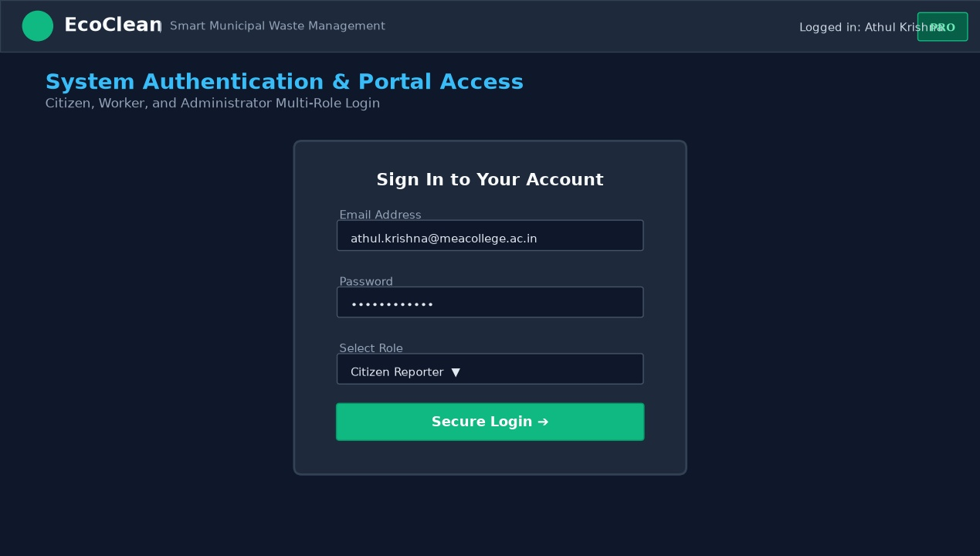

Citizen Registration & Ward Selection Screen

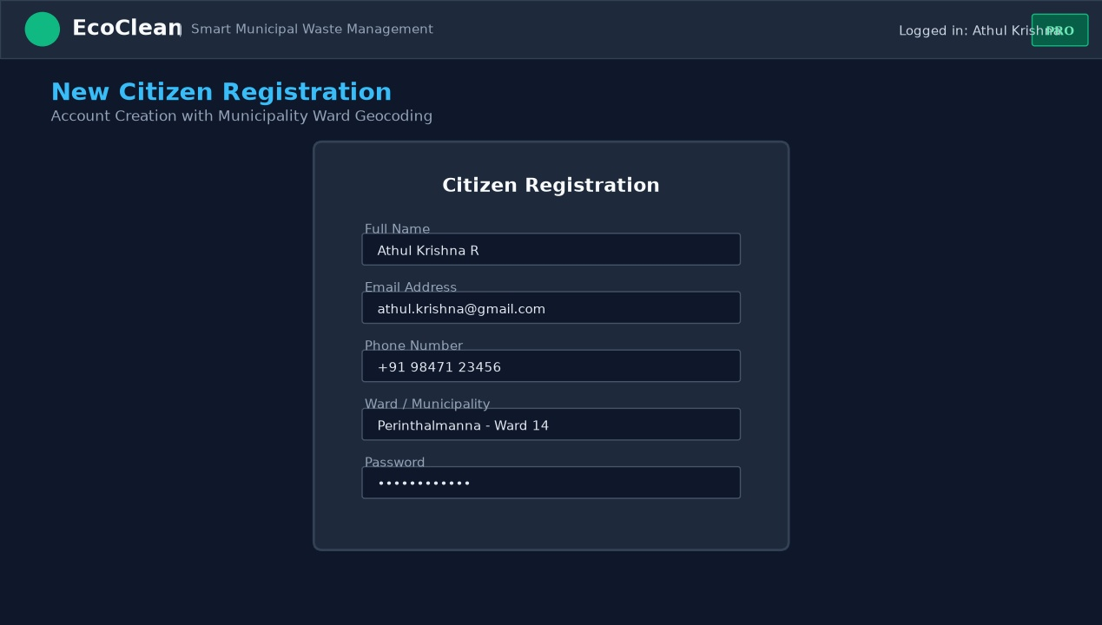

Municipal Admin Live Incident Map & Fleet Control Dashboard

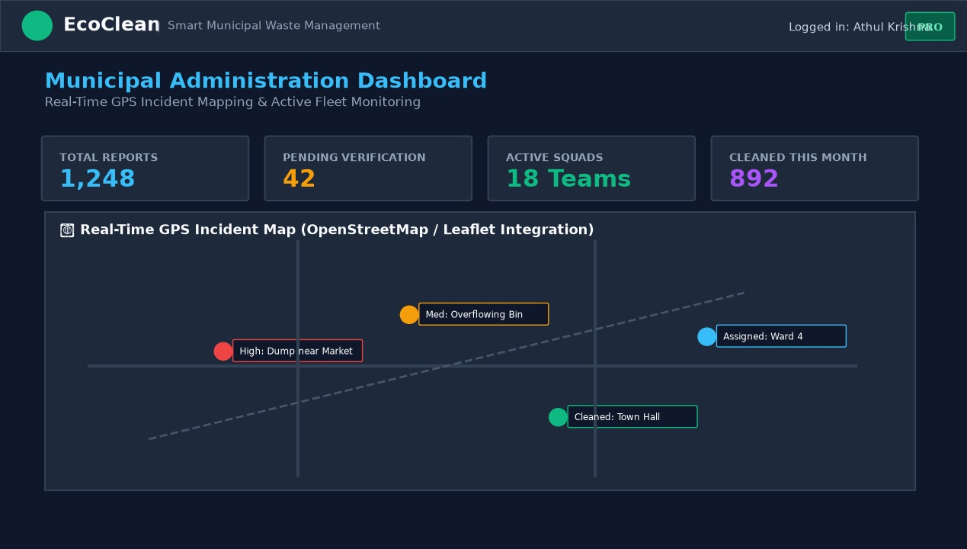

Citizen Waste Reporting & Interactive Map Geolocation Screen

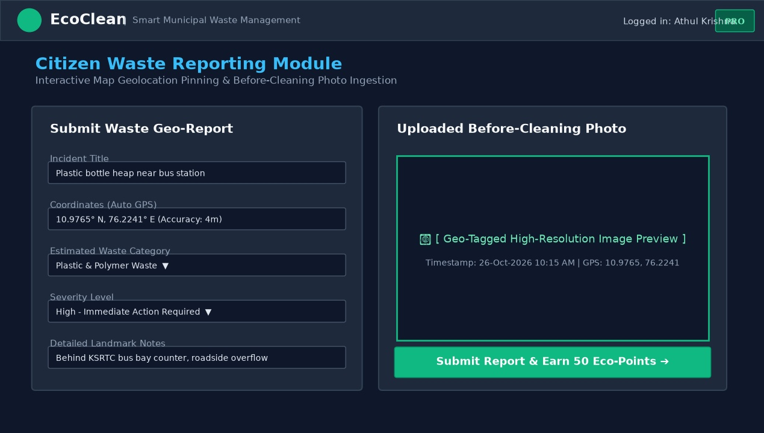

Sanitation Worker Mobile Job Sheet & Navigation Screen

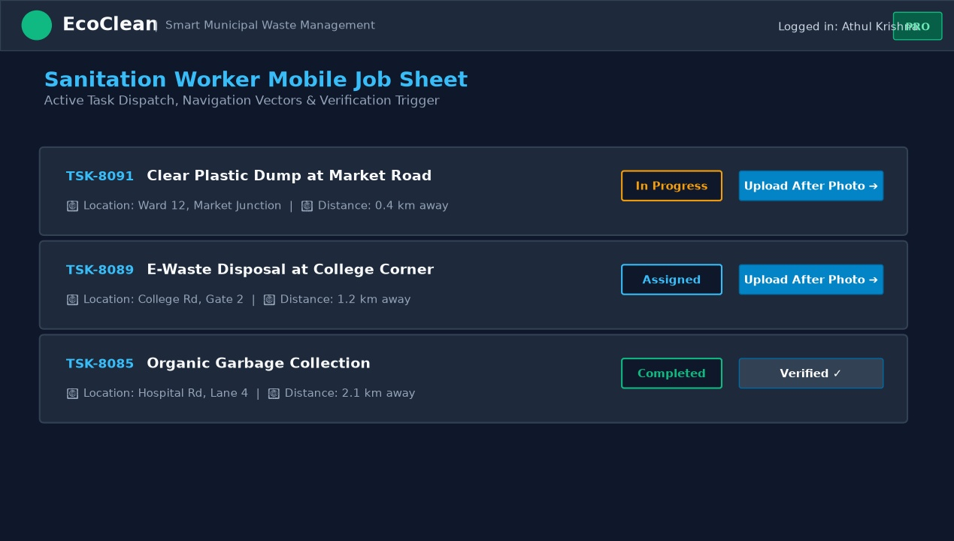

AI Waste Scanner & Material Classification Simulation Screen

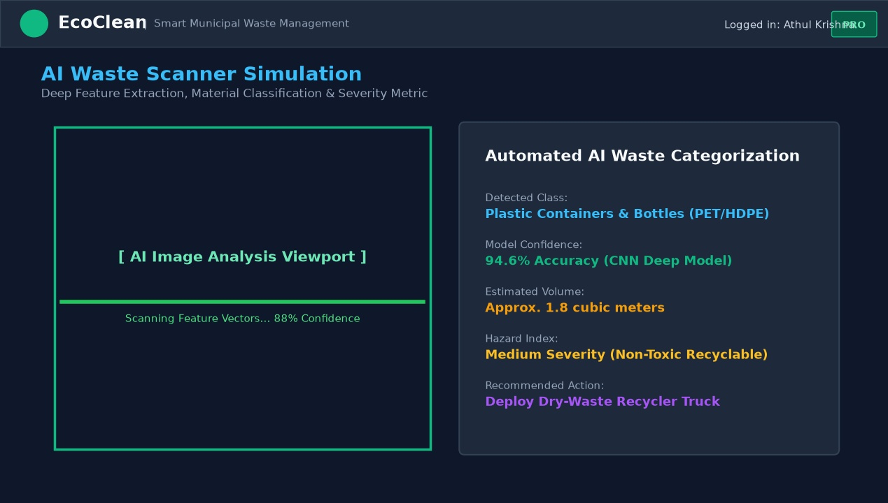

Citizen Eco-Points Ledger & Community Leaderboard Screen

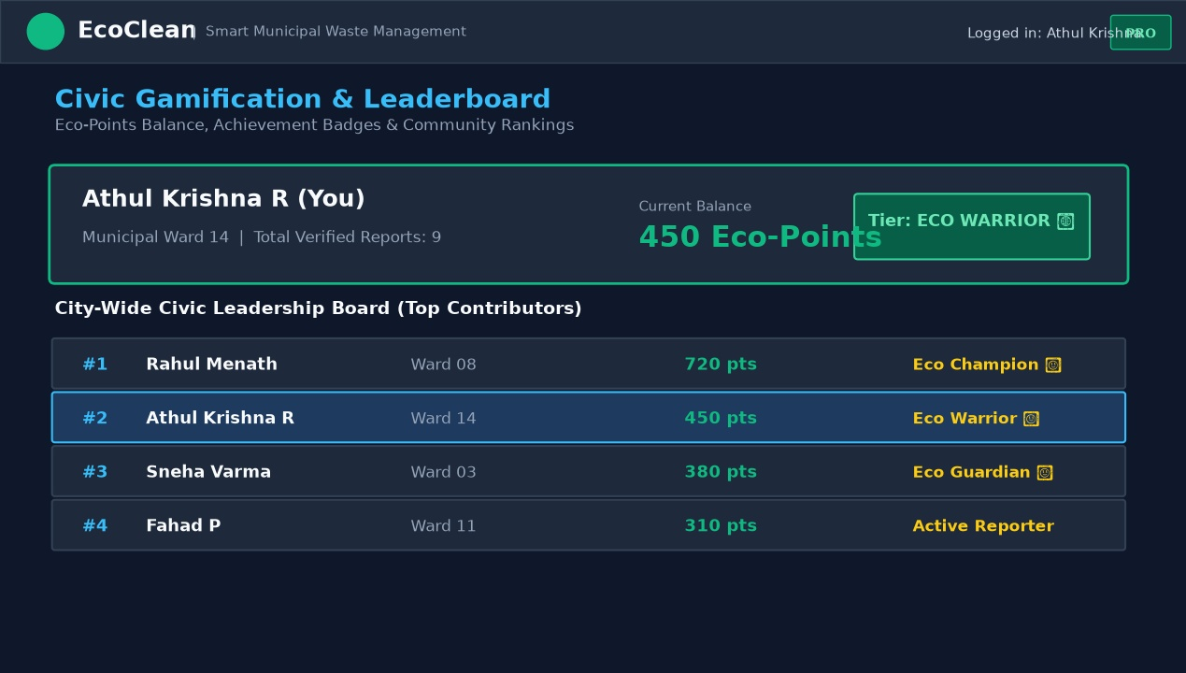

Municipal Waste Intelligence & Category Analytics Screen

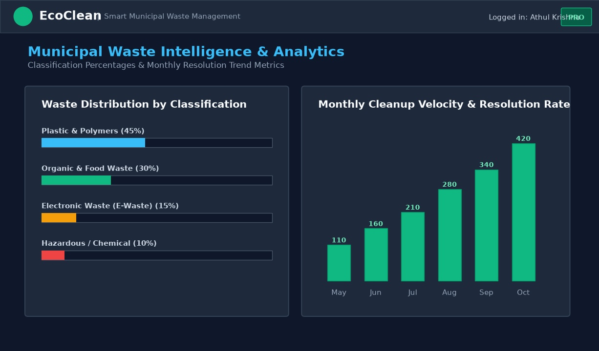

BIBLIOGRAPHY

12. BIBLIOGRAPHY

Journal Papers
- K. S. Kumar, M. Ramesh, and S. Devi, “IoT and Cloud-Based Smart Waste Management System for Clean Cities,” IEEE Transactions on Sustainable Computing, vol. 6, no. 3, pp. 412–424, 2023.
- A. Sharma and R. V. Patel, “Deep Learning Approaches for Automated Municipal Solid Waste Segregation,” Journal of Cleaner Production, vol. 312, pp. 127–139, 2022.
- M. Z. Al-Khafaji and H. Rahman, “Gamification and Crowdsourcing in Municipal Public Services: A Framework for Civic Engagement,” ACM Computing Surveys, vol. 54, no. 5, pp. 1–28, 2022.

Websites
- https://nodejs.org/en/docs/ - Official Node.js Documentation

- https://expressjs.com/ - Express Web Application Framework for Node.js

- https://react.dev/ - React Official Documentation and Reference
- https://www.mongodb.com/docs/ - MongoDB Database Reference and Mongoose ODM

- https://leafletjs.com/reference.html - Leaflet JavaScript Library for Interactive Maps

Books
- Ethan Brown, Web Development with Node and Express: Leveraging the JavaScript Stack, 2nd Edition, O'Reilly Media, 2020.
- Robin Wieruch, The Road to React: Your journey to master plain yet pragmatic React.js, Leanpub, 2022.
- Brad Dayley, Brendan Dayley, and Caleb Dayley, Node.js, MongoDB and React Web Development, 2nd Edition, Addison-Wesley, 2022.

