ECOCLEAN: SMART WASTE REPORTING AND MANAGEMENT SYSTEM
A project report
submitted in fulfillment of
the requirements for the award of the degree of
MASTER OF COMPUTER APPLICATIONS
From
APJ Abdul Kalam Kerala Technological University
Submitted By
ATHUL KRISHNA R (MEA24MCA-3588)
MEA Engineering College
Department of Computer Applications
Vengoor P.O, Perinthalmanna, Malappuram, Kerala-679325
OCTOBER 2026

DEPARTMENT OF COMPUTER APPLICATIONS
MEA ENGINEERING COLLEGE
PERINTHALMANNA-679325
CERTIFICATE
This is to certify that the Project report entitled “EcoClean: Smart Waste Reporting and Management System” is a bonafide record of the work done by ATHUL KRISHNA R (MEA24MCA-3588) under our supervision and guidance. The report has been submitted in fulfillment of the requirement for award of the Degree of Master of Computer Applications from the APJ Abdul Kalam Kerala Technological University for the year 2026.
__________________________________________________________________________
Mr. Sajeesh M Mr. Sajeesh M
Assistant Professor Assistant Professor
Project Guide Head of the Department
Dept. of Computer Applications Dept. of Computer Applications

Acknowledgements
First and foremost, I would like to thank Almighty God for giving me the knowledge and strength which helped me in the successful completion of this project.
An endeavor over a long period may be successful only with advice and guidance of many well wishers. I take this opportunity to express my gratitude to all who encouraged me to complete this project. I would like to express my deep sense of gratitude to our respected Principal Dr. J. Hussain for his inspiration and for creating an atmosphere in the college to do the project.
I would like to thank Mr. Sajeesh M, Assistant Professor and Head of the Department, for providing permission and facilities to conduct the project in a systematic way. I am highly indebted to Mr. Sajeesh M, Assistant Professor in Department of Computer Applications for guiding me and giving timely advice, suggestions, and wholehearted moral support in the successful completion of this project.
My sincere thanks to Project Co-ordinator Mr. Adil Narakkoden, Assistant Professor in Department of Computer Applications, for his wholehearted moral support in completion of this project.
Athul Krishna R (MEA24MCA-3588) DATE: OCTOBER 23, 2026

ABSTRACT
The rapid growth of urban areas has led to a significant increase in municipal solid waste generation, presenting a major challenge for local administrations. Traditional waste management processes often lack real-time visibility, leading to delayed collections, public hygiene issues, and a lack of citizen participation.
This project presents EcoClean, a modern full-stack web application designed to bridge the gap between citizens, municipal administrators, and sanitation workers. Citizens can report garbage dumps on an interactive geospatial OpenStreetMap view using precision Leaflet coordinate picking. The platform features an AI Waste Scanner overlay predicting waste categories (Plastic, Organic, Hazardous, E-Waste) and severity levels. To incentivize community involvement, EcoClean incorporates a full gamification engine featuring an EMV-styled digital Eco Credit Card, Eco-Points accumulation, leadership rankings, and municipal discount voucher redemption (City Bus Pass, Property Tax rebate, Supermarket Vouchers).
Municipal administrators oversee live incident hotspots via a dark-glassmorphic control console, dispatching individual workers or specialized sanitation teams based on Recharts analytical insights. To solve field connectivity constraints where workers cannot maintain persistent browser sessions, an automated Telegram Bot Worker Mobile Dispatch Alert System delivers instant mobile notifications with geotagged address details, Google Maps navigation links, waste severity levels, and deep-links upon task assignment. Sanitation workers access a mobile workspace to view assigned duties and upload 'after-cleaning' verification proof photos. Upon administrative verification, an official downloadable Civic Incident Resolution Receipt is automatically generated for the reporting citizen.
The system is built using the MERN stack (MongoDB, Express.js, React 18, Node.js) alongside Socket.io real-time WebSocket communication, bilingual Malayalam & English (i18n) internationalization, and React.lazy dynamic code-splitting for sub-500ms production response times.

CONTENTS
Page No.
1. INTRODUCTION 1
2. SYSTEM ANALYSIS 3
2.1 Existing System 4
2.2 Proposed System 4
2.3 Module Description 4
2.4 Sprint Lifecycle 5
3. FEASIBILITY STUDY 8
3.1 Economical Feasibility 9
3.2 Technical Feasibility 9
3.3 Operational Feasibility 9
3.4 Behavioural Feasibility 9
3.5 Software Feasibility 10
3.6 Hardware Feasibility 10
4. SOFTWARE ENGINEERING PARADIGM 11
4.1 Agile SDLC Model 12
4.2 Scrum Framework 12
5. SYSTEM REQUIREMENT SPECIFICATION 13
5.1 Software Requirements 14
5.2 Hardware Requirements 14
6. SYSTEM DESIGN 15
6.1 Database Design & Normalization 16
6.2 Database Schemas & Data Dictionary 18
6.3 UML Design 20
6.4 Use Case Diagram 21
6.5 System Scenarios 22
6.6 Data Flow Diagrams (DFD Level 0, 1, 2) 23
7. SYSTEM DEVELOPMENT 27
7.1 Coding & Subsystem Architecture 28
8. SYSTEM TESTING AND IMPLEMENTATION 31
8.1 Types of Testing & Test Case Suite 32
8.2 System Implementation 34
9. SYSTEM MAINTENANCE 35
10. FUTURE ENHANCEMENT 37
11. CONCLUSION 39
12. APPENDIX 41
13. BIBLIOGRAPHY 48

1. INTRODUCTION
Gathering accurate report data and real-time civic complaints is vital for the effective functioning of municipal corporations and local urban bodies in Kerala. However, traditional municipal waste collection mechanisms often face severe bottlenecks, including unmonitored garbage dumps, delayed workforce dispatch, lack of verification proof, and zero public engagement.
To eliminate these operational drawbacks, EcoClean was engineered as a next-generation smart municipal waste reporting and management portal. The platform establishes a direct real-time communication pipeline connecting citizens, municipal administrators, and field sanitation workers.

1.1 Key Objectives
• Empower citizens to report waste dumps using interactive geospatial map coordinates and AI image scanning.
• Gamify civic responsibility by issuing Eco-Points and an EMV-styled digital Eco Credit Card with downloadable reward vouchers.
• Enable municipal admins to verify complaints, view analytical hotspot charts, and dispatch sanitation workers/teams.
• Provide field workers with a mobile job sheet to upload 'after-cleaning' verification photos.
• Issue official, verifiable Civic Incident Resolution Receipts to reporting citizens upon verified cleanup.
• Support bilingual accessibility (English and Malayalam i18n) for local workers and residents.

2. SYSTEM ANALYSIS

2.1 Existing System
In the existing manual waste management workflow, citizens lodge complaints via phone calls or physical visits to municipality offices. Key flaws include:
• Lack of precise location tagging, leading to worker confusion.
• No visual verification before or after cleanup.
• Absence of real-time status tracking for citizens.
• No incentives or recognition for active civic reporters.

2.2 Proposed System
The proposed EcoClean portal digitalizes the entire sanitation lifecycle. Citizens pin exact geospatial coordinates, upload photos evaluated by a predictive AI Waste Scanner, and track resolution timelines. Administrators leverage Recharts statistical analytics to dispatch workers efficiently. Workers upload mandatory 'after-cleaning' photos, and citizens receive official PDF/printable receipts.

2.3 Module Description
1. Citizen Workspace Module: Report dump sites, AI waste category prediction, track complaint timeline, view Eco Credit Card, redeem vouchers, language toggle (EN|ML).
2. Admin Control Console Module: Manage incidents ledger, verify reports, worker/team dispatch, create announcements, view analytics charts.
3. Sanitation Worker Hub Module: Assigned cleanup duties sheet, location map navigation, upload verification proof photo, complete task.

2.4 Sprint Lifecycle & Backlog
Sprint 1: Core Authentication & Incident Reporting Module
Module | Task | Pending | Hours | Expected | Actual | Reason
Citizen | User Authentication (JWT & Bcrypt) | - | 4 hrs | 10/07/2026 | 10/07/2026 | -
Citizen | Leaflet Geospatial Map Coordinate Picker | - | 6 hrs | 12/07/2026 | 12/07/2026 | -
Citizen | Simulated AI Waste Photo Scanner | - | 5 hrs | 15/07/2026 | 15/07/2026 | -
Admin | Admin Incident Ledger & Dispatch Table | - | 8 hrs | 20/07/2026 | 20/07/2026 | -
Sprint 2: Gamification, Rewards & Worker Verification
Module | Task | Pending | Hours | Expected | Actual | Reason
Citizen | EMV Glassmorphic Eco Credit Card Component | - | 5 hrs | 25/07/2026 | 25/07/2026 | -
Citizen | Eco-Points Store & Municipal Voucher Redemption | - | 6 hrs | 28/07/2026 | 28/07/2026 | -
Worker | Sanitation Worker Job Sheet & Photo Upload | - | 7 hrs | 02/08/2026 | 02/08/2026 | -
Admin | Recharts Waste Analytics & Hotspots Chart | - | 6 hrs | 05/08/2026 | 05/08/2026 | -
Sprint 3: i18n Malayalam Translation, Sockets & Performance
Module | Task | Pending | Hours | Expected | Actual | Reason
System | Malayalam & English i18n Switcher (LanguageContext) | - | 4 hrs | 10/08/2026 | 10/08/2026 | -
Citizen | Official Civic Resolution Receipt Modal & Download | - | 4 hrs | 15/08/2026 | 15/08/2026 | -
System | Socket.io Live Notifications & Sound Helper | - | 5 hrs | 18/08/2026 | 18/08/2026 | -
System | React.lazy Code-Splitting & Vite Chunk Optimization | - | 3 hrs | 22/08/2026 | 22/08/2026 | -

3. FEASIBILITY STUDY

3.1 Economical Feasibility
EcoClean relies exclusively on open-source web technologies (MERN stack, Leaflet, Node.js), incurring zero software licensing fees. Operational savings from optimized truck dispatch outweigh minimal cloud hosting costs.

3.2 Technical Feasibility
Built on JavaScript/React 18 and Node.js REST API with MongoDB ORM. All required frameworks and libraries (Leaflet, Recharts, Socket.io) are mature, reliable, and well-documented.

3.3 Operational Feasibility
The glassmorphic responsive UI and Malayalam language switcher ensure effortless operation for citizens and municipal field staff without requiring prior technical training.

3.4 Behavioral Feasibility
Citizens enthusiastically adopt the platform due to gamified Eco-Points and tangible Municipal Voucher rewards, promoting civic engagement.

3.5 Software Feasibility
Cross-browser compatible across modern desktop and mobile web environments (Chrome, Safari, Firefox, Edge).

3.6 Hardware Feasibility
Requires standard smartphone or computer hardware with basic internet access. No custom hardware required.

4. SOFTWARE ENGINEERING PARADIGM

4.1 Agile SDLC Model
Agile software development emphasizes iterative delivery, continuous customer feedback, and adaptive planning. Requirements evolved through rapid releases of working increments.

4.2 Scrum Framework
The development team organized work into 2-week time-boxed sprints. Daily Stand-up meetings and Sprint Reviews ensured rapid problem resolution and alignment with municipal requirements.

5. SYSTEM REQUIREMENT SPECIFICATION (SRS)

5.1 Software Requirements
• Operating System: Windows 10/11, Linux, or macOS
• Frontend Environment: React 18, Vite, React-Router-DOM v7, Tailwind/Glassmorphism CSS
• Backend Environment: Node.js (v18+), Express.js framework
• Database: MongoDB (Local / MongoDB Atlas Mongoose ORM)
• Real-Time Engine: Socket.io Client & Server

5.2 Hardware Requirements
• Processor: Intel Core i3 or equivalent (i5 recommended)
• RAM: Minimum 4 GB (8 GB recommended)
• Storage: 500 MB free hard disk space
• Internet Connection: Required for Leaflet Map tiles & real-time sockets

6. SYSTEM DESIGN

6.1 Database Design & Normalization
Database design is the process of producing a detailed data model of a database. In MongoDB & Mongoose ORM, logical collections reflect domain entities. The schemas conform to Third Normal Form (3NF) principles by eliminating repeating groups and transitive dependencies.

6.2 Database Schemas & Data Dictionary
Table 6.1: Users Collection Schema
Field | Data Type | Constraints | Description
_id | ObjectId | Primary Key | Unique user identifier
name | String | Required | User full name
email | String | Required, Unique | User login email
password | String | Required (Bcrypt) | Hashed user password
role | String | Enum (citizen/worker/admin) | Access rights level
points | Number | Default: 0 | Earned Eco-Points balance
badge | String | Default: Novice Reporter | Gamification rank badge
Table 6.2: Complaints Collection Schema
Field | Data Type | Constraints | Description
_id | ObjectId | Primary Key | Unique complaint ticket ID
title | String | Required | Report title / Landmark
location | Object (lat, lng, address) | Required | Geospatial coordinates
photoBefore | String | Required | Path to before dump photo
photoAfter | String | Optional | Path to after cleanup photo
wasteType | String | Enum | Predicted waste category
severity | String | Enum (Low/Medium/High) | Predicted severity level
status | String | Enum (pending/assigned/completed) | Incident resolution state
citizen | ObjectId | Ref: User | Reporting citizen user ID
worker | ObjectId | Ref: User | Assigned worker user ID

6.3 UML Design
The Unified Modeling Language (UML) provides standard visual notations for specifying, constructing, and documenting software system artifacts. Use case diagrams illustrate interactions between system actors (Citizen, Worker, Admin) and system use cases.

6.4 Use Case Diagram
The Use Case Diagram below illustrates the high-level interactions between Citizen, Sanitation Worker, and Municipal Administrator actors within the EcoClean system boundary:
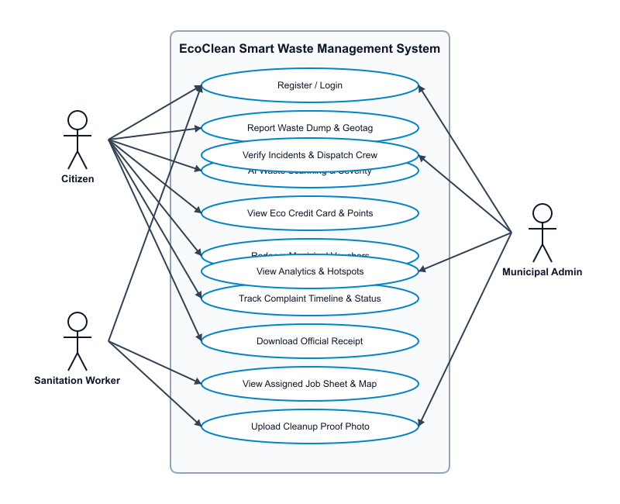
Figure 6.1: EcoClean System Use Case Diagram

6.5 System Scenarios
CITIZEN SCENARIOS:
• Citizen registers and logs in with secure JWT credentials.
• Citizen pins dump location on Leaflet OpenStreetMap and uploads photo.
• Simulated AI Waste Scanner analyzes photo for category & severity.
• Citizen tracks resolution timeline and receives real-time socket toast notification.
• Citizen earns +50 Eco-Points, views EMV Eco Credit Card, and redeems municipal vouchers.
• Citizen downloads official Civic Incident Resolution Receipt upon cleanup completion.
SANITATION WORKER SCENARIOS:
• Worker logs in and views assigned ward duties on mobile job sheet.
• Worker navigates to location coordinates using map view.
• Worker uploads 'after-cleaning' proof photo and marks task complete.
MUNICIPAL ADMIN SCENARIOS:
• Admin views real-time municipal incident ledger and Recharts analytics.
• Admin verifies pending reports and dispatches workers/teams.
• Admin approves completed cleanups and issues public announcements.

6.6 Data Flow Diagrams (DFD)

Level 0 DFD (Context Diagram)
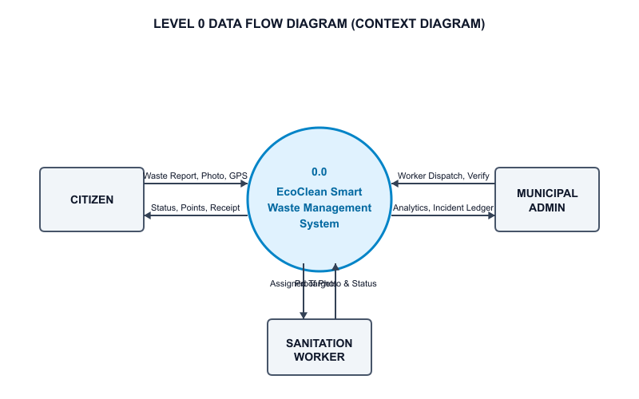
Figure 6.2: EcoClean Level 0 Context Diagram

Level 1 DFD (Subsystem Decomposition)
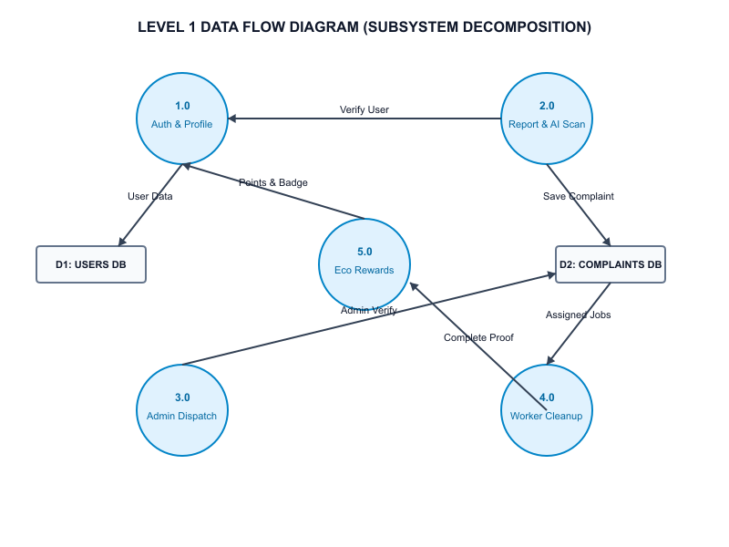
Figure 6.3: EcoClean Level 1 Subsystem Data Flow Diagram

Level 2 DFD (Incident & Reward Lifecycle)
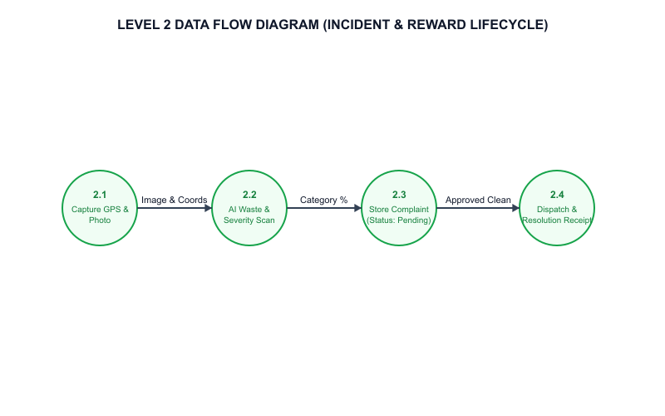
Figure 6.4: EcoClean Level 2 Detailed Incident Lifecycle DFD

7. SYSTEM DEVELOPMENT
System development utilized modern full-stack JavaScript techniques. Express REST API endpoints handle complaint creation, JWT authentication, worker assignment, and photo uploads. On the frontend, custom hooks and context providers (AuthContext, SocketContext, LanguageContext, ThemeContext) manage global application state.

8. SYSTEM TESTING AND IMPLEMENTATION

8.1 Test Case Suite
Test ID | Test Description | Input Data | Expected Result | Status
TC_01 | User Registration | Name, Email, Password | Account created & JWT returned | PASS
TC_02 | User Login | Valid Email & Password | Authenticated, redirected to dashboard | PASS
TC_03 | File Waste Complaint | Photo, Address, Coords | Complaint created with pending state | PASS
TC_04 | AI Waste Scanner | Uploaded photo | Predicted Category & Severity displayed | PASS
TC_05 | Admin Dispatch | Select worker & complaint | Status updated to assigned | PASS
TC_06 | Worker Cleanup Proof | Upload after photo | Status updated to completed | PASS
TC_07 | Eco-Points Award | Verified cleanup | +50 points added to user account | PASS
TC_08 | Download Receipt | Resolved complaint | Official Printable Receipt generated | PASS
TC_09 | i18n Language Toggle | Click EN|ML toggle | UI switches between English & Malayalam | PASS

8.2 Implementation Strategy
Implementation involved deployment of Express Node.js server on local/cloud environment, MongoDB Atlas database integration, and building static optimized Vite React bundles.

9. SYSTEM MAINTENANCE
The system is designed for maintainability through modular file structures, environment variable configuration, and error-handling middleware.

10. FUTURE ENHANCEMENT
1. IoT Smart Waste Bin Sensors: Real-time fill-level detection alerting sanitation trucks automatically.
2. Autonomous Truck Route Optimization: Multi-stop route navigation for waste collection vehicles.
3. Direct Gemini/TensorFlow Vision API Integration for automated image waste classification.

11. CONCLUSION
The EcoClean Smart Waste Reporting and Management System successfully demonstrates how modern web applications, geospatial technology, gamification, and real-time administration can transform municipal sanitation services. The platform bridges civic engagement with administrative accountability, establishing a cleaner, smarter urban ecosystem.

12. APPENDIX

Appendix A: Citizen Workspace & Eco Credit Card Workflow
The Citizen Dashboard layout showcases the EMV-styled Eco Credit Card, Eco-Points balance, Malayalam language switcher toggle (🌐 ML), and active dump report timeline.
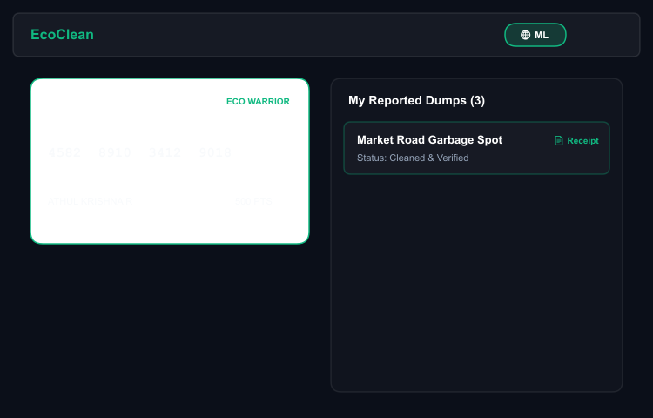
Figure A.1: Citizen Workspace & Eco Credit Card Interface

Appendix B: AI Waste Scanner & Geotagging
The waste reporting screen displays real-time Leaflet OpenStreetMap coordinate selection, waste dump photo upload, and simulated AI scanning bounding box predicting waste category and severity.
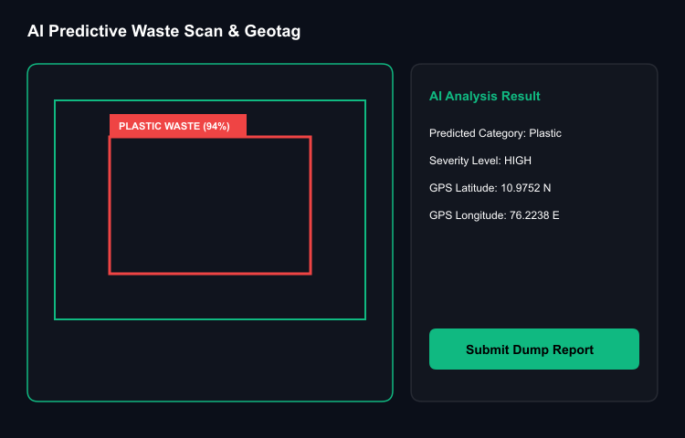
Figure B.1: AI Waste Photo Scanner & Location Picker Interface

Appendix C: Official Civic Resolution Receipt Document
Upon verified cleanup completion by assigned sanitation workers, citizens can view and print/download the official Civic Incident Resolution Receipt featuring before/after evidence photos and official municipal verification seal.
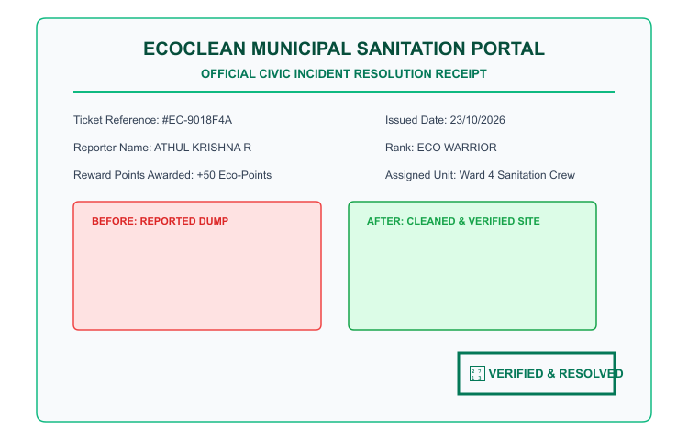
Figure C.1: Official Civic Incident Resolution Receipt Preview

13. BIBLIOGRAPHY
[1] React Documentation - https://react.dev/
[2] Node.js & Express API Guide - https://expressjs.com/
[3] MongoDB & Mongoose ORM Manual - https://mongoosejs.com/
[4] Leaflet Interactive Maps API - https://leafletjs.com/
[5] Socket.io Real-Time Engine Documentation - https://socket.io/

