***VIDEO STREAMING SERVICE ON AWS***

**Lab Overview**

*This lab focuses on creating a* ***“Video Streaming Platform”*** *using* ***“Amazon S3”*** *and* ***“Amazon CloudFront”*** *on AWS. In this lab, you will learn how to upload video content to an S3 bucket and deliver it efficiently to end users using CloudFront’s Content Delivery Network (CDN). You will also explore how to optimize content delivery and ensure secure access to video streams using AWS services.*

**Topics Covered**

***\*****Create an Amazon S3 bucket to store video files.*

***\**** *Upload video content to the S3 bucket.*

***\**** *Configure Amazon CloudFront to distribute the video files globally with caching.*

***\**** *Test video streaming using CloudFront’s URL.*

***\**** *Set up access control and security for video content delivery*.

**AWS Service Restrictions**

*In this lab environment, access to AWS services might be restricted to those required for the lab instructions. You might encounter errors if attempting to access services beyond the scope of this lab.*

**Amazon S3 (Simple Storage Service)**

*Amazon S3 is a scalable object storage service that allows you to store and retrieve any amount of data, including videos, securely. It’s highly durable, cost-effective, and can handle large amounts of video files with ease. You upload your video content to an S3 bucket, where it can be accessed by users or distributed through other services.*

**Amazon CloudFront**

*Amazon CloudFront is a Content Delivery Network (CDN) that caches and delivers video content globally with low latency. It uses a network of edge locations around the world to provide fast access to content, reducing the load on your origin server (in this case, the S3 bucket) and improving the viewer’s experience.*

**How They Work Together**

***\*****Amazon S3* ***-*** *stores the video files.*

***\*****Amazon CloudFront* ***-*** *retrieves and caches the videos from S3 at edge locations closer to users, allowing for faster video streaming.*

***\*****This setup ensures that users worldwide can access your videos quickly, while reducing bandwidth and data transfer costs from S3.*

**Amazon S3 Features**

***\*Scalable Storage* :** *Automatically scales to handle any amount of data, from small files to large video archives.*

*\*****High Durability*****:** *Designed for 99.999999999% durability by redundantly storing data across multiple facilities.*

*\*****Cost-Effective* :** *Pay-as-you-go model with tiered storage classes, allowing you to store frequently or infrequently accessed files at different rates.*

*\*****Security* :** *Provides encryption at rest and in transit, along with access control policies to protect your data.*

***\*Versioning*****:** *Supports file versioning, enabling you to recover previous versions of your videos in case of accidental overwrites or deletions.*

***\*Lifecycle Policies*****:** *Automates data management by transitioning files to cheaper storage classes or deleting them after a specified time.*

***\*Global Access*****:** *Provides easy access to your data from anywhere in the world via HTTP/HTTPS.*

**Amazon CloudFront Features**

**\**Global Content Delivery :*** *Delivers content via a global network of edge locations, ensuring low-latency and high-speed access.*

***\*Caching :*** *Caches content at edge locations, reducing load on the origin (S3) and improving performance for end users.*

***\*Security :*** *Offers HTTPS support, DDoS protection, and the ability to use signed URLs or cookies for secure access control.*

***\*Customizable Cache Behavior :*** *You can control cache settings, expiration times, and cache behaviors to optimize delivery for different content types.*

***\*Real-Time Monitoring :*** *Provides detailed logs and metrics for traffic patterns, request counts, and error rates.*

***\*Automatic Scaling :*** *Automatically scales to handle increased traffic, making it ideal for video streaming platforms with varying demand.*

***\*Content Compression :*** *Supports on-the-fly content compression, reducing bandwidth and speeding up delivery times for viewers.*

**Task 1 : Create an S3 Bucket for Video Streaming**

***1. Log into the AWS Management Console***

*- Go to the AWS website and sign in to your AWS account.*

***2. Navigate to S3***

*- In the search bar at the top of the console, type “S3”*

*and select “Amazon S3” from the search results.*

***3. Create a New Bucket***

*- In the “****S3 dashboard****”, click on “****Create bucket****”.*

***4. Configure Bucket Settings***

*- Bucket Name: Enter a globally unique name for your bucket (e.g. : video-streaming-bucket).*

*- AWS Region: Choose the region closest to your primary audience or the one suggested by your instructor (e.g. : North Virginia).*

*- Leave the default options for “****Object Ownership****”.*

***5. Configure Public Access Settings***

*- Uncheck “****Block all public access****” if you intend to make your videos accessible directly (this can also be restricted later via CloudFront). Confirm that you want to make this bucket publicly accessible.*

***6. Enable Bucket Versioning (Optional)***

*- Scroll down to the “****Bucket Versioning****” section and enable versioning if you want to keep track of changes to your video files or recover previous versions.*

***7. Tagging (Optional)***

*- Add tags to organize and identify your bucket (e.g.: Key : Project , Value : Video Streaming).*

***8. Create the Bucket***

*- Click “****Create bucket****”. Your new S3 bucket will now be created and appear in your list of buckets.*

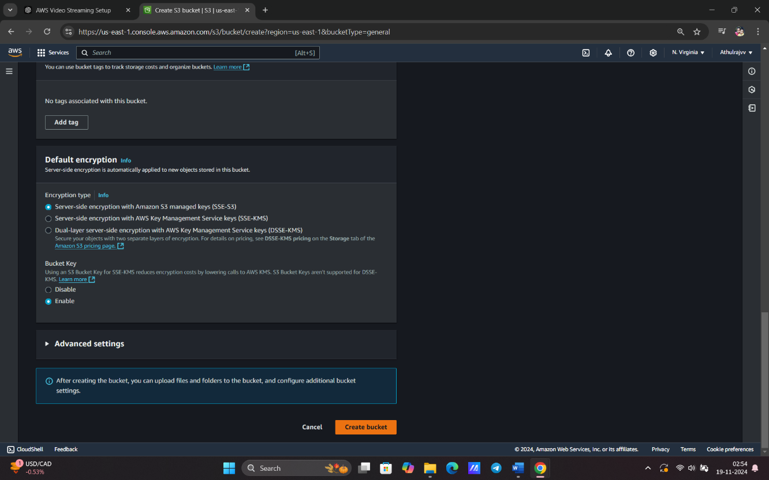

**Task 2: Upload Videos to the S3 Bucket**

***1. Select the Bucket***

*- In the “****S3 dashboard****”, click on the name of the bucket you just created.*

***2. Upload Video Files***

*- Click “****Upload****” and select the video files you want to store in the bucket.*

*- Drag and drop the file (e.g., your 10MB video file) or use the “****Add******files****” button to browse your local storage.*

*- Once files are selected, click “****Upload****”.*

***3. Set Permissions for the Uploaded Files***

*- During the upload process, review the “****Permissions****” settings.*

*- If needed, make the objects publicly accessible (though using CloudFront for secure access is recommended).*

***4. Complete the Upload***

*- After reviewing all settings, click “****Upload****” to complete the process.*

*- You should now see the video files listed within your bucket.*

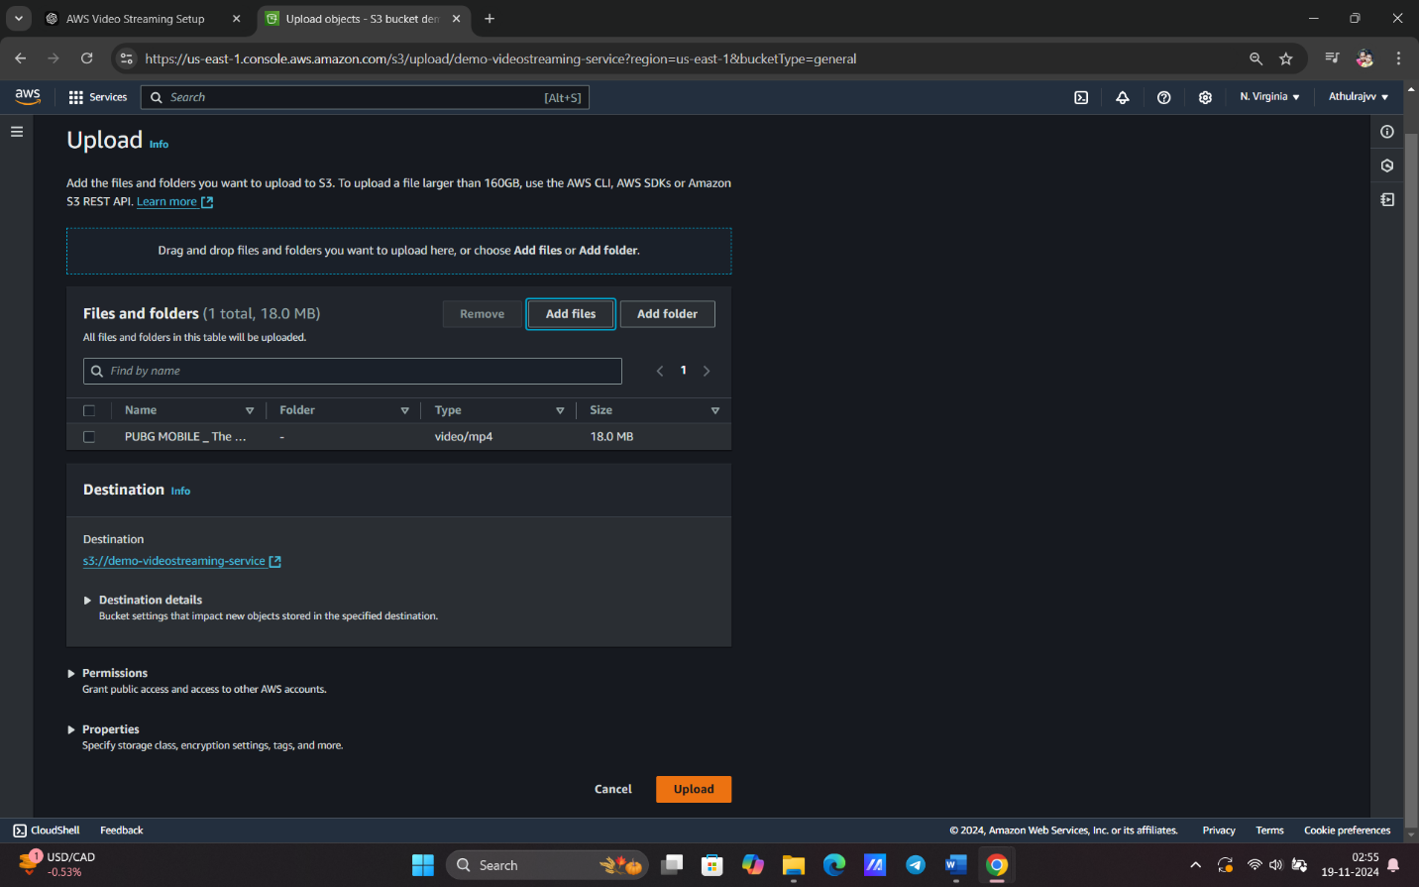

**Task 3 : Set Up CloudFront Distribution**

**Step 1: Navigate to the CloudFront Console**

***1. Access CloudFront***

*- In the AWS Management Console, type “CloudFront” in the search bar and select “CloudFront” from the search results.*

***Step 2: Create a New Distribution***

***1. Click Create Distribution :***

*- In the CloudFront dashboard, click on the “****Create******Distribution****” button.*

***2. Select Web Distribution:***

*- Under the “****Web****” section, click on “****Get******Started****”.*

***Step 3: Configure Origin Settings***

**1. Select Origin Domain Name:**

*- In the “****Origin******Domain******Name****” dropdown menu, select your S3 bucket (e.g., `****video-streaming-bucket.s3.amazonaws.com****`).*

**2. Set Origin Path (Optional):**

*- If you want to specify a folder within your S3 bucket, enter the path here. If not, leave it blank.*

**3. Enable Origin Access Control (OAC):**

*- Enable* ***OAC*** *to restrict direct access to your S3 bucket and ensure that CloudFront can access the content securely.*

**Step 4: Configure Default Cache Behavior Settings**

**1. Viewer Protocol Policy:**

*- Set this to “****Redirect HTTP to HTTPS****” to ensure secure streaming for your viewers.*

**2. Allowed HTTP Methods:**

*- Select “****GET****,* ***HEAD****”, which are sufficient for serving video content.*

**3. Cache Policy:**

*- Choose the default caching policy, or select “****CachingOptimized****” for better performance.*

**Step 5: Configure Distribution Settings**

**1. Price Class :**

*- Choose “****Use******All******Edge Locations****” for optimal performance globally, or select a specific price class based on your budget.*

**2. SSL Certificate:**

*- Leave the default option “****Default CloudFront Certificate (*.cloudfront.net)****” selected unless you have a custom domain with your own SSL certificate.*

**3. Default Root Object:**

*- Leave this blank unless you want to specify a default file (like `****index.html****`) to serve.*

**Step 6: Create the Distribution**

**1. Review All Settings:**

*- Check all your settings to ensure they are correctly configured.*

**2. Click Create Distribution:**

*- After reviewing, click the “****Create Distribution****” button at the bottom of the page.*

**3. Wait for Deployment:**

*- The distribution will show as “****In Progress****” initially. Wait until it changes to “****Deployed****”(this may take several minutes).*

**Step 7: Access CloudFront Domain Name**

**1. Find CloudFront Domain Name:**

*- Once deployed, note the “****Domain Name****” (e.g., `****d123456abcdef8.cloudfront.net****`). This URL will be used to access your video content.*

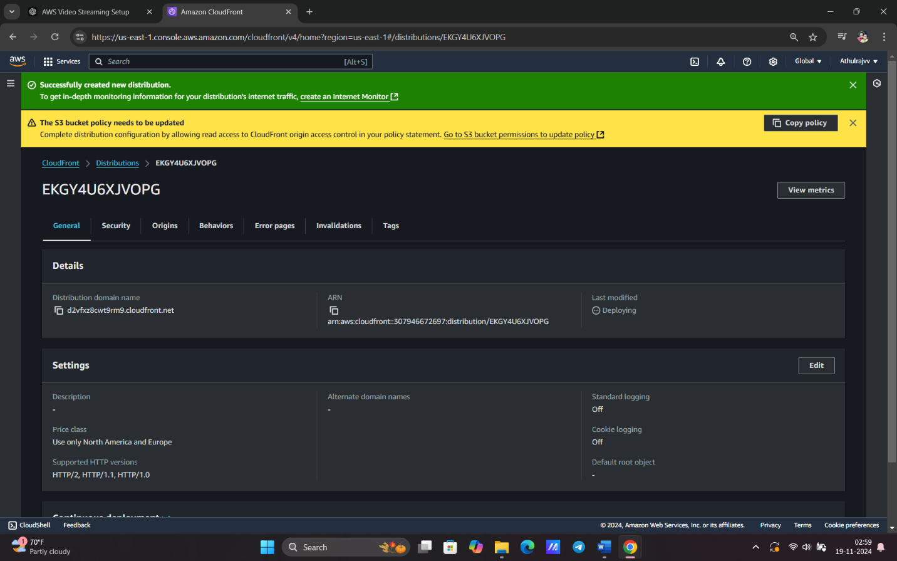

**Task 4: Configure S3 Bucket Permissions for CloudFront**

**Purpose:**

*Ensure that only CloudFront can access your S3 bucket.*

**Step 1: Go to Your S3 Bucket**

**1. Navigate to the S3 Console:**

*- In the AWS Management Console, type “****S3****” in the search bar and select “****S3****” from the search results.*

**2. Select Your Bucket:**

*- Click on the name of the S3 bucket you created for your video streaming (e.g., `****video-streaming-bucket****`).*

**Step 2: Navigate to Permissions**

**1. Open the Permissions Tab:**

*- In the bucket dashboard, click on the Permissions tab at the top of the page.*

**Step 3: Edit Bucket Policy**

**1. Scroll to Bucket Policy:**

*- Find the “****Bucket Policy****”section and click on “****Edit****”.*

**2. Add Bucket Policy:**

*- In the policy editor, enter a policy that allows CloudFront to access the S3 bucket. The policy should look like this:*

*```json*

*{*

*"Version": "2012-10-17",*

*"Statement": [*

*{*

*"Effect": "Allow",*

*"Principal": {*

*"AWS": "arn:aws:iam::cloudfront:user/CloudFront Origin Access Identity <your-oac-id>"*

*},*

*"Action": "s3:GetObject",*

*"Resource": "arn:aws:s3:::your-bucket-name/*"*

*}*

*]*

*}*

*```*

*- Replace* ***`<your-oac-id>`*** *with your CloudFront Origin Access Control ID (you can find this in your CloudFront distribution settings).*

*- Replace `****your-bucket-name****` with the name of your S3 bucket.*

**Step 4: Save the Bucket Policy**

**1. Review the Policy:**

*- Ensure that the policy is correctly formatted and all placeholders are replaced with the appropriate values.*

**2. Click Save:**

*- Once you’re satisfied with the policy, click the “****Save****” button to apply the changes.*

**Step 5: Confirm Policy Application**

**1.Review Permissions:**

*- After saving, review the “****Bucket Policy****” to ensure it is applied correctly and reflects the policy you entered.*

**Conclusion**

*You have successfully configured the S3 bucket permissions to allow CloudFront to access your video content securely. This setup restricts direct access to the S3 bucket, ensuring that only CloudFront can retrieve and deliver your videos.*

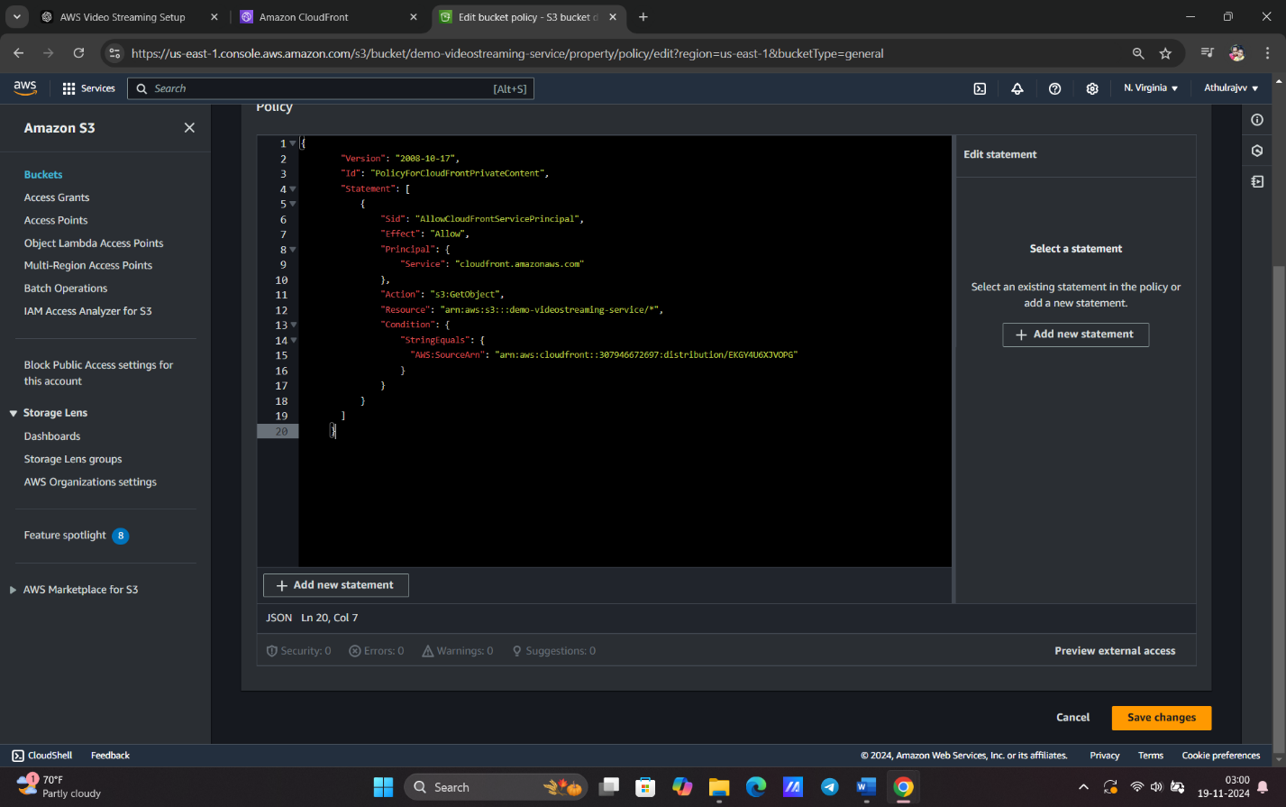

**Task 5: Test Video Streaming**

**Purpose**

*Verify that the video content is accessible and streaming properly via CloudFront.*

**Step 1: Obtain CloudFront Distribution Domain Name**

**1. Access CloudFront Console**

*- In the AWS Management Console, type “****CloudFront****” in the search bar and select “****CloudFront****” from the search results.*

**2. Locate Your Distribution**

*- Find your CloudFront distribution in the list and note the “****Domain******Name****” (e.g., `d123456abcdef8.cloudfront.net`).*

**Step 2: Construct Video URL**

**1. Open a New Web Browser**

*- Launch your preferred web browser (e.g., Chrome, Firefox).*

**2. Paste the CloudFront Domain**

*- Paste the CloudFront domain link you copied from the CloudFront distribution page into the browser's address bar.*

**3. Add a Slash**

*- Append a forward slash (`/`) at the end of the CloudFront domain.*

**Step 3: Retrieve Video Key from S3**

**1. Access the S3 Console**

*- In the AWS Management Console, type “****S3****” in the search bar and select “****S3****” from the search results.*

**2. Select Your Bucket**

*- Click on the name of the S3 bucket where your video is stored (e.g., `***video-streaming-bucket***`).*

**3. Navigate to the Video Folder**

*- Locate the folder where your video file is uploaded.*

**4. Copy the Video Key**

*- Click on the video file and copy its “****Key****” (path).*

**Step 4: Formulate the Full Video URL**

**1. Paste the Video Key**

*- Return to the web browser and paste the copied video key after the forward slash you added earlier.*

*- The full URL should look something like this:*

*```*

*https://d123456abcdef8.cloudfront.net/path/to/your/video.mp4*

*```*

**Step 5: Verify Video Playback**

**1. Check for Video Loading**

*- Press “****Enter****” to load the full video URL in the browser.*

**2. Test Playback Controls:**

*- Ensure the video begins to play and that playback controls (play, pause, seek) are functional.*

**3. Check Quality and Buffering:**

*- Monitor the video quality and buffering during playback to assess performance.*

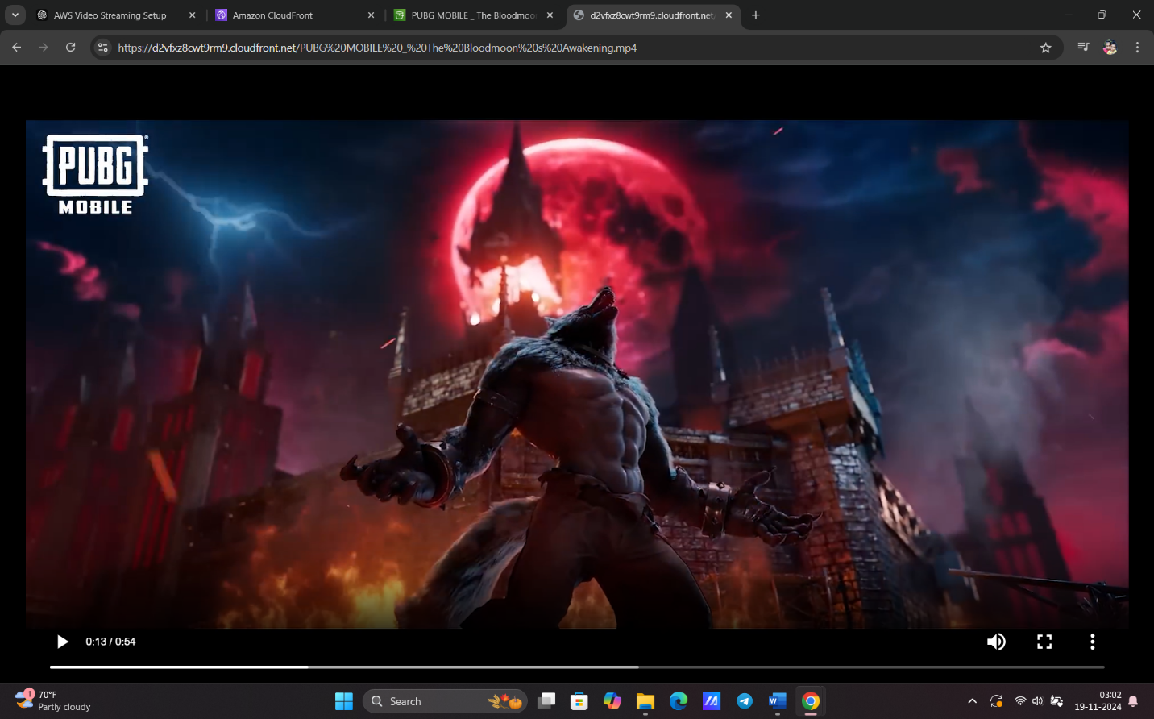

**Conclusion**

*You have successfully tested the video streaming from your CloudFront distribution using the S3 video key. Ensure that the playback is smooth and all controls work as expected.*