1. When to use (Rapid Application Development) RAD model When not to use (Rapid Application Development) RAD model
RAD is adapted from waterfall model and aims at developing a software in short span of time.RAD model is adopted in projects which requires rapid delivery as it reduces the overall development time. RAD cannot be used in case if the client demants high quality product since rapid development will result in lots of bugs in the product.

2.Define an ER diagram of a software Organization with all the relationship model that was discussed in the classroom

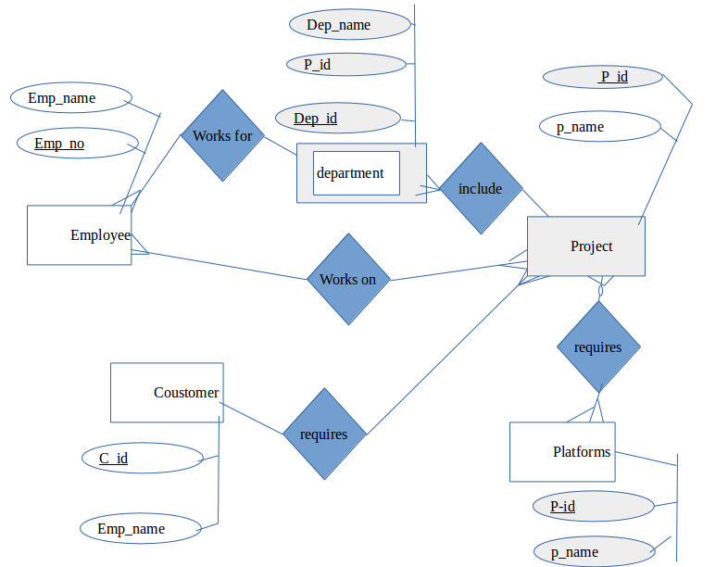
3.Describe the Entity Relationships for the following diagram

Entities are,

1.Login Details
2.Admin
3.Staff Details
4.Leave details

Relationships are,

One user login has many staff details and one staff has many login details.Hence the cardinality between login details and staff details is Many to Many (M:N)

One login has many admins and one admin has many login details.Hence the cardinality between login details and admin is Many to Many (M:N)

One admin can access many leave details and one leave details can be accesed by many admins details.Hence the cardinality between leave details and admin is Many to Many (M:N)

one staff can applay for many leave details and one leave details can be accesed by many staffs.
Hence the cardinality between Staff details and Admin is Many to Many (M:N)

atributes are,

Entity Attributes

Login Details Attribute,Attribute,Attribute
Admin No attributes mentioned
Staff details Staff id,staff name,username,contact
Leave details leave id, status,staff id, apply date,from date,to date, type

