1.Draw a Use Case Diagram for an online Library Management System

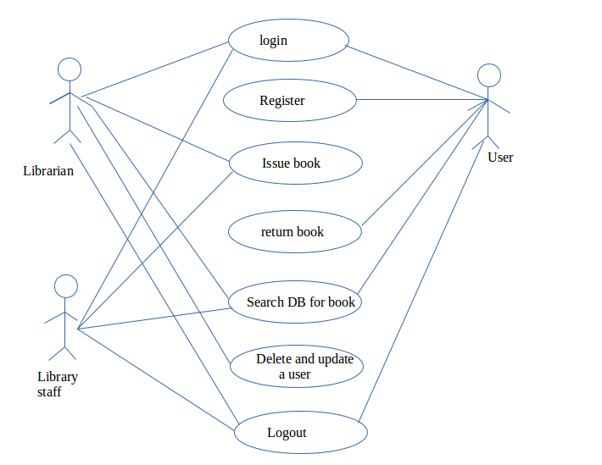
2.List down the best practices from Agile/Scrum methodology

Architecture Envisioning-
high-level Architecture Envisioning is done early in the project to help,make a clarity regarding thetechnical strategy of the team.

Requirment Envisioning-
high-level requirements envisioning is done early in the project to help understand what we are trying to accomplish.

Model storming-
This is the light-weight modelling for a few minutes on a just in time basis to think through an aspect of the solution

Iteration modeling-
This is the light-weight modelling for a few minutes at the beging of iteration to help to identify the teams strategy based on the previous iterations.

Continuous Integration-
Continuous integration of code ensures changes made does not adversely affect the rest of the code.. This new code which is written is verified before it is connected with the old code.

Test first design-
write test case and later write code specific to the user stories to fulfill the test cases.

Refactoring-
make small changes to a part of the solution which improves the quality of the software without affecting the semantics. Test first design plus refactoring makes agile a Test driven design.

3.Collaboration
a. How does collaboration help agile development?
b. What if the team is distributed and can you achieve the same
productivity?
c. What would you do to achieve the productivity for a distributed
team?

Collaboration simply means to work jointly rather than independently to accomplish a task

a. Agile forces people from different backgrounds to work together on the Agile team.Agile practices such as release planning, sprint planning, and standup meetings provide the time and space for teams to collaborate and build relationships with each other .

b. No if the team is distuributed we cannot achieve the same productivety since agile methodology is all about team work and for distributed team it is not easy for collabration. It is also difficult for them to communicate face to face

c. To acheive the productivity for a disturbuted team is difficult but it can be solved up to certain extend through group mails and online remot sessions.

4. What is Sprint Zero in Agile? Describe the activities that are done in Sprint
Zero.

Sprint Zero in agile is the first stage of an agile project development were the potentional projects are identified and intial vission is developed. The activities that are done on sprint zero are as follows

Intial Requirment Envisioning-
High-level requirements envisioning is done early in the project to help understand what we are trying to accomplish.Intial Requirment Envisioning is done to define the high-level requirements for your system. For this we usually use.
Use Case Diagram
Data Flow Diagram
Use Case Diagram 2
Data Flow Diagram 2
Intial Architecture Envisioning-
high-level Architecture Envisioning is done early in the project to help,make a clarity regarding thetechnical strategy of the team. This helps in improving productivity, reduced technical risk,reduced development time,improved communication, mproved team organization. This is also important for scaling agile softwaredevelopment techniques to large, complex, or globally distributed development effort. For this we usually uses
Technology diagrams
User interface flow
Domain models
Change cases

