1. Unit impulse function

l = 5;

n = -l:l;

x = [zeros(1,l),ones(1,1),zeros(1,l)];

plot2d3(n,x);

xlabel("time");

ylabel("impulse");

title("unit impulse function");

a = gca();

a.x_location("origin");

a.y_location("origin");

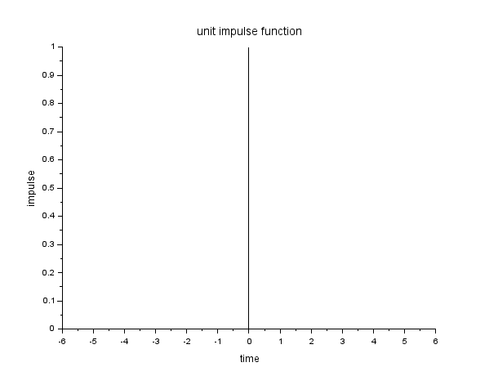

1. Unit pulse function

n = linspace(0,10,50);

unit_pulse = sqrt(squarewave(n));

plot(n, unit_pulse, color = "green");

plot2d3(n, unit_pulse);

xlabel('time');

ylabel('amplitude');

title('unit pulse function');

legend("continuous signal", "discrete signal");

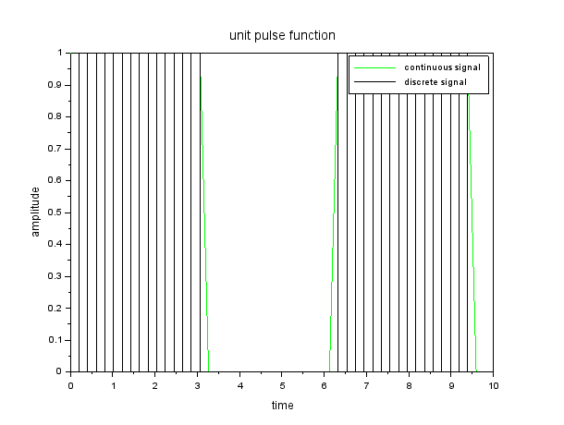

1. Unit ramp function

n = 0:10;

x = n;

plot(n,x,color = "blue");

plot2d3(n,x);

xlabel("time");

ylabel("amplitude");

title("unit ramp function");

legend("continuous ramp", "discrete ramp");

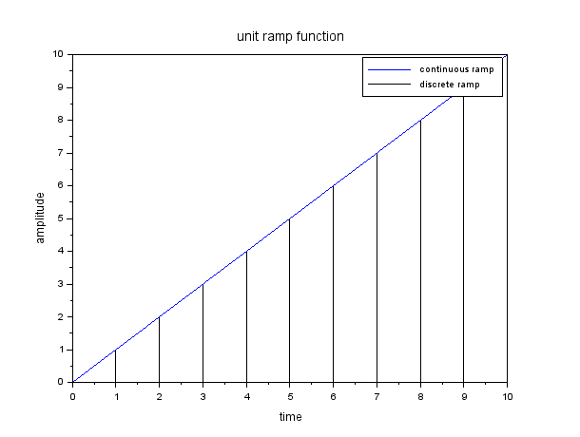

1. Bipolar function

n = linspace(0,10,50);

bipolar = squarewave(n);

a = gca()

a.x_location="origin";

plot(n, bipolar, color = "red");

plot2d3(n, bipolar);

xlabel('time');

ylabel('amplitude');

title('unit pulse function');

legend("continuous signal", "discrete signal");

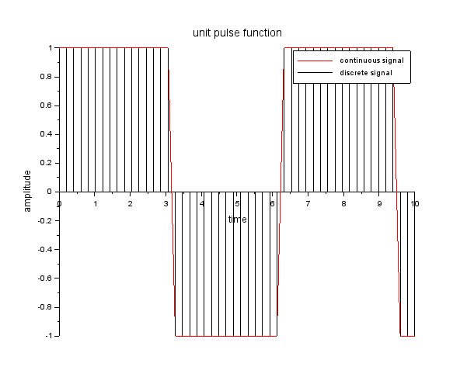

1. Triangular function

a = 8;

t = 0:(%pi/2):(4*%pi);

b = gca()

b.x_location="origin";

y = a*sin(t);

plot(t,y, color = "red");

plot2d3(t,y);

xlabel("time");

ylabel("amplitude");

title("triangular function");

legend("continuous", "discrete");

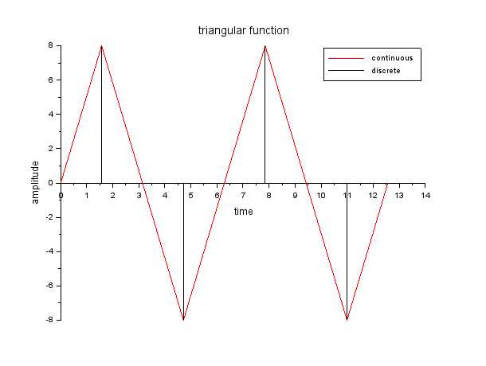

1. Unit step function

t = 0:4;

y = ones(1,5);

plot(t,y, color = "blue");

plot2d3(t,y);

xlabel("time");

ylabel("amplitude");

title("unit step function");

legend("continuous", "discrete");

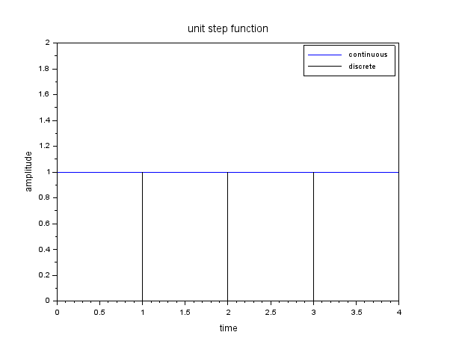

1. Exponential function

t = -2:0.1:2;

x = exp(t);

plot(t,x, color = "green");

plot2d3(t,x);

xlabel("time");

ylabel("amplitude");

title("exponential function");

legend("continuous","discrete");

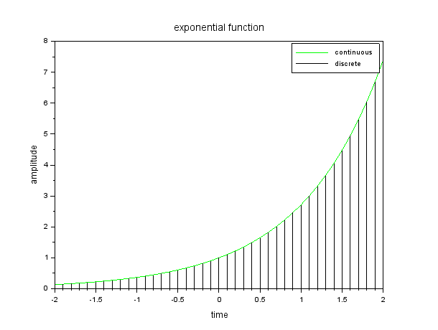

1. Sine wave

f = 0.2;

t = 0:0.1:10;

x = sin(2*%pi*f*t);

plot(t,x,color = "blue");

plot2d3(t,x);

xlabel("time");

ylabel("amplitude");

title("exponential function");

legend("continuous","discrete");

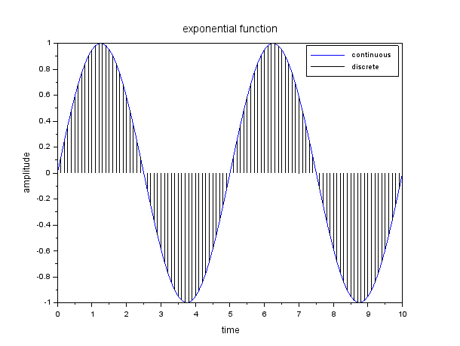

1. Cosine wave

f = 0.2;

t = 0:0.1:10;

x = cos(2*%pi*f*t);

plot(t,x,color = "blue");

plot2d3(t,x);

xlabel("time");

ylabel("amplitude");

title("exponential function");

legend("continuous","discrete");

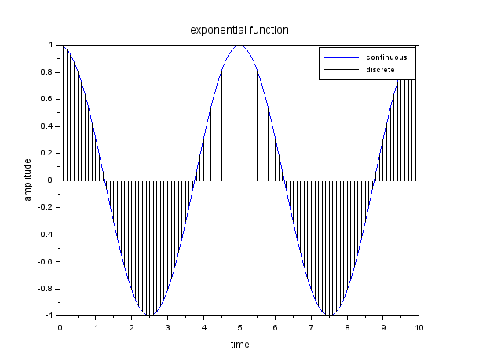

1. Square wave with and without duty cycle

t = linspace(0,10,1000);

u = squarewave(t);

v = squarewave(t,30);

a = gca()

a.x_location="origin";

xgrid(4,1,7);

plot(t,u, color = "red");

plot(t,v, color = "blue");

title("square wave with and without dutycycle of 0.3");

xlabel("time");

ylabel("amplitude");

legend("square without dutycycle", "square with dutycycle");

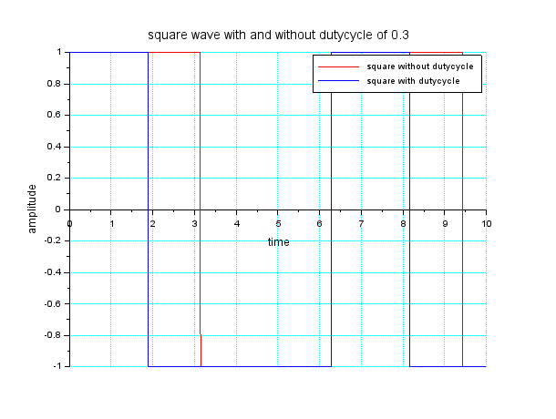

1. Sinc function

t = -10:0.1:10;

x = sinc(t);

a = gca()

a.x_location="origin";

plot(t,x , color = "green");

plot2d3(t,x);

title("sinc function");

xlabel("time");

ylabel("amplitude");

legend("continuous", "discrete");

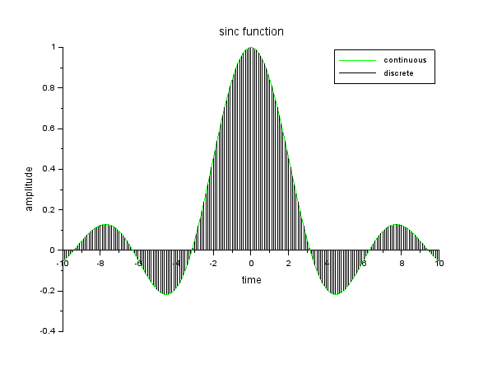

1. Sigum function

t = -10:0.1:10;

x = sign(t);

a = gca()

a.x_location="origin";

plot(t,x , color = "blue");

plot2d3(t,x);

title("signum function");

xlabel("time");

ylabel("amplitude");

legend("continuous", "discrete");

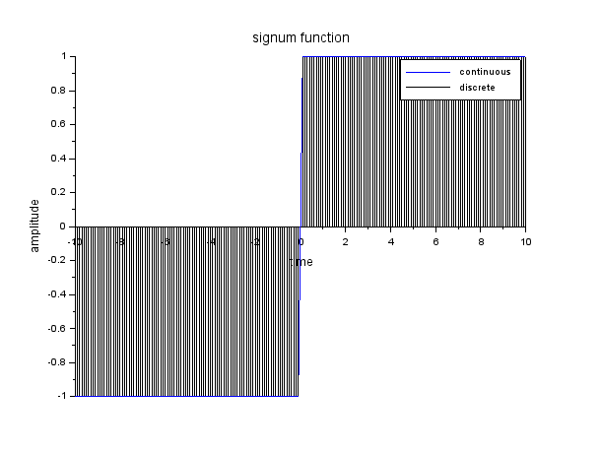

1. Parabola function

t = 0:0.1:3;

x = t^2;

a = gca()

a.x_location="origin";

plot(t,x, color = "red");

plot2d3(t,x);

title("parabolic function");

xlabel("time");

ylabel("amplitude");

legend("continuous", "discrete");

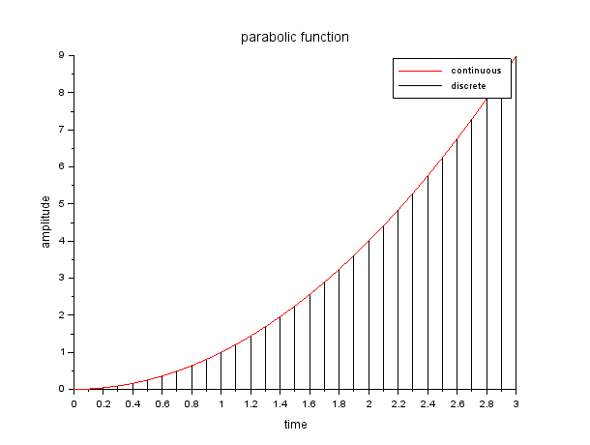

1. Sint + sin3t/3 + sin5t/5 + sin7t/7 + sin9t/9

t = 0:0.01:%pi;

y1 = sin(t);

y2 = sin(3*t)/3;

y3 = sin(5*t)/5;

y4 = sin(7*t)/7;

y5 = sin(9*t)/9;

y = y1+y2+y3+y4+y5;

plot(t,y,t,y1,t,y2,t,y3,t,y4,t,y5);

legend('y', 'y1','y2','y3','y4','y5');

title("generation of sinusoidal signals");

xgrid(1);

xlabel("time");

ylabel("amplitude");

