Program 1

import datetime

t=datetime.time(22,56,44)

print(t)

print("hour",t.hour)

print("minute",t.minute)

print("second",t.second)

print("microsecond",t.microsecond)

d=datetime.date.today()

print(d)

print("year",d.year)

print("month",d.month)

print("day",d.day)

d1=datetime.date.today()

print(d1)

td=datetime.timedelta(days=2)

print(td)

d2=d1+td

print(d2)

dt=datetime.datetime.combine(d,t)

print(dt)

Output:

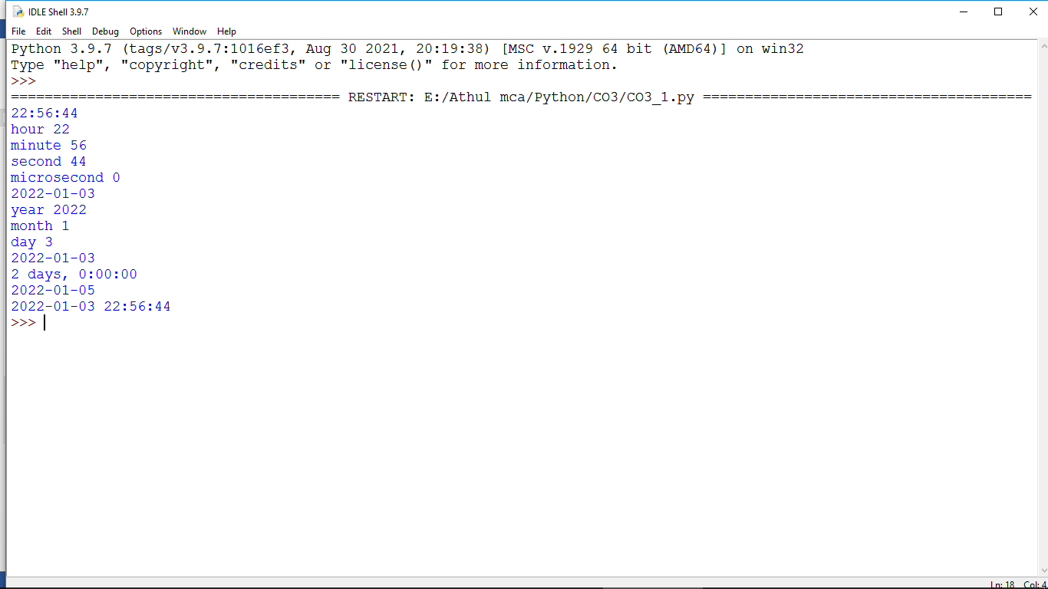

Program 1-2

import calendar

mm=int(input("Enter month:"))

yy=int(input("Enter year:"))

print(calendar.month(yy,mm))

print(calendar.calendar(2015))

Output:

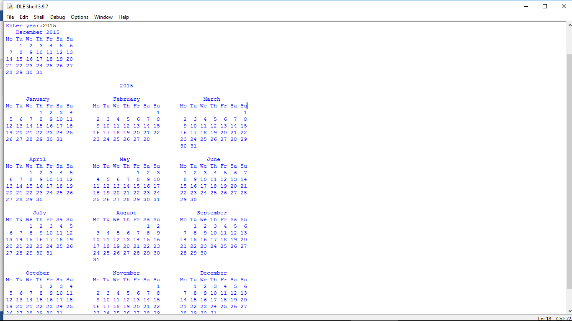

Program 1-3

import math

print(math.pi)

import math as m

print(m.pi)

from math import pi,sqrt

print(math.pi)

print(math.sqrt(4))

print(math.cos(90))

print(math.sin(1/2))

print(math.tan(0))

Output:

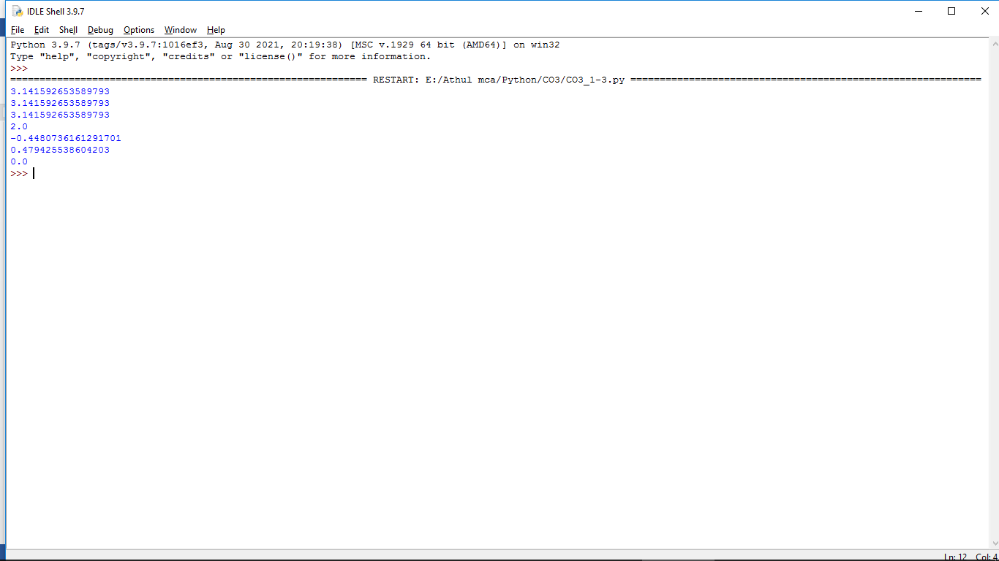

Program 1-4

import time

print("current time in sec:",time.time())

print("current time",time.ctime())

print("current time after 30 sec",time.ctime(time.time()+30))

Output:

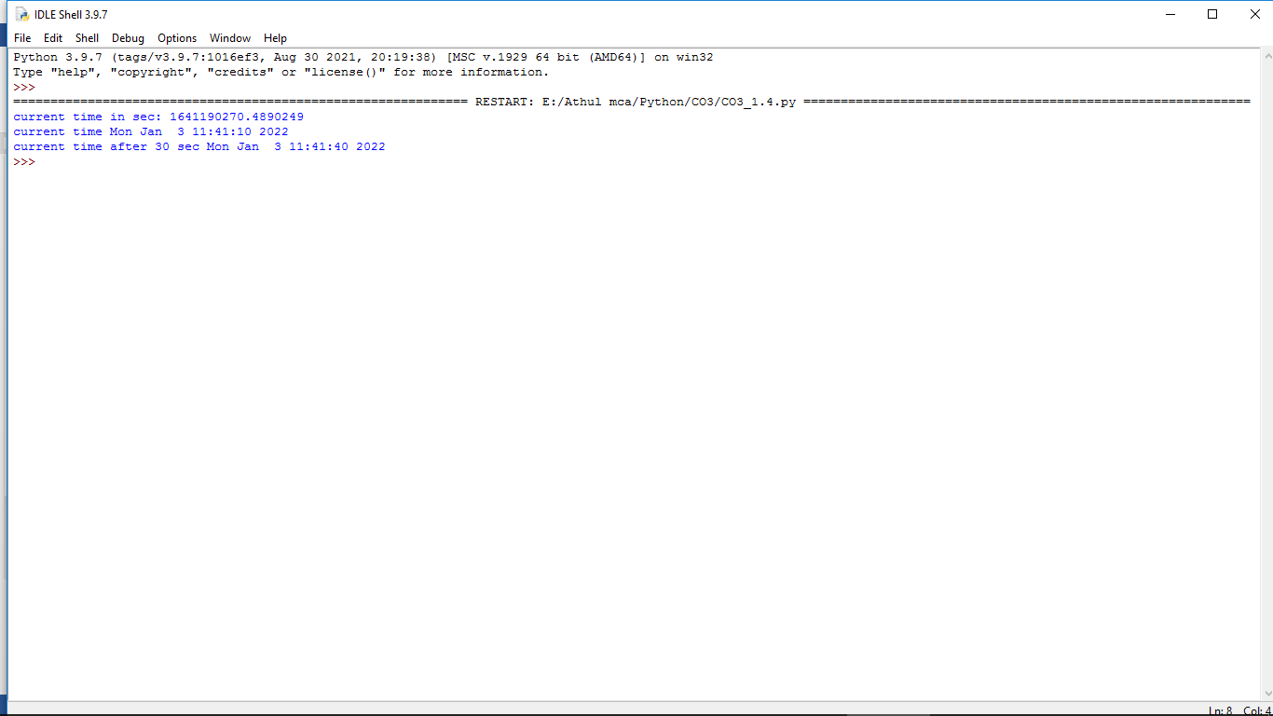

Program 1-5

import statistics

l=[4,6,8,9,3,4,5,7,8,7,0,7,3]

a=statistics.mean(l)

print(a)

b=statistics.median(l)

print(b)

c=statistics.mode(l)

print(c)

d=statistics.stdev(l)

print(d)

e=statistics.variance(l)

print(e)

Output:

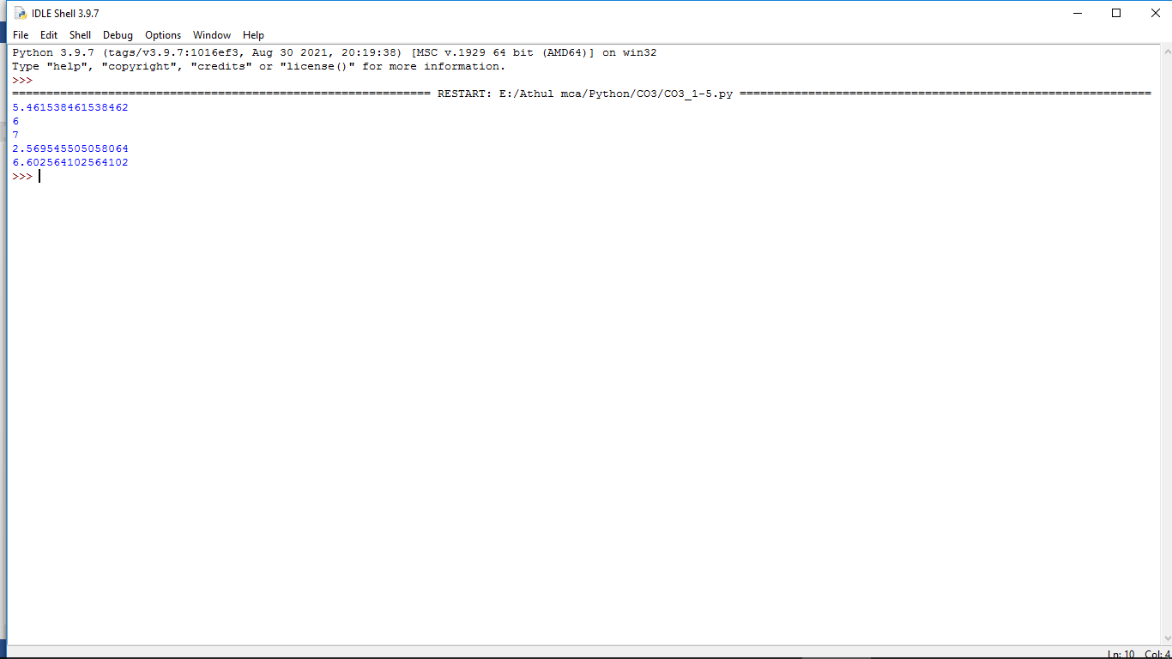

Program 1-6

import random

l1 = [2, 4, 6, 8, 10, 12]

print(random.choice(l1))

random.seed(4)

print(random.random())

print(random.random())

r1=random.randint(2,4)

print(r1)

Output:

