RESEARCH PAPER REVIEW AND IMPLEMENTATION REPORT

ON THE ARTICLE

Unsupervised Representation Learning with Deep Convolutional Generative Adversarial Networks (Radford, Metz and Chintala, 2015)

Submitted By

Nived Narayan – 2024BCD0025
Athul Kampiyil – 2024BCD0037
Abhinav S – 2024BCD0057
Niranjan R Soorej – 2024BCS0117
Mohammed Ashar Husain - 2024BCS0137

Course: CSE 311 Artificial Intelligence
Course instructor: Dr. A V Prajeesh

INDIAN INSTITUTE OF INFORMATION TECHNOLOGY KOTTAYAM


Contents
Page No.
Introduction 3
Motivation 4
Problem statement 5
Literature survey 6
Review of the Proposed Methodology 8
Results and Discussion 11
Conclusion 15
Future Work 16
References 17
GitHub Repository and Reproducibility Details 18

Introduction
Generative adversarial networks (GANs) learn to synthesize data by training two competing neural networks: a generator G maps a random latent vector to an image, while a discriminator D tries to distinguish generated images from real images. The discriminator supplies a learned training signal to the generator. Goodfellow et al. introduced this framework in 2014 [1]. Radford, Metz and Chintala subsequently proposed deep convolutional GAN (DCGAN) design rules for more stable image generation and useful latent representations [2].
This course project implements a DCGAN face generator and an interactive Latent Studio. Its primary output is a 64 × 64 RGB synthetic portrait sampled from a 100-dimensional Gaussian latent space. Training uses a CelebA-derived image array; the repository also records a smaller FFHQ experiment. Beyond sample generation, the project compares training configurations and exposes interpolation, latent editing, and image inversion through a FastAPI backend and Next.js frontend. The supplied article is Radford et al. [2]; this report reviews that article and distinguishes its claims from the narrower findings supported by this implementation.

Scope and contributions
— Implement five-layer convolutional generator and discriminator, with transposed convolution for upsampling and strided convolution for downsampling.
— Train and compare baseline, normalization, learning-rate, Adam momentum, batch-size and network-width configurations using logged losses and reported Fréchet Inception Distance (FID).
— Provide face grids, interpolations, latent edits, reconstruction by test-time optimization, and a browser-based demonstration.
— Document limitations: 64 × 64 native resolution, single recorded seed per experiment, and incomplete public provenance for some derived assets.

How to read this report
Sections 1–4 introduce the motivation, research question and prior work. Section 5 describes the reproducible portions of the implementation. Section 6 separates recorded numerical results from interpretation. The last sections summarize conclusions, practical extensions, references and repository instructions. Numeric results below are transcribed from results/results.json and results/summary_table.md; they were not rerun for this report.

Motivation

Why study adversarial face generation?
Human faces are a compact but challenging image domain. Successful synthesis requires a model to capture global structure such as pose and head shape together with local appearance such as eyes, hair and lighting. A simple convolutional GAN therefore provides a useful teaching example for representation learning, image synthesis, optimization and experimental design. Synthetic samples can be inspected qualitatively, while FID provides a distribution-level quantitative measure [4].
A DCGAN also offers a tractable baseline. More advanced generators may produce much higher resolution, but their complexity can obscure the effects of common design choices. Here, turning off BatchNorm, changing Adam β₁, widening the networks or changing batch size provides direct illustrations of how adversarial training responds to experimental conditions. The purpose is not to claim state-of-the-art image quality; it is to study the behavior of an interpretable baseline.

Why explore latent space?
The generator maps nearby latent inputs to related images, making interpolation and controlled editing possible. Linear interpolation may move through low-norm regions of a high-dimensional Gaussian prior. Spherical interpolation follows a path with approximately preserved radius; side-by-side image strips let users inspect whether this mathematical distinction has a visible effect [3]. Test-time inversion asks the complementary question: given an image, can optimization find a latent code whose generated output resembles it? These activities connect probability, geometry and neural image synthesis.

Educational and social context
A browser demo makes experimental outcomes easier to communicate than a table of losses alone. However, synthetic-face work raises concerns about consent, provenance, representation and misuse. The provided weights were trained using CelebA, whose use is restricted to non-commercial research. Generated faces should be identified as synthetic, and the model’s celebrity-photo distribution should not be mistaken for the diversity of the population. User-uploaded photographs should be handled carefully; this report does not assert a deployment-grade privacy or security review.

Problem statement
Primary problem: learn a mapping G: R¹⁰⁰ → R³×⁶⁴×⁶⁴ that turns z drawn from N(0, I) into plausible face images, while a discriminator D separates generated and dataset images. The learned model should permit sampling without retrieving or copying a particular training image. This implementation trains both networks on normalized image tensors and assesses outputs through visual inspection and FID.

Research questions
Can the DCGAN implementation generate recognizable 64 × 64 face-like images after training on CelebA?
How do normalization and optimizer settings affect recorded image quality under a matched 10-epoch comparison?
Does increasing network width improve recorded FID after accounting for the batch-size change in the wide run?
Can interpolation, simple latent directions and test-time inversion provide useful qualitative explorations of the trained generator?

Success criteria and boundaries
Evidence comprises generated sample grids, loss curves and FID computed against the corresponding real-image dataset. Lower FID generally indicates closer feature statistics but is not a proof of realism, diversity, fairness or novelty. Comparisons are most defensible when the real dataset, preprocessing, sample count and training budget match. Recorded single-seed differences cannot establish statistical significance. FFHQ’s FID uses FFHQ real images and is not directly comparable with CelebA FID. A working demo is an engineering outcome, not independent evidence that latent edits are semantically disentangled.

Literature survey

Generative adversarial networks
Goodfellow et al. [1] frame GAN training as a minimax game: min_G max_D V(D,G) = Eₓ[log D(x)] + E_z[log(1 − D(G(z)))]. When the model distribution matches the data distribution, an ideal discriminator cannot distinguish the two and outputs one half. The project uses the non-saturating generator update, maximizing the probability that generated examples are labeled real, to avoid weak gradients early in training. In code, D emits logits and BCEWithLogitsLoss incorporates the sigmoid operation numerically safely.

DCGAN design rules
Radford et al. [2] advocate all-convolutional architectures with learned upsampling, BatchNorm in most hidden layers, ReLU in the generator, LeakyReLU in the discriminator, Tanh at the generator output and a stable Adam configuration. Their work also investigates arithmetic and interpolation in latent space. This project follows those broad principles while specializing to 64 × 64 faces. Reproducing a design pattern does not reproduce the original paper’s dataset, all benchmarks or its broader conclusions.

Interpolation and latent semantics
White [3] discusses spherical interpolation for generative networks. In a 100-dimensional standard normal prior, E[||z||²] = 100, while the linear midpoint of two independent vectors has E[||(z₀+z₁)/2||²] = 50. Thus its typical radius is about 7.1 rather than 10. The implemented Slerp normalizes endpoints, interpolates their directions and interpolates endpoint norms; it does not enforce exactly radius 10 for endpoints with different norms. The math motivates a visual comparison, not a guarantee that every midpoint looks better.

Evaluating generated images
Heusel et al. [4] introduced FID, which compares means and covariances of deep image features for real and generated samples. FID can detect both poor fidelity and some distribution mismatch, but depends on the feature extractor, sample count and preprocessing. The project uses torchmetrics’ FrechetInceptionDistance with 2048-dimensional features and defaults to 10,000 real and 10,000 generated samples. Lucic et al. [5] show why GAN comparisons require careful tuning and repeated experimental runs. Accordingly, this report avoids declaring significance from a single run.

Comparison with this project
Source | Relevant idea | Use and limitation here
Goodfellow et al. [1] | Adversarial objective | Two-network training; non-saturating G loss
Radford et al. [2] | DCGAN design and latent arithmetic | Five-layer 64 × 64 implementation; limited reproduction
White [3] | Spherical interpolation | Slerp/Lerp comparison in latent exploration
Heusel et al. [4] | FID metric | 10k-versus-10k default evaluation
Lucic et al. [5] | Fair GAN comparison | Single-seed comparisons treated as exploratory

Review of the Proposed Methodology

System overview
The workflow has four stages. First, prepare_data.py obtains images from a configured Kaggle dataset or a supplied local root; it recursively finds JPEG/PNG files, converts to RGB, crops the centered square, resizes to 64 × 64 with Lanczos, then saves a uint8 NumPy array. Second, train.py loads the array into CPU memory and trains G and D on a CUDA GPU. Third, fid_eval.py evaluates a selected checkpoint and plots or sample grids show qualitative progress. Finally, generate.py, demo_app.py and the FastAPI/Next.js application expose inference and latent operations. Training arrays and full checkpoints are excluded from Git by .gitignore.

Generator architecture
The generator begins with a 100 × 1 × 1 latent tensor and uses five transposed-convolution layers. Its hidden channel widths are 512, 256, 128 and 64 at 4, 8, 16 and 32 pixels. A final 3-channel layer produces a 64 × 64 RGB image. Hidden layers use BatchNorm and ReLU, while the output uses Tanh, matching image normalization to [−1, 1]. The baseline generator parameter count recorded in results/results.json is 3,576,704.
Stage | Operation | Output
Input | z ~ N(0, I₁₀₀) | 100 × 1 × 1
1 | ConvTranspose 4×4, BatchNorm, ReLU | 512 × 4 × 4
2 | ConvTranspose stride 2, BatchNorm, ReLU | 256 × 8 × 8
3 | ConvTranspose stride 2, BatchNorm, ReLU | 128 × 16 × 16
4 | ConvTranspose stride 2, BatchNorm, ReLU | 64 × 32 × 32
5 | ConvTranspose stride 2, Tanh | 3 × 64 × 64

Discriminator architecture
The discriminator reverses the spatial sequence: 64 → 32 → 16 → 8 → 4 → 1 pixels. Five strided convolution layers use hidden channel widths 64, 128, 256 and 512. The first input layer has no BatchNorm; the next three do; the output layer has neither BatchNorm nor an explicit sigmoid. Hidden activations are LeakyReLU with slope 0.2. The baseline discriminator has 2,765,568 parameters according to results/results.json. It returns one real/fake logit per image.

Training objective and updates
The code initializes convolution weights from N(0, 0.02²), optimizes G and D with Adam (learning rate 2 × 10⁻⁴, β₁ = 0.5, β₂ = 0.999 by default), and uses BCEWithLogitsLoss. Each training iteration updates D on real images with target 1 and detached generated images with target 0. It then updates G against target 1 using the discriminator output on generated images. An optional --label-smooth flag changes D’s real target but defaults to zero; it is not part of the documented baseline. Real images are mapped from uint8 to [−1, 1] and independently flipped horizontally at probability 0.5.
The default batch size is 128; the baseline runs 25 epochs, while most comparisons run 10. train.py seeds Python, NumPy and PyTorch with 42 by default. It requires CUDA and refuses CPU training. It saves checkpoint files, periodic 8 × 8 sample grids and CSV logs. This is sufficient to rerun code given data and compatible hardware, but complete bitwise determinism is not guaranteed by setting these seeds alone.

Dataset and preparation limits
CelebA contains 202,599 face images in the source dataset [6]. The repository’s preparation script does not perform an explicit train/validation/test split; FID reads the first N entries in its saved array. No duplicate audit or identity-disjoint split is implemented. FFHQ preparation uses a separate Kaggle source; the recorded experiment describes 52,001 images. Distribution differences, dataset size and training budget limit cross-dataset interpretations.

FID protocol
fid_eval.py constructs FrechetInceptionDistance(feature=2048), updates it on the first 10,000 real images in data/celeba_64.npy by default, then on 10,000 newly sampled generated images. Generated tensors are mapped from [−1, 1] to uint8 [0, 255]. Batch size defaults to 100. The script runs on CUDA; installation of torchmetrics, torch-fidelity, torch and torchvision is required. Its implementation does not explicitly fix an evaluation seed, so a newly computed score need not match the recorded scalar exactly.

Latent-space experiments
Interpolation: latent_ops.py implements Lerp and Slerp, builds comparison strips and GIFs, and visualizes transitions. The standalone generate.py interpolation mode uses Lerp, whereas the dedicated latent_ops.py comparison offers both methods. Attribute editing: load_attribute_vectors reads four precomputed vectors from weights/attribute_vectors.pt (smile, pose, gender and light), and project_to_sphere restores the edited latent’s original Euclidean norm. The repository does not include a script documenting how those attribute vectors were estimated; their semantic labels should therefore be described as supplied assets, not independently verified labels.
Inversion: invert_face center-crops and resizes an input photo, tests 30 random latent candidates, selects the lowest initial pixel MSE, and optimizes that code with Adam for 40 iterations by default at learning rate 0.10. Its loss is pixel MSE plus 0.001 times mean(z²). It neither projects the optimized latent to the Gaussian shell nor computes a perceptual similarity score. Reconstructing an image generated by G is easier than reconstructing an arbitrary real photograph; no broad real-photo accuracy claim follows from this code.

Application architecture
The FastAPI backend loads weights/generator_celeba_dcgan.pt at startup, exposes health and generation-related endpoints, and serves recorded plots from results/. A separate Next.js frontend calls http://localhost:8000 by default and offers a mock mode. Mock visuals are procedural and must not be represented as outputs of the trained GAN. The legacy Gradio application remains available. These interfaces demonstrate the same generator and latent tools but are not necessary to train the model.

Implementation controls and threats to validity
— Compare 10-epoch variants with base_10ep (FID 30.15), not with the 25-epoch baseline (29.85).
— The wide model also used batch size 64; compare it with exp_bs64 (FID 28.75), not solely with batch-128 baseline.
— No repeated-seed distribution or error bars are provided; treat numerical differences as observations, not inferential conclusions.
— The public repository lacks raw prepared arrays and full experiment checkpoints; the lightweight generator weight is present for inference.
— Evaluation settings and external package versions are not locked. Reported FID should be regarded as historical recorded output pending reproduction.

Results and Discussion

Recorded quantitative outcomes
Table 3 reproduces the saved results, not a new measurement. FID is lower-is-better within comparable real-image distributions and protocols. Final losses are training diagnostics rather than standalone quality scores; adversarial losses need not decrease monotonically when both players learn.
Run | Change | Epochs | FID | Loss D | Loss G
celeba_baseline | baseline | 25 | 29.85 | 0.080 | 4.005
base_10ep | 10-epoch control | 10 | 30.15 | 0.321 | 2.955
exp_nobn | remove BatchNorm | 10 | 44.20 | 0.884 | 0.747
exp_lr5e-4 | learning rate 5e-4 | 10 | 32.28 | 1.128 | 2.146
exp_beta0.9 | Adam β₁ = 0.9 | 10 | 148.64 | 0.125 | 7.147
exp_bs64 | batch size 64 | 10 | 28.75 | 0.118 | 4.708
exp_w128 | width 128; batch 64 | 10 | 23.95 | 0.182 | 5.291
ffhq_baseline | FFHQ real reference | 10 | 94.39 | 0.456 | 3.876

Against base_10ep, removing BatchNorm worsened the recorded FID by 14.05 points; β₁ = 0.9 worsened it by 118.49. The high learning-rate run was 2.13 points worse. Changing batch size to 64 was 1.40 points better in this one run. Comparing the width-128 experiment with its matched batch-64 control gives a 4.80-point difference (23.95 versus 28.75). These are descriptive differences, not statistically significant effects. The FFHQ run used a different real distribution and should be discussed separately.
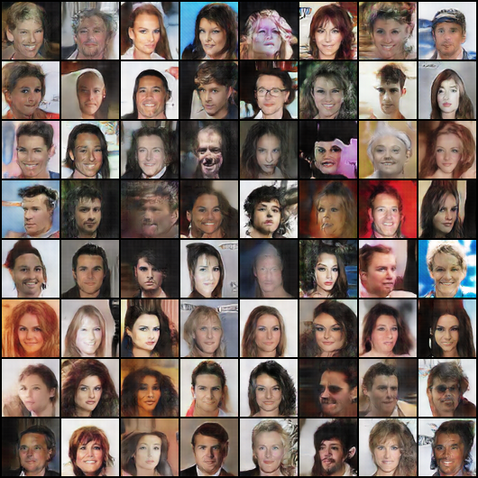
Figure 1. Saved final face grid. Native model output is 64 × 64 per image.
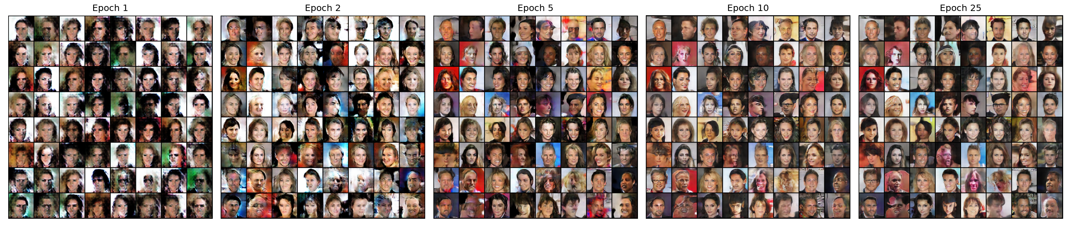
Figure 2. Saved epoch progression from the CelebA baseline.

Training dynamics and visual observations
The saved grid and epoch strip offer direct qualitative context for the numeric table. Face-like global structure emerges over training, while some samples retain artifacts and limited fine detail. Loss curves trace the adversarial interaction rather than a simple monotonic optimization objective. Inspecting generated images alongside FID reduces the risk of overinterpreting one number; nevertheless, neither evidence source proves that every sample is realistic or unique.
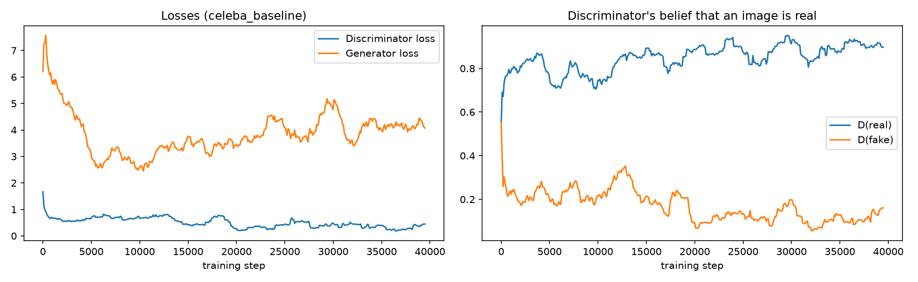
Figure 3. Recorded discriminator and generator loss traces for the 25-epoch baseline.
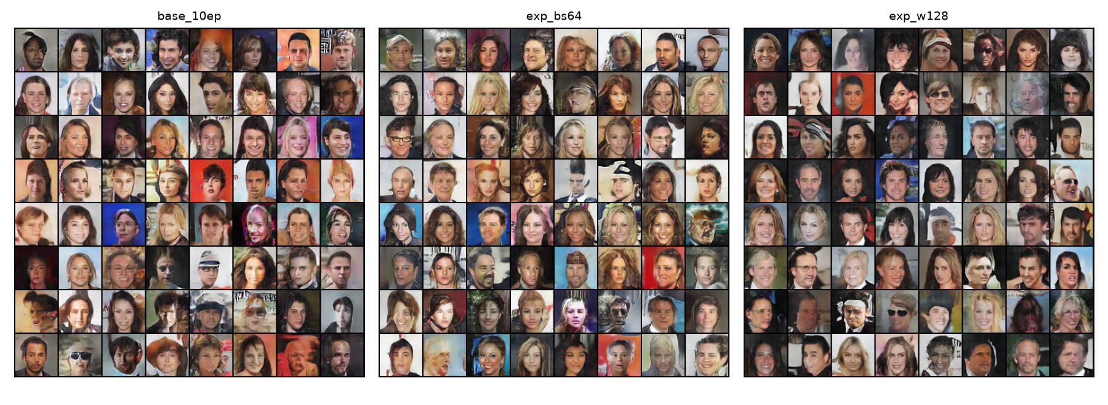
Figure 4. Saved comparison visualization for width and batch-size controls.

Ablation interpretation
The no-BatchNorm and β₁ = 0.9 runs produced much worse recorded FID than their 10-epoch control. Their magnitude supports identifying them as visible failures in these specific runs. It does not estimate how often they fail across seeds, datasets or hardware. The 2.13-point learning-rate gap and 1.40-point batch-size gap are especially sensitive to run-to-run variation and should not be promoted as general rules. The width comparison is better controlled once batch size is matched, but remains a single-seed observation.
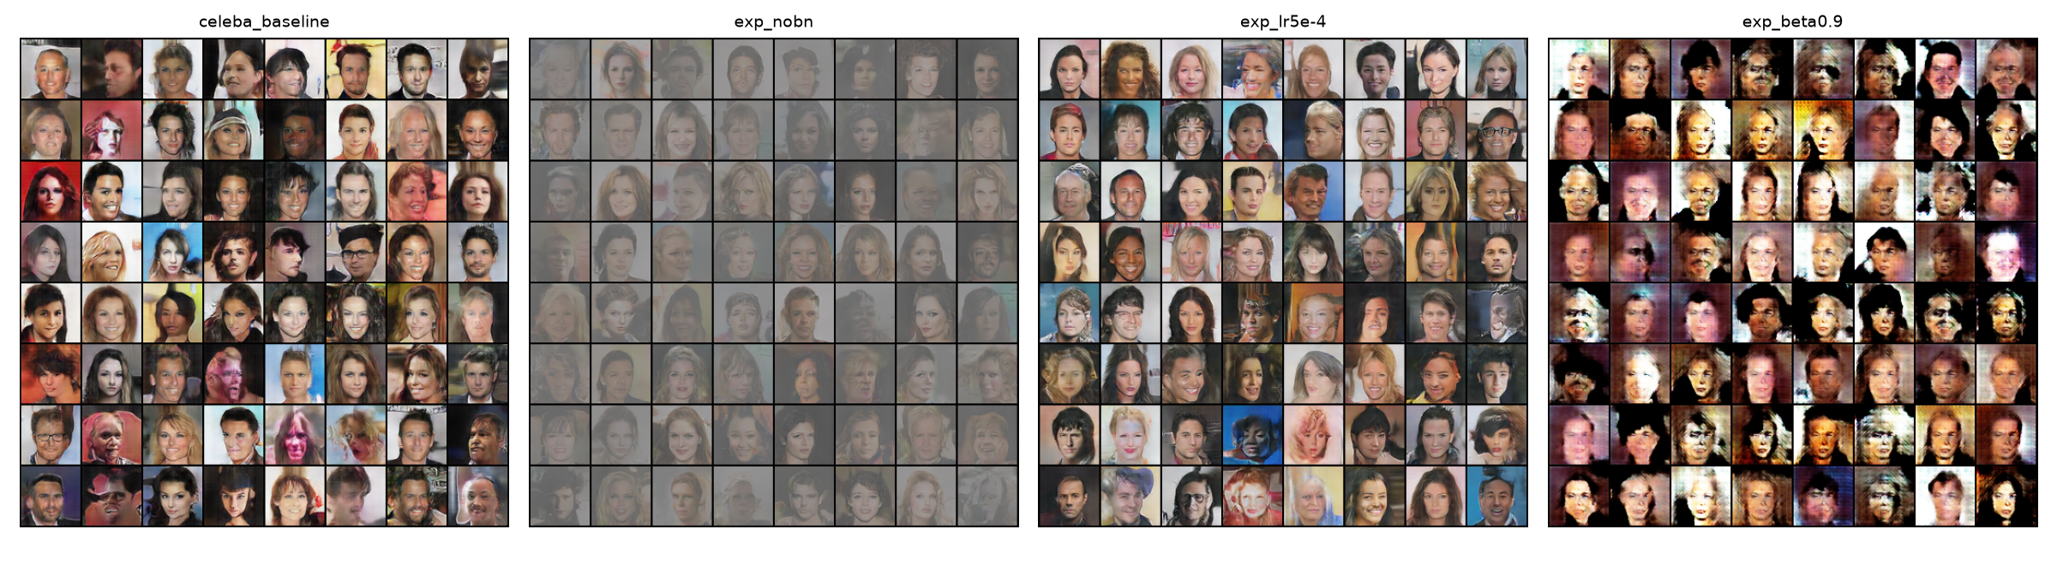
Figure 5. Saved comparison of visually degraded experiment outputs.

Interpolation and inversion discussion
The saved interpolation image documents that the generator can traverse between sampled latent endpoints. A controlled Slerp-versus-Lerp comparison should be generated from identical endpoint pairs when demonstrating the geometric claim; the archived interpolation file alone does not establish which route is better. Pixel-MSE inversion can find a closer generated reconstruction for some inputs, but a real photograph may not lie in the limited 64 × 64 generator manifold. The interface should show initial and final error for the exact demo image rather than cite a universal improvement percentage.
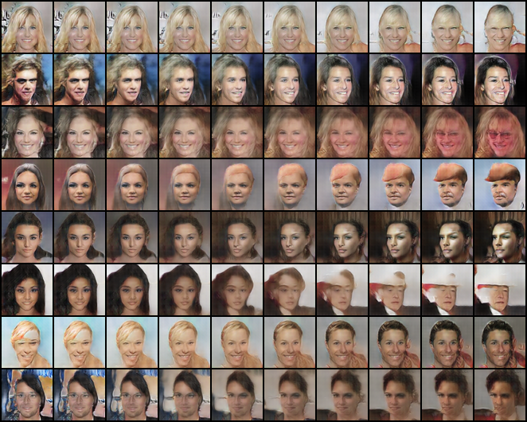
Figure 6. Saved latent interpolation montage; path and endpoints should be specified for any formal comparison.

Limitations
— Resolution is 64 × 64; enlarging output in the interface does not increase learned image detail.
— Single recorded seed per ablation, no confidence intervals, and no independent evaluation rerun for this report.
— FID is sensitive to sample size, source distribution and implementation; FFHQ and CelebA values are not cross-comparable.
— No documented construction pipeline for attribute vectors; controls may entangle multiple visual traits.
— No real-photo reconstruction benchmark, user study, diversity audit or identity-memorization analysis is included.

Conclusion
The implementation meets its central engineering objective: it trains a DCGAN-style 64 × 64 face generator, saves quantitative and visual artifacts, and makes the model explorable through command-line and web interfaces. The baseline CelebA run records FID 29.85 after 25 epochs; a comparable 10-epoch control records 30.15. The recorded no-BatchNorm and high-β₁ settings perform substantially worse in these runs, while a wider network at matched batch size records lower FID. These findings illustrate training sensitivity, but repeated runs are necessary before generalizing their magnitudes.
Latent interpolation, norm-preserving slider edits and test-time inversion extend the project beyond unconditional image sampling. Their mathematical behavior is understood from the code, but semantic reliability and real-photo reconstruction quality remain incompletely measured. The project is best presented as a working educational reproduction and exploratory analysis, not a state-of-the-art face generator or a statistically conclusive benchmark.

Future Work
Repeat each experiment across at least three or more documented seeds, report mean and dispersion of FID, and preserve exact evaluation configurations.
Document the attribute-vector construction procedure and measure whether edits change intended traits without changing unrelated features.
Benchmark inversion separately on generated images and consented real photos, including residual error, perceptual similarity and runtime.
Add a fixed validation protocol, versioned dependencies, dataset checksums or source revisions, and model-card-style dataset and usage disclosures.
Evaluate stronger architectures and higher native resolution only after baseline reproducibility and fair compute-matched comparisons are established.

References
[1] I. Goodfellow et al., “Generative Adversarial Nets,” Advances in Neural Information Processing Systems 27, 2014. https://arxiv.org/abs/1406.2661
[2] A. Radford, L. Metz and S. Chintala, “Unsupervised Representation Learning with Deep Convolutional Generative Adversarial Networks,” ICLR, 2016 (preprint 2015). https://arxiv.org/abs/1511.06434
[3] T. White, “Sampling Generative Networks,” 2016. https://arxiv.org/abs/1609.04468
[4] M. Heusel et al., “GANs Trained by a Two Time-Scale Update Rule Converge to a Local Nash Equilibrium,” Advances in Neural Information Processing Systems 30, 2017. https://arxiv.org/abs/1706.08500
[5] M. Lucic et al., “Are GANs Created Equal? A Large-Scale Study,” Advances in Neural Information Processing Systems 31, 2018. https://arxiv.org/abs/1711.10337
[6] Z. Liu et al., “Deep Learning Face Attributes in the Wild,” Proceedings of ICCV, 2015. https://mmlab.ie.cuhk.edu.hk/projects/CelebA.html
[7] T. Karras, S. Laine and T. Aila, “A Style-Based Generator Architecture for Generative Adversarial Networks,” CVPR, 2019. https://arxiv.org/abs/1812.04948
[8] Project repository, “DCGAN Face Generator / Latent Studio,” source code and recorded results. https://github.com/AthulKampiyil/AI_Project (local revision 23015721c0dfd39bf3741dac0b7880481fb73707; accessed 23 October 2026).

GitHub Repository and Reproducibility Details
Repository: https://github.com/AthulKampiyil/AI_Project. This report was assembled from local revision 23015721c0dfd39bf3741dac0b7880481fb73707 on 23 October 2026. Key files are models.py (architecture), prepare_data.py (data), train.py (training), fid_eval.py (FID), latent_ops.py (latent exploration), main.py (API), frontend/ (browser interface), results/results.json (recorded values), and weights/generator_celeba_dcgan.pt (inference checkpoint).

Environment and dataset
Use a compatible Python version with PyTorch, torchvision, NumPy, Pillow, torchmetrics, torch-fidelity, FastAPI, Uvicorn, python-multipart and the remaining packages in requirements.txt. The latter file alone omits some packages required by imports. A CUDA-capable GPU is mandatory for train.py and fid_eval.py; generate.py and the API can use CPU if compatible weights load. The repository does not pin package versions or record the original GPU and exact dataset download revisions. These values should be filled in from the actual execution environment before a strict reproduction claim.
CelebA and FFHQ images are not distributed in this repository. Obtain datasets from the sources named in README.md, comply with their respective licenses, and run python prepare_data.py --dataset celeba (or --dataset ffhq). The default output is data/celeba_64.npy. Verify the image count before training. Dataset acquisition may need Kaggle credentials; alternate local input is supported with --root.

Minimum reproduction commands
python prepare_data.py --dataset celeba
python train.py --run-name celeba_baseline --epochs 25
python fid_eval.py --data data/celeba_64.npy --ckpt checkpoints/celeba_baseline/latest.pt --n 10000 --batch 100
python generate.py --ckpt weights/generator_celeba_dcgan.pt --mode grid --out results/generated.png
python main.py # backend at http://localhost:8000
cd frontend && npm ci && npm run dev # browser at http://localhost:3000
To reproduce a comparison, use the same real-data array and FID settings, then vary only the intended flag. For example, --no-bn or --beta1 0.9 with --epochs 10 uses base_10ep as control. For the width experiment, specify --ngf 128 --ndf 128 --batch-size 64 and compare with a batch-64 width-64 run. Existing run_experiments.sh automates several variants but does not encompass every recorded run or fully lock the environment.

Availability and unresolved provenance
The tracked repository includes final inference weights and some generated plots, but excludes raw data, intermediate checkpoints and samples. weights/attribute_vectors.pt is present without a generation script. Historical FID and training-time values are recorded in results/results.json; this report does not independently verify them. Any submitted reproduction should include environment versions, hardware, dataset source/revision, exact run commands, seed values, logs, and notes about unavailable artifacts. Only load .pt checkpoints from trusted sources.

