Software Architecture and Design Document
for
CodeForge: Rise of Solvers
Version 1.1
Prepared by Group 7
Athul Kampiyil (2024BCD0037)
Harikrishnan S (2024BCS0025)
Niranjan R Soorej (2024BCS0117)
Mohammed Ashar Husain (2024BCS0137)
Department of Computer Science and Engineering
IIIT Kottayam
August 09, 2026 (v1.1 update)

Revision History
Name | Date | Reason For Changes | Version
Group 7 | August 08, 2026 | Initial Software Architecture and Design Document, derived from approved SRS v1.0 | 1.0
Group 7 | August 09, 2026 | Added detailed game-logic algorithms (matchmaking, territory scoring, trophy calculation), judge-sync fault tolerance (proxy rotation, circuit breaker, dead-letter queue), atomic write patterns for high-contention tables, a PostgreSQL-backed cooldown architecture removing the Redis single point of failure, and WebSocket event payload schemas. | 1.1

Table of Contents
Revision History 2
1 Introduction 5
1.1 Purpose 5
1.2 Scope 5
1.3 Intended Audience 5
1.4 References 5
1.5 Definitions and Acronyms 5
2 Architectural Overview 6
2.1 Architectural Goals 6
2.2 Architectural Style 6
2.3 Design Principles 8
2.4 Technology Stack 8
2.5 Design Rationale 8
3 System Context 9
3.1 Context Diagram 9
3.2 External Systems 9
3.3 High-Level Data Flow 9
4 Module Identification and Design 10
4.1 Module Identification 10
4.2 Functional Requirement to Module Mapping 10
4.3 Module Decomposition 11
4.4 Module Description 11
4.5 Module Interaction 15
4.6 Package Diagram 16
5 Interface Design 16
5.1 User Interface Overview 16
5.2 Module Interfaces 16
5.3 External Interfaces 17
5.4 Communication Interfaces 17
6 Database Design 17
6.1 Database Design Overview 17
6.2 ER Diagram 18
6.3 Entity Description 18
6.4 Data Dictionary 19
6.5 Database Constraints 20
6.6 Normalization 22
7 Detailed Design 22
7.1 Object-Oriented Design Overview 22
7.2 Class Diagram 23
7.3 Class Description 24
7.4 Sequence Diagrams 26
7.5 Activity Diagram 28
7.6 State Diagram 30
8 User Interface Design 30
8.1 UI Design Principles 30
8.2 Wireframes 30
8.3 Navigation Flow 32
9 Security Design 32
10 Error Handling 33
11 Deployment Design 34
12 Traceability Matrix 35
13 Assumptions and Limitations 37
Submission Checklist 38
Appendix A: Glossary 39
Appendix B: API Specifications 39
B.1 WebSocket Event Schemas 40
Appendix C: Additional UML Diagrams 41
Appendix D: Design Decisions 41
Appendix E: Version History 42

1 Introduction

1.1 Purpose
This Software Architecture and Design Document (SADD) describes the software architecture and detailed design for Version 1.0 of CodeForge: Rise of Solvers, a gamified competitive-programming practice platform. It complements the approved Software Requirements Specification (SRS v1.0) by translating each stated requirement into a concrete architecture, module structure, database design, class- and sequence-level detailed design, interface design, security design, and deployment topology. Where the SRS specifies what the system must do, this document specifies how the system will be built to do it, and is the primary artifact reviewed during the Architecture Review.

1.2 Scope
CodeForge: Rise of Solvers turns individual competitive-programming practice into a strategy game inspired by village-building and clan-war formats. The design scope covers all functional features defined in SRS Sections 4.1-4.7 - Authentication & Account Linking, Coding Platform Sync, Personal Code Village Management, Async Village Attacks, Guild Management & Territory Control, Guild War Room, and League & Trophy Progression - together with the supporting real-time notification and admin/game-balance concerns implied by the SRS's communications interfaces and use cases UC-11/UC-12. The system's boundary excludes hosting problems or accepting code submissions; problem solving continues to happen on the linked external judges (Codeforces, LeetCode, CodeChef), and CodeForge observes, scores, and gamifies that activity. Users are competitive-programming students and solvers (individually and organized into guilds); the course instructor/evaluator is a secondary audience for this document.

1.3 Intended Audience
- Developers (frontend, backend, and game-visualization) - should read Sections 4 through 11 closely before implementation.
- Testers - should use Sections 4, 6, 7, and 12 (Traceability Matrix) to derive test cases.
- Project Guide / Evaluators - may focus on Sections 1-3 and 12-13 for scope, rationale, and traceability.
- Maintainers / future team members - should read this document alongside the SRS before extending any module.

1.4 References
- Group 7, Software Requirements Specification for CodeForge: Rise of Solvers, v1.0, July 26, 2026.
- IEEE Std 830-1998, IEEE Recommended Practice for Software Requirements Specifications.
- IEEE Std 1016-2009, IEEE Standard for Information Technology - Systems Design - Software Design Descriptions.
- Codeforces API documentation - https://codeforces.com/apiHelp
- FastAPI documentation - https://fastapi.tiangolo.com
- Phaser.js documentation - https://docs.phaser.io
- PostgreSQL and Redis official documentation.

1.5 Definitions and Acronyms
Term | Definition
SADD | Software Architecture and Design Document (this document).
SRS | Software Requirements Specification (Group 7, v1.0), the input to this document.
REQ-x.y | A functional requirement identifier from the SRS, feature x, requirement y.
NFR-x.y | A nonfunctional requirement identifier from the SRS.
UC-n | A use case identifier from the SRS Use Case List.
Village / Code Village | A solver's personal visual representation of topic-wise practice progress.
Judge | An external competitive-programming platform: Codeforces, LeetCode, or CodeChef.
Zone | A topic-based region of the shared territory-control map contested by guilds.
ORM | Object-Relational Mapping layer used by the backend to access PostgreSQL.
WS / WSS | WebSocket / WebSocket Secure - the transport used for real-time, server-pushed events.

2 Architectural Overview

2.1 Architectural Goals
The architecture is driven directly by the constraints and quality attributes in SRS Sections 2.6, 2.7, and 5.4:
- Scalability - support a growing number of concurrent solvers and guilds without redesigning core game logic (SRS 5.4).
- Maintainability - organize authentication, sync, village, attacks, guilds, war room, and league as separable modules (SRS 5.4).
- Performance - 2-second dashboard/map load, 3-second matchmaking response, 3-second real-time notification delivery (NFR-1.1 to NFR-1.4).
- Security - verified judge ownership, salted password hashing, role-based access, rate limiting, and administrative audit logging (NFR-3.1 to NFR-3.5).
- Availability - core features degrade gracefully rather than fail entirely if a single judge's data source is temporarily unreachable (SRS 5.4).
- Extensibility - a new judge can be added without redesigning core village, attack, or territory-control logic (SRS 5.4).

2.2 Architectural Style

2.2.1 Selected Style
CodeForge adopts a layered, modular service-oriented architecture with an event-driven notification path, deployed as a horizontally-scalable stateless API tier in front of a shared relational store (PostgreSQL) and a shared in-memory coordination store (Redis).

Reason for Selection
The technology stack is fixed by the SRS (FastAPI, PostgreSQL, React + Phaser.js, Redis - SRS 2.7). Within that stack, a layered architecture cleanly separates the game-visualization concerns of the client from backend game logic, while a modular, feature-based decomposition inside the Domain Service layer mirrors the SRS's own feature grouping (Sections 4.1-4.7), so each module can be developed, tested, and later extended independently. An event-driven publish/subscribe path is layered on top for the cross-cutting real-time concerns (incoming attack, territory change, village update) that must reach an already-connected client without polling.

Advantages
- Clear separation of presentation, API, domain, and persistence concerns, matching SRS 5.4 Maintainability.
- Stateless application nodes can be scaled horizontally behind a load balancer without redesigning cooldown or matchmaking logic (SRS 5.4 Scalability).
- Module boundaries mirror the SRS feature list one-to-one, keeping requirements traceability simple (Section 12).
- A single relational store keeps cross-module invariants (an attack outcome affecting village, trophy, and territory state together) transactionally simple, avoiding distributed-transaction complexity.

Limitations
- A modular monolith couples the deployment lifecycle of all domain modules together; a bug or crash in one module's process can affect the availability of others unless carefully isolated with process-level fault boundaries.
- Redis is a single shared dependency for matchmaking, cooldowns, and caching; its unavailability degrades several features simultaneously.
- Judge-integration volatility (official API vs. community API vs. scraping, per SRS Appendix C TBD-1) is contained but not eliminated by the Judge Adapter boundary.

Architecture Diagram
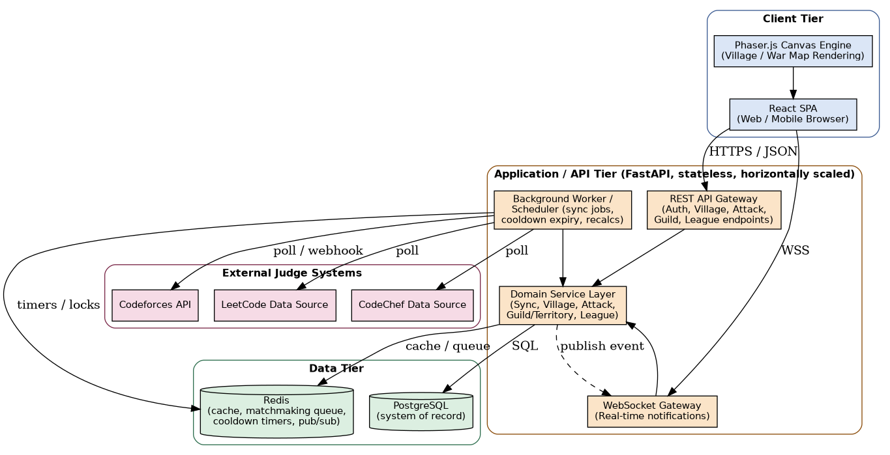
Figure 2.1 - High-Level System Architecture

Design Rationale
A microservice-per-feature style was considered and rejected for v1.0: the team size (4 developers), the single fixed relational store, and the tight coupling between Attack, Village, and League state (an attack outcome atomically affects village defense perception, trophy count, and potentially territory control) make a modular monolith with clearly separated internal modules a better fit than distributed services communicating over the network. Module boundaries are nonetheless drawn so that any module could later be extracted into its own service without redesigning its public interface, satisfying the SRS's Extensibility attribute without the operational cost of microservices during initial development.

2.3 Design Principles
- Modularity - each of the nine modules (Section 4) owns one cohesive responsibility drawn directly from an SRS feature grouping.
- High cohesion - sub-components within a module (e.g., Judge Adapter, Topic Tagger inside Coding Platform Sync) each address a single concern.
- Low coupling - cross-module calls are made through narrow, explicit interfaces (e.g., Attack reads Village's defense rating but never writes to it); only the Sync module depends on external judge integrations.
- Separation of concerns - presentation (React/Phaser), API/gateway, domain logic, and persistence are kept in distinct layers so that a change to one does not require changes to the others.
- Reuse - shared infrastructure concerns (session/cooldown state, real-time publishing) are centralized in Redis and the Notification module rather than duplicated per feature module.

2.4 Technology Stack
Layer | Technology | Reason
Client UI | React | Component-based SPA framework; fixed by SRS 2.6/2.7; wide browser support.
Game Canvas | Phaser.js | Purpose-built 2D canvas/game engine for the Village and War Map visualizations (SRS 2.6).
Backend API | FastAPI (Python) | Fixed by SRS 2.7; async-friendly, OpenAPI schema generation, strong typing support.
Real-time Transport | WebSocket (over FastAPI) | Required for near-real-time attack/territory notifications without polling (SRS 3.4, NFR-1.4).
Relational Database | PostgreSQL | Fixed by SRS 2.7; system of record with strong consistency and durability guarantees (NFR-2.1).
In-Memory Store | Redis | Fixed by SRS 2.7; matchmaking queue, cooldown timers, caching, and pub/sub broker.
Deployment | Linux-based server / container infrastructure | Fixed by SRS 2.6; supports horizontal scaling of stateless application nodes.

2.5 Design Rationale
The key architectural trade-off in this design is choosing a modular monolith over microservices for v1.0, accepting a shared deployment lifecycle across modules in exchange for transactional simplicity across the Attack-Village-League-Territory boundary and a much lower operational burden for a four-person student team. The second key trade-off is separating interactive request handling (FastAPI application nodes) from background judge polling and recalculation (a dedicated Worker node): this costs an extra deployable process but protects the NFR-1.1/NFR-1.3 latency budgets from third-party judge slowness, which SRS 2.7 and 2.9 explicitly flag as a real risk. Both decisions are revisited module-by-module in Section 4 and validated against the full requirement set in Section 12.

3 System Context

3.1 Context Diagram
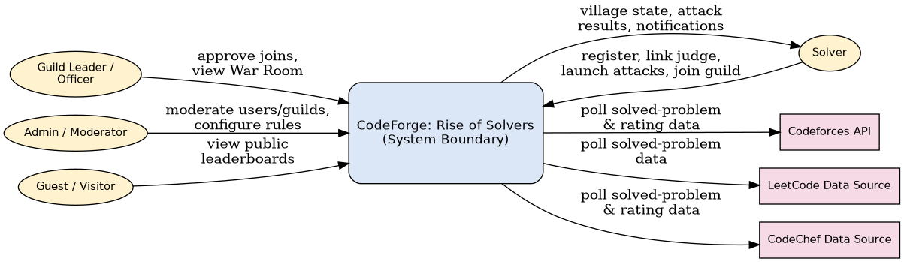
Figure 3.1 - System Context Diagram

Design Rationale
The system boundary is drawn so that CodeForge never writes to an external judge and never hosts problem content itself (SRS 2.1); all four actor classes (Solver, Guild Leader/Officer, Admin/Moderator, Guest/Visitor) interact with CodeForge exclusively through its own REST/WebSocket surface, and all three external judges are treated uniformly as read-only data sources reached only from the Sync module / Background Worker, never from the interactive request path.

3.2 External Systems
External System | Interaction | Notes
Codeforces API | Polled for solved-problem and rating data via the official public REST API. | Most stable integration; official API documented at codeforces.com/apiHelp (SRS 1.5, 2.7).
LeetCode Data Source | Polled for solved-problem data. | No official public API; integration depends on a community-maintained API or profile data, pending finalization (SRS Appendix C, TBD-1).
CodeChef Data Source | Polled for solved-problem and rating data. | Same risk profile as LeetCode; official API availability unconfirmed (SRS 2.7).

3.3 High-Level Data Flow
A solver registers and links one or more judge accounts (M1), which are verified before being trusted (NFR-3.1). The Sync module (M2) periodically polls each linked judge, tags newly solved problems by topic, and reconciles that activity into the solver's Village (M3), which recomputes topic levels and an overall defense rating. That defense rating feeds Matchmaking (M4), which suggests attack targets; a launched attack curates problems from the target's weakest topics, and its resolution feeds both the League module (M7, trophy effects) and the Guild/Territory module (M5, if the solver belongs to a guild whose zone contribution is affected). Guild Leaders view aggregated member strength through the War Room (M6). Every state change that a connected client should see immediately (an incoming attack, a territory-ownership change) is fanned out through the Notification module (M8) over WebSocket. Administrative configuration of cooldowns, league thresholds, and account/guild moderation (M9) sits alongside this flow and can adjust its parameters without changing the flow's structure.

4 Module Identification and Design

4.1 Module Identification
Modules were identified by grouping the SRS's seven functional features (Sections 4.1-4.7) into cohesive software modules along functional-cohesion lines, then adding two supporting modules that the SRS's use cases and communications interfaces require but do not name as a standalone feature: a Notification & Realtime Gateway (implied by SRS 3.4 and the near-real-time NFRs) and an Admin & Game-Balance Configuration module (implied by UC-11 and UC-12). Each module represents a major functional responsibility rather than a screen or a database table: for example, Personal Code Village Management is one module even though it spans multiple screens (dashboard, topic detail) and multiple tables (TOPIC, VILLAGE_TOPIC_PROGRESS). Modules were kept to nine, one per major responsibility, deliberately avoiding a one-module-per-screen or one-module-per-table decomposition, and were checked for high internal cohesion (each module's sub-components share a single purpose) and low coupling (cross-module dependencies are limited to the narrow interfaces described in Section 4.4).

4.2 Functional Requirement to Module Mapping
Functional Requirement | Module Responsible
REQ-1.1 Register with unique email/username and password | M1 Authentication & Account Linking
REQ-1.2 Login and reject invalid credentials | M1 Authentication & Account Linking
REQ-1.3 Link at least one supported judge profile | M1 Authentication & Account Linking
REQ-1.4 Verify ownership of a linked judge profile | M1 Authentication & Account Linking
REQ-1.5 Link/unlink additional judge profiles | M1 Authentication & Account Linking
REQ-1.6 7-day persistent session, explicit logout | M1 Authentication & Account Linking
REQ-2.1 Automatic recurring sync | M2 Coding Platform Sync
REQ-2.2 On-demand sync, rate-limited | M2 Coding Platform Sync
REQ-2.3 Map solved problems to topic tags | M2 Coding Platform Sync
REQ-2.4 Display last-sync timestamp and status | M2 Coding Platform Sync
REQ-2.5 Handle unavailable/rate-limited judge gracefully | M2 Coding Platform Sync
REQ-3.1 Maintain per-topic level | M3 Personal Code Village Management
REQ-3.2 Reflect topic level as village structure state | M3 Personal Code Village Management
REQ-3.3 Compute overall defense rating | M3 Personal Code Village Management
REQ-3.4 Update village view without full reload | M3 Personal Code Village Management
REQ-4.1 Suggest comparable-strength attack targets | M4 Async Village Attacks
REQ-4.2 Curate problem set from target's weak topics | M4 Async Village Attacks
REQ-4.3 Track and score attacker performance | M4 Async Village Attacks
REQ-4.4 Enforce configurable attack cooldown | M4 Async Village Attacks
REQ-4.5 Notify target and summarize outcome | M4 Async Village Attacks / M8 Notification
REQ-5.1 Create a guild with a unique name | M5 Guild Management & Territory Control
REQ-5.2 Request/approve guild join | M5 Guild Management & Territory Control
REQ-5.3 Aggregate member scores per zone | M5 Guild Management & Territory Control
REQ-5.4 Update zone ownership on threshold crossing | M5 Guild Management & Territory Control
REQ-5.5 Display territory-control map to all users | M5 Guild Management & Territory Control
REQ-6.1 Per-member topic-strength summary for leadership | M6 Guild War Room
REQ-6.2 Highlight contested-zone alignment | M6 Guild War Room
REQ-6.3 View member's territory-control contribution | M6 Guild War Room
REQ-7.1 Maintain trophy count | M7 League & Trophy Progression
REQ-7.2 Define six league tiers | M7 League & Trophy Progression
REQ-7.3 Automatic promotion/demotion | M7 League & Trophy Progression
REQ-7.4 Display league, trophies, progress | M7 League & Trophy Progression
REQ-7.5 Global and guild-scoped leaderboards | M7 League & Trophy Progression
UC-11 Manage users and guilds | M9 Admin & Game-Balance Configuration
UC-12 Configure attack/cooldown rules | M9 Admin & Game-Balance Configuration

4.3 Module Decomposition
Figure 4.1 - Module Decomposition Diagram

Design Rationale
Each top-level module is decomposed into two or three sub-components, each owning a single concern (for example, M2's Judge Adapter isolates judge-specific integration logic from M2's Sync Scheduler and Topic Tagger). This was chosen over a flatter, single-class-per-module design because the SRS's own risk notes (Appendix C, TBD-1 through TBD-7) identify several sub-concerns - the sync/judge-integration method, the matchmaking weighting, the territory scoring formula, and the trophy values - as independently likely to change; decomposing each affected module along exactly those lines means a change to one sub-concern does not require touching sibling sub-components.

4.4 Module Description

M1 - Authentication & Account Linking
Module Name | M1 Authentication & Account Linking
Purpose | Allow a person to create a CodeForge account, log in, and link/verify one or more supported judge profiles.
Responsibilities | Credential storage and validation; session issuance and expiry; judge-account linking and one-time ownership verification; unlinking.
Functional Requirements Covered | REQ-1.1, REQ-1.2, REQ-1.3, REQ-1.4, REQ-1.5, REQ-1.6
Inputs | Registration/login form data; judge handle and verification submission.
Outputs | Session token; verified JudgeAccount record.
Interfaces Provided | registerUser(), login(), logout(), linkJudgeAccount(), verifyOwnership(), unlinkJudgeAccount()
Interfaces Required | PostgreSQL (persistence); external judge profile page/API for verification token lookup.
Dependencies | None (foundational module; M2 depends on it).
Internal Classes | User, JudgeAccount

M2 - Coding Platform Sync
Module Name | M2 Coding Platform Sync
Purpose | Periodically retrieve each linked judge's solved-problem history and reconcile it into the solver's profile.
Responsibilities | Scheduled and on-demand sync triggering; judge-specific data fetch; topic tagging; loss-free reconciliation under partial failure.
Functional Requirements Covered | REQ-2.1, REQ-2.2, REQ-2.3, REQ-2.4, REQ-2.5
Inputs | Verified JudgeAccount; external judge activity feed.
Outputs | Tagged SolvedProblem records; sync-status indicator.
Interfaces Provided | scheduledSync(), onDemandSync(account), reconcileTopics()
Interfaces Required | M1 (verified JudgeAccount); Codeforces/LeetCode/CodeChef data sources; Redis (rate-limit state).
Dependencies | M1 Authentication & Account Linking
Internal Classes | SyncService, JudgeAdapter, TopicTagger

M2 Internal Architecture - Fault-Tolerant Judge Adapter
Codeforces has an official REST API and needs only standard retry/backoff. LeetCode and CodeChef (SRS Appendix C, TBD-1) rely on community APIs or scraping, which introduces rate-limiting (HTTP 429), WAF blocks (HTTP 403/503), and layout drift as first-class failure modes. The JudgeAdapter abstraction is extended internally as follows:
JudgeAdapter (interface)
|-- CodeforcesAdapter -- official API, standard retry/backoff only
|-- LeetCodeAdapter -- wraps ScrapingPipeline
`-- CodeChefAdapter -- wraps ScrapingPipeline
ScrapingPipeline
|-- ProxyRotator
|-- CircuitBreaker (per judge)
`-- RetryPolicy (exponential backoff + jitter)

ProxyRotator
- Maintains a pool of outbound proxy endpoints (and rotating user-agent strings) per scraped judge.
- Tracks a rolling success/failure ratio per proxy over a sliding 10-minute window.
- On HTTP 429/403/503, marks the current proxy "cooling" for PROXY_COOLDOWN (default 5 min) and selects the next healthy proxy for the retry.
- A proxy exceeding a failure threshold (>50% failures over 20 requests) is removed from the active rotation and re-tested only after PROXY_QUARANTINE (default 30 min).

CircuitBreaker (per judge, not per account)
- States: CLOSED -> OPEN -> HALF_OPEN -> CLOSED.
- Trips to OPEN after N_CONSECUTIVE_FAILURES (default 5) across any accounts being synced for that judge within a 2-minute window - this is a judge-wide signal, not per-account, since a WAF block or layout change affects every account uniformly.
- While OPEN, all sync jobs for that judge are short-circuited immediately (no HTTP calls) and routed straight to the Dead-Letter Queue with reason=circuit_open, protecting the worker pool from wasting cycles hammering a blocked source.
- After COOLDOWN_PERIOD (default 10 min), transitions to HALF_OPEN and allows exactly one trial request; success closes the circuit, failure re-opens it with exponential cooldown growth (10 min to 20 min to 40 min, capped at 2 h).

Dead-Letter Queue (DLQ) Strategy
The Background Worker's primary sync queue must not stall because one account (or one entire judge, via the circuit breaker) is failing. This is implemented as two distinct queues:
sync_queue -- Redis list, populated by the Scheduler every polling interval (TBD-7)
sync_dead_letter -- PostgreSQL table (durable; survives Redis restarts), NOT a Redis structure
sync_dead_letter schema:
Column | Type | Notes
dlq_id | UUID (PK)
judge_account_id | UUID (FK)
failure_reason | ENUM | rate_limited, circuit_open, parse_error, auth_expired, unknown
attempt_count | INTEGER
last_attempted_at | TIMESTAMP
next_retry_at | TIMESTAMP | Exponential backoff: now() + (2^attempt_count) minutes, capped at 6h
payload_snapshot | JSONB | Last raw response/error, for debugging layout drift
Worker behavior:
FOR EACH judge_account due for sync:
TRY sync via JudgeAdapter (respecting CircuitBreaker state)
ON success: update last_sync_at, clear any existing DLQ row for this account
ON failure:
IF attempt_count < MAX_INLINE_RETRIES (2): retry inline with backoff
ELSE: UPSERT INTO sync_dead_letter (...), CONTINUE to next account immediately
-- the main queue is never blocked waiting on this account
A separate, low-frequency DLQ Sweeper worker (runs every 15 minutes, independent of the main scheduler) pulls rows where next_retry_at <= now(), retries them, and either clears them or increments attempt_count/backoff. This satisfies REQ-2.5 ("without losing previously-synced data") even under sustained judge-side blocking, and ensures one bad account can never starve the sync queue for the rest of the user base.

M3 - Personal Code Village Management
Module Name | M3 Personal Code Village Management
Purpose | Represent a solver's cumulative topic-wise practice as a personal, visual Code Village.
Responsibilities | Maintain per-topic level; render village canvas state; compute overall defense rating; push live updates.
Functional Requirements Covered | REQ-3.1, REQ-3.2, REQ-3.3, REQ-3.4
Inputs | Tagged SolvedProblem records from M2.
Outputs | VillageTopicProgress; defense rating; render-ready village state for Phaser.js.
Interfaces Provided | applySolvedProblem(), computeDefenseRating(), getRenderState()
Interfaces Required | M2 (tagged activity); M8 (publish village-updated event).
Dependencies | M2 Coding Platform Sync
Internal Classes | Village, TopicProgress

M4 - Async Village Attacks
Module Name | M4 Async Village Attacks
Purpose | Let a solver challenge another solver's village with a curated, weak-topic problem set.
Responsibilities | Matchmaking; problem-set curation; attack scoring; cooldown enforcement; outcome notification.
Functional Requirements Covered | REQ-4.1, REQ-4.2, REQ-4.3, REQ-4.4, REQ-4.5
Inputs | Attacker request; target village strength (from M3); submitted solve results.
Outputs | Attack record and score; cooldown state; trophy/territory effect events.
Interfaces Provided | suggestTargets(), launchAttack(), scoreAttack(), resolve()
Interfaces Required | M3 (read target strength, read-only); Redis (cooldown/matchmaking state); M7 (trophy effects); M8 (notify target).
Dependencies | M3 Personal Code Village Management
Internal Classes | MatchmakingEngine, Attack, ProblemSetCurator

M5 - Guild Management & Territory Control
Module Name | M5 Guild Management & Territory Control
Purpose | Let solvers form/join guilds and pool practice scores to contest a shared territory-control map.
Responsibilities | Guild creation and membership approval; per-zone contribution aggregation; zone-ownership resolution.
Functional Requirements Covered | REQ-5.1, REQ-5.2, REQ-5.3, REQ-5.4, REQ-5.5
Inputs | Guild creation/join requests; member practice scores (from M3/M4).
Outputs | GuildMembership records; ZoneContribution scores; zone-ownership changes.
Interfaces Provided | createGuild(), approveJoin(), recalcZoneContribution(), recalculateOwnership()
Interfaces Required | M3/M4 (member score inputs); M8 (publish territory-changed event).
Dependencies | M3 Personal Code Village Management
Internal Classes | Guild, GuildMembership, TerritoryMap, ZoneContribution

M6 - Guild War Room
Module Name | M6 Guild War Room
Purpose | Give Guild Leaders/Officers a consolidated view of member topic strengths for war planning.
Responsibilities | Compose per-member strength summaries; highlight contested-zone alignment; role-gated access.
Functional Requirements Covered | REQ-6.1, REQ-6.2, REQ-6.3
Inputs | Guild roster and member village strengths (from M5/M3).
Outputs | War Room summary view.
Interfaces Provided | getMemberSummaries(guild), highlightContested(zones)
Interfaces Required | M5 (guild/zone data); M3 (member village data); role check against M1 session.
Dependencies | M5 Guild Management & Territory Control
Internal Classes | WarRoomService

M7 - League & Trophy Progression
Module Name | M7 League & Trophy Progression
Purpose | Track each solver's long-term progression through a six-tier league and trophy system.
Responsibilities | Append trophy events; evaluate promotion/demotion; serve leaderboards.
Functional Requirements Covered | REQ-7.1, REQ-7.2, REQ-7.3, REQ-7.4, REQ-7.5
Inputs | Trophy-affecting events from M4 (attack outcomes) and M2/M3 (practice milestones).
Outputs | Trophy count; league tier; leaderboard rankings.
Interfaces Provided | applyTrophyDelta(event), checkPromotion(), getLeaderboard()
Interfaces Required | M4 (attack events); M8 (promotion/demotion notification).
Dependencies | M4 Async Village Attacks
Internal Classes | LeagueProfile, TrophyLedger

M8 - Notification & Realtime Gateway
Module Name | M8 Notification & Realtime Gateway
Purpose | Deliver real-time, server-pushed events to connected clients.
Responsibilities | Maintain WebSocket connections; publish/broadcast domain events within the NFR-1.4 latency budget.
Functional Requirements Covered | SRS 3.4 Communications Interfaces (cross-cutting; supports REQ-4.5, REQ-5.4, REQ-3.4)
Inputs | Domain events from M3, M4, M5, M7.
Outputs | Pushed WebSocket messages to affected clients.
Interfaces Provided | publish(event, userIds)
Interfaces Required | Redis pub/sub (internal broker).
Dependencies | None directly; consumed by M3, M4, M5, M7.
Internal Classes | NotificationPublisher

M9 - Admin & Game-Balance Configuration
Module Name | M9 Admin & Game-Balance Configuration
Purpose | Let Admin/Moderator users manage accounts/guilds and tune global game-balance settings.
Responsibilities | Account/guild moderation (suspend, resolve disputes); cooldown and league-threshold configuration; audit logging.
Functional Requirements Covered | UC-11, UC-12, NFR-3.5
Inputs | Admin actions (suspend account, change cooldown duration).
Outputs | Updated configuration values; audit log entries.
Interfaces Provided | suspendAccount(), resolveDispute(), setCooldownDuration(), setLeagueThresholds()
Interfaces Required | M1 (account state); M4 (cooldown config consumer); M7 (league threshold consumer).
Dependencies | None (cross-cutting configuration authority).
Internal Classes | AccountGuildModeration, GameBalanceConfig

4.5 Module Interaction
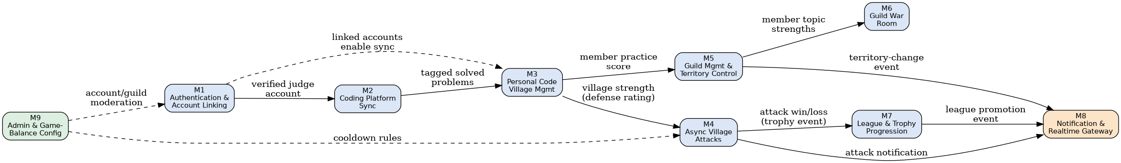
Figure 4.2 - Module Interaction Diagram

Design Rationale
The interaction diagram shows a predominantly one-directional flow from Authentication through Sync, Village, Attack/Guild, and finally League/Notification, with Admin (M9) injecting configuration into M1 and M4 rather than participating in the main gameplay flow. This acyclic shape was a deliberate design choice: it means a change to a downstream module (e.g., adding a new League tier rule in M7) can never require a change to an upstream module (M2 or M3), which keeps the most foundational modules the most stable and the least frequently touched during iterative development.

4.6 Package Diagram
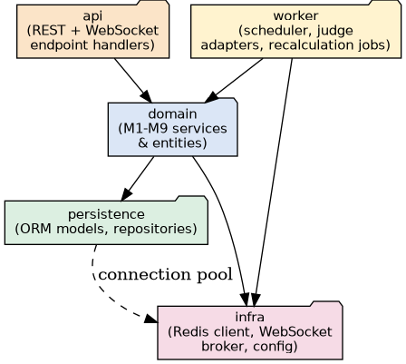
Figure 4.3 - Package Diagram

Design Rationale
Source code is organized into five packages - api, domain, worker, persistence, and infra - cutting across the nine functional modules. This organization was chosen over one-package-per-module because several modules share the same persistence and infrastructure access patterns, while keeping api, worker, and domain separate enforces the architectural rule from Section 2 that request-handling code and background-job code never share a call stack, which is what protects the NFR-1.1 latency budget.

5 Interface Design

5.1 User Interface Overview
The client is a single-page React application with an embedded Phaser.js canvas for the two visually rich views - the Code Village and the territory-control War Map (SRS 3.1, Figures 3.1-3.4). Primary screens are: Login/Register, Onboarding (judge linking), Village Dashboard (home), Attack Screen, Guild Roster/Create-Join, War Map, Guild War Room (Leader/Officer only), Season Standings/Leaderboards, and World Events. Navigation between these screens is summarized in Section 8.3.

5.2 Module Interfaces
Interface | Input | Output | Description
M1.registerUser / login | Credentials | Session token | Creates an account or authenticates an existing one.
M1.linkJudgeAccount / verifyOwnership | Judge type, handle, verification token | Verified JudgeAccount | Links and verifies a judge profile.
M2.onDemandSync | JudgeAccount id | Sync status, new SolvedProblem records | Manually triggers a sync, rate-limited to once per 5 minutes.
M3.getRenderState | User id | Village render state (topics, levels, defense rating) | Supplies the Phaser.js canvas with current village state.
M4.suggestTargets | User id | Ranked candidate village list | Matchmaking query for attack targets.
M4.launchAttack / submitAttackResult | Attacker id, target id, solve results | Attack record, score, cooldown state | Starts and resolves an attack session.
M5.createGuild / approveJoin | Guild name / join request id | Guild, GuildMembership | Creates a guild or approves a pending join request.
M6.getMemberSummaries | Guild id (Leader/Officer session) | Per-member strength summary | Role-gated War Room data.
M7.getLeaderboard | Scope (global/guild) | Ranked leaderboard | Serves trophy/league rankings.
M8.publish | Event type, target user ids | WebSocket message delivery | Fans out a real-time event to connected clients.

5.3 External Interfaces
- Codeforces API - REST, polled by the Judge Adapter sub-component of M2 for solved-problem and rating data.
- LeetCode Data Source - community/public API or profile data, polled by the same Judge Adapter abstraction.
- CodeChef Data Source - official or community API/profile data, polled identically.
- No payment, email, or maps integrations are in scope for v1.0.

5.4 Communication Interfaces
- All client-server communication uses HTTPS with JSON as the data-interchange format for REST requests/responses (SRS 3.4).
- Real-time in-app events are delivered over a WebSocket (WSS) connection between the client and the FastAPI backend (SRS 3.4).
- Judge synchronization occurs via scheduled polling and, where supported, webhook-based notifications (SRS 3.4).
- Internal service-to-cache communication uses the Redis wire protocol (RESP) over TCP within the private network.
- Any credentials or tokens used against linked judge accounts are transmitted and stored using industry-standard encryption in transit (TLS) and at rest (NFR-3.2).

6 Database Design

6.1 Database Design Overview
A relational database (PostgreSQL) was selected as the system of record because CodeForge's core state - users, judge accounts, solved problems, village progress, attacks, guild membership, territory contribution, and league standing - is highly structured, relationally connected, and requires strong consistency guarantees (NFR-2.1 durability; NFR-2.2 validation before applying sync data). PostgreSQL is additionally fixed by the SRS technology-stack constraint (SRS 2.7). The design deliberately separates externally-sourced, immutable facts (SOLVED_PROBLEM) from internally-derived, recomputable game state (VILLAGE_TOPIC_PROGRESS, LEAGUE_PROFILE, ZONE_CONTRIBUTION), so that a correction to derivation logic can recompute derived state without re-fetching from an external judge.

6.2 ER Diagram
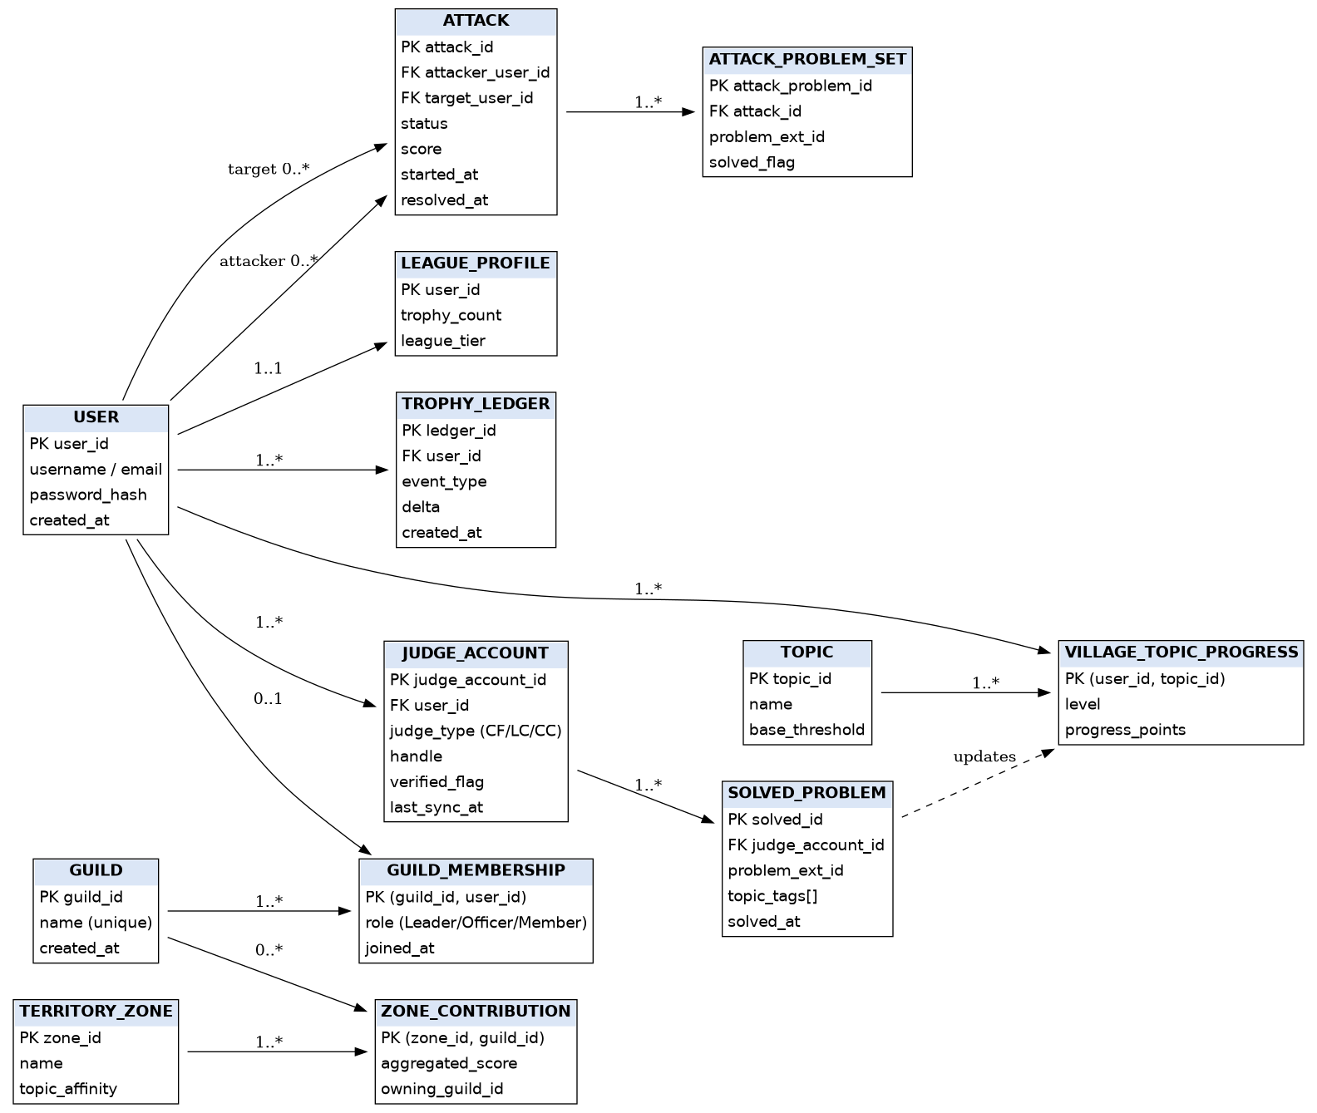
Figure 6.1 - Entity-Relationship Diagram

Design Rationale
Solved-problem history and derived village state are kept as separate tables rather than one denormalized table, even though every write to the former triggers a write to the latter. This is what allows NFR-2.2's validation requirement to be enforced at the reconciliation step rather than at raw ingestion, and it allows the topic-leveling formula to be re-tuned in a later release by recomputing VILLAGE_TOPIC_PROGRESS from the immutable SOLVED_PROBLEM history, without any external judge resync.

6.3 Entity Description
Entity | Description
USER | A registered solver account holding login credentials and identity.
JUDGE_ACCOUNT | A linked, verified external judge profile (Codeforces/LeetCode/CodeChef) belonging to a user; gates whether its solve history influences game state until verified.
SOLVED_PROBLEM | One synced, immutable solved-problem record from a judge account, carrying topic tags used by the Village feature.
TOPIC | A canonical practice topic (e.g., Arrays, Graphs, Dynamic Programming) recognized by the Village feature.
VILLAGE_TOPIC_PROGRESS | A user's derived level and progress points for one topic; recomputable from SOLVED_PROBLEM history.
ATTACK | One asynchronous attack session between an attacker and a target, with status, score, and timestamps.
ATTACK_PROBLEM_SET | The curated problems assigned to a specific attack, with per-problem solved status.
GUILD | A player-formed group with a unique name.
GUILD_MEMBERSHIP | A user's role (Leader/Officer/Member) within at most one active guild at a time.
TERRITORY_ZONE | A topic-affinity zone on the shared territory-control map.
ZONE_CONTRIBUTION | A guild's aggregated contribution score for one zone, and the currently owning guild.
LEAGUE_PROFILE | A user's current trophy count and league tier, incrementally maintained from TROPHY_LEDGER.
TROPHY_LEDGER | An append-only, auditable log of trophy-affecting events.

6.4 Data Dictionary
Entity | Attribute | Type | Description
USER | user_id | UUID (PK) | Unique identifier.
USER | username / email | VARCHAR (unique) | Login identifier (REQ-1.1).
USER | password_hash | VARCHAR | Salted hash, never stored in plaintext (NFR-3.2).
USER | created_at | TIMESTAMP | Account creation time.
JUDGE_ACCOUNT | judge_account_id | UUID (PK) | Unique identifier.
JUDGE_ACCOUNT | user_id | UUID (FK -> USER) | Owning user.
JUDGE_ACCOUNT | judge_type | ENUM (CF/LC/CC) | Which external judge.
JUDGE_ACCOUNT | handle | VARCHAR | External profile handle; unique per judge_type (REQ-1.3).
JUDGE_ACCOUNT | verified_flag | BOOLEAN | Set true only after ownership verification (NFR-3.1).
JUDGE_ACCOUNT | last_sync_at | TIMESTAMP | Last successful sync (REQ-2.4).
SOLVED_PROBLEM | solved_id | UUID (PK) | Unique identifier.
SOLVED_PROBLEM | judge_account_id | UUID (FK) | Source judge account.
SOLVED_PROBLEM | problem_ext_id | VARCHAR | External judge problem identifier.
SOLVED_PROBLEM | topic_tags | TEXT[] | Topic tags mapped by M2 (REQ-2.3).
SOLVED_PROBLEM | solved_at | TIMESTAMP | When the problem was solved on the judge.
TOPIC | topic_id | UUID (PK) | Unique identifier.
TOPIC | name | VARCHAR | Topic name (e.g., Graphs).
TOPIC | base_threshold | INTEGER | Progress points required per level.
VILLAGE_TOPIC_PROGRESS | user_id, topic_id | Composite PK | One row per user per topic.
VILLAGE_TOPIC_PROGRESS | level | INTEGER | Current topic level (REQ-3.1).
VILLAGE_TOPIC_PROGRESS | progress_points | INTEGER | Accumulated points toward next level.
ATTACK | attack_id | UUID (PK) | Unique identifier.
ATTACK | attacker_user_id / target_user_id | UUID (FK -> USER) | Participants (REQ-4.1).
ATTACK | status | ENUM | Created / InProgress / Completed / Abandoned / Resolved.
ATTACK | score | INTEGER | Attack outcome score (REQ-4.3).
ATTACK | started_at / resolved_at | TIMESTAMP | Lifecycle timestamps.
ATTACK_PROBLEM_SET | attack_problem_id | UUID (PK) | Unique identifier.
ATTACK_PROBLEM_SET | attack_id | UUID (FK) | Owning attack.
ATTACK_PROBLEM_SET | problem_ext_id | VARCHAR | Curated problem (REQ-4.2).
ATTACK_PROBLEM_SET | solved_flag | BOOLEAN | Whether the attacker solved this problem.
GUILD | guild_id | UUID (PK) | Unique identifier.
GUILD | name | VARCHAR (unique) | Guild name (REQ-5.1).
GUILD_MEMBERSHIP | guild_id, user_id | Composite PK | One active membership per user (business rule).
GUILD_MEMBERSHIP | role | ENUM | Leader / Officer / Member.
TERRITORY_ZONE | zone_id | UUID (PK) | Unique identifier.
TERRITORY_ZONE | name / topic_affinity | VARCHAR | Zone identity and topic weighting.
ZONE_CONTRIBUTION | zone_id, guild_id | Composite PK | One score row per guild per zone.
ZONE_CONTRIBUTION | aggregated_score | INTEGER | Sum of member contributions (REQ-5.3).
ZONE_CONTRIBUTION | owning_guild_id | UUID (FK) | Current owner (REQ-5.4).
LEAGUE_PROFILE | user_id | UUID (PK, FK) | One row per user.
LEAGUE_PROFILE | trophy_count / league_tier | INTEGER / ENUM | Current standing (REQ-7.1-7.4).
TROPHY_LEDGER | ledger_id | UUID (PK) | Unique identifier.
TROPHY_LEDGER | user_id, event_type, delta, created_at | mixed | Append-only audit trail (REQ-7.1).

6.5 Database Constraints

6.5.1 Concurrency Control for High-Contention Writes
ZONE_CONTRIBUTION and LEAGUE_PROFILE are hot rows: many concurrent attack resolutions can target the same guild's zone score or the same league profile simultaneously. A naive read-modify-write (SELECT current value in application code, add delta, UPDATE with the new value) is a classic lost-update race. All mutations to these tables use atomic, single-statement increments instead.

Trophy delta (LEAGUE_PROFILE)
UPDATE league_profile
SET trophy_count = trophy_count + :delta,
updated_at = now()
WHERE user_id = :user_id
RETURNING trophy_count;
The returned trophy_count is compared in application code (LeagueProfile.checkPromotion()) against tier thresholds; a tier change is a separate, idempotent follow-up UPDATE ... WHERE league_tier != :new_tier so a duplicate promotion check is a no-op rather than a double-write.

Zone contribution delta (ZONE_CONTRIBUTION)
INSERT INTO zone_contribution (zone_id, guild_id, aggregated_score, owning_guild_id)
VALUES (:zone_id, :guild_id, :delta, NULL)
ON CONFLICT (zone_id, guild_id)
DO UPDATE SET aggregated_score = zone_contribution.aggregated_score + EXCLUDED.aggregated_score,
updated_at = now();
This single UPSERT handles both the "first contribution to this zone" and "increment existing contribution" cases atomically, with no separate existence check.

Ownership resolution (multi-row read + compare + write)
Unlike the two increments above, resolving ownership requires comparing scores across all guilds contesting a zone - an inherently multi-row critical section that a single atomic UPDATE cannot express. This step uses a row-level lock scoped to the zone:
BEGIN;
SELECT guild_id, aggregated_score
FROM zone_contribution
WHERE zone_id = :zone_id
FOR UPDATE; -- locks all contending guild rows for this zone
-- application code computes leading_guild + hysteresis check (Section 7.3.1.2)
UPDATE territory_zone
SET owning_guild_id = :leading_guild_id,
updated_at = now()
WHERE zone_id = :zone_id
AND owning_guild_id IS DISTINCT FROM :leading_guild_id; -- no-op write if unchanged
COMMIT;
SELECT ... FOR UPDATE is scoped only to rows for the single zone being recalculated, so it never blocks writes to other zones - the atomic increments above can still land on other zones' rows concurrently without contention.

6.5.2 Role of Redis (Redlock) in Territory Recalculation
Redis distributed locking (Redlock) is deliberately not used to protect ZONE_CONTRIBUTION/TERRITORY_ZONE data correctness - that guarantee comes entirely from PostgreSQL's row locks and atomic upserts above, which are transactional and durable. Redlock's failure modes (clock drift, lock-loss during GC pauses) make it unsuitable as the correctness mechanism for state of this importance.
Redlock's appropriate role is job-scheduling deduplication: when the Background Worker runs a periodic full-reconciliation sweep (recomputing every zone's score from scratch to correct drift, Section 7.3.1.2), only one worker instance across the horizontally-scaled pool should kick off that sweep at a time, to avoid duplicate wasted work. This is a best-effort, worst-case-wastes-some-CPU concern, not a correctness concern - exactly the class of problem Redlock is appropriate for:
lock_acquired <- redlock.acquire("territory_sweep_lock", ttl=5min)
IF lock_acquired:
run_full_reconciliation_sweep()
redlock.release("territory_sweep_lock")
ELSE:
skip -- another worker instance is already running the sweep
If the lock is lost mid-sweep (e.g., due to a GC pause), the worst outcome is two workers redundantly recomputing the same zones - harmless, since the recomputation is idempotent (it overwrites aggregated_score with a freshly-summed value, not an increment).

6.5.3 Additional Base Constraints
- USER.username/email UNIQUE; JUDGE_ACCOUNT UNIQUE(judge_type, handle) so two users cannot claim the same external profile.
- GUILD.name UNIQUE; GUILD_MEMBERSHIP enforces at most one active membership per user via a partial unique index, encoding the SRS's one-guild-per-solver business rule at the schema level.
- SOLVED_PROBLEM UNIQUE(judge_account_id, problem_ext_id) makes re-sync idempotent, supporting REQ-2.5's no-data-loss guarantee under retry.
- All foreign keys are NOT NULL and reference their parent with ON DELETE RESTRICT to prevent orphaned game state.
- Composite indexes on VILLAGE_TOPIC_PROGRESS(user_id, topic_id) and ZONE_CONTRIBUTION(zone_id, guild_id) support the NFR-1.1 2-second dashboard/map load target.

6.6 Normalization
The schema is in Third Normal Form (3NF): every non-key attribute depends on the whole primary key and nothing but the key. Derived aggregates (LEAGUE_PROFILE.trophy_count, ZONE_CONTRIBUTION.aggregated_score) are the one deliberate, documented exception - they are maintained as materialized projections of TROPHY_LEDGER and member-level scores respectively, purely for read-performance on the hottest queries (leaderboard, territory map), and are always recomputable from their normalized source tables.

7 Detailed Design

7.1 Object-Oriented Design Overview
Each module's public interface is realized as one or more domain classes. Encapsulation is used throughout: entity classes (User, Village, Attack, Guild) expose behavior (e.g., Attack.resolve()) rather than public setters, so invariants (such as 'a cooldown must be started whenever an attack is launched') cannot be bypassed by external callers. Abstraction is used at the judge-integration boundary: SyncService depends only on a JudgeAdapter abstraction, not on Codeforces/LeetCode/CodeChef-specific code, so a new judge can be added by implementing the same abstraction (SRS 5.4 Extensibility). Polymorphism is applied by JudgeAdapter implementations (CodeforcesAdapter, LeetCodeAdapter, CodeChefAdapter), each returning a common normalized-activity shape to SyncService regardless of the source judge's native format. Inheritance is used sparingly - only where adapters genuinely share behavior - to avoid the fragile hierarchies that can hurt maintainability.

7.2 Class Diagram
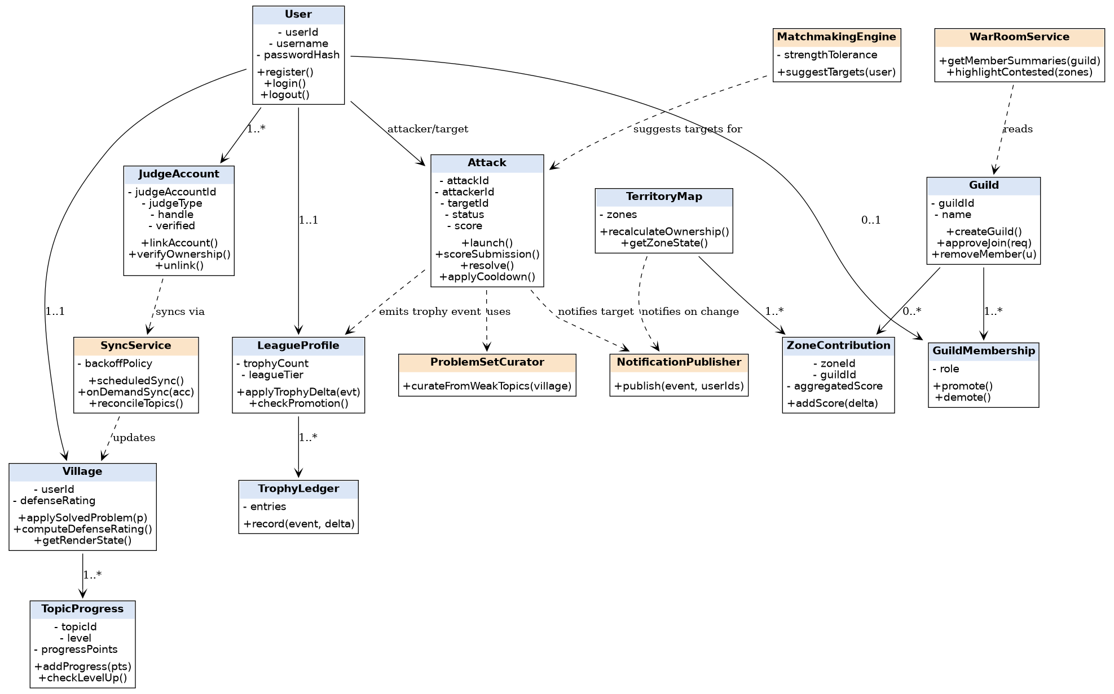
Figure 7.1 - Class Diagram

Design Rationale
Attack depends on Village only through ProblemSetCurator (read-only), so Village - the class every other gameplay class ultimately depends on for solver strength - has no outbound dependency on gameplay rules. This keeps Village independently testable and insulates it from churn in the more frequently changing Attack and Guild rules, directly supporting SRS 5.4 Maintainability and Extensibility. LeagueProfile is only ever mutated through TrophyLedger.record(event, delta), never a direct setter, so every trophy change is auditable and attributable to a specific event.

7.2.1 Cooldown Architecture (PostgreSQL Source of Truth)
The v1.0 design stored active attack cooldowns exclusively in Redis, meaning a Redis restart silently erased every player's in-flight cooldown. PostgreSQL is now the durable source of truth; Redis is repositioned as a read-through/write-through cache that exists solely to meet the NFR-1.3 3-second matchmaking/launch latency budget.
A cooldown_expires_at column is added to USER (chosen over a per-row ATTACK lookup because it is a single, direct O(1) check with no join, and a user has at most one active cooldown at a time):
ALTER TABLE users ADD COLUMN attack_cooldown_expires_at TIMESTAMP NULL;
Write-through on attack launch:
1. cooldown_expires_at <- now() + cooldown_duration(tier)
2. BEGIN transaction:
UPDATE users SET attack_cooldown_expires_at = :cooldown_expires_at WHERE user_id = :id;
INSERT INTO attack (...);
COMMIT;
3. SET Redis key cooldown:{user_id} = :cooldown_expires_at, EX = cooldown_duration_seconds
-- cache populated AFTER the durable write commits, never before
Read-through on cooldown check (hot path, called on every launchAttack request):
1. value <- Redis.GET("cooldown:" + user_id)
2. IF value EXISTS:
cooldown_active <- (value > now()) -- O(1), meets the 3-second SLA
3. ELSE (cache miss - no cooldown OR Redis was flushed/restarted):
row <- SELECT attack_cooldown_expires_at FROM users WHERE user_id = :id
IF row.attack_cooldown_expires_at > now():
remaining_ttl <- row.attack_cooldown_expires_at - now()
Redis.SET("cooldown:" + user_id, row.attack_cooldown_expires_at, EX=remaining_ttl)
cooldown_active <- true
ELSE:
cooldown_active <- false
This guarantees that a Redis restart or key eviction never loses a cooldown - the worst case is one extra PostgreSQL read on the next check for that user, after which the cache is transparently repopulated with the correct remaining TTL. The NFR-1.3 latency budget is preserved because PostgreSQL is only consulted on a cache miss, which is the rare path (immediately after a Redis restart, or a user's very first check).

7.3 Class Description
Class | Responsibility
User | Registration, authentication, session lifecycle (REQ-1.1, REQ-1.2, REQ-1.6).
JudgeAccount | Represents and verifies one linked external judge profile.
SyncService | Runs scheduled/on-demand sync; delegates fetch and tagging; persists without data loss on partial failure.
Village | Owns a user's topic progress and computes the overall defense rating.
TopicProgress | Tracks level and progress points for one topic; decides level-up thresholds.
MatchmakingEngine | Suggests attack targets of comparable overall strength.
Attack | Owns the lifecycle of one attack session: launch, score, resolve, cooldown.
ProblemSetCurator | Builds a curated problem set from a target village's weakest topics.
Guild | Owns guild creation and membership approval.
GuildMembership | Represents one user's role within a guild.
TerritoryMap | Recalculates zone ownership from aggregated contribution scores.
ZoneContribution | Holds one guild's aggregated score for one zone.
WarRoomService | Composes per-member strength summaries for guild leadership, scoped by role.
LeagueProfile | Tracks trophy count and league tier; evaluates promotion/demotion.
TrophyLedger | Append-only record of trophy-affecting events.
NotificationPublisher | Publishes real-time events to the WebSocket Gateway for connected clients.

7.3.1 Game Logic Algorithms
The following formulas define the previously-abstracted game logic behind MatchmakingEngine, TerritoryMap, and TrophyLedger, resolving SRS Appendix C TBD-2, TBD-3, and TBD-5.

7.3.1.1 Matchmaking Algorithm - MatchmakingEngine.suggestTargets
Matchmaking satisfies REQ-4.1 by computing an acceptable target Defense Rating band around the attacker's rating, widened or tightened by league tier to account for the shrinking population of opponents at higher tiers.
tolerance_pct(tier) = BASE_TOLERANCE + TIER_ADJUSTMENT[tier]
target_min = R_attacker * (1 - tolerance_pct)
target_max = R_attacker * (1 + tolerance_pct)
Constant | Value | Rationale
BASE_TOLERANCE | 0.12 (+/-12%) | Wide enough to guarantee 3+ candidates for a mid-tier population without trivializing fairness.
TIER_ADJUSTMENT[Bronze] | +0.08 | Small population at extremes needs a wider net to avoid empty results.
TIER_ADJUSTMENT[Silver] | +0.05
TIER_ADJUSTMENT[Gold] | +0.02
TIER_ADJUSTMENT[Platinum] | 0.00 | Baseline population density.
TIER_ADJUSTMENT[Diamond] | -0.02 | Tighter band; players expect closer fights.
TIER_ADJUSTMENT[Legend] | -0.08 | Fewest players, but competitive integrity matters most - accept a smaller candidate pool.
Selection pipeline:
1. R_attacker <- Village.computeDefenseRating(attacker)
2. tier <- LeagueProfile.league_tier(attacker)
3. [target_min, target_max] <- formula above
4. candidates <- SELECT villages WHERE defense_rating BETWEEN target_min AND target_max
AND user_id != attacker.user_id
AND user_id NOT IN (recently_attacked_by(attacker, window=24h))
AND NOT under_active_defense_grace(target)
5. IF candidates.count < MIN_CANDIDATES (3):
widen tolerance_pct by +0.05 and retry once (cap at +0.30 total)
6. RETURN candidates ranked by |R_target - R_attacker| ascending
A defense grace period (configurable via M9, default 15 minutes) excludes a village that was attacked in the last N minutes from being re-selected as a target, preventing pile-on abuse.

7.3.1.2 Territory Scoring Formula - TerritoryMap.recalculateOwnership
Each TERRITORY_ZONE carries a topic_affinity map (topic to weight, weights summing to 1.0) representing which practice topics matter for that zone. A member's contribution to a zone weights their per-topic village level by that zone's affinity and decays with sync inactivity, so a guild cannot indefinitely bank a zone on inactive members.
member_zone_score(m, Z) = SUM_{t in Z.topic_affinity} ( Z.topic_affinity[t] * VILLAGE_TOPIC_PROGRESS(m, t).level )
* activity_decay(m)
activity_decay(m) = max(0.5, 1 - 0.02 * days_since_last_sync(m))
guild_zone_score(G, Z) = SUM_{m in active_members(G)} member_zone_score(m, Z)
This aggregate is the value persisted incrementally in ZONE_CONTRIBUTION.aggregated_score (see Section 6.5.1 for the atomic write pattern); it is maintained as a running total and only fully recomputed from scratch on a periodic reconciliation sweep to correct drift. Ownership is resolved with a hysteresis margin so that marginal fluctuations do not cause ownership to flap and spam real-time notifications:
leading_guild <- argmax_G guild_zone_score(G, Z)
current_owner <- Z.owning_guild_id
IF current_owner IS NULL:
Z.owning_guild_id <- leading_guild
ELSE IF leading_guild != current_owner
AND guild_zone_score(leading_guild, Z) > guild_zone_score(current_owner, Z) * (1 + HYSTERESIS_MARGIN):
Z.owning_guild_id <- leading_guild
emit TERRITORY_ZONE_CHANGED
-- else: no change
HYSTERESIS_MARGIN = 0.05 (5%) - the challenger must exceed the incumbent by a clear margin, protecting the NFR-1.4 real-time notification budget from noise-level ownership flips.

7.3.1.3 Trophy Calculation - TrophyLedger.record
Trophy deltas use an Elo-style expected-outcome model so they scale with the rating gap between attacker and target, resolving TBD-5.
E_attacker = 1 / (1 + 10^((R_target - R_attacker) / 400))
E_target = 1 - E_attacker
League Tier | K-Factor
Bronze - Gold | 32
Platinum - Diamond | 24
Legend | 16
Case 1 - Attack completed and scored (attacker solved fraction f of the curated set, f in [0,1]):
S_attacker = f
Delta_attacker = round(K * (S_attacker - E_attacker))
Delta_target = round(K * ((1 - S_attacker) - E_target))
Worked example: attacker R=1200, target R=1200 (E=0.5 each), attacker solves 2/3 problems (f=0.667), K=32: Delta_attacker = round(32 * (0.667 - 0.5)) = +5; Delta_target = round(32 * (0.333 - 0.5)) = -5.
Case 2 - Successful defense (attacker abandons or the window elapses with f below DEFENSE_THRESHOLD = 0.34), treated as a full target win with S_attacker = 0:
Delta_target = round(K * (1 - E_target))
Delta_attacker = round(K * (0 - E_attacker))
Case 3 - Attack abandoned before any submission (f = 0, elapsed time < window): a flat, non-Elo penalty is used instead of the full loss debit, since no competitive signal was produced:
Delta_attacker = -ABANDON_PENALTY (flat, default = 5)
Delta_target = 0
All three cases write through TrophyLedger.record(user_id, event_type, delta); LEAGUE_PROFILE.trophy_count is never set directly (see Section 6.5.1 for the atomic increment pattern), preserving the append-only auditability guarantee.

7.4 Sequence Diagrams
Three representative, architecturally significant use cases are detailed below, each realizing a distinct cross-module flow.

7.4.1 Coding Platform Sync (UC-2, UC-4)
Realizes REQ-2.1 through REQ-2.5 and NFR-2.2: the Scheduler triggers a sync independently of user action, the Judge Adapter isolates judge-specific fetch logic, and the Topic Tagger reconciles new activity before anything is persisted, catching malformed data before it can corrupt village state.
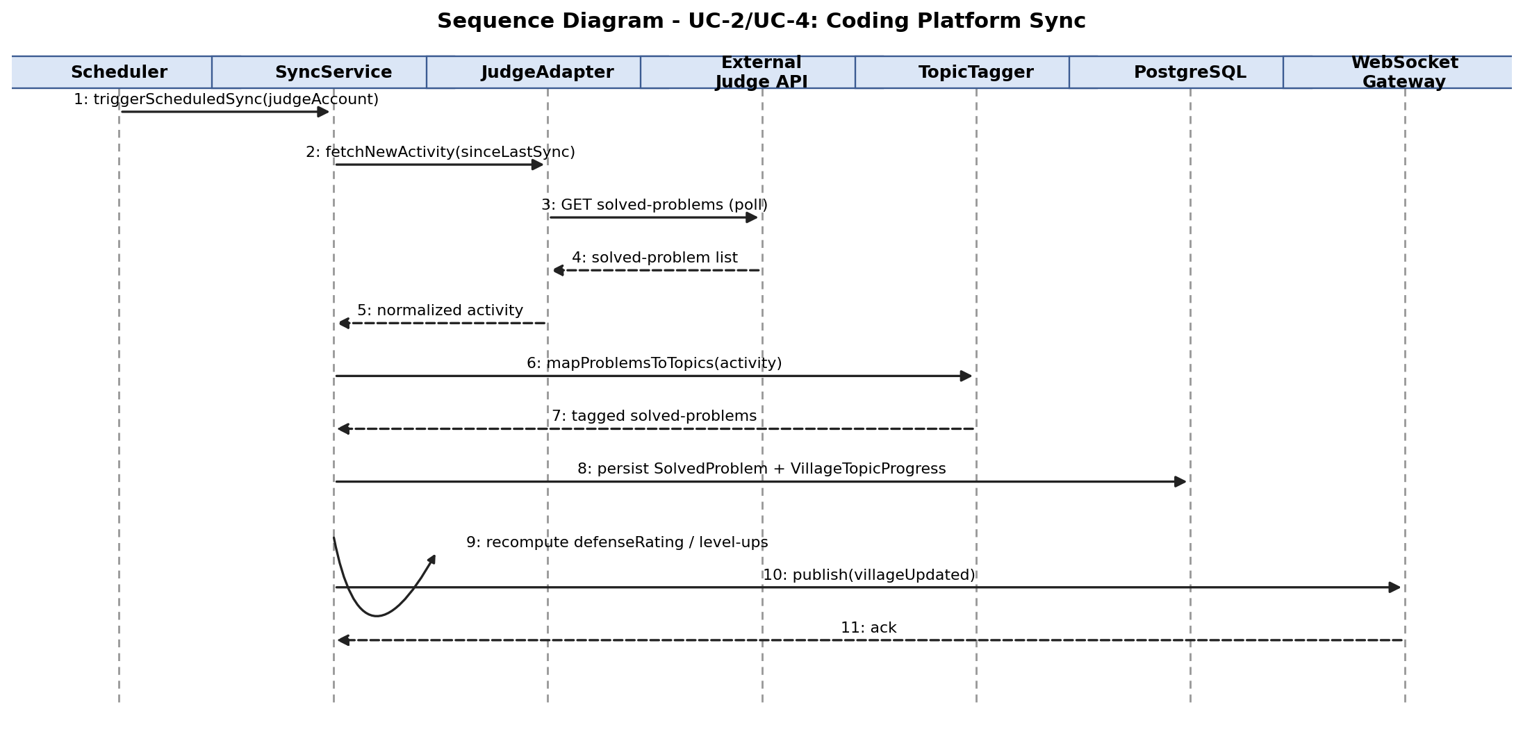
Figure 7.2 - Sequence Diagram: Coding Platform Sync

7.4.2 Launch Async Village Attack (UC-5, UC-6)
Realizes REQ-4.1 through REQ-4.5. Matchmaking and cooldown checks both consult Redis so concurrent attack requests remain consistent and low-latency; resolution fans out to League (trophy effect) and Notification (target awareness) concerns.
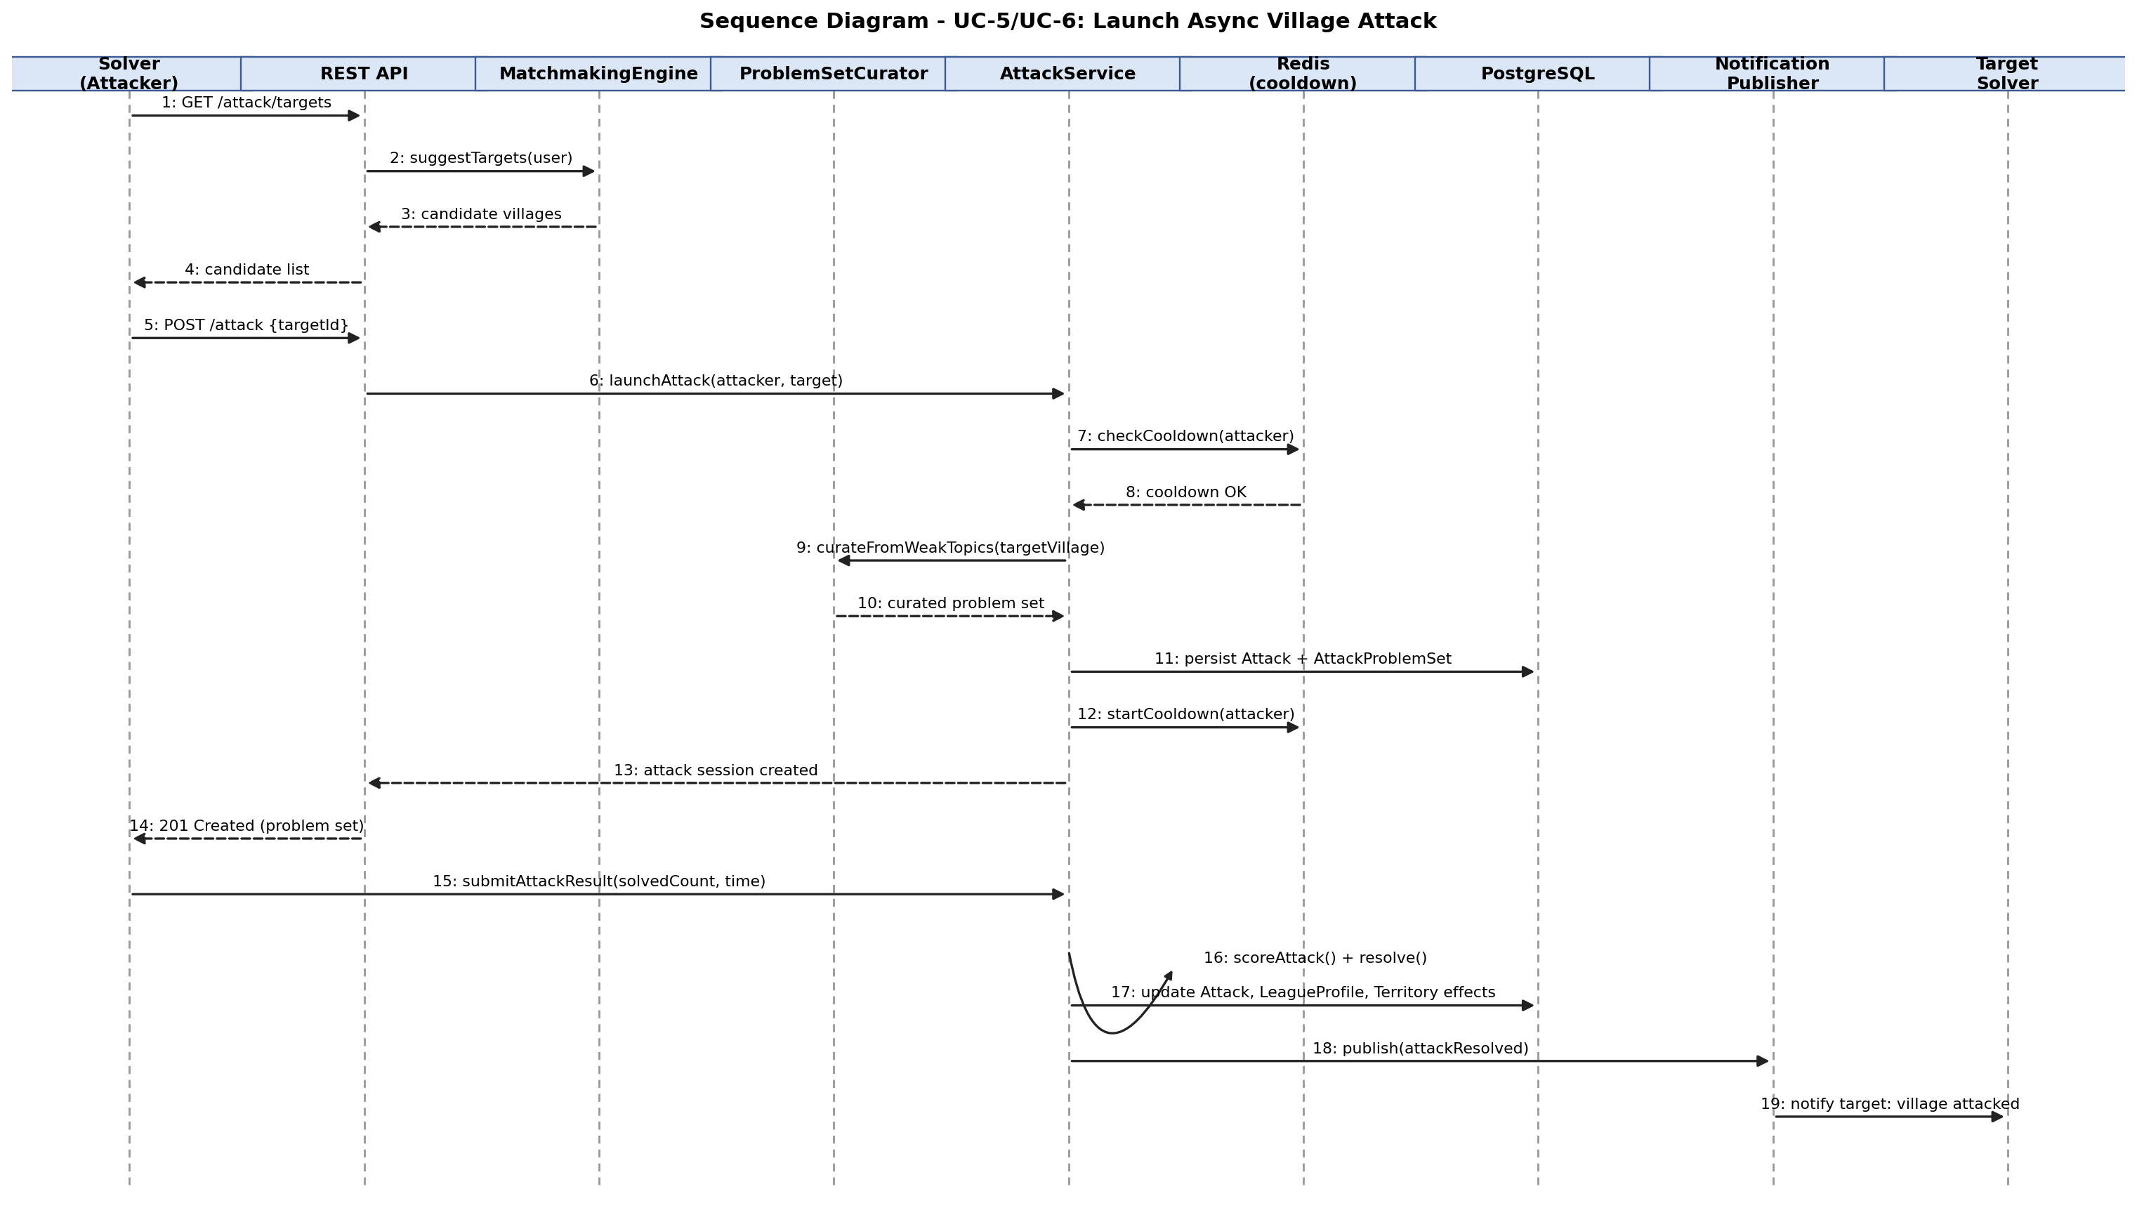
Figure 7.3 - Sequence Diagram: Launch Async Village Attack

7.4.3 Guild Join & Territory Contribution (UC-7, UC-8)
Realizes REQ-5.2 and REQ-5.3. A join request is persisted as pending; only a Guild Leader/Officer session can approve it, after which the new member's score is folded into the guild's zone contribution and a territory-changed event is published.
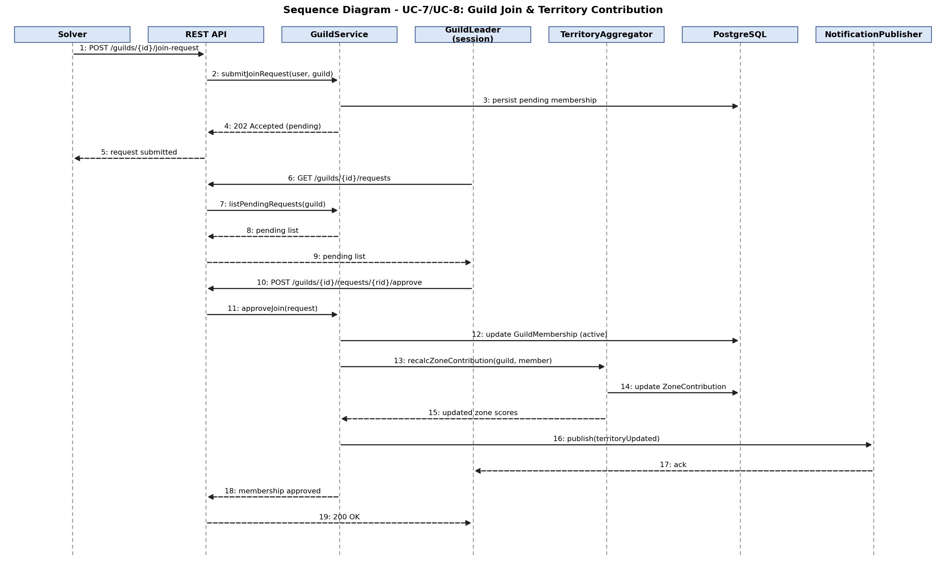
Figure 7.4 - Sequence Diagram: Guild Join & Territory Contribution

7.5 Activity Diagram
Figure 7.5 details the end-to-end activity flow behind the Launch Async Village Attack use case, including the cooldown decision point and the completed-vs-abandoned branch at scoring time.
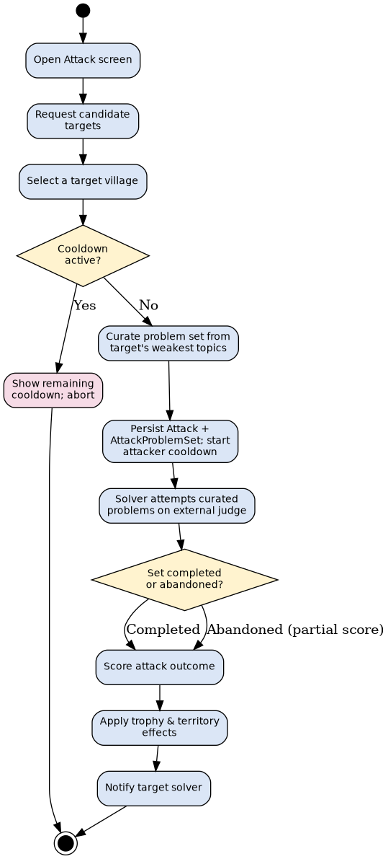
Figure 7.5 - Activity Diagram: Launch Async Village Attack

7.6 State Diagram
Figure 7.6 shows the lifecycle states of an Attack instance, from creation through matchmaking, curation, the active cooldown window, and final resolution.
Figure 7.6 - State Diagram: Attack Lifecycle

8 User Interface Design

8.1 UI Design Principles
- Consistency - a single top navigation bar (War Map, Guild, Season, Events, Profile) is present on every authenticated screen.
- Usability - first-time users can complete account creation, judge linking, and reach their first village view within 5 minutes via a guided onboarding flow of no more than 5 steps (SRS 5.4).
- Accessibility - color is never the sole carrier of meaning (e.g., zone ownership on the War Map is labeled with guild name on hover, not color alone).
- Responsiveness - the layout adapts to both desktop and mobile browsers (SRS 2.6); the Phaser.js canvas resizes to the available viewport.

8.2 Wireframes
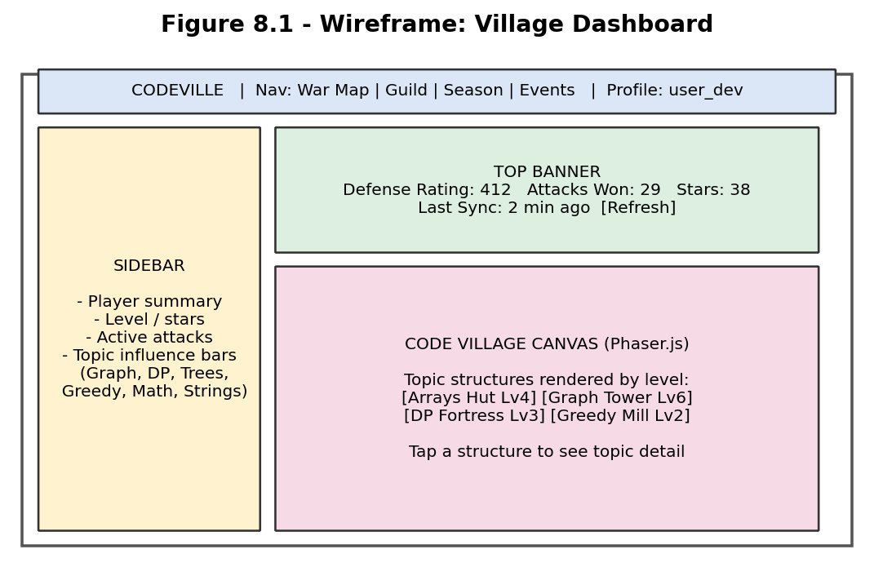
Figure 8.1 - Wireframe: Village Dashboard
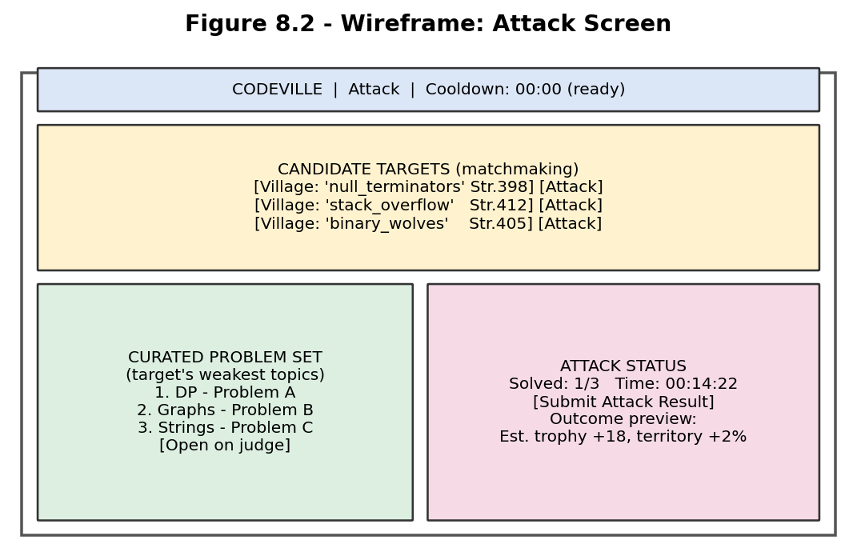
Figure 8.2 - Wireframe: Attack Screen
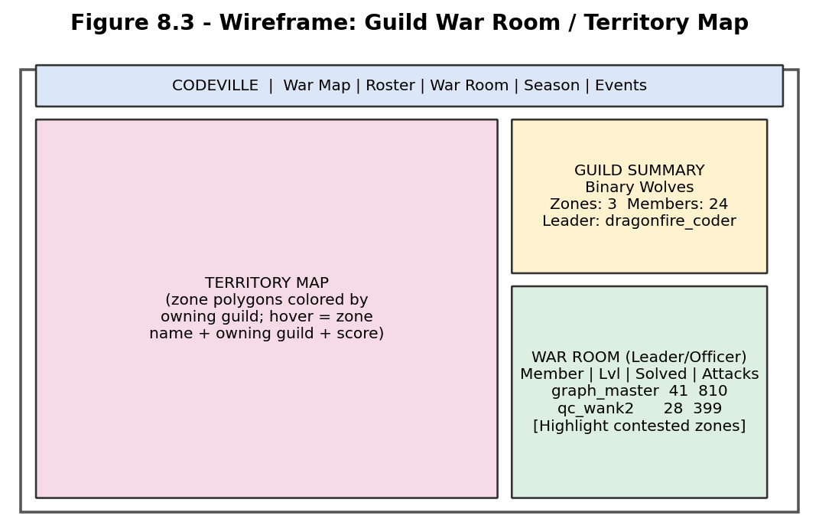
Figure 8.3 - Wireframe: Guild War Room / Territory Map

8.3 Navigation Flow
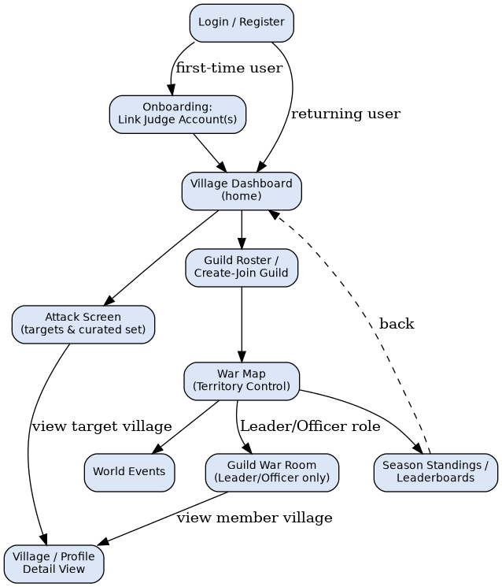
Figure 8.4 - Navigation Flow Diagram

9 Security Design

9.1 Security Requirements
The major security requirements, drawn directly from SRS Section 5.3, are: verified ownership of any linked judge profile before it can influence game state; secure storage of passwords and judge credentials/tokens; role-based access control for guild and admin functions; rate limiting against abuse and leaderboard manipulation; and auditability of administrative actions. The principal threats considered are account/profile impersonation (a user claiming another person's solve history), credential theft, unauthorized access to guild-leadership or admin functions, and automated abuse of attack/sync endpoints.

9.2 Authentication
- Users authenticate with a username/email and password; invalid credentials are rejected with a clear, non-revealing error message (REQ-1.2).
- Successful login issues a persistent session token valid for at least 7 days of inactivity; explicit logout invalidates the session immediately (REQ-1.6).
- Linking a judge profile requires a one-time verification step (e.g., a verification submission or profile token) before that profile is treated as authoritative (REQ-1.4, NFR-3.1).

9.3 Authorization
- Role-based access is enforced so that only a guild's Leader/Officer can view that guild's full War Room detail (NFR-3.3).
- Only an Admin/Moderator can access account- and guild-management functions and modify global game-balance settings (NFR-3.3, SRS Business Rules 5.5).
- A Guest/Visitor may view public leaderboards and marketing content but cannot access village, attack, or guild features until registered.

9.4 Data Security
- Passwords are stored using a secure, salted hashing algorithm; judge account credentials or tokens are never stored in plaintext (NFR-3.2).
- All client-server traffic uses HTTPS/WSS; judge credentials/tokens are encrypted in transit and at rest (SRS 3.4).
- PostgreSQL data is persisted durably so a single component failure does not permanently lose solved-problem or village-progression data (NFR-2.1).

9.5 Input Validation
- Incoming sync data is validated before being applied to a solver's village state, preventing corrupted or malformed judge data from producing an inconsistent village or territory-control state (NFR-2.2).
- Registration, login, and judge-linking form inputs are validated and sanitized server-side regardless of client-side checks.
- Rate limiting is applied to attack initiation, sync requests, and guild actions to reduce opportunities for abuse or leaderboard manipulation (NFR-3.4).

10 Error Handling

10.1 Error Handling Strategy
- Validation errors (bad input, duplicate username, invalid judge handle) return a clear, actionable error response at the API boundary without exposing internal implementation details.
- A temporarily unavailable or rate-limited judge data source is retried according to a backoff policy in the Sync module, and a sync-status indicator (up to date / in progress / failed) is surfaced to the user without losing previously-synced data (REQ-2.4, REQ-2.5).
- Domain-level exceptions (e.g., attempting to launch an attack while on cooldown, or approving a join request for a guild the approver does not lead) are caught at the service layer and translated into specific, user-facing error messages rather than generic failures.
- Unexpected server-side errors are logged with enough context (module, operation, correlation id) to diagnose the failure, and administrative actions are additionally logged for auditability (NFR-3.5).
- The client displays a non-blocking retry affordance for failed on-demand sync or attack-submission requests, so a transient network error does not require a full page reload.
- Judge-sync failures follow the tiered escalation in Section 4.4 (inline retry, then Dead-Letter Queue, then scheduled DLQ sweep) rather than blocking the main sync queue; a judge-wide CircuitBreaker trip is surfaced on the sync-status indicator (REQ-2.4) as "degraded: <judge_name>" so the UI can distinguish "your account has an issue" from "this judge is temporarily down for everyone."

11 Deployment Design

11.1 Deployment Overview
Three environments are used: Development (local Docker Compose stack - single FastAPI instance, single PostgreSQL and Redis container, mocked judge adapters), Testing/Staging (a scaled-down mirror of production with real judge integrations against test accounts, used for integration and load testing against the NFR-1.x targets), and Production (the horizontally-scaled topology in Section 11.2). All three environments share the same container images and configuration mechanism, differing only in scale and in which judge credentials/endpoints are configured.
As of v1.1, Redis is not a durable store for any gameplay state - it is safe to restart, evict, or fail over the Redis instance at any time without data loss for attack cooldowns, since PostgreSQL is authoritative and Redis is repopulated on next read (Section 7.2.1). This removes cooldown state from the system's single-point-of-failure surface identified during architecture review.

11.2 Deployment Diagram
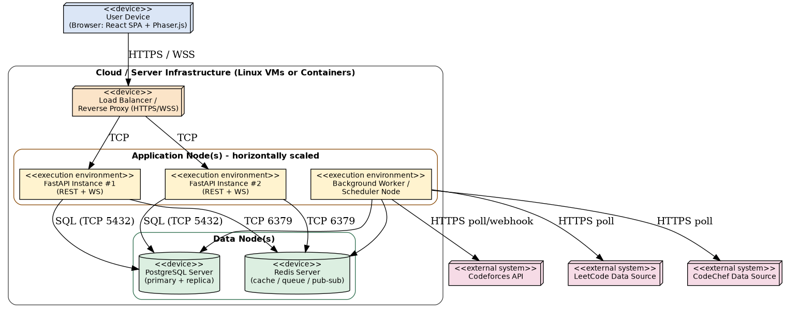
Figure 11.1 - Deployment Diagram

Design Rationale
Separating the Background Worker from the request-serving FastAPI nodes directly supports NFR-1.1 (2-second dashboard load) and NFR-1.3 (3-second matchmaking response): a slow or rate-limited external judge call executes on the worker node and can never occupy a request-handling thread on an application node. Placing all cooldown, matchmaking, and cache state in a single shared Redis instance - rather than per-node in-memory state - is what allows the application tier to be scaled horizontally behind the load balancer while still enforcing a single, globally-consistent cooldown per solver.

11.3 Hardware Requirements
Component | Minimum Specification (per node, production)
FastAPI Application Node | 2 vCPU, 4 GB RAM; scales horizontally with concurrent user load.
Background Worker Node | 2 vCPU, 4 GB RAM; scales with number of linked judge accounts and sync frequency.
PostgreSQL Server | 4 vCPU, 8 GB RAM, SSD-backed storage; sized to solved-problem and event-log volume.
Redis Server | 2 vCPU, 4 GB RAM (in-memory dataset); persistence (RDB/AOF) optional for faster warm restarts.
Client Device | Any desktop, laptop, or mobile device capable of running a current-generation web browser.

11.4 Software Requirements
- Operating System: Linux (server-side, e.g., Ubuntu LTS).
- Backend runtime: Python 3.x with FastAPI; PostgreSQL and Redis client libraries.
- Database: PostgreSQL (with a read replica anticipated for leaderboard/reporting reads); Redis for matchmaking, cooldowns, caching, and pub/sub.
- Frontend build toolchain: Node.js/React build pipeline producing static assets; Phaser.js bundled with the client.
- Client browsers: current and previous major versions of Chrome, Firefox, Edge, and Safari (SRS 2.6).

11.5 Installation Requirements
- Application and worker nodes are packaged as container images and deployed via the environment's orchestration tooling (e.g., Docker Compose for development, a container orchestrator for production).
- Database schema is provisioned and evolved via versioned migrations, applied before an application node is brought into service.
- Environment-specific configuration (database/Redis connection strings, judge API credentials, cooldown/league defaults) is supplied via environment variables or a secrets manager, never hard-coded.

11.6 Third-party Services
- Codeforces API (official) - solved-problem and rating data.
- LeetCode data source (official or community) - solved-problem data; integration method pending finalization (SRS Appendix C, TBD-1).
- CodeChef data source (official or community) - solved-problem and rating data; same pending status as LeetCode.

12 Traceability Matrix
This matrix demonstrates how each functional requirement specified in the SRS is addressed by the software design, tracing every requirement to a responsible module, a representative class, the sequence diagram (if any) that illustrates its realization, and a placeholder test case identifier for the test team.

12.1 Requirement Mapping
SRS ID | Requirement | Module | Class | Sequence Diagram | Test Case
REQ-1.1 | Register with unique email/username and password | M1 | User | N/A | TC-AUTH-01
REQ-1.2 | Login and reject invalid credentials | M1 | User | N/A | TC-AUTH-02
REQ-1.3 | Link at least one supported judge profile | M1 | JudgeAccount | N/A | TC-AUTH-03
REQ-1.4 | Verify ownership of a linked judge profile | M1 | JudgeAccount | N/A | TC-AUTH-04
REQ-1.5 | Link/unlink additional judge profiles | M1 | JudgeAccount | N/A | TC-AUTH-05
REQ-1.6 | 7-day persistent session, explicit logout | M1 | User | N/A | TC-AUTH-06
REQ-2.1 | Automatic recurring sync | M2 | SyncService | Fig. 7.2 | TC-SYNC-01
REQ-2.2 | On-demand sync, rate-limited | M2 | SyncService | Fig. 7.2 | TC-SYNC-02
REQ-2.3 | Map solved problems to topic tags | M2 | SyncService | Fig. 7.2 | TC-SYNC-03
REQ-2.4 | Display last-sync timestamp and status | M2 | SyncService | Fig. 7.2 | TC-SYNC-04
REQ-2.5 | Handle unavailable/rate-limited judge gracefully | M2 | SyncService | Fig. 7.2 | TC-SYNC-05
REQ-3.1 | Maintain per-topic level | M3 | TopicProgress | Fig. 7.2 | TC-VILL-01
REQ-3.2 | Reflect topic level as village structure state | M3 | Village | N/A | TC-VILL-02
REQ-3.3 | Compute overall defense rating | M3 | Village | N/A | TC-VILL-03
REQ-3.4 | Update village view without full reload | M3 | Village | Fig. 7.2 | TC-VILL-04
REQ-4.1 | Suggest comparable-strength attack targets | M4 | MatchmakingEngine | Fig. 7.3 | TC-ATK-01
REQ-4.2 | Curate problem set from target's weak topics | M4 | ProblemSetCurator | Fig. 7.3 | TC-ATK-02
REQ-4.3 | Track and score attacker performance | M4 | Attack | Fig. 7.3 | TC-ATK-03
REQ-4.4 | Enforce configurable attack cooldown | M4 | Attack | Fig. 7.3 | TC-ATK-04
REQ-4.5 | Notify target and summarize outcome | M4 / M8 | NotificationPublisher | Fig. 7.3 | TC-ATK-05
REQ-5.1 | Create a guild with a unique name | M5 | Guild | Fig. 7.4 | TC-GLD-01
REQ-5.2 | Request/approve guild join | M5 | GuildMembership | Fig. 7.4 | TC-GLD-02
REQ-5.3 | Aggregate member scores per zone | M5 | ZoneContribution | Fig. 7.4 | TC-GLD-03
REQ-5.4 | Update zone ownership on threshold crossing | M5 | TerritoryMap | Fig. 7.4 | TC-GLD-04
REQ-5.5 | Display territory-control map to all users | M5 | TerritoryMap | N/A | TC-GLD-05
REQ-6.1 | Per-member topic-strength summary for leadership | M6 | WarRoomService | N/A | TC-WAR-01
REQ-6.2 | Highlight contested-zone alignment | M6 | WarRoomService | N/A | TC-WAR-02
REQ-6.3 | View member's territory-control contribution | M6 | WarRoomService | N/A | TC-WAR-03
REQ-7.1 | Maintain trophy count | M7 | TrophyLedger | N/A | TC-LEA-01
REQ-7.2 | Define six league tiers | M7 | LeagueProfile | N/A | TC-LEA-02
REQ-7.3 | Automatic promotion/demotion | M7 | LeagueProfile | N/A | TC-LEA-03
REQ-7.4 | Display league, trophies, progress | M7 | LeagueProfile | N/A | TC-LEA-04
REQ-7.5 | Global and guild-scoped leaderboards | M7 | LeagueProfile | N/A | TC-LEA-05
UC-11 | Manage users and guilds | M9 | AccountGuildModeration | N/A | TC-ADM-01
UC-12 | Configure attack/cooldown rules | M9 | GameBalanceConfig | N/A | TC-ADM-02

13 Assumptions and Limitations

13.1 Assumptions
- Solvers have an existing account on at least one supported judge (Codeforces, LeetCode, or CodeChef) before using CodeForge (SRS 2.9).
- The Codeforces public API remains available and stable throughout development and operation (SRS 2.9).
- A workable method for retrieving LeetCode and CodeChef solve history will remain accessible; if this assumption fails, sync for that judge may be delayed to a later release (SRS 2.9).
- Each judge's rate limits permit at least one scheduled sync per linked account per polling interval without breaching that judge's terms of service.
- A single PostgreSQL primary is sufficient for v1.0 write volume; a read replica is a scaling addition, not a launch requirement.
- Redis is treated as best-effort for cache/matchmaking data (rebuildable from PostgreSQL) but authoritative for active cooldown timers during their TTL window.

13.2 Constraints
- The technology stack is fixed: FastAPI, PostgreSQL, React with Phaser.js, and Redis (SRS 2.7).
- Codeforces provides an official public REST API; LeetCode and CodeChef do not currently provide equivalent official public APIs, so integration may depend on community-maintained APIs or scraping (SRS 2.7, Appendix C TBD-1).
- Near-real-time progress sync must be achieved through polling and/or webhook-based mechanisms, since not all judges support push notifications (SRS 2.7).
- Version 1.0 targets English-language users only; internationalization is out of scope (SRS Section 6).
- Use of third-party judge data must comply with each judge's terms of service and applicable API usage policies (SRS Section 6).

13.3 Future Enhancements
- Weighted (rather than equal-weighted) topic contribution to the village defense rating, once sufficient gameplay data justifies tuning.
- Recency- and guild-affiliation-aware matchmaking, extending the current comparable-strength matching (SRS Appendix C, TBD-3).
- Support for additional judges beyond Codeforces, LeetCode, and CodeChef, enabled by the existing Judge Adapter abstraction (SRS 5.4 Extensibility).
- A PostgreSQL read replica and/or a clustered Redis deployment, introduced when production load requires it (Section 11.1).
- Internationalization/localization of the client UI for non-English-speaking solvers.

Submission Checklist
Item | Completed
Architecture Diagram | Included - Figure 2.1
Module Decomposition | Included - Figure 4.1
Module Interaction | Included - Figure 4.2
Database Design | Included - Section 6
ER Diagram | Included - Figure 6.1
Data Dictionary | Included - Section 6.4
Class Diagram | Included - Figure 7.1
Sequence Diagrams (Minimum 3) | Included - Figures 7.2, 7.3, 7.4
Deployment Diagram | Included - Figure 11.1
Traceability Matrix | Included - Section 12.1

Appendix A: Glossary
Term | Definition
Code Village | A solver's personal, visual representation of topic-wise practice progress, where each topic is shown as a structure that levels up with related solved problems.
Guild | A player-formed group of solvers whose combined practice scores contest control of zones on the shared territory-control map.
Territory Control / Territory-Control Map | A shared map divided into topic-based zones, each owned by whichever guild holds the highest aggregated contribution score for that zone.
War Room | A guild-scoped view, visible to Guild Leaders/Officers, summarizing member topic strengths for war and territory-control planning.
League | A long-term progression tier (Bronze through Legend) reflecting a solver's sustained performance.
Trophy | A point unit awarded or deducted based on attack, defense, and practice outcomes, used to determine league standing.
Async Attack | A challenge a solver launches against another solver's village, consisting of a curated problem set drawn from the target's weak topics, completed asynchronously.
Cooldown | A configurable waiting period a solver must observe between consecutive attacks.
Judge | An external, third-party competitive-programming platform (Codeforces, LeetCode, or CodeChef) where problems are actually solved and verdicts are issued.
Topic Level | A numeric indicator of a solver's practice depth in a given topic, derived from synced solve history.

Appendix B: API Specifications
Representative REST endpoints exposed by the FastAPI backend, grouped by module. Full OpenAPI schemas will be generated automatically by FastAPI during implementation; this table summarizes the primary endpoints referenced by the design.
Endpoint | Method | Module | Description
/auth/register | POST | M1 | Create a new user account.
/auth/login | POST | M1 | Authenticate and issue a session token.
/judge-accounts | POST | M1 | Link a judge profile and start verification.
/judge-accounts/{id}/verify | POST | M1 | Complete ownership verification.
/sync/{judgeAccountId} | POST | M2 | Trigger an on-demand sync (rate-limited).
/village | GET | M3 | Retrieve the current user's village render state.
/attack/targets | GET | M4 | Retrieve matchmaking candidate villages.
/attack | POST | M4 | Launch an attack on a chosen target.
/attack/{id}/result | POST | M4 | Submit an attack's solve results.
/guilds | POST | M5 | Create a new guild.
/guilds/{id}/join-request | POST | M5 | Request to join an existing guild.
/guilds/{id}/requests/{rid}/approve | POST | M5 | Approve a pending join request (Leader/Officer only).
/territory | GET | M5 | Retrieve the current territory-control map.
/guilds/{id}/war-room | GET | M6 | Retrieve War Room member summaries (Leader/Officer only).
/league/profile | GET | M7 | Retrieve the current user's trophy count and league tier.
/leaderboards | GET | M7 | Retrieve global or guild-scoped leaderboards.
/admin/users/{id}/suspend | POST | M9 | Suspend a user account (Admin only).
/admin/config/cooldown | PUT | M9 | Update the global attack cooldown duration (Admin only).
/ws/events | WS | M8 | WebSocket channel for real-time attack/territory/league notifications.

B.1 WebSocket Event Schemas
The /ws/events endpoint (Section 5.4, M8) pushes JSON messages using a common envelope, with an event-specific payload. Schemas for the three most critical server-pushed events are given below.
{
"event_type": "string (enum, see below)",
"event_id": "uuid",
"version": "1.0",
"timestamp": "ISO-8601 datetime",
"payload": { }
}

ATTACK_INCOMING
Sent to target_user_id the moment an attack is launched against them (REQ-4.5).
{
"event_type": "ATTACK_INCOMING",
"event_id": "b3f1...",
"version": "1.0",
"timestamp": "2026-08-09T10:15:00Z",
"payload": {
"attack_id": "uuid",
"attacker": {
"user_id": "uuid",
"username": "string",
"defense_rating": "integer"
},
"target_user_id": "uuid",
"curated_problem_count": "integer",
"attack_window_expires_at": "ISO-8601 datetime"
}
}

TERRITORY_ZONE_CHANGED
Broadcast globally (all connected clients viewing the War Map) when TerritoryMap.recalculateOwnership flips a zone's owner (REQ-5.4).
{
"event_type": "TERRITORY_ZONE_CHANGED",
"event_id": "a91c...",
"version": "1.0",
"timestamp": "2026-08-09T10:16:30Z",
"payload": {
"zone_id": "uuid",
"zone_name": "string",
"previous_owner_guild_id": "uuid|null",
"new_owner_guild_id": "uuid",
"guild_scores": [
{ "guild_id": "uuid", "guild_name": "string", "aggregated_score": "number" }
]
}
}

VILLAGE_UPDATED
Sent to a user when a background sync (M2) causes a topic level-up or defense-rating change (REQ-3.4).
{
"event_type": "VILLAGE_UPDATED",
"event_id": "77de...",
"version": "1.0",
"timestamp": "2026-08-09T10:17:05Z",
"payload": {
"user_id": "uuid",
"topic_id": "uuid",
"topic_name": "string",
"previous_level": "integer",
"new_level": "integer",
"new_defense_rating": "integer",
"source": "sync | attack_resolution",
"source_ref_id": "uuid"
}
}
source_ref_id points to the triggering sync job id or attack_id, giving the client enough context to show "leveled up from solving 3 problems" vs. "leveled up from an attack outcome" without a follow-up API call.

Appendix C: Additional UML Diagrams
The following diagrams appear in the body of this document and are cross-referenced here for convenience: Figure 2.1 (Architecture), Figure 3.1 (System Context), Figure 4.1 (Module Decomposition), Figure 4.2 (Module Interaction), Figure 4.3 (Package Diagram), Figure 6.1 (Entity-Relationship Diagram), Figure 7.1 (Class Diagram), Figures 7.2-7.4 (Sequence Diagrams), Figure 7.5 (Activity Diagram), Figure 7.6 (State Diagram), Figure 8.4 (Navigation Flow Diagram), and Figure 11.1 (Deployment Diagram). No additional UML diagrams beyond those already presented are required for Version 1.1.

Appendix D: Design Decisions
A consolidated record of the key design decisions and trade-offs discussed throughout this document.
- Modular monolith over microservices for v1.0 (Section 2.2.1 / 2.5) - chosen for transactional simplicity across Attack/Village/League/Territory state and lower operational overhead for a four-person team; module boundaries are kept extraction-ready.
- Stateless application tier with session and matchmaking-queue state in Redis (Section 2.3) - enables horizontal scaling; as of v1.1, attack cooldowns are backed by PostgreSQL with Redis as a read-through/write-through cache rather than the sole store (Section 7.2.1), removing a single point of failure.
- Separate Background Worker process for judge polling and recalculation (Section 2.3 / 11.1) - isolates third-party judge latency/failure from interactive request handling.
- Judge Adapter abstraction (Section 4.4, M2) - isolates judge-specific integration volatility (official API vs. community API vs. scraping) behind one stable interface; extended in v1.1 with a per-judge CircuitBreaker, ProxyRotator, and a PostgreSQL-backed Dead-Letter Queue so one failing account or blocked judge cannot stall the sync queue.
- Separation of SOLVED_PROBLEM (immutable, externally sourced) from VILLAGE_TOPIC_PROGRESS (derived, recomputable) (Section 6.1) - allows leveling-formula changes without a judge resync.
- Read-only dependency of Attack on Village via ProblemSetCurator (Section 7.2) - keeps Village free of outbound dependencies on gameplay rules that change more frequently.
- Append-only TrophyLedger as the sole path to mutate LeagueProfile (Section 7.2) - guarantees every trophy change is auditable and attributable to a specific event; the delta itself is computed via an Elo-style formula as of v1.1 (Section 7.3.1.3) rather than a flat, undetermined value.
- Acyclic module interaction flow, Admin injecting configuration rather than participating in the gameplay flow (Section 4.5) - keeps foundational modules (M1-M3) stable against downstream changes.
- Atomic single-statement UPDATE/UPSERT for LEAGUE_PROFILE and ZONE_CONTRIBUTION, with a narrowly-scoped SELECT ... FOR UPDATE only for cross-guild ownership resolution (Section 6.5.1) - avoids lost-update races under concurrent attack resolution without lock contention across unrelated zones.
- Redis distributed locking (Redlock) is used only to deduplicate the periodic territory reconciliation sweep across worker instances, never for correctness-critical state (Section 6.5.2), since PostgreSQL's transactional guarantees already provide correctness.

Appendix E: Version History
Version | Date | Description
1.0 | August 08, 2026 | Initial Software Architecture and Design Document, derived from approved SRS v1.0 and aligned to the Group SADD template v0.9.
1.1 | August 09, 2026 | Added explicit game-logic algorithms (Section 7.3.1: matchmaking band, territory scoring with hysteresis, Elo-style trophy calculation); fault-tolerant Judge Adapter architecture for scraped judges (Section 4.4: ProxyRotator, per-judge CircuitBreaker, PostgreSQL-backed Dead-Letter Queue); atomic write patterns and scoped row-locking for high-contention tables (Section 6.5.1-6.5.2); a PostgreSQL-backed, Redis-cached attack cooldown architecture removing a single point of failure (Section 7.2.1, 11.1); and WebSocket event payload schemas for ATTACK_INCOMING, TERRITORY_ZONE_CHANGED, and VILLAGE_UPDATED (Appendix B.1).

