**INTRODUCTION TO ELECTRICAL ENGINEERING [19AIE104]**

**S1 B.TECH CSE (AIE)**

**OBSTACLE AVOIDING CAR**

A Project Report

*Submitted b*y

ROLL NUMBER:- AM.EN.U4AIE21020, NAME:- ATHUL GIREESH

ROLL NUMBER:- AM.EN.U4AIE21006, NAME:- ADITHYA S NAIR

ROLL NUMBER:-AM.EN.U4AIE21005, NAME:- ADITHYA KRISHNA

ROLL NUMBER:-AM.EN.U4AIE21047, NAME:- NAVNEETH KRISHNA

ROLL NUMBER:-AM.EN.U4AIE21015, NAME:- ANOOP BOBY MANUEL

**

AMRITA SCHOOL OF ENGINEERING

AMRITA VISHWA VIDYAPEETHAM

AMRITAPURI 690 525

January 2022

**ABSTRACT**

Our project is based on an obstacle avoiding car which can automatically sense the obstacle in its way and avoid it by changing the direction. This design allows the robot to navigate in an unknown environment by avoiding collisions which is the primary requirement for autonomous mobile vehicles. It's designed as a four wheeled car having a board at its top and ultrasonic sensor at the front to avoid the obstacles.

**TABLE OF CONTENT**

1. **INTRODUCTION Pg-4**
2. **COMPONENTS Pg-5**
3. **BLOCK DIAGRAM Pg-7**
4. **CIRCUIT DIAGRAM Pg-8**
5. **SCHEMATIC DIAGRAM Pg-10**
6. **WORKING OF THE SYSTEM Pg-11**
7. **APPENDIX Pg-12**
8. **RESULT AND CONCLUSION Pg-15**
9. **REFERENCES Pg-16**

**INTRODUCTION**

Going by the basic definition of obstacle avoidance, it means to be able to identify and detect any kind of interference, which can also be termed as obstacles, and either avoid collision into it or even manoeuvre its path around it. Such a project would be very helpful in helping robots in factories, warehouses, or even in day to day house chores.

**PROBLEM ADDRESSED:** Road accidents are a major issue in many countries, mostly fast moving vehicles face collision on roads. Usually to avoid the collision and accidents on the road the road breakers and traffic police wardens are controlling the flow of traffic. Even if the person is capable of following the traffic rules, sometimes the weather conditions abruptly change and the driver cannot control the happenings. Another issue is the uncontrollable condition that if a person gets sleepy during the driving it can also cause collisions with nearby objects.

**SOLUTION TO THE PROBLEM:** This project will solve the problems described above in the issue. While the vehicle is moving on the road. The sensor will be active all the time to detect any obstacle coming in its way. When an obstacle is detected the ultrasonic sensor attached at the front of the car will send the 4 signals to the main board. The signals will be sent through H- bridge to change the direction of the wheels.

**COMPONENTS**

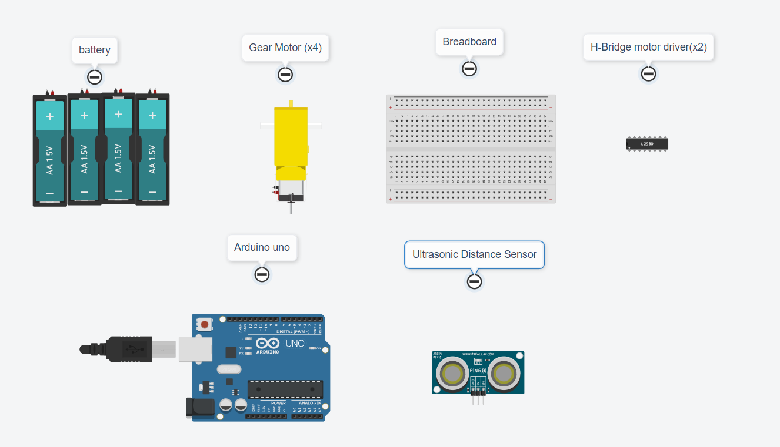

1 ) Battery 1.5v (x4)

2 ) Ultra Sonic Sensor

It is an ultrasonic range finder, which works on the principle of a RADAR, but instead of using radio waves, it uses ultrasonic sound waves. It consists of a transmitter which emits ultrasound of the frequency 40 KHz [4], and an echo receiver which receives reflected sound waves. The time difference between emitting and receiving of the waves gives the distance between the sensor and the surface off which waves are reflecting. It works in the range of 2-400cm in 15o effective measuring angle. It has 4 pins, one for +5V power supply, one neutral, or ground pin, one signal pin to trigger the transmitter and one echo pin to obtain the results

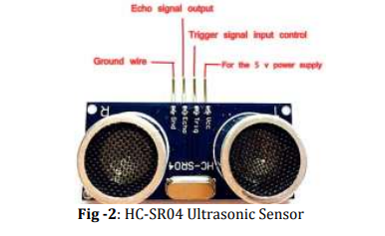

3 ) Motor Driver IC (x2)

The L293D is a 16-pin Motor Driver IC which can control a set of two DC motors simultaneously in any direction.

4 ) BreadBoard

A breadboard, or protoboard, is a construction base for prototyping of electronics.

5 ) Arduino Uno R3

Arduino Uno is a development board housing an ATmega328 microcontroller, and has fourteen digital and 6 analog pins as input-output ports, for connections to different peripherals [3]. It has an open sourced design which makes it much cost effective, and was introduced in 2005 to provide an easy and inexpensive way for students, hobbyists and professionals alike to create devices working with different actuators and sensors. It requires an external power source with voltage in the range of 9-12V. Apart from the fourteen digital and six analog pins, it also has a USB connection, a power jack, and a reset button.

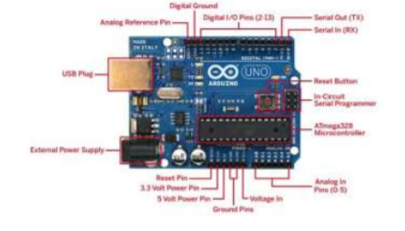

6 ) Gear Motor(x4)

A gearmotor is **an all-in-one combination of an electric motor and a gearbox**. This makes it a simple, cost-effective solution for high-torque, low-speed applications because it combines a motor with a gear reducer system

**BLOCK DIAGRAM**

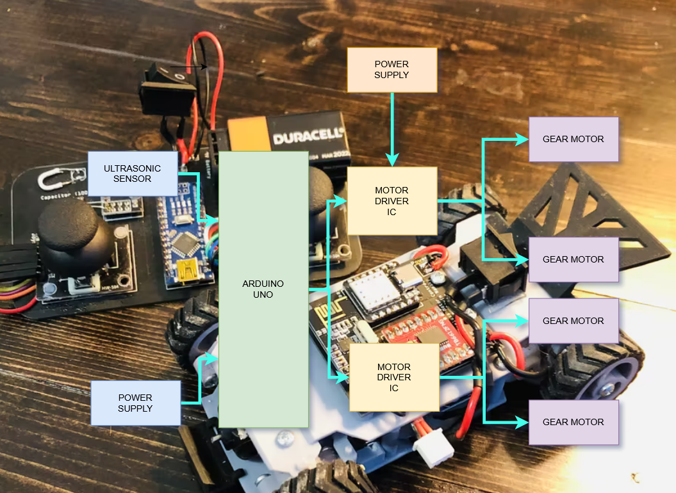

**CIRCUIT DIAGRAM**

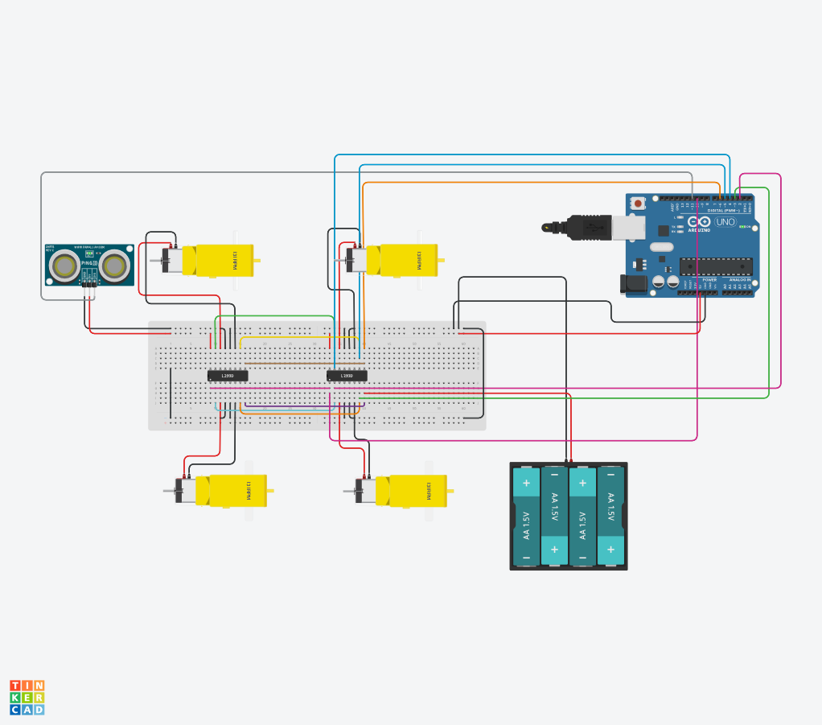

TinkerCad Link:

<https://www.tinkercad.com/things/dhNKG9CSW0a-obstacle-avoiding-rc-carfinal/editel?sharecode=5z_c_8N-CiMDAYIaKHCmoeKJfMKRawMcfWxUAuVU27M>

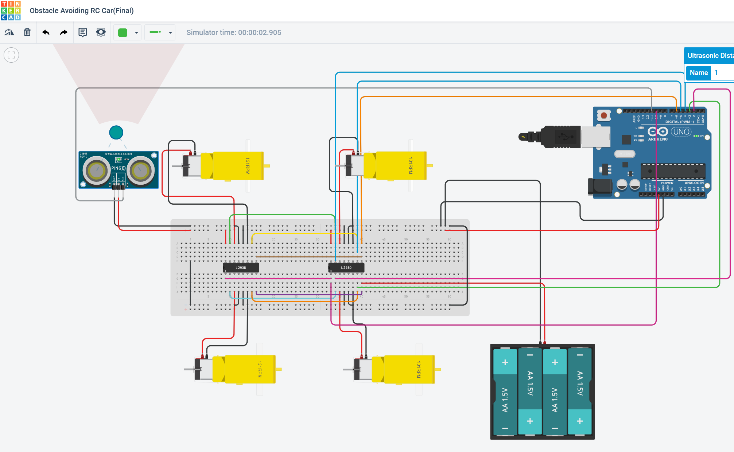

**SCHEMATIC DIAGRAM**

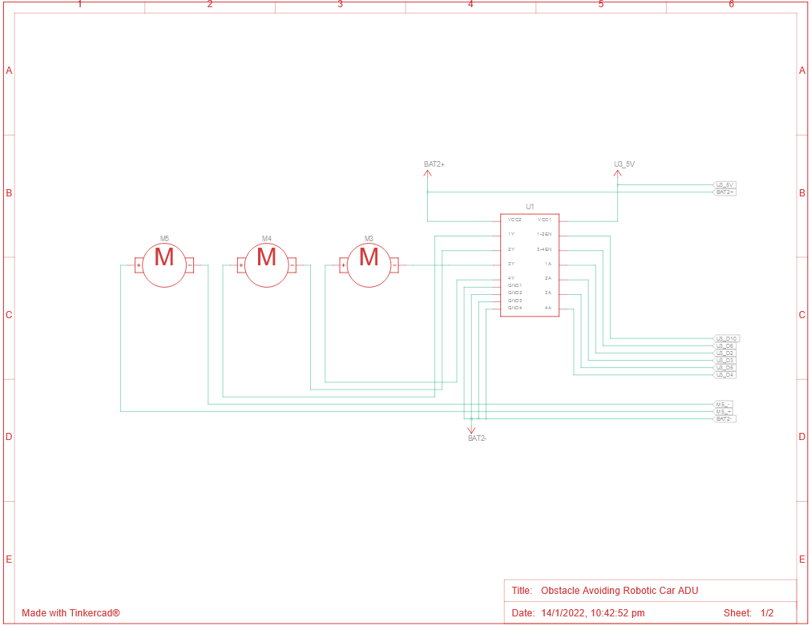

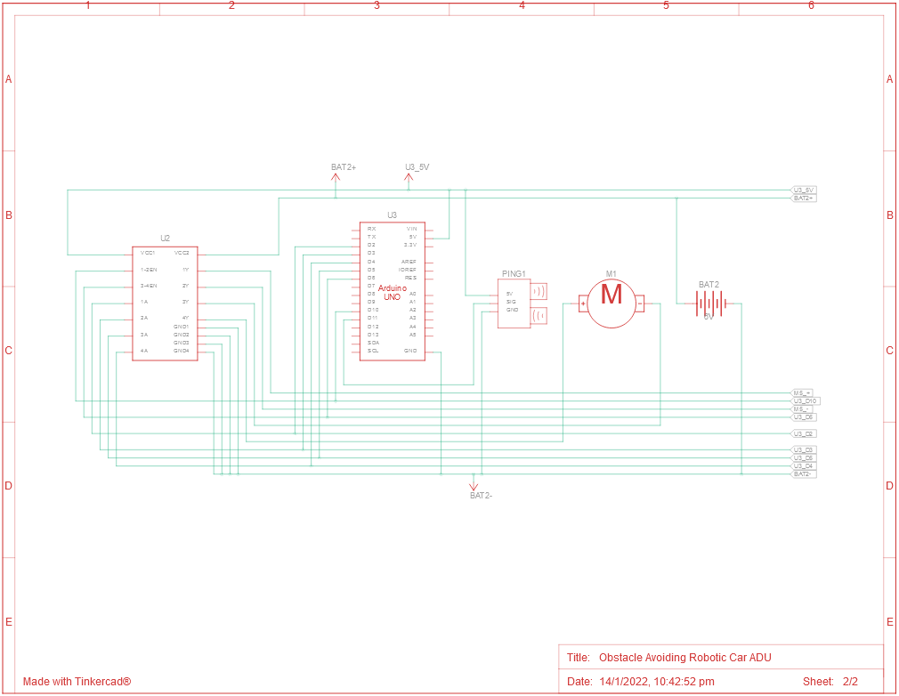

**WORKING OF THE SYSTEM**

Before going to work on the project, it is important to understand how the ultrasonic sensor works. The basic principle behind the working of ultrasonic sensor is as follows:

Using an external trigger signal, the Trig pin on the ultrasonic sensor is made high for at least 10µs. A sonic burst from the transmitter module is sent. This consists of 8 pulses of 40KHz.

The signals return back after hitting a surface and the receiver detects this signal. The Echo pin is high from the time of sending the signal and receiving it. This time can be converted to distance using appropriate calculations.

When the robot is powered on, both the motors of the robot will run normally and the robot moves forward. During this time, the ultrasonic sensor continuously calculates the distance between the robot and the reflective surface.

This information is processed by the Arduino. If the distance between the robot and the obstacle is less than 15cm, the Robot Turns Right and scans again. If no obstacle is found under 15 cm from the sensor it moves forward. Similarly if it finds another obstacle it will turn another 90 degrees .

**APPENDIX**

int distance = 0;

int i = 0;

long readUltrasonicDistance(int triggerPin, int echoPin)

{

pinMode(triggerPin, OUTPUT); // Clear the trigger

digitalWrite(triggerPin, LOW);

delayMicroseconds(2);

// Sets the trigger pin to HIGH state for 10 microseconds

digitalWrite(triggerPin, HIGH);

delayMicroseconds(10);

digitalWrite(triggerPin, LOW);

pinMode(echoPin, INPUT);

// Reads the echo pin, and returns the sound wave travel time in microseconds

return pulseIn(echoPin, HIGH);

}

void setup()

{

pinMode(5, OUTPUT);

pinMode(4, OUTPUT);

pinMode(3, OUTPUT);

pinMode(2, OUTPUT);

pinMode(6, OUTPUT);

pinMode(10, OUTPUT);

}

void loop()

{

distance = 0.01723 * readUltrasonicDistance(11, 11);

distance = (distance / 2.54);

if (distance > 15) {

// MoveForward

digitalWrite(5, LOW);

digitalWrite(4, HIGH);

digitalWrite(3, LOW);

digitalWrite(2, HIGH);

analogWrite(6, 255);

analogWrite(10, 255);

} else {

// TurnRight

digitalWrite(5, HIGH);

digitalWrite(4, LOW);

digitalWrite(3, LOW);

digitalWrite(2, HIGH);

analogWrite(6, 80);

analogWrite(10, 80);

}

delay(10); // Delay a little bit to improve simulation performance

}

**RESULT**

The outcome of this project is a simple, Arduino-controlled robot car which moves around detecting obstacles in its way and avoiding them. During operation of the robot, the ultrasonic sensor sends out an ultrasound wave to the front position (90 degrees). When the wave strikes an obstacle, it bounces back and the distance is stored for the front position. After this, the microcontroller compares the values based on its algorithm and determines whether to move forward or change path

Limitations :- The limitations were related to cases of some obstacles not being detected and this was as a result of the sensor not being able to measure obstacles outside the measuring range of the sensor. When an object is in the way of the car and this object is not within the line of sight of the sensor, it will not be detected thereby leading to collision.

**How to Improve**

*) To implement a car which will detect multiple obstacles and avoid them, more sensors have to be used in order to cover a wider range for obstacle detection.

* ) The use of servo Motor to change the direction of the ultrasonic sensor .

**CONCLUSION**

The hardware project performed as per our expectations, and worked autonomously, that is, after feeding the code, it required no human interaction and could work on its own, even in unknown and dynamic environments.

**REFERENCES**

[**https://create.arduino.cc/projecthub/Isaac100/getting-started-with-the-hc-sr04-ultrasonic-sensor-036380**](https://create.arduino.cc/projecthub/Isaac100/getting-started-with-the-hc-sr04-ultrasonic-sensor-036380)

[**https://create.arduino.cc/projecthub/adam/obstacle-avoiding-car-a192d9**](https://create.arduino.cc/projecthub/adam/obstacle-avoiding-car-a192d9)

**https://www.tinkercad.com/things/gTk0bxDJ7Fa-obstacle-avoiding-robotic-car-adu**

**=================================================================**