**Brand Name:** *StatPlay Insights*

**Mission statement :**

Our client, the National Endowment for the Arts, which is an independent federal agency that funds and promotes the creative capacity of communities by providing diverse opportunities for arts participation in the United States , is looking to promote a talented group of high school musicians who will be performing at the University of Maryland women's softball games this coming season.

As StatPlay Insight, a Sports Analytics consulting firm, our mission for this project is to analyze the historical performance data of the UMD women's softball team in order to recommend the best games for the musicians to perform at to jumpstart their careers.

**Mission Objective : We need to replace these with the business questions in our sql file.**

* Which team does Maryland have the best win rate against, at home games?
* Which team does Maryland have the best win rate against, at away games?
* What is the overall win rate trend from 1995 to 2023?
* Which stadiums does Maryland team the best win rate against, at away games in spring season?
* What is the coach win rate trend from 2017 to 2023?

By focusing on key performance metrics(questions) such as home versus away winning differentials we can advise games likely to give the performers a competitive platform primed for applause as they look to build artistic momentum.

**Business Tasks and Processes:**

Data:

* For Season Data, we are going to consider all the years and months from 1995 to 2023. We will categorize them into Spring, summer, autumn and winter. Here primary key will be year+month
* Opponent data will be collected from all the matches that have occurred from 1995 to 2023. Unique opponent data will be collected and a sequential 3 alpha-numeric characters will be assigned as the primary key for each team.
* Score data had information regarding the match scores. The primary key here will be the opponentID + 4 digit sequential number. 4 digit is selected because there are over 1500 games.
* Stadium contains the locations at which the games have occurred over the years. The primary key here is a sequentially generated 3 alpha-numeric characters.
* Coach entity contains details about the coach and the years they have been active for. The primary key for the coach is a sequentially generated alpha-numeric character.

Tasks:

* Investigate Maryland team performance by analyzing Umterps website's win-loss data.
* Consider multiple parameters such as season, coach, and opponent.
* Assess performance in home and away matches based on match location and win-loss data.
* Analyze team performance season-wise by factoring in match location, match date, season and opponent.
* Finally, evaluate the highest potential impact games for the musicians' performances. In other words, to match the best softball games for the high school musicians to perform at as they start their artistic careers and aim to gain praise and recognition early on.

**Entities, Attributes, and Primary Keys:**

1) Calendar(**calYear, calMonth,** =calSeason)

2) Opponent(**oppId**, oppName, oppLocation, -oppCity, -oppState,-oppCountry)

3) Score (**scoreId**, scoreMd, scoreOpp, =scoreResult)

4) Stadium**(stdId**, stdLocation,-stdCity, -stdState,-stdCountry)

5) Coach (**coachId**, coachName, -coachFirstName, -coachLastName, coachExp, coachStartDt, coachEndDt)

**Relationships, Attributes, Degrees, Participating Entities and Constraints**

Manage: binary relationship

1 Calendar to 1 Coach

1 Coach to 1 or more Calendar

Match (matchVenueType): ternary relationship

1 Calendar and 1 Score to 1 Opponent

1 Opponent and 1 Calendar to 1 or more Scores

1 Score and 1 Opponent to 1 Match

Locate: ternary relationship

1 Stadium and 1 Score to 1 Opponent

1 Stadium and 1 Opponent to 1 or more Scores

1 Opponent and 1 Score to 1 Stadium

**ER Diagram:**

[**https://lucid.app/lucidchart/d8b36fee-6525-446d-ac14-7ec329746453/edit?viewport_loc=-1734%2C-205%2C2465%2C1292%2C0_0&invitationId=inv_16efadec-dc0c-4aa0-9dd3-b628da4df214**](https://lucid.app/lucidchart/d8b36fee-6525-446d-ac14-7ec329746453/edit?viewport_loc=-1734%2C-205%2C2465%2C1292%2C0_0&invitationId=inv_16efadec-dc0c-4aa0-9dd3-b628da4df214)

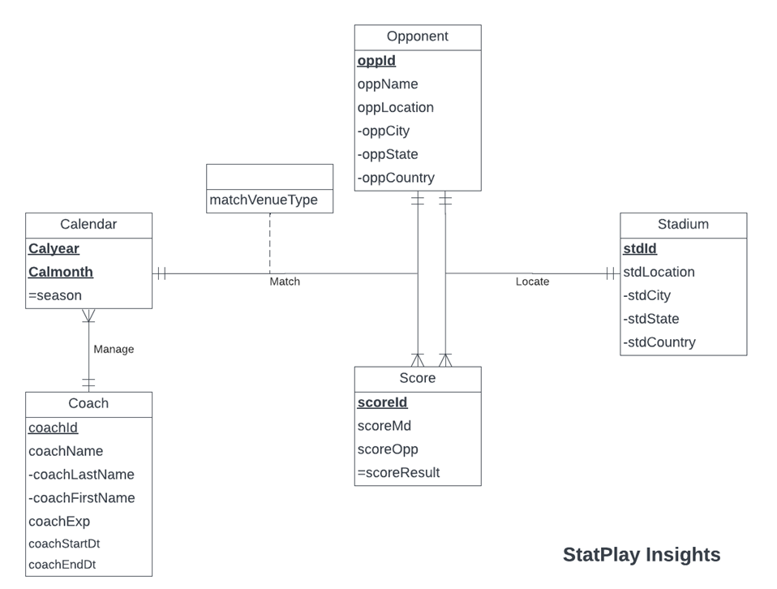

**Relations:**

1) Calendar(**calYear, calmonth,** *coachId*)

2) Opponent (**oppId**, oppName, oppCity, oppState,oppCountry)

3) Score(**scoreId**, scoreMd, scoreOpp)

4) Stadium**(stdId**, stdCity, stdState,stdCountry)

5) Coach (**coachId**, coachFirstName, coachLastName, coachExp, coachStartDt, coachEndDt)

6) Match (***scoreId,*** *calYear, calMonth,oppId,* matchVenueType)

7) Locate (***scoreId****, oppId*,*stdId*)

**Business Rules:**

[R1]: When a Coach manages a Season and the information on a Coach is deleted in the database, the corresponding Coach information is set to NULL.

[R2]: When a Coach manages a Calendar and the information on a Coach is changed, the corresponding Coach information is also changed

[R3]: For a match in one calendar with one score and one opponent ,the Score/ Calendar information cannot be deleted from the database.

[R4]: For a match in one calendar with one score and one opponent and the Score / Calendar information is changed in the database, the corresponding Match information is also changed.

[R5]: For a match in one calendar with one score and one opponent and the Opponent information is deleted/updated in the database, the corresponding match information is deleted/updated.

[R6]: For a game with one Score and one Stadium, the Score information in the database cannot be deleted.

[R7]: For a game with one Score and one Stadium and the Score information in the database is updated, the corresponding Locate information is updated.

**Referential Integrity:**

| **Relation** | **Foreign Key** | **Base Relation** | **Primary Key** | **Business Rule** | **Constraint: ON DELETE** | **Business Rule** | **Constraint: ON UPDATE** |
| --- | --- | --- | --- | --- | --- | --- | --- |
| Season | coachId | Coach | coachID | R1 | SET NULL | R2 | CASCADE |
| Match | scoreId | Score | scoreId | R3 | NO ACTION | R4 | CASCADE |
| Match | (seaYear,seaMonth) | Season | (seaYear, seaMonth) | R3 | NO ACTION | R4 | CASCADE |
| Match | oppId | Opponent | oppId | R5 | CASCADE | R5 | CASCADE |
| Locate | scoreId | Score | scoreId | R6 | NO ACTION | R7 | CASCADE |
| Locate | oppId | Opponent | oppId | R6 | NO ACTION | R7 | CASCADE |
| Locate | stdId | Stadium | stdId | R6 | NO ACTION | R7 | CASCADE |

**Sample Data:**

**Calendar**

| **calYear** | **calMonth** | **calSeason** |
| --- | --- | --- |
| 1995 | 01 | Winter |
| 1995 | 02 | Winter |
| 1995 | 03 | Spring |
| 1995 | 04 | Spring |
| 1995 | 05 | Spring |
| 1995 | 06 | Summer |
| 1995 | 07 | Summer |
| 1995 | 08 | Summer |

**Opponent**

| **oppId** | **oppName** | **oppCity** | **oppState** | **oppCountry** |
| --- | --- | --- | --- | --- |
| T01 | North Carolina | Chapel Hill | NC | US |
| T02 | East Carolina | Greenville | NC | US |
| T03 | Indiana | Bloomington | IN | US |
| T04 | Rutgers | Piscataway | NJ | US |
| T05 | Iowa | Iowa City | IA | US |
| T06 | Illinois | Urbana-Champaign | IL | US |
| T07 | Baylor | Waco | TX | US |
| T08 | Florida International University | Miami | FL | US |

More than more than 1000 college in US and <10000 in US hence primary key is a 3 alpha-numeric character

**Score**

| **scoreId** | **scoreMd** | **scoreOpp** | **scoreResult** |
| --- | --- | --- | --- |
| M0001T01 | 0 | 8 | L |
| M0002T02 | 0 | 11 | L |
| M0003T03 | 0 | 6 | L |
| M0004T04 | 0 | 8 | L |
| M0005T05 | 0 | 17 | L |
| M0006T06 | 1 | 15 | L |
| M0007T07 | 7 | 3 | W |
| M0008T08 | 10 | 2 | W |
| M0009T09 | 1 | 2 | L |

* oppID + Sequential number

**Stadium**

| **stdId** | **stdCity** | **stdState** | **stdCountry** |
| --- | --- | --- | --- |
| S01 | College Park | MD | USA |
| S02 | Chapel Hill | NC | USA |
| S03 | Austin | TX | USA |
| S04 | Puerto Vallarta | Jalisco | MEXICO |

* stdId is a sequentially generated unique number.

**Coach**

| **coachId** | **coachFirstName** | **coachLastName** | **coachExp** | **coachStartDt** | **coachEndDt** |
| --- | --- | --- | --- | --- | --- |
| C01 | Mark | Montgomery | 19 | 09-09-2019 | 07-27-2023 |
| C02 | Julie | Wright | 11 | 07-17-2015 | 09-08-2019 |

* coachId is a sequentially generated unique number.