CODING CONTEST

QUESTION 1

1.

package Test4.test;

import org.openqa.selenium.By;

import org.openqa.selenium.JavascriptExecutor;

import org.openqa.selenium.WebDriver;

import org.openqa.selenium.WebElement;

import org.openqa.selenium.chrome.ChromeDriver;

import org.openqa.selenium.chrome.ChromeOptions;

import io.github.bonigarcia.wdm.WebDriverManager;

public class App

{

public static void main( String[] args )

{

WebDriverManager.chromedriver().setup();

ChromeOptions co=new ChromeOptions();

co.addArguments("--remote-allow-origins=*");

WebDriver driver=new ChromeDriver(co);

driver.get("https://www.saucedemo.com");

driver.manage().window().maximize();

JavascriptExecutor js=(JavascriptExecutor) driver;

js.executeScript("window.scrollBy(0,1000)","");

WebElement txt1=driver.findElement(By.id("user-name"));

txt1.sendKeys("standard_user");

WebElement txt2=driver.findElement(By.id("password"));

txt2.sendKeys("secret_sauce");

driver.findElement(By.id("login-button")).submit();

js.executeScript("window.scrollBy(0,1000)","");

driver.findElement(By.id("add-to-cart-sauce-labs-onesie")).click();

System.out.println("Added to cart");

}

}

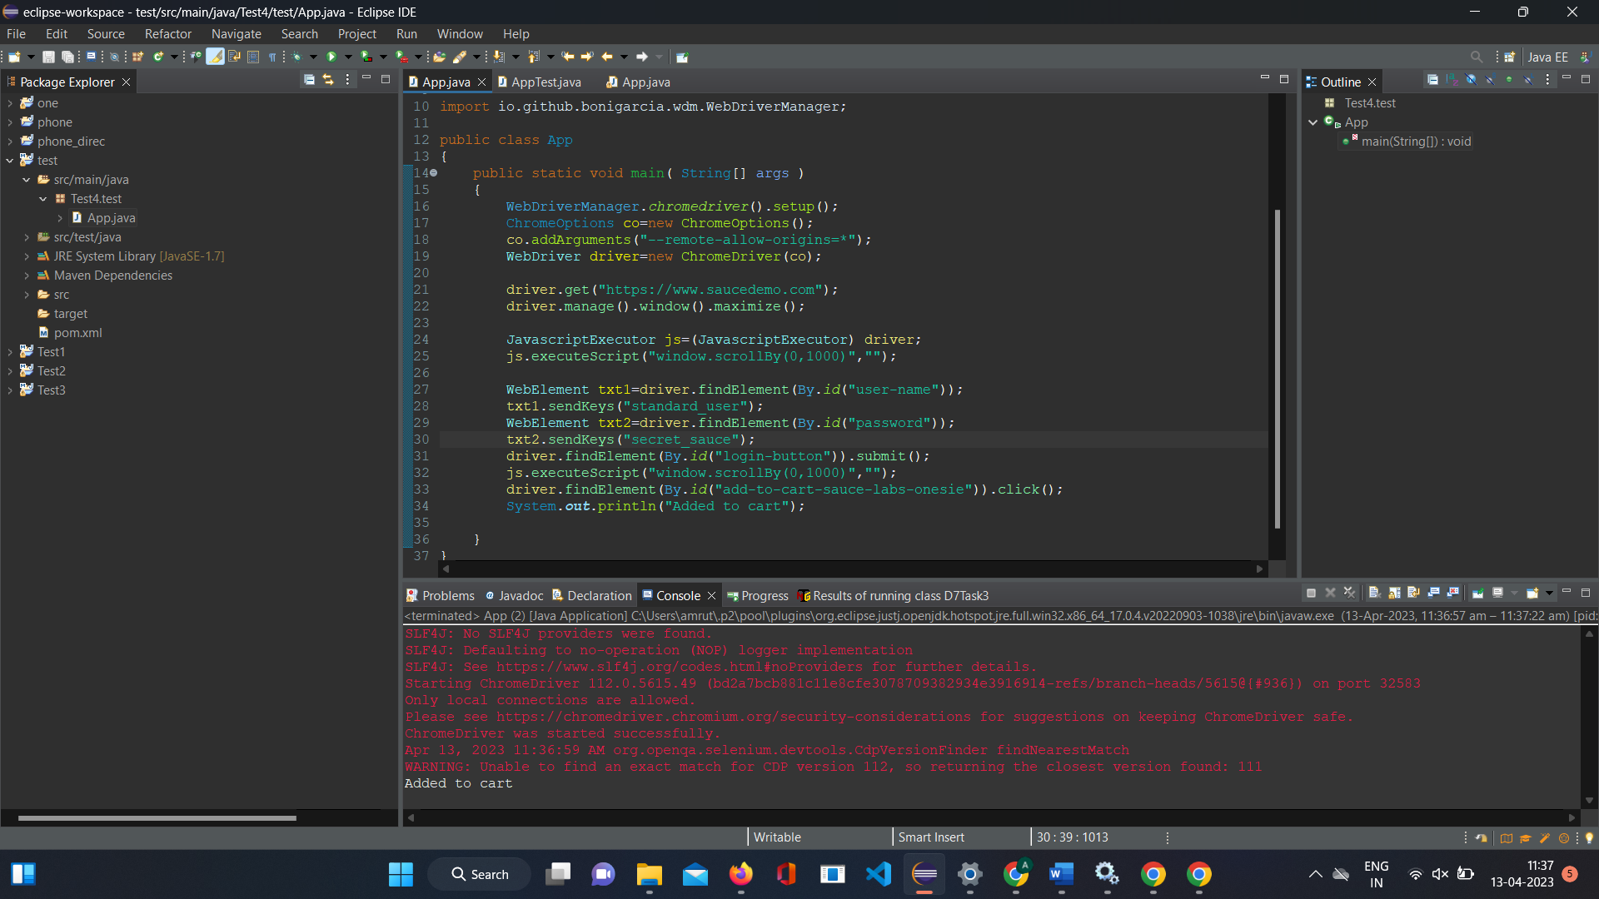

2.

package Test4.test;

import org.openqa.selenium.By;

import org.openqa.selenium.JavascriptExecutor;

import org.openqa.selenium.WebDriver;

import org.openqa.selenium.WebElement;

import org.openqa.selenium.chrome.ChromeDriver;

import org.openqa.selenium.chrome.ChromeOptions;

import io.github.bonigarcia.wdm.WebDriverManager;

public class cc1_2 {

public static void main( String[] args )

{

WebDriverManager.chromedriver().setup();

ChromeOptions co=new ChromeOptions();

co.addArguments("--remote-allow-origins=*");

WebDriver driver=new ChromeDriver(co);

driver.get("https://www.saucedemo.com");

driver.manage().window().maximize();

JavascriptExecutor js=(JavascriptExecutor) driver;

js.executeScript("window.scrollBy(0,1000)","");

WebElement txt1=driver.findElement(By.id("user-name"));

txt1.sendKeys("standard_user");

WebElement txt2=driver.findElement(By.id("password"));

txt2.sendKeys("secret_sauce");

driver.findElement(By.id("login-button")).submit();

driver.findElement(By.id("add-to-cart-sauce-labs-backpack")).click();

System.out.println("Added to cart");

driver.findElement(By.id("shopping_cart_container")).click();

driver.findElement(By.id("remove-sauce-labs-backpack")).click();

System.out.println("Contents can be viewed in the cart");

}

}

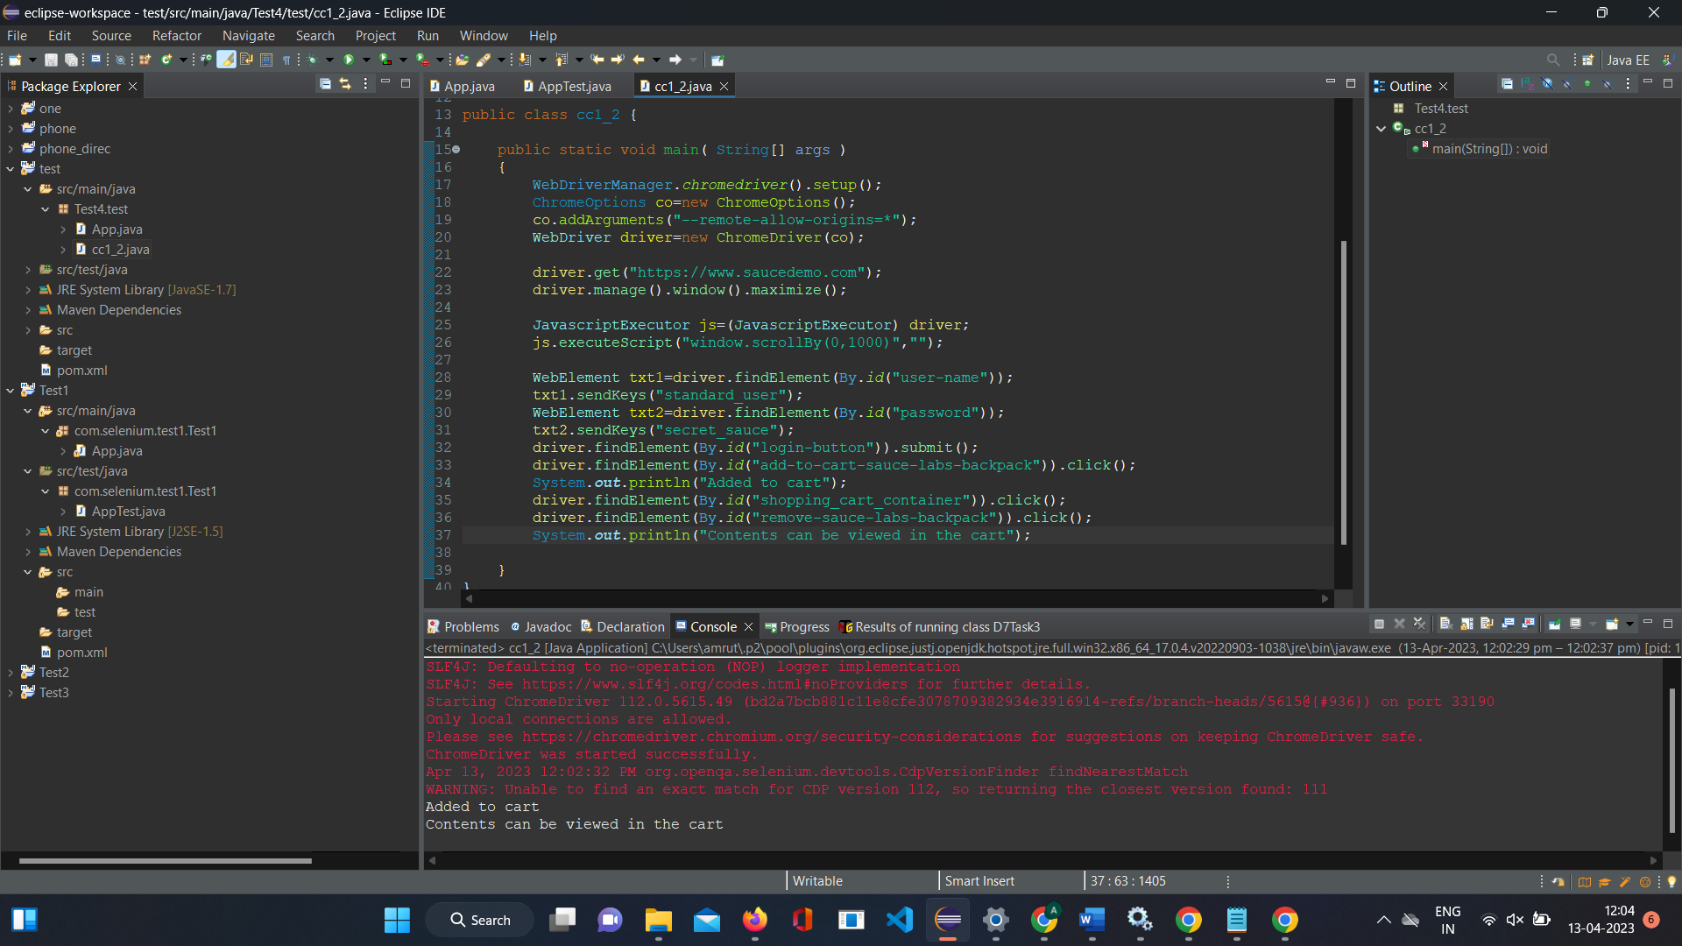

3.

package Test4.test;

import org.openqa.selenium.By;

import org.openqa.selenium.JavascriptExecutor;

import org.openqa.selenium.WebDriver;

import org.openqa.selenium.WebElement;

import org.openqa.selenium.chrome.ChromeDriver;

import org.openqa.selenium.chrome.ChromeOptions;

import io.github.bonigarcia.wdm.WebDriverManager;

public class cc1_3 {

public static void main( String[] args )

{

WebDriverManager.*chromedriver*().setup();

ChromeOptions co=new ChromeOptions();

co.addArguments("--remote-allow-origins=*");

WebDriver driver=new ChromeDriver(co);

driver.get("https://www.saucedemo.com");

driver.manage().window().maximize();

JavascriptExecutor js=(JavascriptExecutor) driver;

js.executeScript("window.scrollBy(0,1000)","");

WebElement txt1=driver.findElement(By.*id*("user-name"));

txt1.sendKeys("standard_user");

WebElement txt2=driver.findElement(By.*id*("password"));

txt2.sendKeys("secret_sauce");

driver.findElement(By.*id*("login-button")).submit();

driver.findElement(By.*id*("add-to-cart-sauce-labs-backpack")).click();

System.***out***.println("Added to cart");

driver.findElement(By.*id*("shopping_cart_container")).click();

driver.findElement(By.*id*("remove-sauce-labs-backpack")).click();

System.***out***.println("Contents can be viewed in the cart");

driver.findElement(By.*id*("checkout")).click();

String info=driver.findElement(By.*className*("header_secondary_container")).toString();

String info2="Checkout: Your Information";

if(info.equals(info2))

System.***out***.println("YOur information is displayed");

}

}

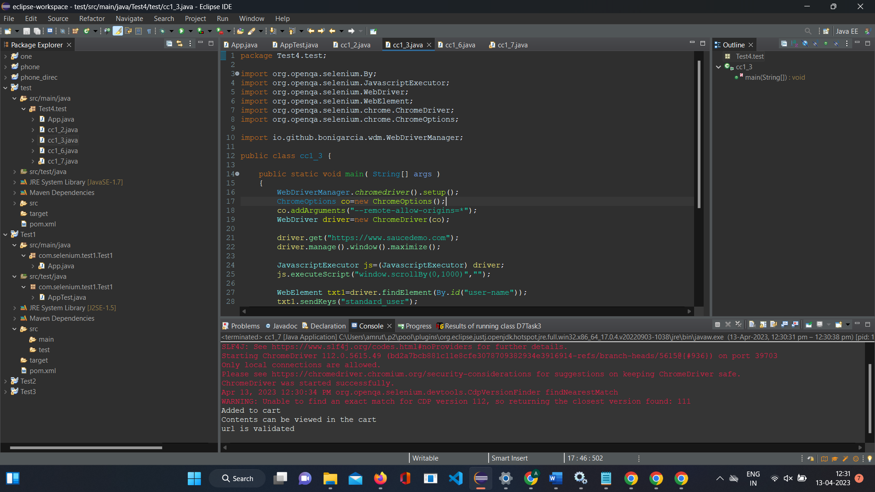

6.

package Test4.test;

import org.openqa.selenium.By;

import org.openqa.selenium.JavascriptExecutor;

import org.openqa.selenium.WebDriver;

import org.openqa.selenium.WebElement;

import org.openqa.selenium.chrome.ChromeDriver;

import org.openqa.selenium.chrome.ChromeOptions;

import io.github.bonigarcia.wdm.WebDriverManager;

public class cc1_6

{

public static void main( String[] args )

{

WebDriverManager.chromedriver().setup();

ChromeOptions co=new ChromeOptions();

co.addArguments("--remote-allow-origins=*");

WebDriver driver=new ChromeDriver(co);

driver.get("https://www.saucedemo.com");

driver.manage().window().maximize();

JavascriptExecutor js=(JavascriptExecutor) driver;

js.executeScript("window.scrollBy(0,1000)","");

WebElement txt1=driver.findElement(By.id("user-name"));

txt1.sendKeys("standard_user");

WebElement txt2=driver.findElement(By.id("password"));

txt2.sendKeys("secret_sauce");

driver.findElement(By.id("login-button")).submit();

js.executeScript("window.scrollBy(0,1000)","");

String cartTitle = driver.getTitle();

if (cartTitle.equals("Swag Labs")) {

System.out.println("Title is validated");

}

}

}

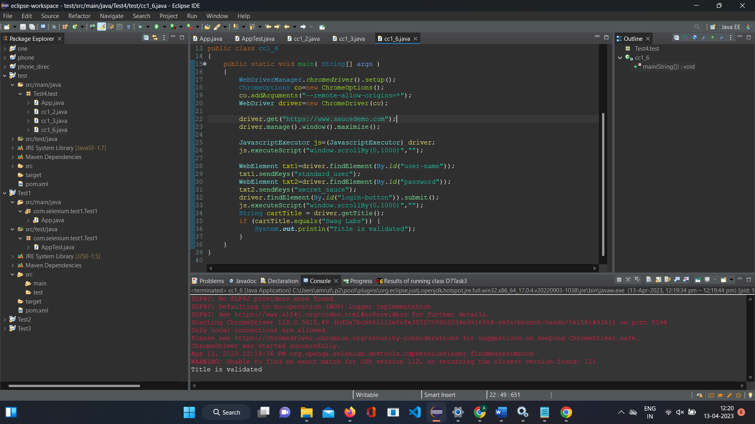

7.

package Test4.test;

import org.openqa.selenium.By;

import org.openqa.selenium.JavascriptExecutor;

import org.openqa.selenium.WebDriver;

import org.openqa.selenium.WebElement;

import org.openqa.selenium.chrome.ChromeDriver;

import org.openqa.selenium.chrome.ChromeOptions;

import io.github.bonigarcia.wdm.WebDriverManager;

public class cc1_7 {

public static void main( String[] args )

{

WebDriverManager.*chromedriver*().setup();

ChromeOptions co=new ChromeOptions();

co.addArguments("--remote-allow-origins=*");

WebDriver driver=new ChromeDriver(co);

driver.get("https://www.saucedemo.com");

driver.manage().window().maximize();

JavascriptExecutor js=(JavascriptExecutor) driver;

js.executeScript("window.scrollBy(0,1000)","");

WebElement txt1=driver.findElement(By.*id*("user-name"));

txt1.sendKeys("standard_user");

WebElement txt2=driver.findElement(By.*id*("password"));

txt2.sendKeys("secret_sauce");

driver.findElement(By.*id*("login-button")).submit();

driver.findElement(By.*id*("add-to-cart-sauce-labs-backpack")).click();

System.***out***.println("Added to cart");

driver.findElement(By.*id*("shopping_cart_container")).click();

driver.findElement(By.*id*("remove-sauce-labs-backpack")).click();

System.***out***.println("Contents can be viewed in the cart");

driver.findElement(By.*id*("checkout")).click();

WebElement teext1=driver.findElement(By.*id*("first-name"));

teext1.sendKeys("standard_user");

WebElement teext2=driver.findElement(By.*id*("last-name"));

teext2.sendKeys("secret_sauce");

WebElement teext3=driver.findElement(By.*id*("postal-code"));

teext3.sendKeys("641006");

driver.findElement(By.*id*("continue")).click();

String url1=driver.getCurrentUrl();

String url2="https://www.saucedemo.com/checkout-step-two.html";

if(url1.equals(url1))

System.***out***.println("url is validated");

}

}

