QUESTION:

1. ReactJS-HOL

Create a new React Application with the name “myfirstreact”, Run the application to print “welcome to the first session of React” as heading of that page

App.js

export default function App() {

return (

<div className="App">

<h1>Welcome to My First React App</h1>

</div>

);

}

OUTPUT:

2.

**React HOL: Studentapp**

Create a react app for Student Management Portal named StudentApp and create a component named Home which will display the Message “Welcome to the Home page of Student Management Portal”. Create another component named About and display the Message “Welcome to the About page of the Student Management Portal”. Create a third component named Contact and display the Message “Welcome to the Contact page of the Student Management Portal”. Call all the three components

Home.js

App.js

OUTPUT:

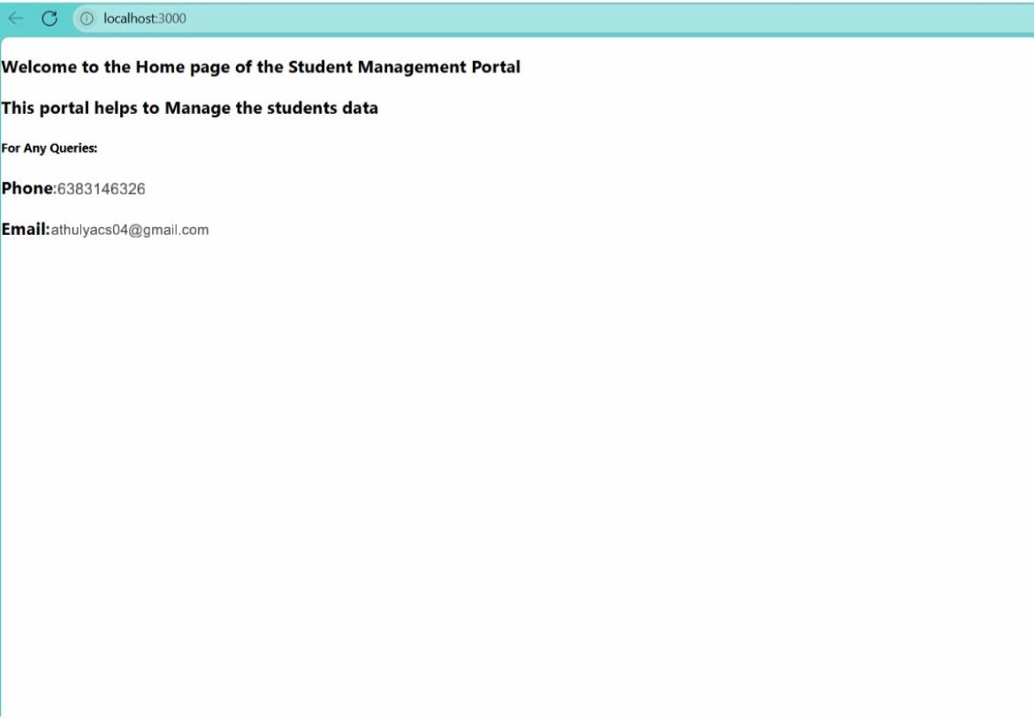

**3.Problem - Scorecalculator app**

Create a react app for Student Management Portal named scorecalculatorapp and create a function component named “CalculateScore” which will accept Name, School, Total and goal in order to calculate the average score of a student and display the same.

**calculatorscore.js:**

import './Stylesheets/mystyle.css';

const percentToDecimal = (decimal) => {

return (decimal.toFixed(2) + '%')

}

const calcScore = (total, goal) => {

return percentToDecimal(total / goal)

}

export const CalculateScore = ({ Name, School, total, goal }) => (

<div className="formatstyle">

<h1><font color="Brown">Student Details:</font></h1>

<div className="Name">

<b><span> Name: </span></b>

<span>{Name}</span>

</div>

<div className="School">

<b><span> School: </span></b>

<span>{School}</span>

</div>

<div className="Total">

<b><span>Total:</span></b>

<span>{total}</span>

<span>Marks</span>

</div>

<div className="Score">

<b>Score:</b>

<span>

{calcScore(

total,

goal

)}

</span>

</div>

</div>

)

**Mystyle.css**

Name {

font-weight: 300;

color: blue;

}

.School {

color: crimson;

}

.Total {

color: darkmagenta;

}

.formatstyle {

text-align: center;

font-size: large;

}

.Score

{ color: forestgreen; }

**App .js:**

**import { CalculateScore } from '../src/components/CalculateScore';**

**function App() {**

**return (**

**<div>**

**<CalculateScore**

**Name={"Mugilan"}**

**School={"SNS COLLEGE OF TECHNOLOGY"}**

**total={284}**

**goal={3}**

**/>**

**</div>**

**);**

**}**

**export default App;**

**OUTPUT:**

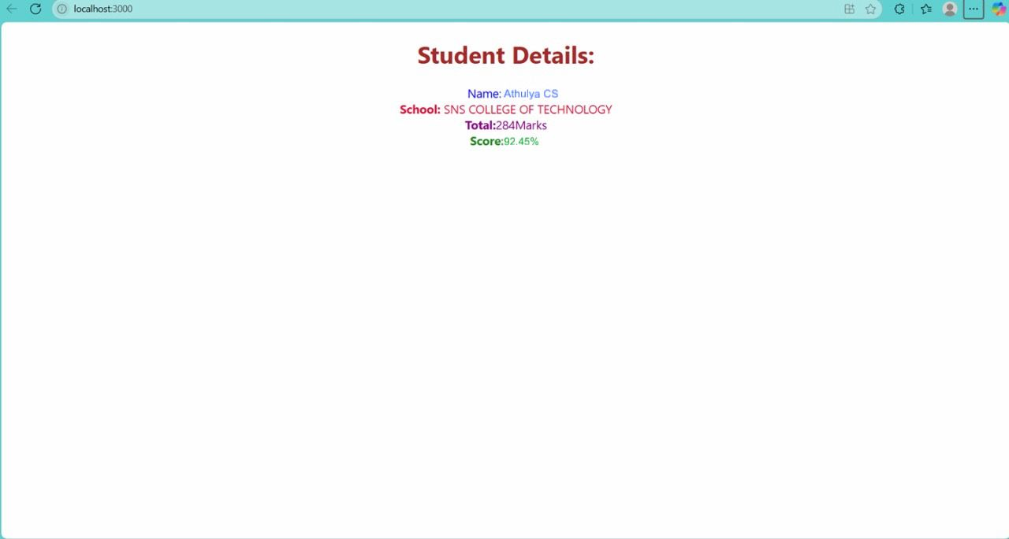

**4.React – Blogapp**

Create a new react application using *create-react-app* tool with the name as “blogapp”

**post.js:**

**class Post{**

**constructor(id,title,body){**

**this.id=id;**

**this.title=title;**

**this.body=body;**

**}**

**}**

**export default Post;**

**Posts:**

import React from 'react';

import Post from './Post';

class Posts extends React.Component {

constructor(props) {

super(props);

this.state = {

posts: [],

hasError: false,

errorMessage: ''

};

}

loadPosts() {

fetch('https://jsonplaceholder.typicode.com/posts')

.then(response => response.json())

.then(data => {

const postObjects = data.map(item => new Post(item.id,

item.title, item.body));

this.setState({ posts: postObjects });

})

.catch(error => {

console.error('Error:', error);

this.setState({ hasError: true, errorMessage:

error.message });

});

}

componentDidMount() {

this.loadPosts();

}

componentDidCatch(error, info) {

console.error('Render error:', error);

this.setState({ hasError: true, errorMessage: error.toString()

});

}

render() {

if (this.state.hasError) {

return <div>Error loading posts:

{this.state.errorMessage}</div>;

}

return (

<div>

<h1>Blog Posts</h1>

{this.state.posts.map(post => (

<div key={post.id} style={{ marginBottom: '20px'

}}>

<h2>{post.title}</h2>

<p>{post.body}</p>

<hr />

</div>

))}

</div>

);

}

}

export default Posts;

**OUTPUT:**

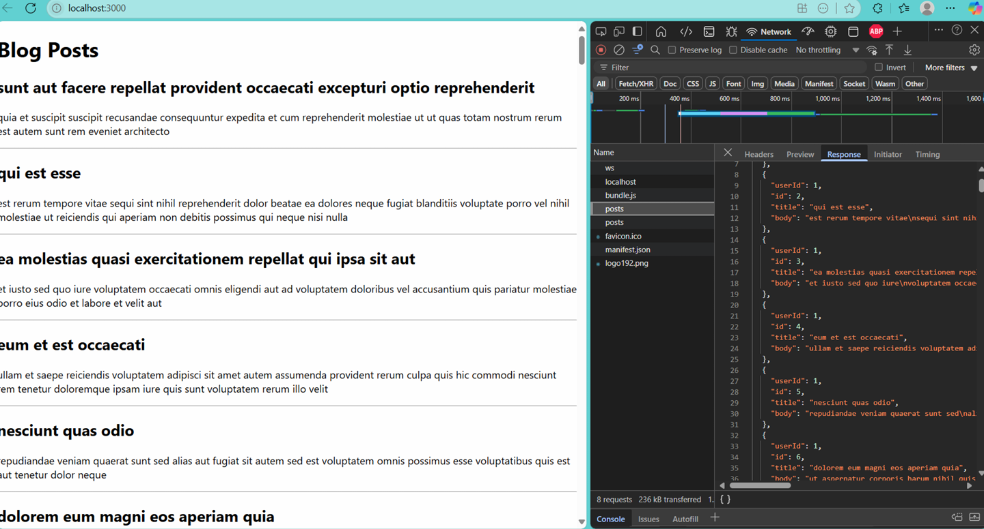

**React - 5 Cohorttracker**

My Academy team at Cognizant want to create a dashboard containing the details of ongoing and completed cohorts. A react application is created which displays the detail of the cohorts using react component. You are assigned the task of styling these react components.

CohortDetails.module.css:

box {

width: 300px;

display: inline-block;

margin: 10px;

padding: 10px 20px;

border: 1px solid black;

border-radius: 10px;

}

dt {

font-weight: 500;

}

**Cohortdetails.js:**

import styles from './CohortDetails.module.css';

function CohortDetails(props) {

const { cohort } = props;

const headingStyle = {

color: cohort.currentStatus.toLowerCase() === 'ongoing' ?

'green' : 'blue'

};

return (

<div className={styles.box}>

<h3 style={headingStyle}>

{cohort.cohortCode} - <span>{cohort.technology}</span>

</h3>

<dl>

<dt>Started On</dt>

<dd>{cohort.startDate}</dd>

<dt>Current Status</dt>

<dd>{cohort.currentStatus}</dd>

<dt>Coach</dt>

<dd>{cohort.coachName}</dd>

<dt>Trainer</dt>

<dd>{cohort.trainerName}</dd>

</dl>

</div>

);

}

export default CohortDetails;

**OUTPUT:**

