

Department of Computer Application

Course: BBA (Computer Application)
Academic Year: 2025–2026

Project Synopsis
AI Smart Library Management System using Raspberry Pi with Face
Recognition and QR Code
TEAM
SB1130 GAURAV BORHADE
SB1131 ATHARV PUJARI
SB1132 SIDDHANT BIDVE
SB1136 DEVANG BHOSALE

Introduction
Libraries are important resources in educational institutions, providing students with access to books and study materials. However, many libraries still use manual systems to manage book issuing and returning, which can be slow and prone to errors. Managing records manually also makes it difficult to track books and due dates efficiently.
The proposed AI Smart Library Management System aims to automate library operations using a Raspberry Pi 3 Model B+, face recognition technology, and QR Code scanning. The system identifies students using face recognition and scans QR codes attached to books to record transactions. All data is stored in a digital database, and the system provides confirmation through an LCD display and buzzer.
This automation improves the efficiency of the library system, reduces manual work, and helps maintain accurate records of books and users.

Problem Statement
Many libraries still manage book issuing and returning using manual methods such as registers or basic computer entries. This process takes more time and may lead to mistakes in recording student and book information. It also becomes difficult for librarians to track issued books, due dates, and overdue returns efficiently.
Because of these limitations, students often experience delays while issuing or returning books. Therefore, there is a need for an automated library management system that can identify students quickly, track books accurately, and maintain digital records to improve the overall efficiency of library operations.

Objectives
The main objectives of this project are:
- To automate the process of book issuing and returning in the library.
- To identify students using face recognition technology.
- To identify books using QR code scanning.
- To maintain a digital database of students, books, and transactions.
- To reduce manual work and improve efficiency in library management.
- To provide confirmation of operations through an LCD display and buzzer notification.

Proposed System / Methodology
The proposed system is an automated library management system that uses a Raspberry Pi 3 Model B+, camera module, and QR Code technology to manage library operations efficiently.
In this system, a camera connected to the Raspberry Pi is used to perform face recognition to identify students. Once the student is verified, the system allows the next step where the QR code attached to the book is scanned using the camera. The QR code contains a unique identification number for each book.
After scanning the book, the system records the transaction in a digital database, including student details, book details, issue date, and return date. If the book is returned after the due date, the system can calculate the fine automatically.
The system also provides visual and audio feedback using an LCD display and a buzzer. The LCD screen shows messages such as “Student Verified”, “Book Issued”, or “Book Returned”, while the buzzer gives a sound to confirm that the operation has been completed.
This methodology helps automate library activities, reduce manual errors, and make the book issuing and returning process faster and more efficient.

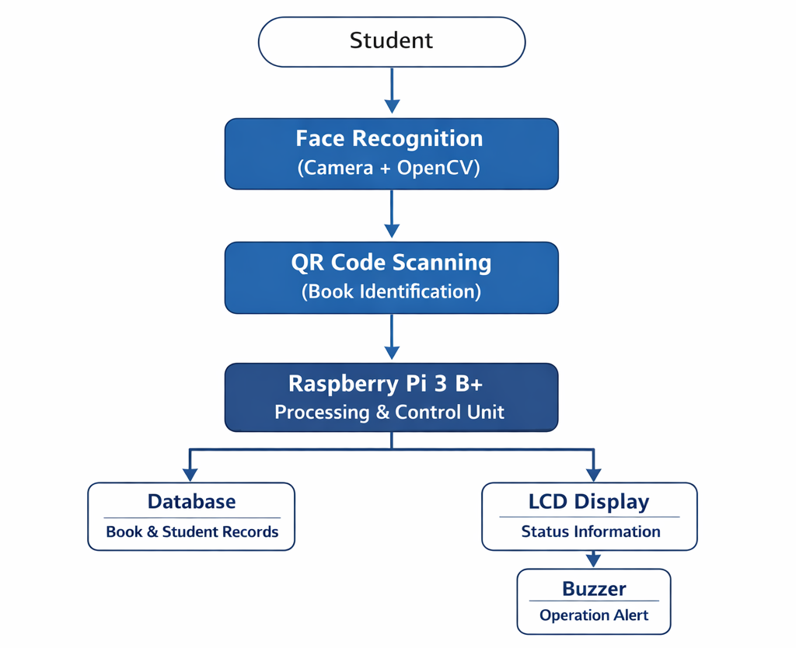

Technology Stack

The proposed system uses a combination of hardware and software technologies to implement the smart library management system.
Hardware:
The system is built using Raspberry Pi 3 Model B+ as the main processing unit. A camera module is used to capture student faces and scan QR Code labels attached to books. An LCD display is used to show system messages, and a buzzer provides audio alerts when operations such as book issuing or returning are completed.
Software:
The project is developed using the Python programming language, which is widely used for automation and AI-based applications. The OpenCV library is used for implementing face recognition, while the Pyzbar library is used to detect and read QR codes. The system runs on Raspberry Pi OS, which is a Linux-based operating system designed for Raspberry Pi devices.
Database:
A lightweight SQLite database is used to store information about students, books, and transaction records such as issue date, return date, and fines.
Together, these technologies work to create an efficient and automated library management system.

Expected Outcome
The expected outcome of this project is to develop a smart and automated library management system that simplifies the process of issuing and returning books. The system will be able to identify students using face recognition and scan QR codes attached to books to record transactions automatically.
All library records, including student details, book information, issue dates, and return dates, will be stored in a digital database. The system will also display messages on the LCD screen and give a buzzer alert when an operation is successfully completed.
By implementing this system, the library can reduce manual work, improve accuracy in record keeping, and make the process of managing books faster and more efficient for both students and librarians.

Future Scope

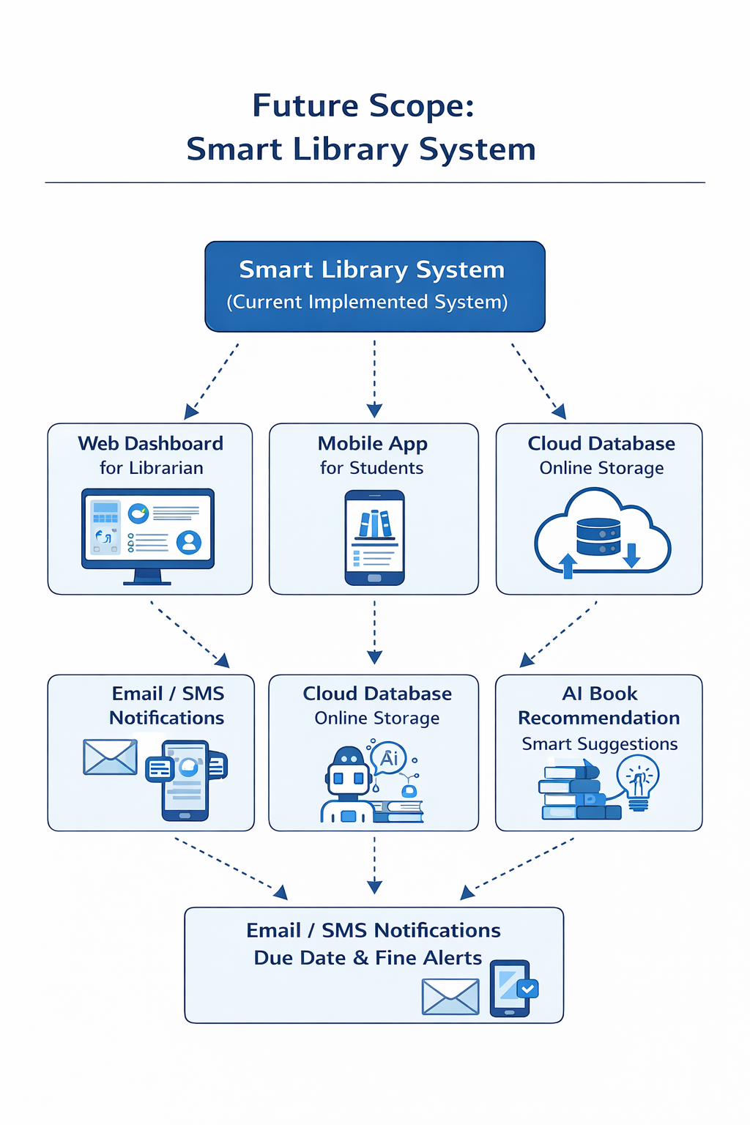
The proposed system can be further improved by adding additional features and technologies. In the future, a web or mobile application can be developed to allow students to check book availability, reserve books, and view their issued books online.
The system can also be upgraded with email or SMS notifications to remind students about due dates and fines. A cloud-based database can be used to store and manage data for larger libraries with many users. Additionally, advanced features such as AI-based book recommendation systems can be added to suggest books to students based on their reading history.
These improvements can make the system more intelligent, scalable, and suitable for use in large educational institutions.

Conclusion
The AI Smart Library Management System is designed to automate the traditional library processes of issuing and returning books. By using a Raspberry Pi 3 Model B+, face recognition technology, and QR Code scanning, the system provides a modern and efficient solution for managing library operations.
The proposed system helps reduce manual work, improves accuracy in maintaining records, and speeds up the book issuing and returning process. The use of an LCD display and buzzer provides clear feedback to the user when an operation is completed.
Overall, this project demonstrates how modern technologies such as artificial intelligence and automation can be applied to improve traditional library systems, making them more efficient, reliable, and user-friendly for both students and librarians.

