AIAC ASSIGNMENT – 16.2

Name : Jannu Athyunnatha
H.No : 2303A51956
Batch : 22

Task Descrption-1: (Design Database Schema for Student Management System)
Instructions:
• Using AI tools, generate CREATE TABLE statements for a Student Management Database.
• Tables: Students, Courses, Enrollments.
• Include primary keys, foreign keys, and suitable data types.
Ensure the schema follows normalization rules (1NF, 2NF, 3NF).
Code :
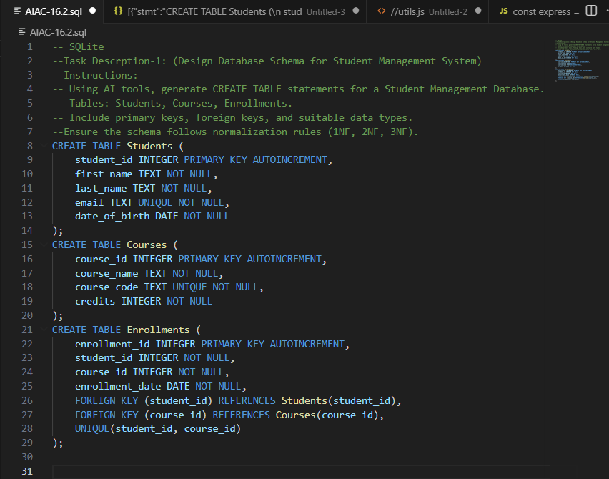
Output :
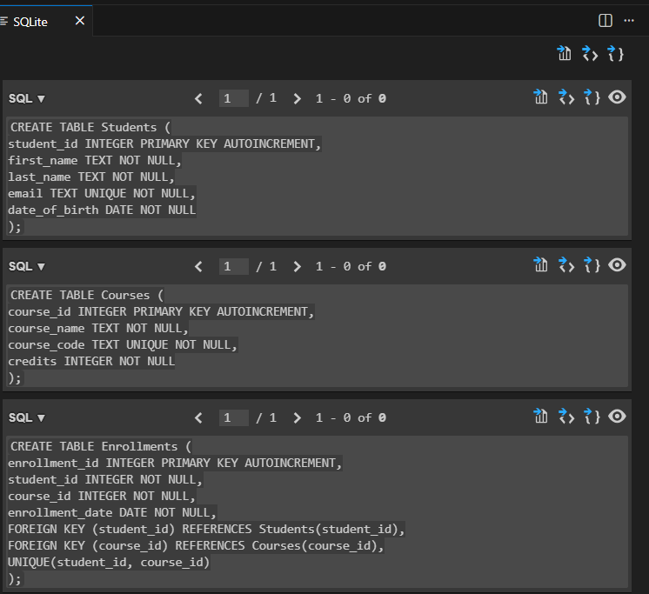
Observation :
The AI assistant makes creating database tables much easier because it generates clear and structured SQL code automatically. Instead of writing everything from scratch, the AI provides ready-to-use CREATE TABLE statements with primary keys, foreign keys, and constraints already included. This saves time, reduces errors, and shows how AI can simplify complex tasks like designing a normalized database schema.

Task Description- 2: (Insert Sample Records)
Instructions:
• Use AI tools to generate INSERT statements to populate the
tables.
• Insert at least 3 students, 4 courses, and 5 enrollment records.
Verify data using SELECT queries.

Code :
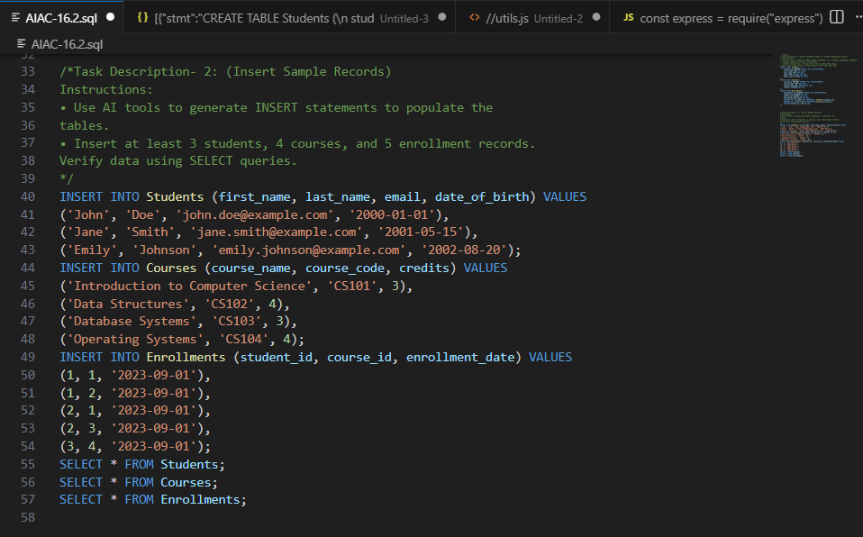

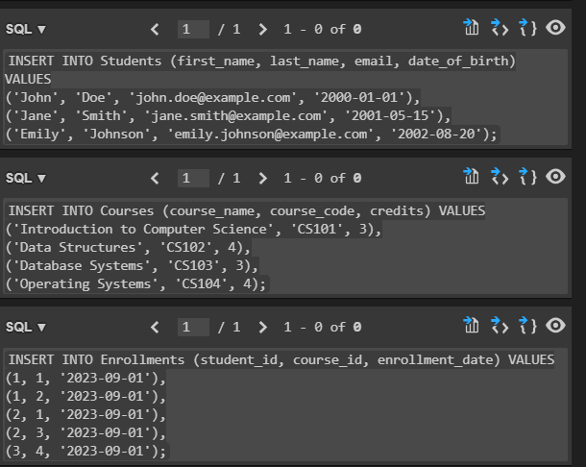

Output :
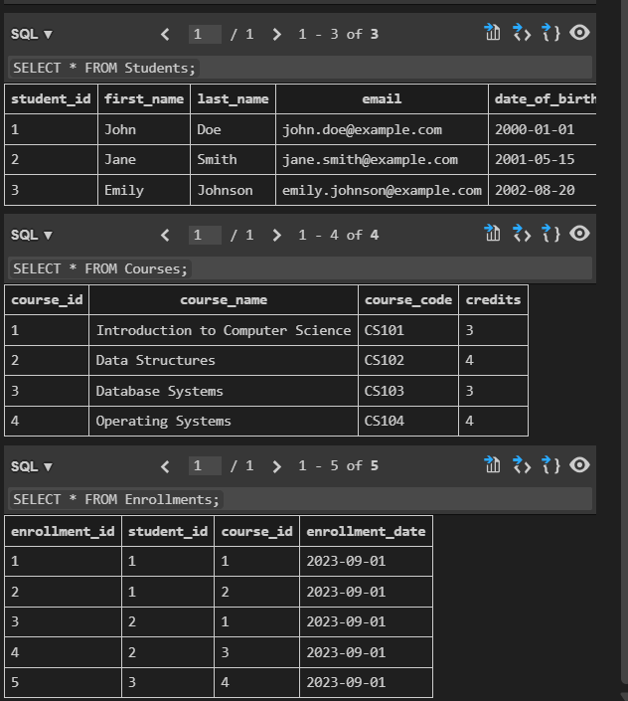

Observation :
The AI assistant makes inserting sample records very straightforward. Instead of manually thinking up values and writing multiple INSERT statements, the AI generates complete, ready-to-use SQL code with realistic student names, course details, and enrollment records. This not only saves time but also reduces the chance of mistakes, while giving clear examples that make it easy to understand how the database works in practice.

Task Description- 3: (Perform CRUD Operations)
Instructions:
Use AI to generate SQL queries for basic CRUD operations:
• Retrieve all courses
• Update a student’s email
• Delete an enrollment record
• Validate the changes using SELECT statements.

Code :
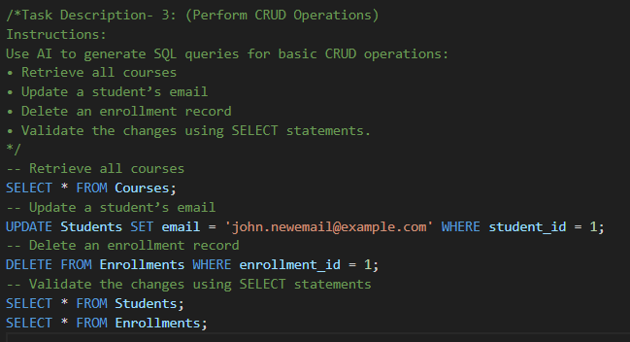

Output :
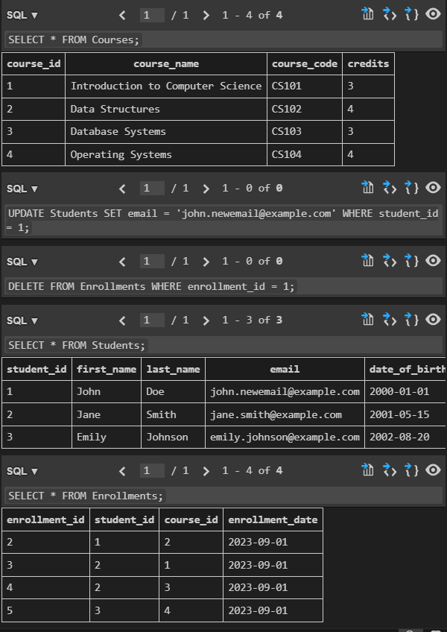
Observation :
The AI assistant makes performing CRUD operations very easy by generating clear SQL queries for each task. Instead of figuring out the exact syntax manually, the AI provides ready-made statements to retrieve data, update records, and delete entries, along with validation queries to check the changes. This helps save time, reduces errors, and shows how AI can simplify database management tasks in a practical way.

Task Description- 4: (Execute Aggregate Queries)
Instructions:
Use AI tools to write aggregate queries:
• Count number of students enrolled per course
• Display courses with more than one student enrolled
Analyze the correctness of results.

Code :
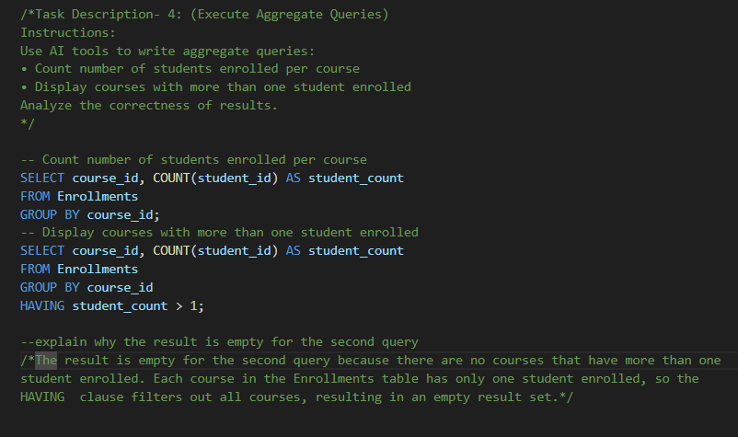

Output :
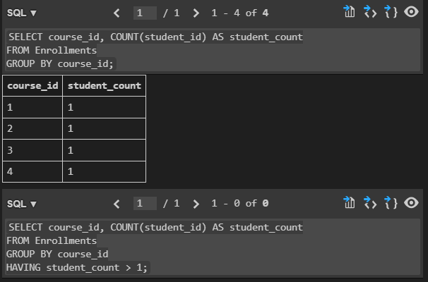

Observation :
The AI assistant makes writing aggregate queries simple by automatically generating the correct SQL syntax for tasks like counting students per course and filtering courses with more than one student. It also explains the results clearly—for example, why the second query returned empty—showing that the AI doesn’t just give code but also helps in understanding the logic behind it. This makes learning and verifying aggregate functions much easier and more intuitive.

Task Description- 5: (Query Optimization)
Instructions:
• Use AI tools to analyze query performance.
• Rewrite inefficient sub queries using JOINs and test both queries
for correctness.

Code :
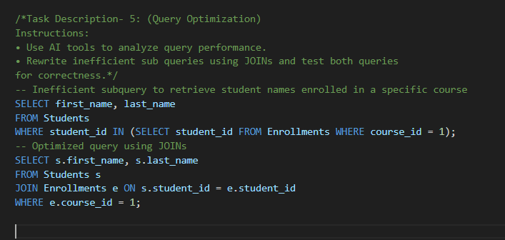

Output :
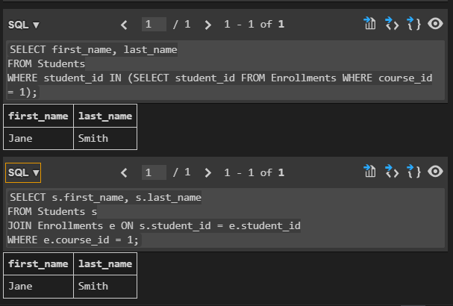

Observation :
The AI assistant helps in improving query performance by analyzing the code and suggesting optimized versions. For example, it rewrites an inefficient subquery into a JOIN, which makes the query faster and easier to understand. This shows that the AI doesn’t just generate working SQL, but also guides toward better practices, making database operations more efficient and practical to use in real scenarios.

