Assignment : 14.2

Name : J. Athyunnatha
Ht.No : 2303A51956
Batch : 22

Task Description 1 : (Landing Page Design)
- Create a simple landing page for a product or service. Include a header, hero section, and footer.
Requirements:
- Use HTML and CSS to structure the page.
- Use AI to suggest layout alignment and typography.
- Ensure the page is responsive across devices.
Code :

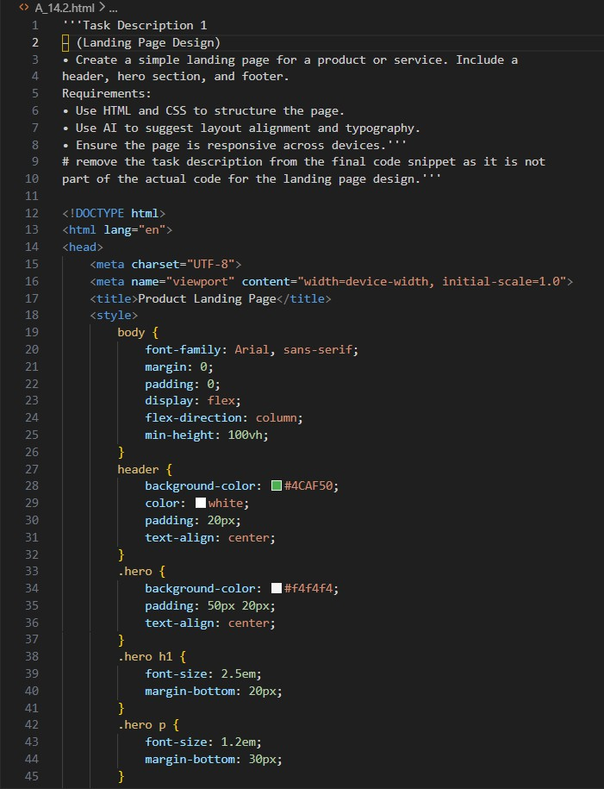

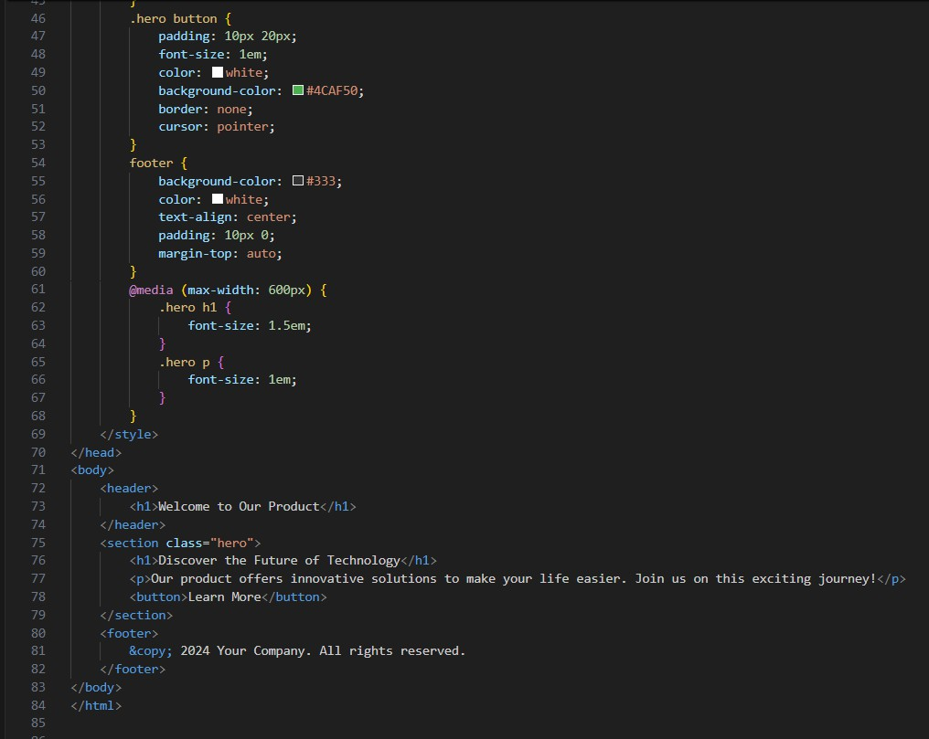
Output:


Observation : The landing page was created using HTML and CSS
with a header, hero section, and footer. Proper layout alignment and typography were used to make the page visually clear and structured.
Responsive design techniques were applied so the page adapts to
different screen sizes. The design provides a simple and user-friendly interface for presenting a product or service.

Task Description 2 : (Theme Toggle Feature)
- Provide a button to switch between light and dark themes.. Requirements:
- Use JavaScript to toggle CSS classes.
- Use AI assistance to manage color contrast and accessibility.
- Ensure theme preference applies instantly on click.

Code :
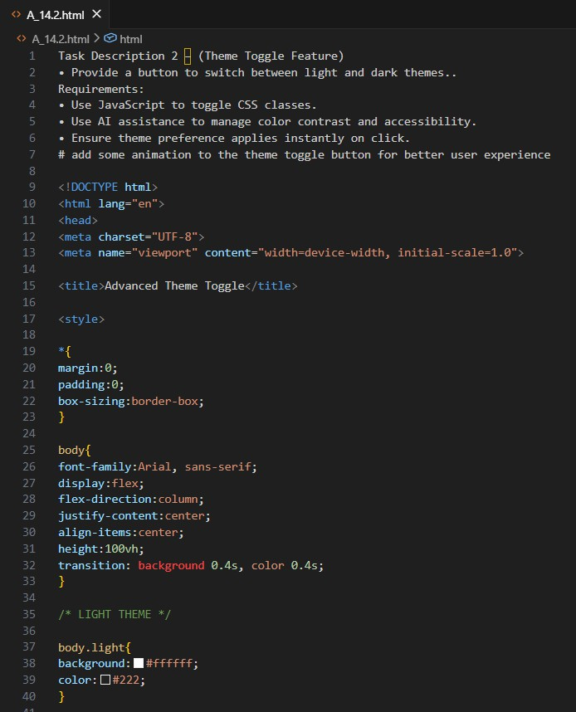

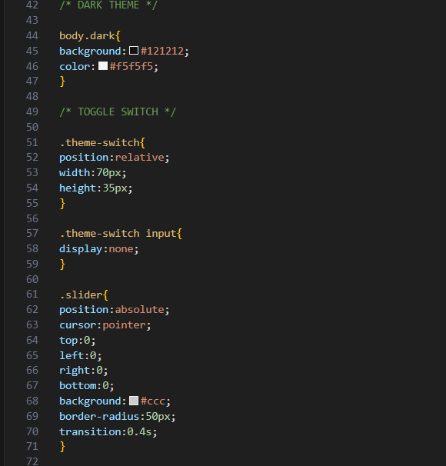

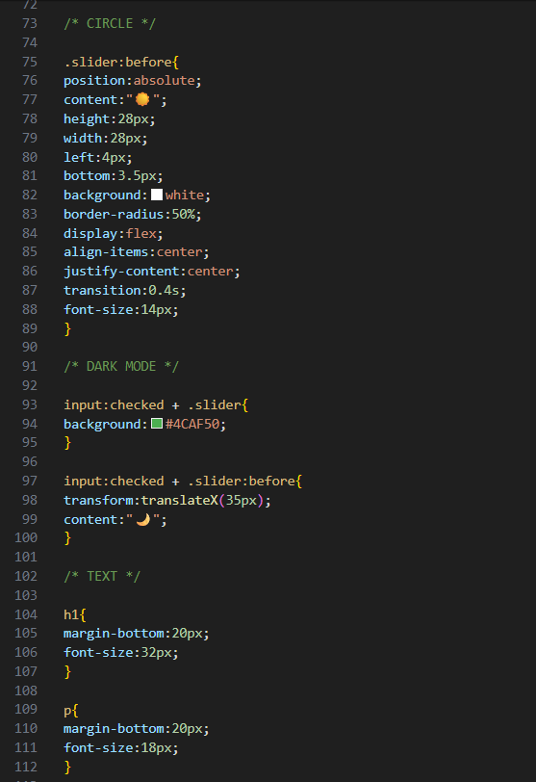

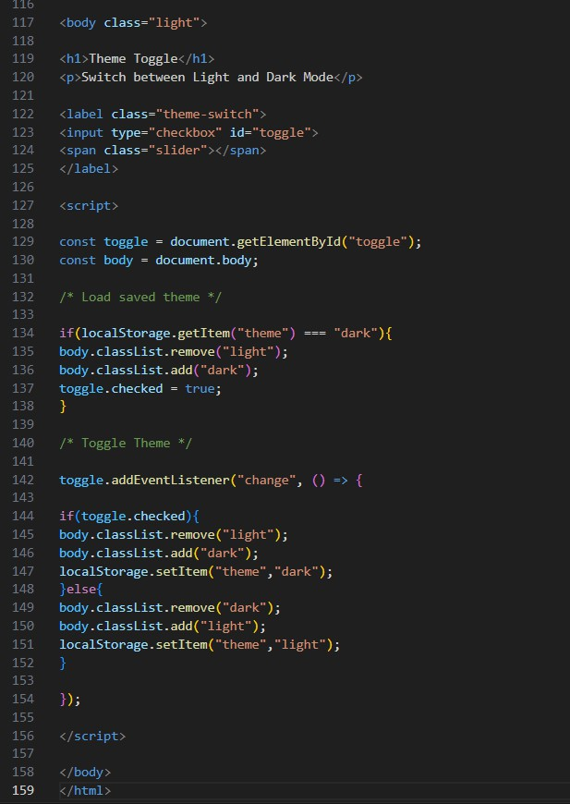

Output : before

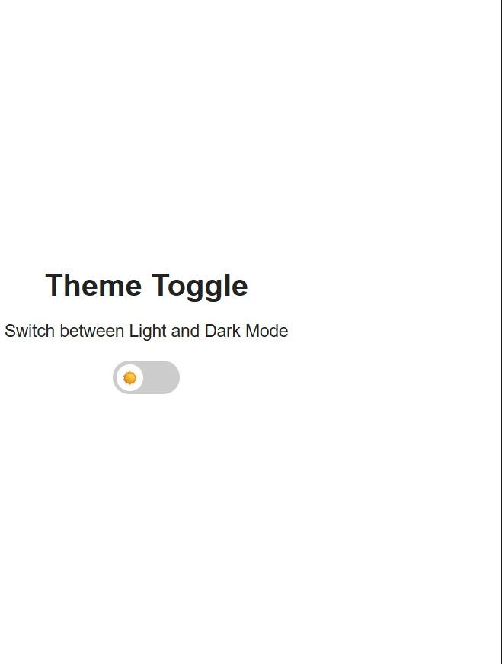

Output : After

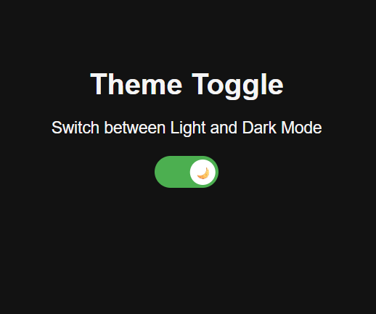

Observation : The theme toggle feature allows users to switch
between light and dark modes using a button. JavaScript is used to dynamically toggle CSS classes to change the webpage appearance
instantly. Smooth animations improve the user experience during the theme transition. The selected theme is stored using local storage so the preference remains even after refreshing the page.

Task Description 3 – (User Feedback Form)
- Create a feedback form with fields: Username, Rating, Comments.
Requirements:
- Use JavaScript to validate required fields.
- Display success or error messages dynamically.

- Use AI to improve form usability and layout.
Code :
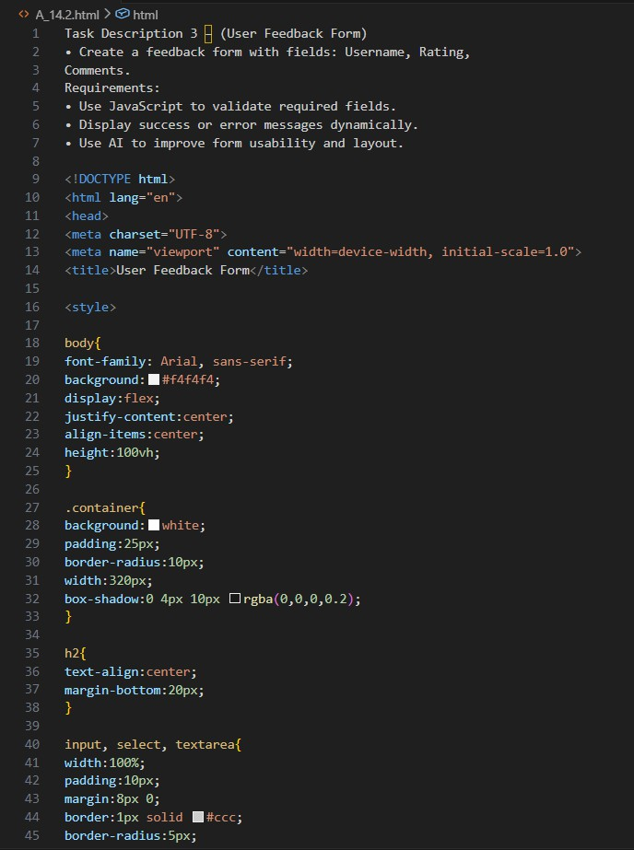

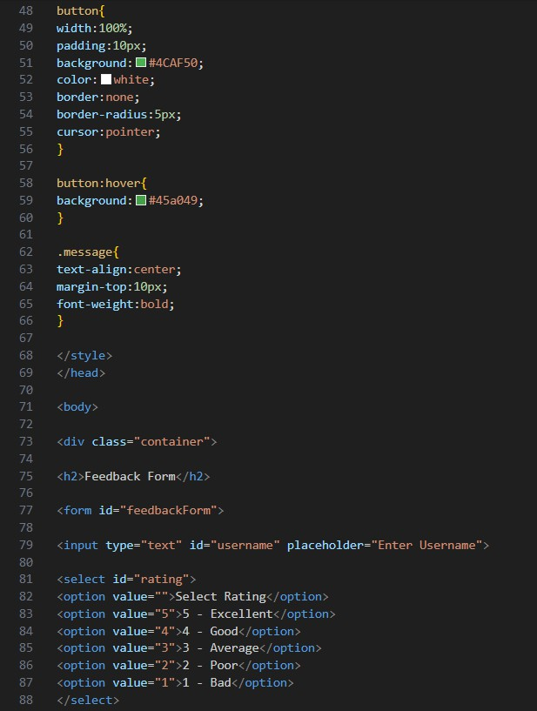

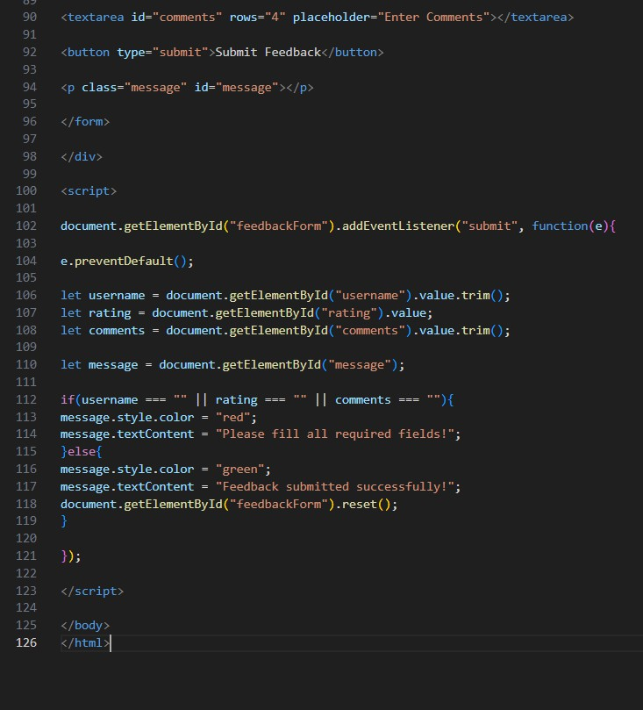
Output :

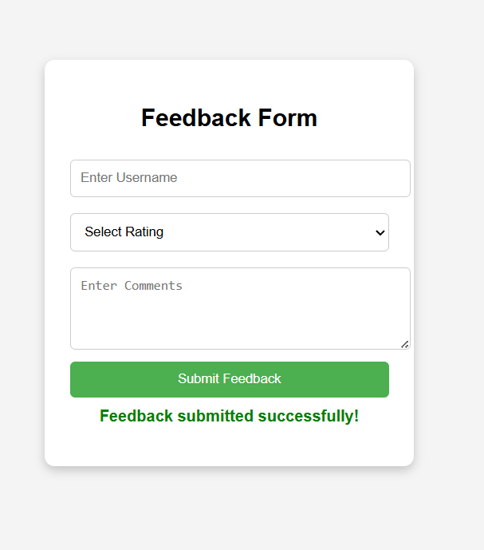
Observation: The user feedback form was created using HTML to collect username, rating, and comments from users. JavaScript was used to validate the required fields before submitting the form.
Dynamic success and error messages are displayed based on user input. The layout was designed to be simple and user-friendly for better usability.

Task Description - 4 (Image Gallery with JavaScript)
- Task: Display a small image gallery on a web page. Requirements:
- Use JavaScript to dynamically load images.
- Add next/previous navigation buttons.
- Use AI to optimize layout responsiveness.
Code :
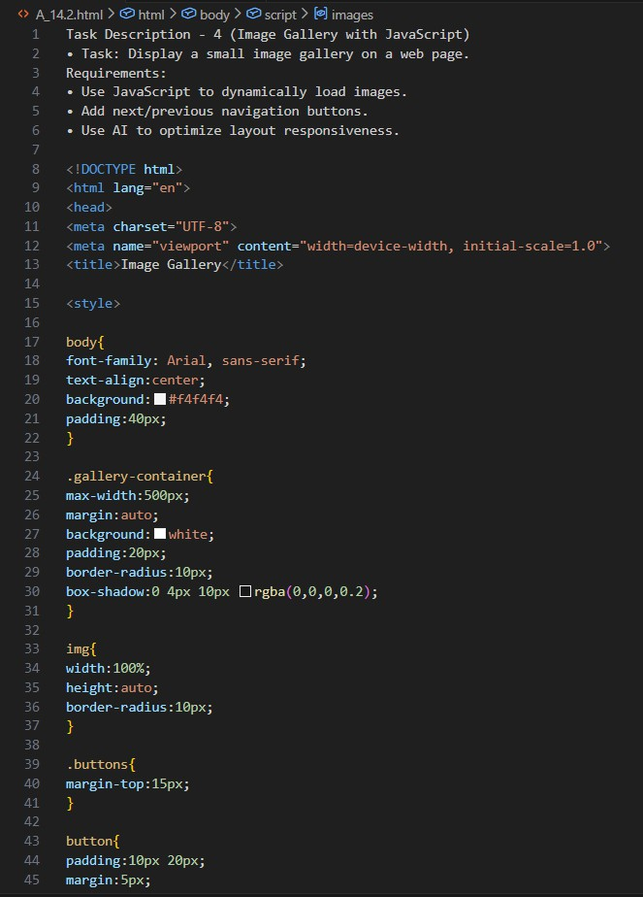

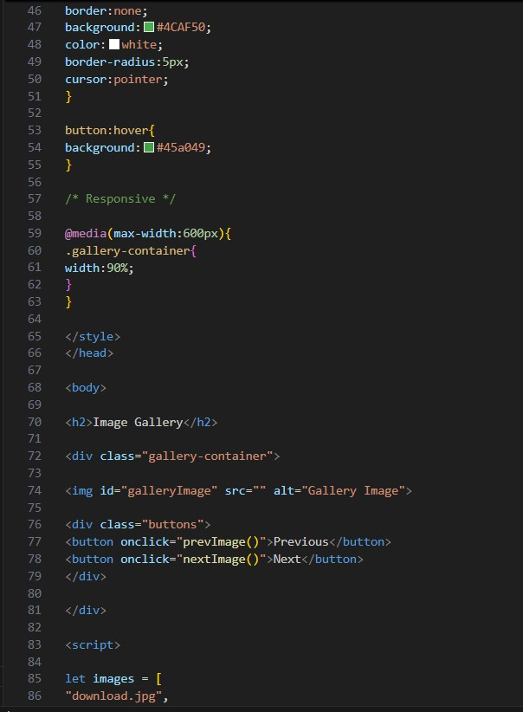

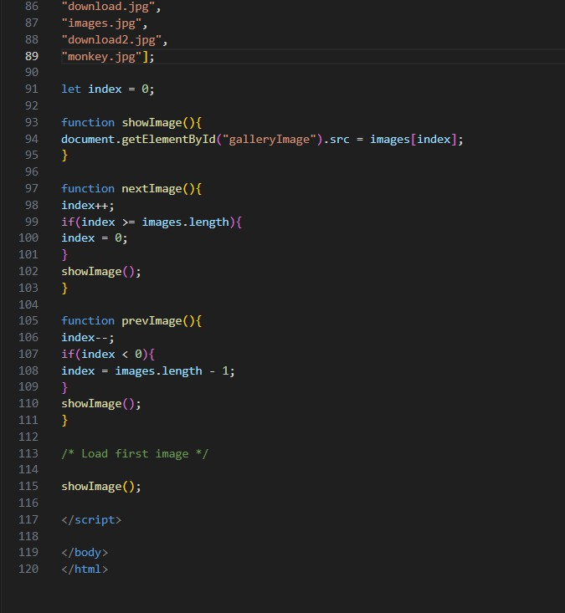

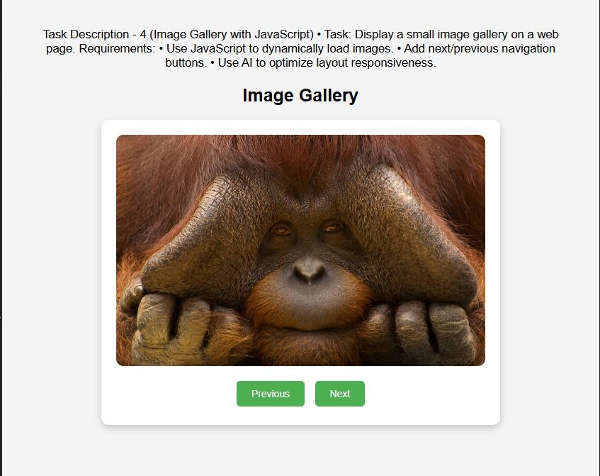
Observation : The image gallery was created using HTML, CSS, and JavaScript to display multiple images on a web page. JavaScript was used to dynamically load images from an array. Next and Previous buttons allow users to navigate through the images easily. The layout was optimized to be responsive so the gallery works properly on
different screen sizes.
Task Description - 5: (Notification Banner)
- Display a notification banner at the top of the page. Requirements:
- Use JavaScript to show and hide the banner.
- Style the banner using CSS.
- Use AI to ensure smooth transitions and clean UI behavior.

Code :
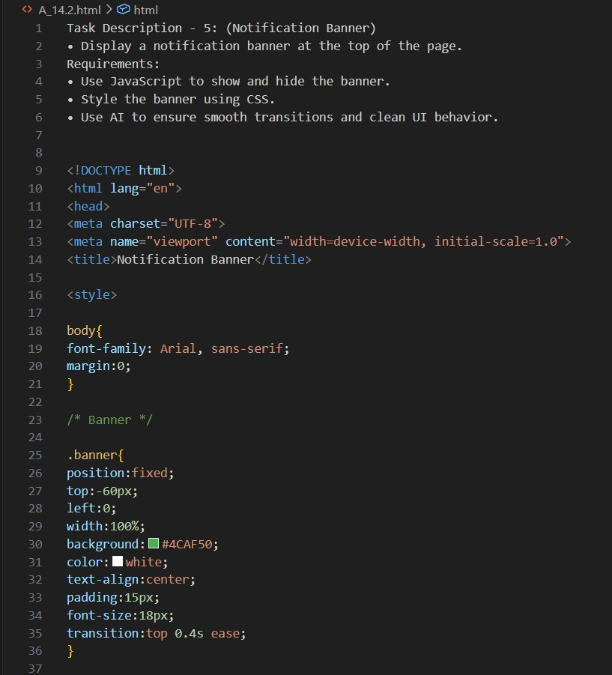

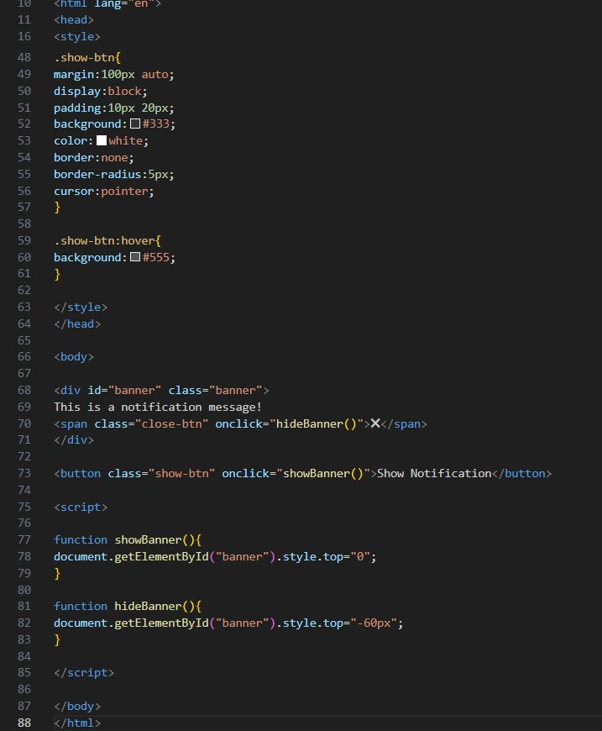
Output :

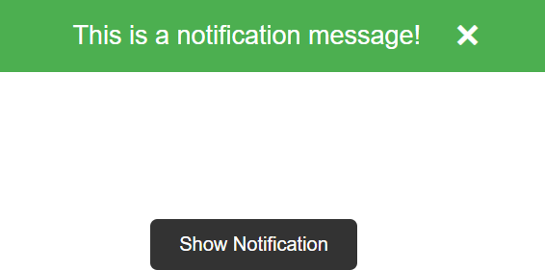

Observation : The notification banner was created using HTML and styled using CSS to appear at the top of the webpage. JavaScript functions were used to show and hide the banner dynamically.
Smooth transition effects were added to provide better user experience. The design ensures a clean and simple interface for displaying notifications.

