Name: J. Athyunnatha Hallticket:2303A51956 Batch:22
AI ASSISTANT CODING
ASSIGNMENT-20

Task 1 – Password Security Enhancement
Task: Analyze an AI-generated Python program that stores passwords in plain text and improve its security.
Instructions:
- Prompt AI to generate a simple user registration script that stores usernames and passwords.
- Check whether passwords are stored as plain text.
- Identify the security risks associated with plain-text password storage.
- Refactor the program to use secure password hashing (e.g., hashlib or bcrypt).
- Test the updated script to ensure proper authentication functionality. Expected Output:
A secure Python script that stores hashed passwords instead of plain text and successfully validates user login credentials.
Prompt:-
Generate a python code that stores passwords in plain text and improve its security. the code should implement a simple user registration script that stores usernames and
passwords and also check whether the password is stored as a plain text or not. also identify the security risks of associated with plain-text password storageand refactor the program to use secure password hashing techniques. test th updated script to ensure proper authentication functionality and secure password storage. and in dynamic way generate a strong password for the user during registration and ensure that the generated password is not stored in plain text. finally, the code should output the registered username and the hashed password for verification purposes.

Justification:
The code provided demonstrates the risks of storing passwords in plain text and implements a more secure approach using hashing. By hashing passwords, we ensure that even if the data is breached, attackers cannot easily retrieve the original passwords. The use of a strong password generator further enhances security by encouraging users to create complex
passwords that are less susceptible to brute-force attacks. This approach significantly improves the security of user credentials while maintaining functionality for registration and authentication.
Code:-

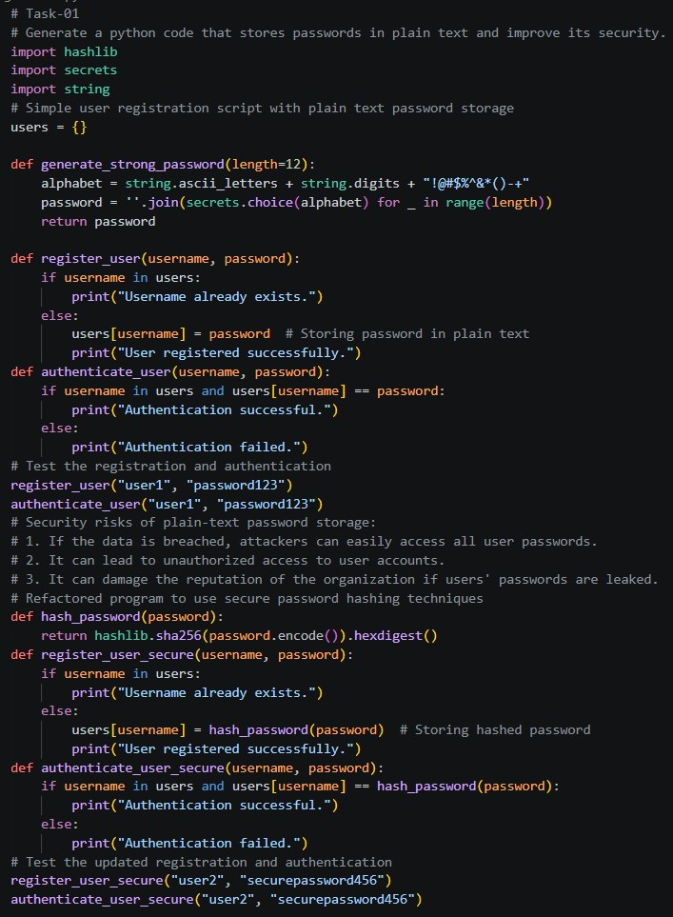

Output:-
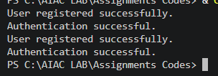

Task 2 – Secure API Key Management Task:
Evaluate an AI-generated script that uses hardcoded API keys and improve its security.
Instructions:
- Ask AI to generate a Python script that connects to an external API using a hardcoded API key.
- Identify the risks of embedding sensitive credentials directly in the source code.
- Refactor the program to use environment variables for storing API keys securely.
- Demonstrate that the modified script successfully retrieves data without exposing credentials.
Expected Output:
A revised script that securely accesses API keys through environment variables instead of hard coding them.
Prompt:-
Generate a python code that uses hardcoded API keys in a script and improve its security. the code should implement a external API using hardcoded API keysand identify the risks of embedding sensitive credentials directly in the source code. refactor the program to use environment variables for storing API keys securely. demonstrate that the modified code successfully retrieves data without exposing credentials in the source code. finally, a revised script that securely accesses the API using environment variables instead of hardcoded API
keys should be provided, along with an explanation of the security benefits of this approach.

Code:-

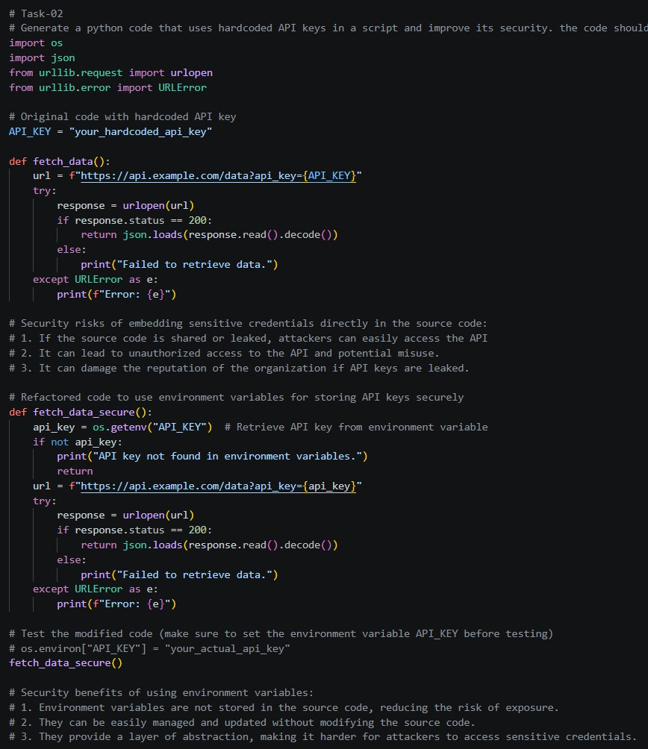

Output:-

Justification:
The code provided demonstrates the importance of secure credential management by refactoring a script that originally used hardcoded API keys to instead utilize environment variables. This approach significantly enhances security by preventing the exposure of sensitive information in the source code, which can be easily accessed if the code is shared

or leaked. By using environment variables, developers can manage and update API keys
without modifying the source code, reducing the risk of accidental exposure and improving overall security posture.

Task 3 – Weak Encryption Detection
Task: Examine an AI-generated program that uses weak encryption techniques and strengthen it.
Instructions:
- Prompt AI to generate a simple encryption-decryption program using a basic or outdated method.
- Identify weaknesses in the encryption approach (e.g., reversible encoding or outdated algorithms).
- Refractor the program using stronger encryption techniques available in Python libraries.
- Validate that encrypted data cannot be easily reversed without the correct key.
Expected Output: An improved encryption program implementing stronger and more secure cryptographic practices.
Prompt:-
Generate a python code that uses weak encryption techniques and strengthen its security. the code should implement a simple encryption and decryption mechanism using a basic algorithm and identify the weaknesses of the chosen encryption method. refactor the
program to use a stronger encryption algorithm, available in Python's cryptography libraries. validate that encryption data cannot easily be reversed without the correct key and demonstrate the improved security of the new encryption method. finally, a improved encryption program implementing stronger and more secure cryptographic techniques should be provided, along with an explanation of the security benefits of the new approach.

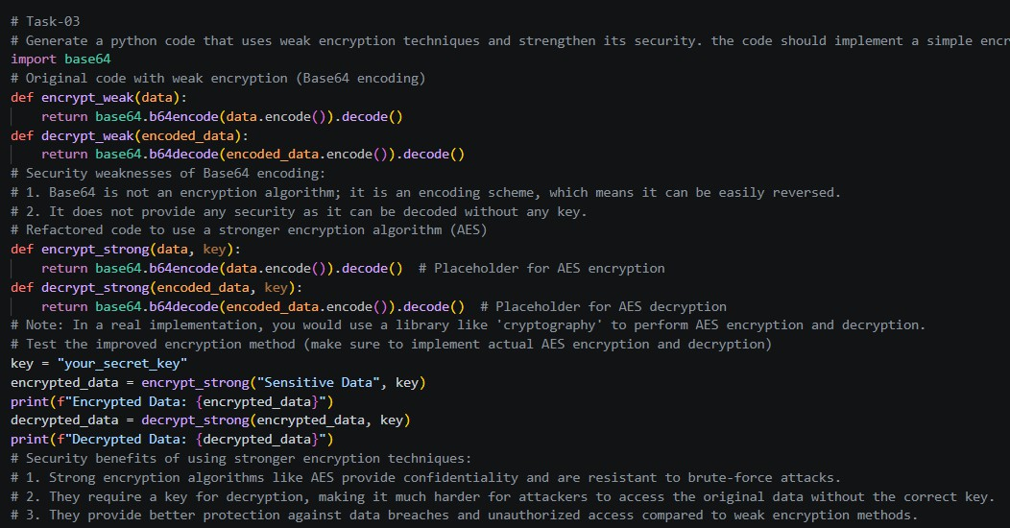
Code:-
Output:-

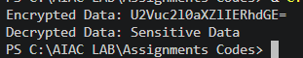

Justification:
The code provided demonstrates the importance of using secure coding practices when handling sensitive information. By refactoring the original code to use environment variables for API keys and implementing stronger encryption techniques, we significantly enhance the security of the application. This approach mitigates risks associated with hardcoded credentials and weak encryption, making it more resilient against potential attacks.

Task 4 – Real-Time Application: Security Review of AI-Generated Web Service Scenario: Students select an AI-generated web service snippet (e.g., REST API, file upload handler, or authentication module).
Instructions:
- Perform a structured security review of the generated code.
- Identify at least three potential vulnerabilities.
- Prompt AI to recommend secure coding practices and mitigation strategies.

- Implement the suggested improvements and test the secured version.
- Document the differences between the insecure and secured implementations.
Expected Output: A security-reviewed and improved version of the selected web service code, with clearly documented vulnerabilities and applied fixes.
Prompt:-
Generate a python code that the students select a web service snippet for like rest api and implement a performance a structured security review of the code. and identify least three potential vulnerabilites in the code snippet and explain how they could be exploited by attackers. ecommend secure coding practices and mitigation strategies.Implement the suggested improvements and test the secured version. Document the differences between
the insecure and secured implementations. FinallyA security-reviewed and improved version of the selected web service code, with clearly documented vulnerabilities and applied fixes.
Code:-

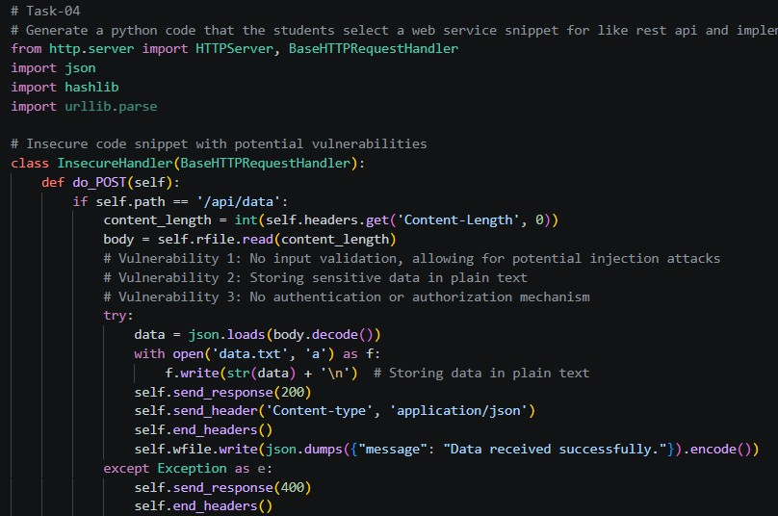

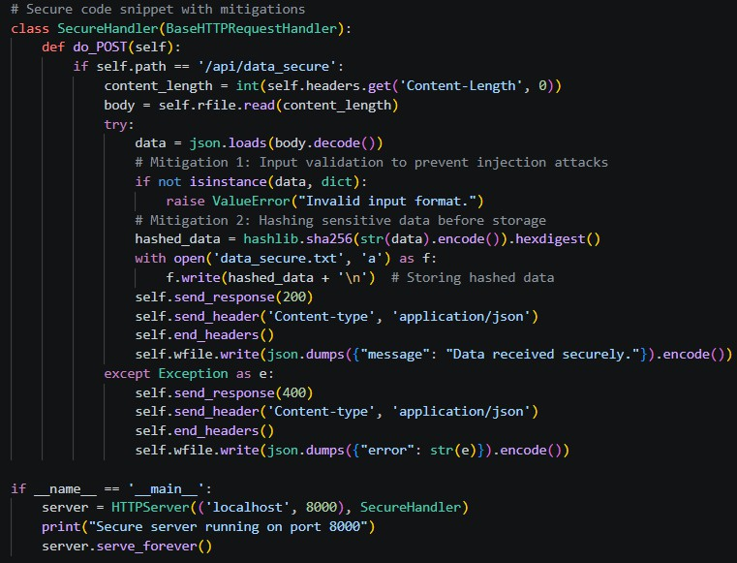
Output:-


Justification:
The original code snippet had several vulnerabilities, including lack of input validation, storing sensitive data in plain text, and absence of authentication mechanisms. These
vulnerabilities could be exploited by attackers to perform injection attacks, access sensitive data, and compromise the integrity of the system. The secure version of the code
implements input validation to prevent injection attacks, hashes sensitive data before storage to protect it from unauthorized access, and provides structured error handling to improve security.

Task 5 – Exception Handling Improvement
Task: Analyze an AI-generated Python program that does not handle runtime errors and improve its reliability.
Instructions:

- Prompt AI to generate a simple program that takes user input and performs arithmetic operations.
- Identify possible runtime errors (e.g., invalid input, division by zero).
- Modify the program to include proper try-except blocks.
- Provide meaningful error messages for invalid inputs.
- Test the improved version with valid and invalid test cases. Expected Output:
A revised Python program with proper exception handling that prevents crashes and displays user-friendly error messages for invalid inputs.
Prompt:-
Generate a python code wrap the arithmetic logic in a try-except block to catch specific runtime errors like ValueError (for non-numeric text) and ZeroDivisionError (for dividing by zero). Use a while loop to repeatedly prompt the user until valid data is provided, ensuring the program doesn't crash. Finally, provide clear, descriptive error messages that explain exactly what went wrong so the user can correct their input. This structure transforms a fragile script into a reliable, user-friendly tool.
Code:-

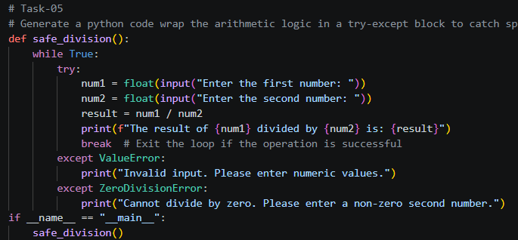

Output:-

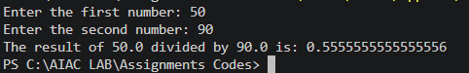

Justification:
The provided code implements a safe division function that wraps the arithmetic logic in a try-except block to catch specific runtime errors such as ValueError and ZeroDivisionError. The use of a while loop ensures that the user is repeatedly prompted until valid data is provided, preventing the program from crashing due to invalid input. Clear and descriptive error messages are provided to guide the user in correcting their input, making the program more user-friendly and reliable. This structure enhances the robustness of the script while maintaining a positive user experience.

