AIAC Assignment - 15.5

NAME : J. ATHYUNNATHA

HT.NO : 2303A51956

BATCH : 22

Task 1 – Student Attendance API Task:
Create a RESTful API for student attendance tracking.
Instructions:
- Endpoints required:
- GET /attendance → View attendance records
- POST /attendance → Mark attendance
- PUT /attendance/{id} → Update attendance record
- DELETE /attendance/{id} → Remove attendance entry
- Ensure JSON-based request and response handling.
Expected Output:
- API for maintaining and updating attendance records. GET:
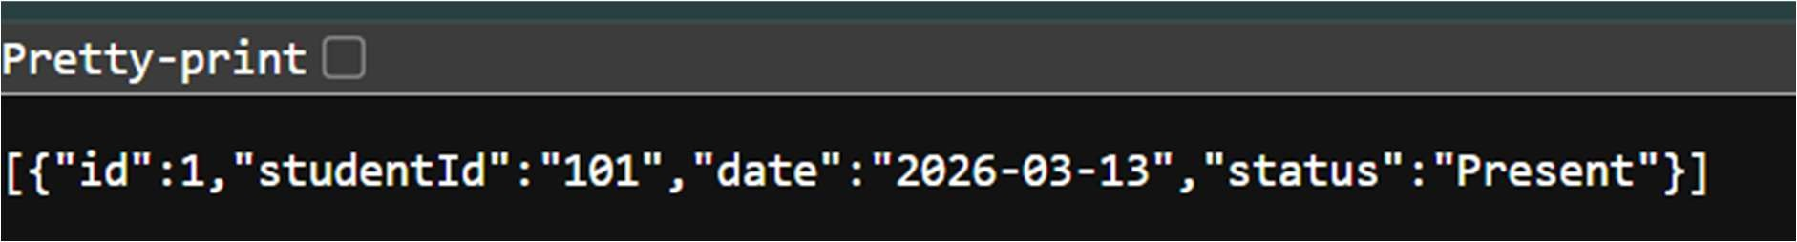
POST:
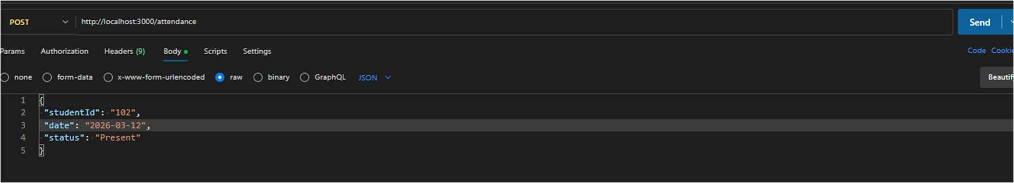
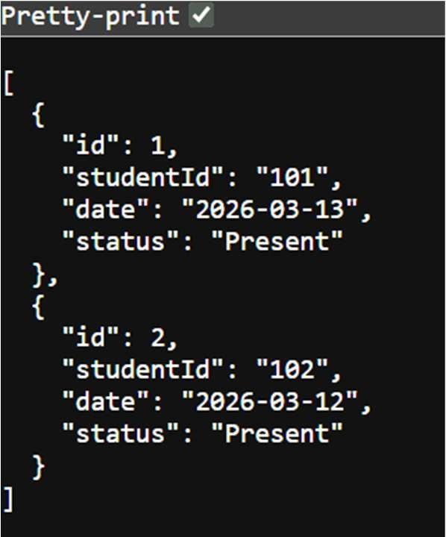

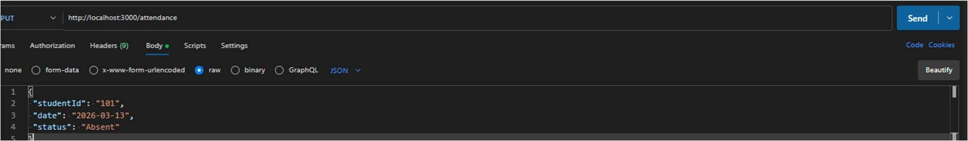
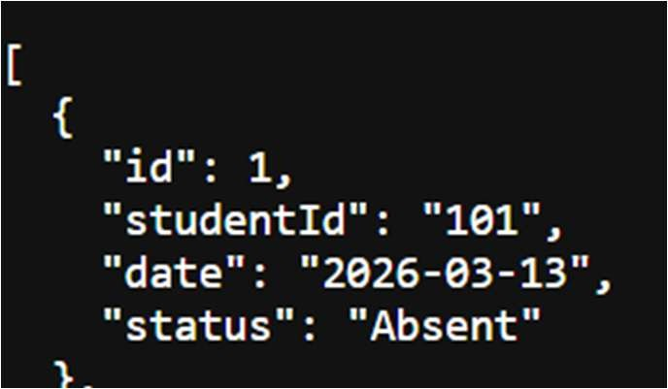
DELETE:
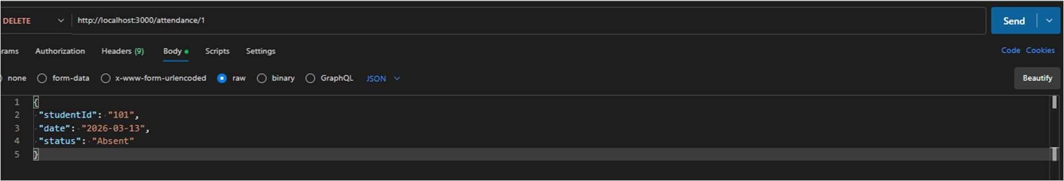
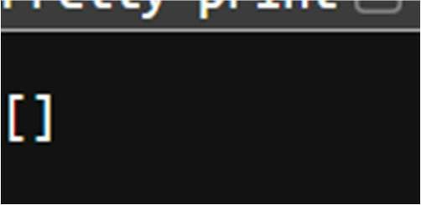

Task 2 – Inventory Management API Task:
Develop a REST API for warehouse inventory management.
Instructions:
- Endpoints required:
- GET /inventory → List all items
- POST /inventory → Add new item
- PUT /inventory/{id} → Update stock quantity
- DELETE /inventory/{id} → Remove an item
- Implement validation for stock values.
Expected Output:
- API capable of managing inventory stock levels. GET:
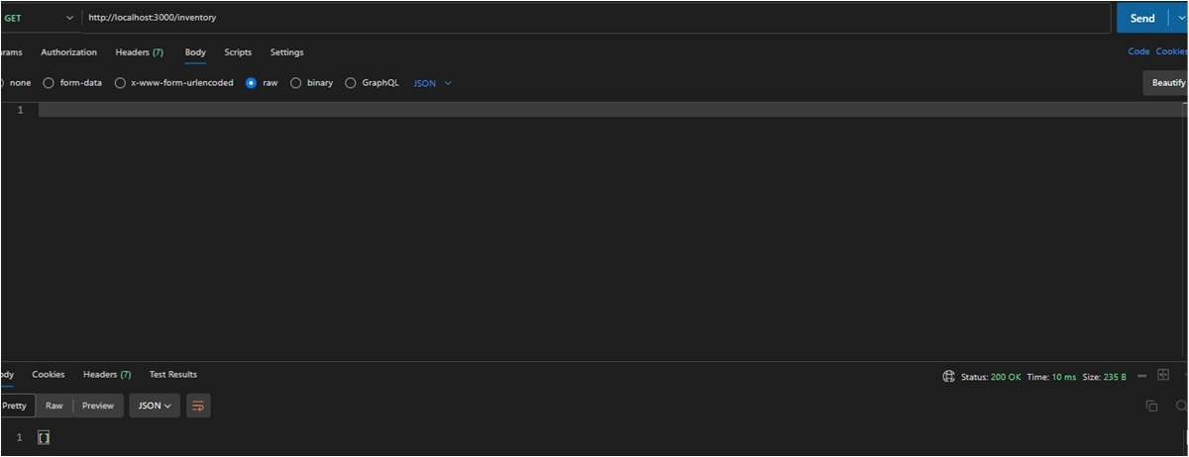

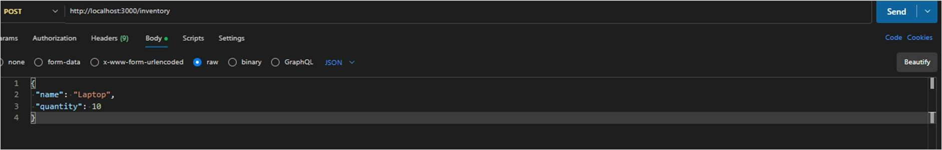
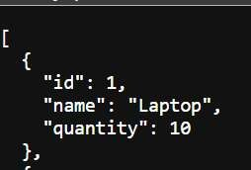
PUT:
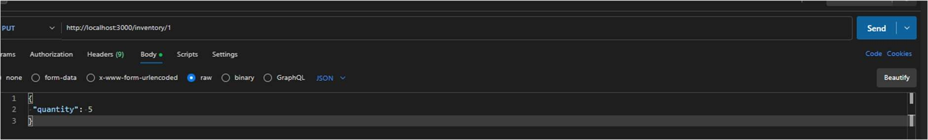
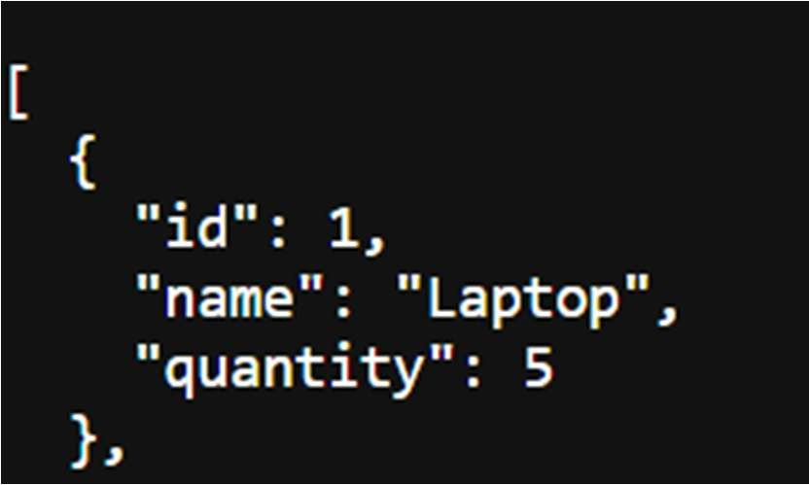

DELETE:
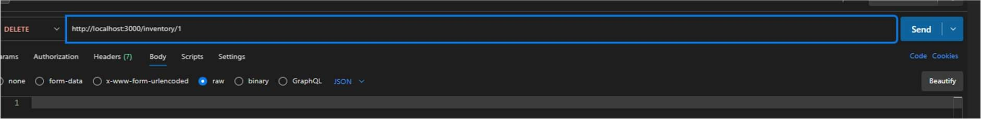
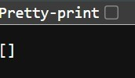

Task 3 – Hotel Room Booking API Task:
Develop a RESTful API for hotel room booking.

- Endpoints required:
- GET /rooms → View available rooms
- POST /rooms/book → Book a room
- GET /rooms/{id} → View booking details
- DELETE /rooms/{id} → Cancel booking
- Implement error handling for unavailable rooms.
Expected Output:
- API simulating hotel room booking operations. GET:
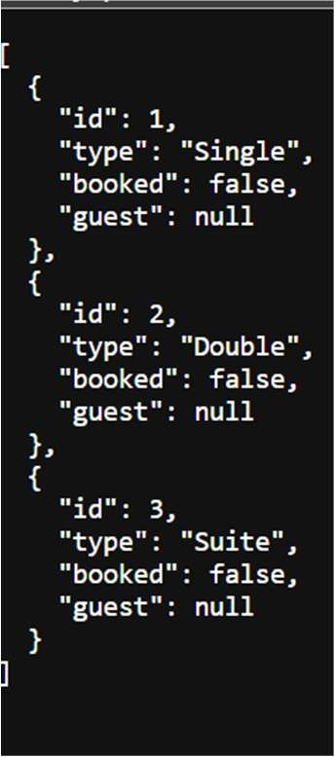
POST:
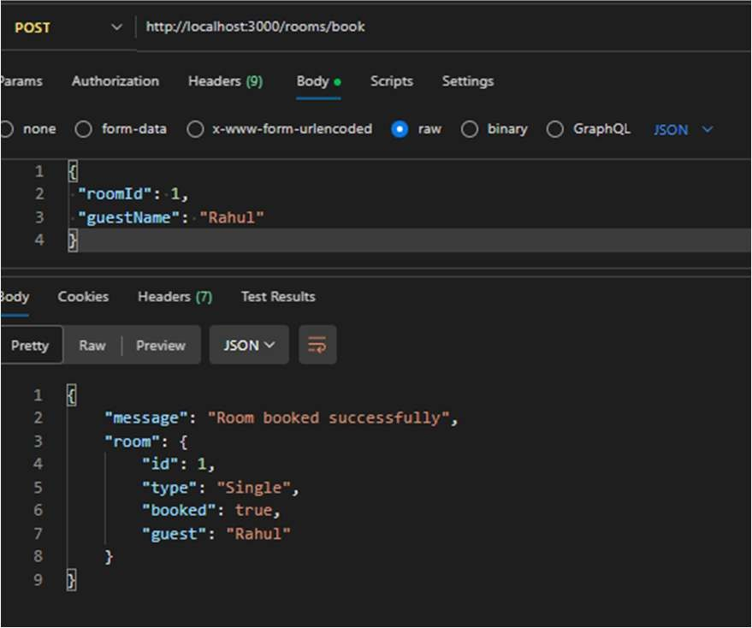

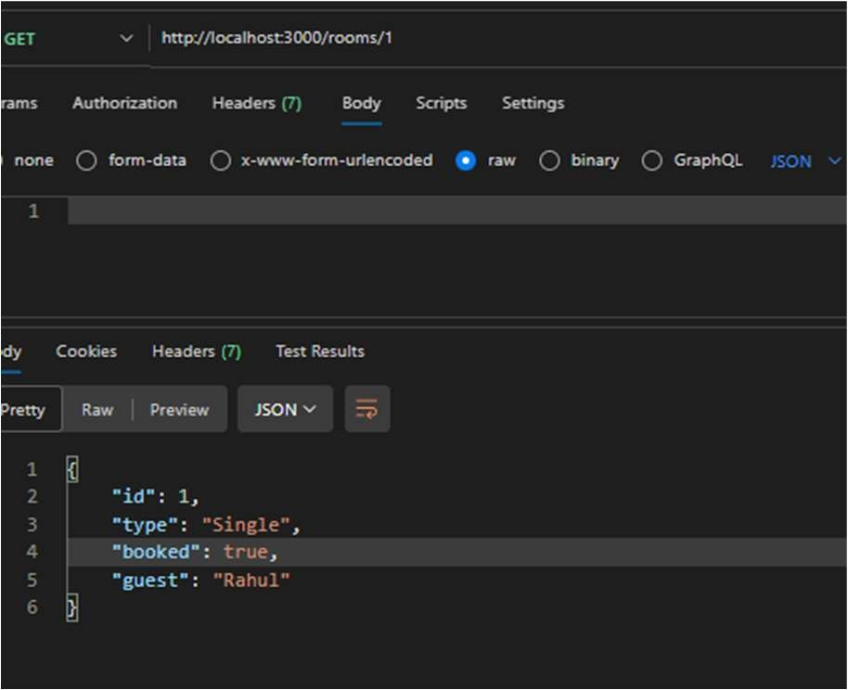
DELETE:
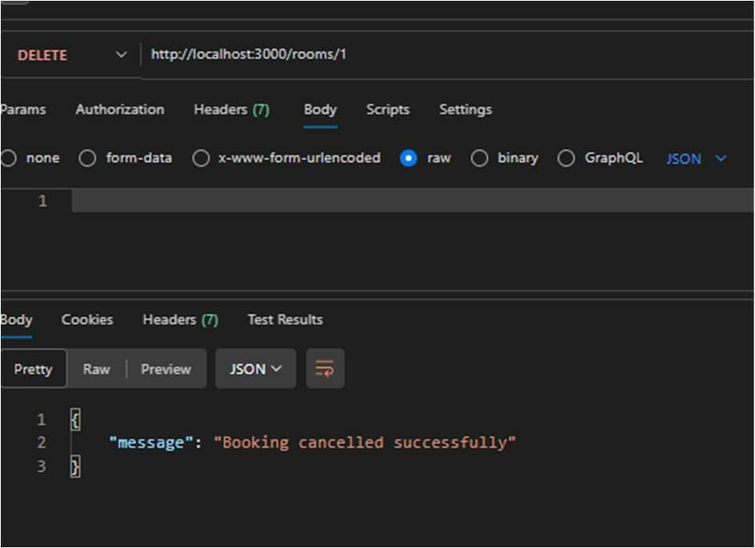
Task 4 – Online Voting API Task:
Create a RESTful API for an online voting system.
Instructions:
- Endpoints required:
- GET /candidates → List candidates
- POST /vote → Cast a vote
- GET /results → View voting results
- Ensure one vote per user using in-memory validation.
Expected Output:
- API simulating a secure online voting process. GET:
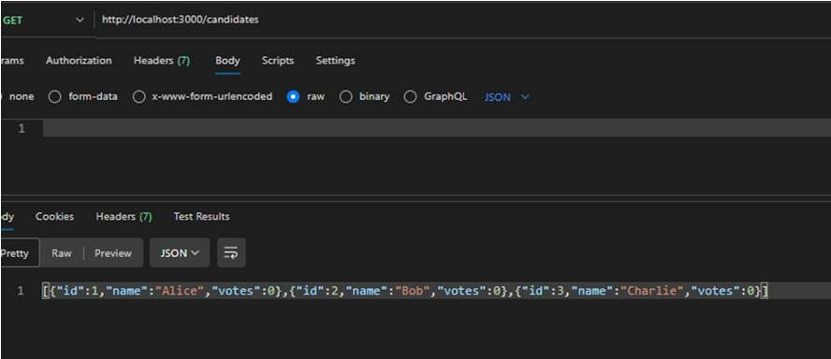

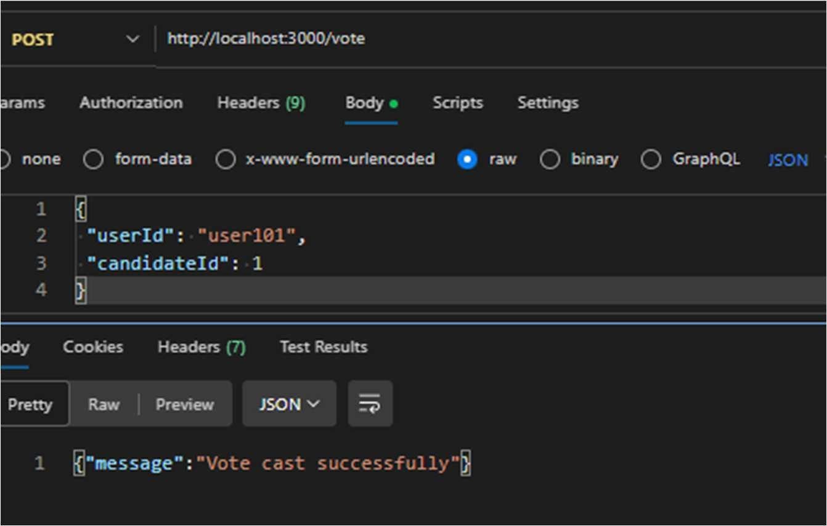
GET:
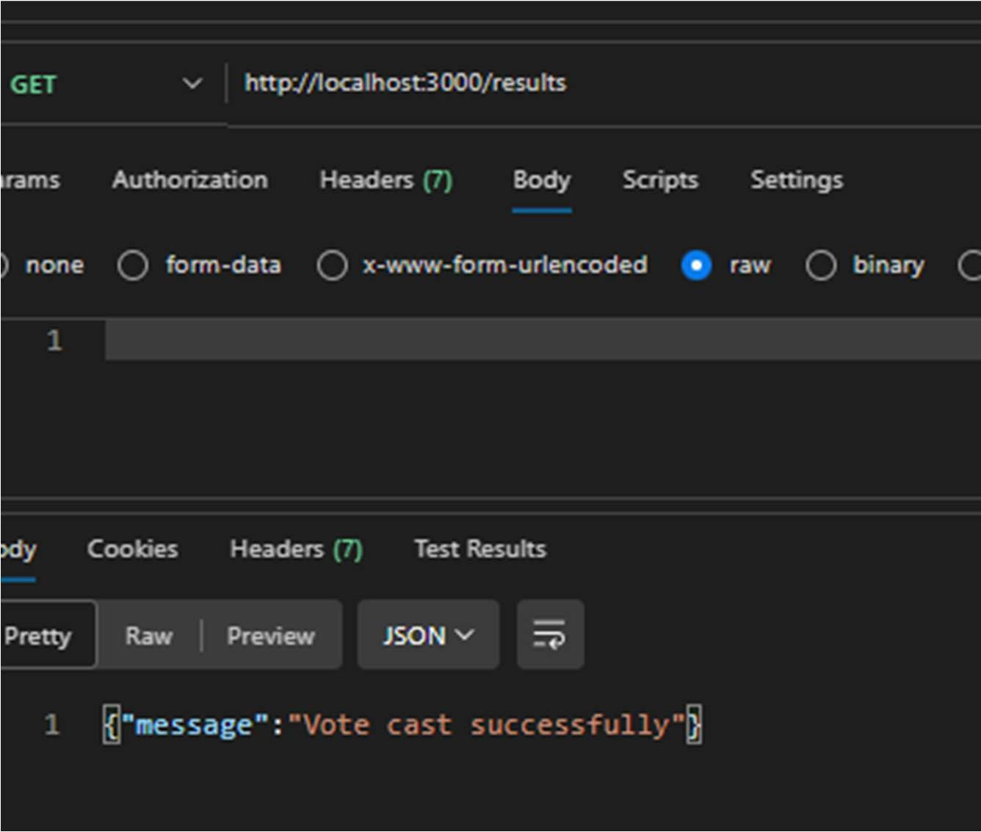
Task 5 – Teacher Management API Task:
Develop a RESTful API to manage teacher records.
Instructions:
- Endpoints required:
- GET /teachers → List all teachers
- POST /teachers → Add a new teacher
- PUT /teachers/{id} → Update teacher details
- DELETE /teachers/{id} → Remove a teacher
- Ensure proper error handling and JSON responses.

- Functional API for managing teacher information. GET:
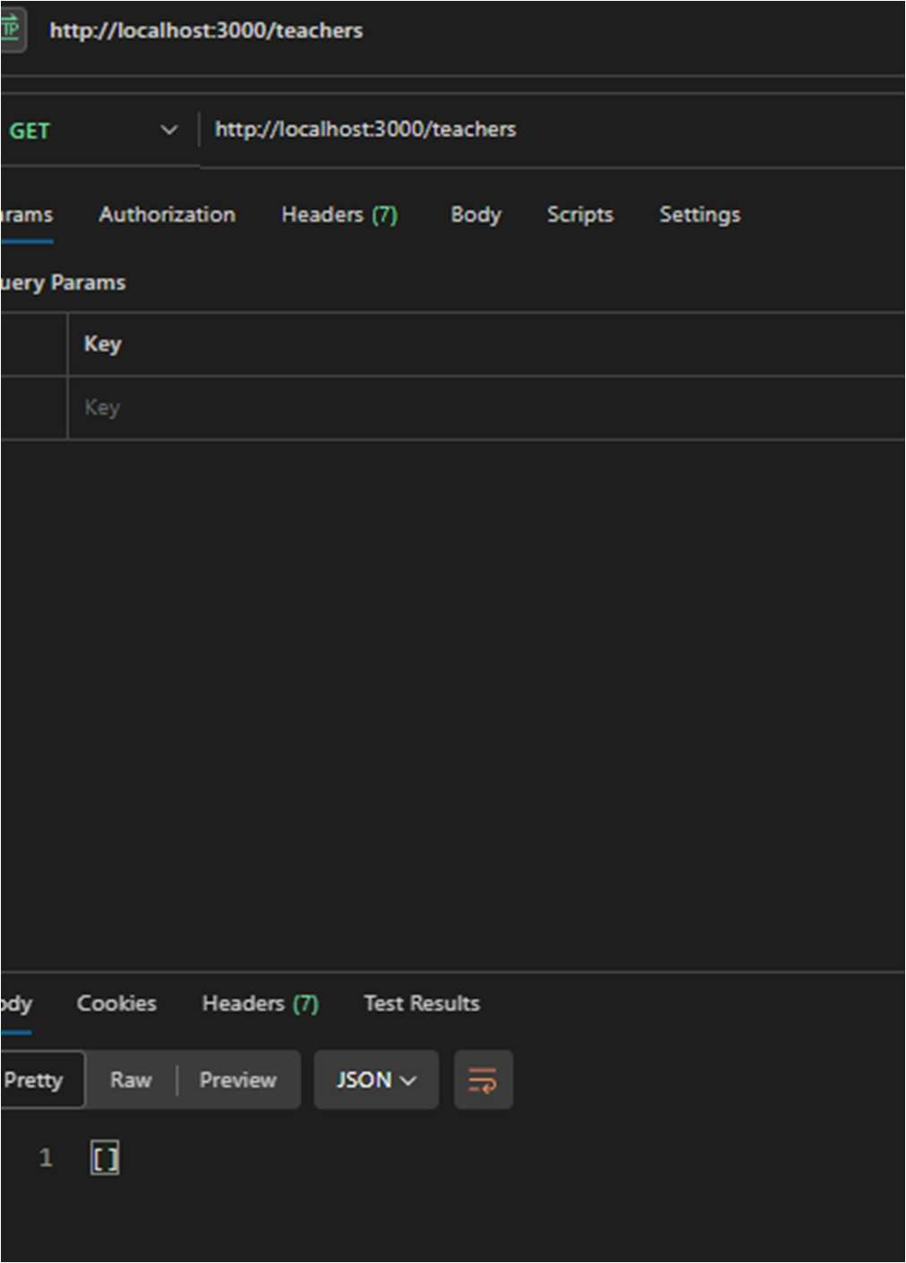
POST:

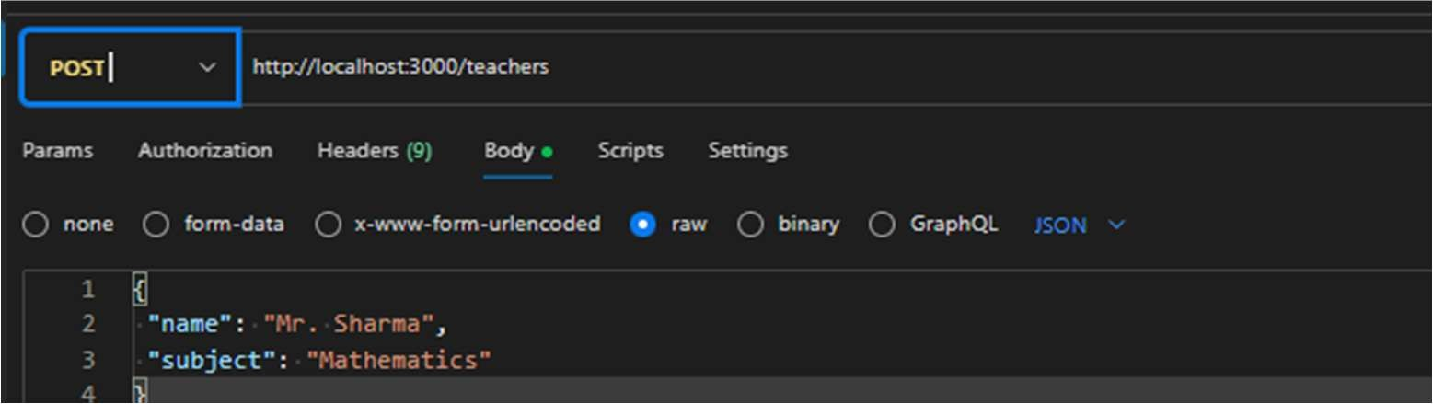
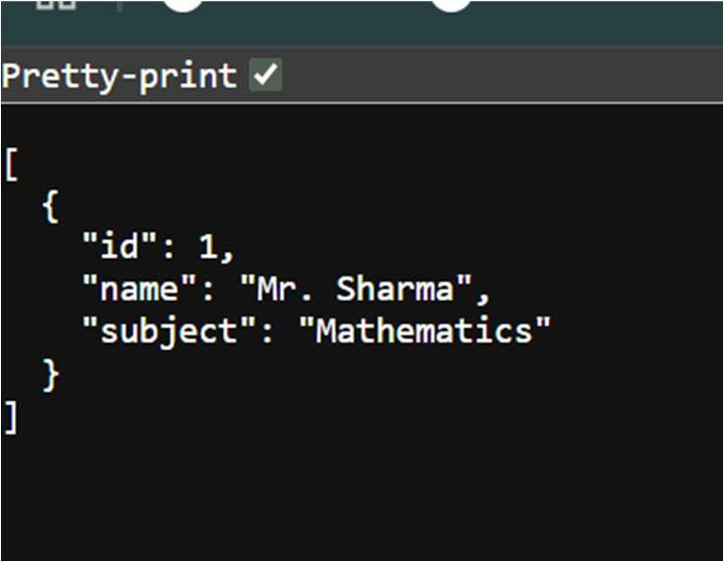

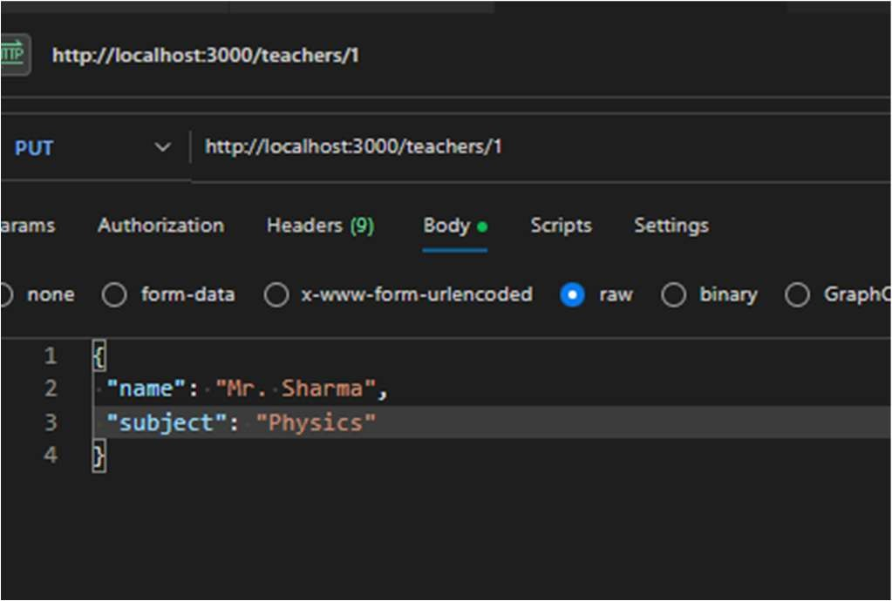
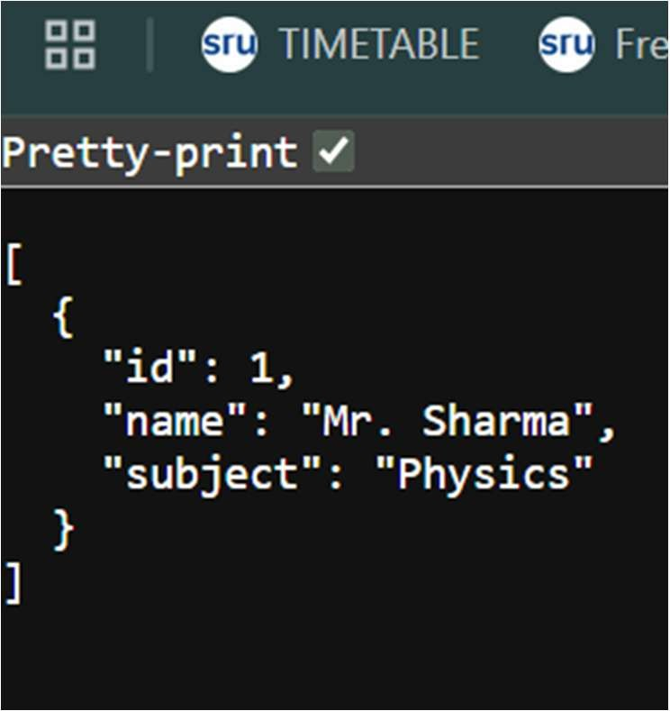
DELETE:
