

SENTIMENT ANALYSIS OF THE 2024 PARIS OLYMPICS

TABLE OF CONTENTS

BUSINESS UNDERSTANDING 2

Overview 2

Challenges 2

Proposed Solutions 3

Success Metrics 3

Conclusion 4

Problem Statement 4

Objectives 4

**Main Objective 4**

**Specific Objectives 4**

DATA UNDERSTANDING 5

Data Sources 5

Datasets 5

Relevance of The Data 5

DATA PREPARATION 6

Data Cleaning 6

Exploratory Data Analysis 7

MODELING 9

CONCLUSION 10

RECOMMENDATIONS 10

# BUSINESS UNDERSTANDING

## Overview

The Paris Olympics is a global sporting event that has garnered significant attention and engagement across various social media platforms. Analyzing public sentiment regarding the Olympics can provide valuable insights into how athletes, countries and the overall event are perceived. This analysis can benefit sports organizations, media outlets, sponsors offering feedback on public perception, performance and engagement levels thus helping to tailor content and marketing strategies. Sentiment analysis can also benefit city officials to improve planning and address concerns such as health and sanitation.

The goal of this project is to perform a comprehensive sentiment analysis of social media content related to this year's Paris Olympics to understand public sentiment, identify emerging trends and provide a comprehensive understanding of how different aspects of the Olympics resonate with audiences worldwide.

## Challenges

1. Social media data is noisy and unstructured presenting challenges for accurate analysis.
2. Distinguishing between positive, negative and neutral sentiments can be difficult especially when dealing with multilingual content thus affecting sentiment analysis accuracy
3. The volume of social media posts and comments can be overwhelming particularly during major events like the Olympics. Managing and processing large volumes of real-time data necessitates efficient data handling and processing techniques.
4. Interpreting context and sarcasm an extra layer of complexity as the sentiment expressed may not always align with the literal meaning of the words used. Social media content often includes informal language, slang and nuanced expressions that can skew sentiment analysis.

## Proposed Solutions

1. Use API access to collect data from major social media platforms and ensure compliance with platform policies and data protection regulations.
2. Implement text normalization, tokenization and content filtering while utilizing language detection and translation tools for multilingual data handling.
3. Employ advanced natural language processing models like BERT or GPT for sentiment classification incorporating sarcasm detection and contextual analysis for improved accuracy.
4. Create an interactive dashboard using Tableau to display sentiment trends and insights with features for data filtering and exploring different aspects of the data.

## Stakeholders

1. Organizers of the Paris Olympics 2024 - Sentiment analysis helps them gauge public opinion allowing them to make informed decisions and adjust their strategies accordingly.
2. Sponsors - Sentiment analysis helps them understand how their brand is perceived in relation to the Olympics.
3. Media outlets - Sentiment analysis provides them with insights into public interest and trending topics.
4. Fans and general public - They are the primary audience for the Olympics and their sentiment directly impacts the event's success.
5. Athletes - They are the central figures of the Olympics and public sentiment towards them can affect their performance and well-being.
6. Local authorities and businesses in Paris - The Olympics significantly impact the host city and sentiment analysis can help gauge public opinion on local issues related to the event.

## Success Metrics

1. Accuracy – The proportion of correctly classified sentiments (positive, negative, neutral) out of all sentiments predicted by the model.

**85% - 90%**

1. Precision - The proportion of true positive sentiment predictions (correctly identified positive tweets) out of all predicted positives.

**80% - 90% for both positive and negative sentiment classes.**

**75% - 85% for the neutral class.**

1. Recall - The proportion of true positive sentiment predictions out of all actual positives.

**75% - 80% for all sentiment classes.**

1. F1 Score - The harmonic mean of Precision and Recall that provides a single metric that balances both precision and recall.

**0.75 to 0.85**

## Conclusion

This sentiment analysis project aims to deliver a comprehensive understanding of public opinion about the Paris Olympics by leveraging social media data. By addressing the challenges of data quality, sentiment accuracy, multilingual content and implementing advanced NLP techniques, the project will provide actionable insights to the aforementioned stakeholders. Successful execution will enable better engagement strategies and enhance the overall experience of the Olympics for audiences worldwide

## Problem Statement

The Paris Olympics is a high-profile event that generates a substantial volume of unstructured social media data that reflects public sentiment. The challenge lies in effectively analyzing this vast and diverse stream of data while also tackling challenges such as language differences, sentiment variations and contextual meanings in order to provide accurate and actionable insights.

## Objectives

Main Objective

Develop a comprehensive social media sentiment analysis model that accurately captures and interprets public sentiment about the Paris Olympics from social media data.

Specific Objectives

1. To extract, preprocess and clean social media data from multiple platforms addressing quality issues and handling multilingual content related to the Paris Olympics.
2. To develop and train advanced natural language processing models to accurately classify sentiments incorporating techniques to handle sarcasm and contextual nuances.
3. To create interactive visualizations to display sentiment trends and key events providing actionable insights to stakeholders based on comprehensive analysis of public opinions.

# DATA UNDERSTANDING

## Data Sources

1. APIs - Extract data from social media sites such as Twitter, Facebook and Instagram in the form of posts, tweets, comments and hashtags using their respective APIs.

The focus will be on posts mentioning Paris Olympics, relevant hashtags and location-based data.

1. **Web Scraping -** Extract additional data from comments and discussions from news sites and sports forums such as ESPN and Sports Center

## Datasets

1. **Social media data in the form of tweets, facebook and Instagram posts and comments mentioning the Paris Olympics.**
2. **News articles, comments and replies discussing the various** aspects of the Olympics.

## Relevance of The Data

The data sources and datasets identified for this project are highly relevant to analyzing public sentiment surrounding the Paris Olympics. Social media platforms like Twitter, Facebook and Instagram capture immediate reactions, discussions and emotional responses from a global audience thus providing a rich source of unfiltered public sentiment.

The inclusion of location-based data and relevant hashtags allows for more targeted analysis potentially revealing geographical trends and topic-specific sentiments. Complementing this with web scraping of news sites and sports forums like ESPN and Sports Center adds depth to the analysis by incorporating more structured discussions and content.

This combination of data sources offers a comprehensive view of public sentiment ranging from spontaneous reactions on social media to more considered opinions in news comment sections and sports forums.

# DATA PREPARATION

The data processing involved steps to analyze and clean a dataset of tweets related to the 2024 Paris Olympics. The initial dataset was composed of multiple CSV files but was later merged into a single DataFrame. A DataUnderstanding class was created to check the dataset’s shape, columns, unique values, missing data and duplicates.

Upon examining the dataset we noted that some columns had missing values particularly in the `Tweet_Timestamp`, `Tweet_Number_of_Reviews`, ``Tweet_Image_URL, `Tweet_Number_of_Retweets`, `Tweet_Number_of_Likes` and `Tweet_Number_of_Looks` columns. The dataset also contained a high number of duplicated records which were primarily false positives due to partial similarities rather than exact matches across all columns.

While the dataset contained many apparent duplicates, the true duplicates were fewer. The analysis revealed discrepancies and potential errors in data identification prompting further data cleaning to ensure accurate results.

## Data Cleaning

In the data cleaning process, irrelevant columns such as `Tweet_Image_URL`, `Web_Page_URL` and `Tweet_AD` were dropped, duplicates and rows with null values were also removed. Column names were stripped of whitespace and the `Tweet_Timestamp` column was converted to datetime format. The cleaned dataset was then filtered to include only data from the year 2024. Data completeness was ensured by confirming the absence of null values and addressing consistency issues where rows were incorrectly identified as duplicates. Engagement columns were converted to numeric values and text preprocessing involved removing URLs (unlimited resource locators), mentions, hashtags, punctuation and numbers while retaining relevant tokens.

## Exploratory Data Analysis

Exploratory Data Analysis involved examining and visualizing data to understand its main characteristics, patterns and relationships. It revealed trends, correlations and anomalies in the tweet sentiments and engagement around the Olympics which may not have been immediately apparent in the raw data. We made use of bar plots, heat maps, word clouds and line plots to visualize the Paris Olympics 2024.

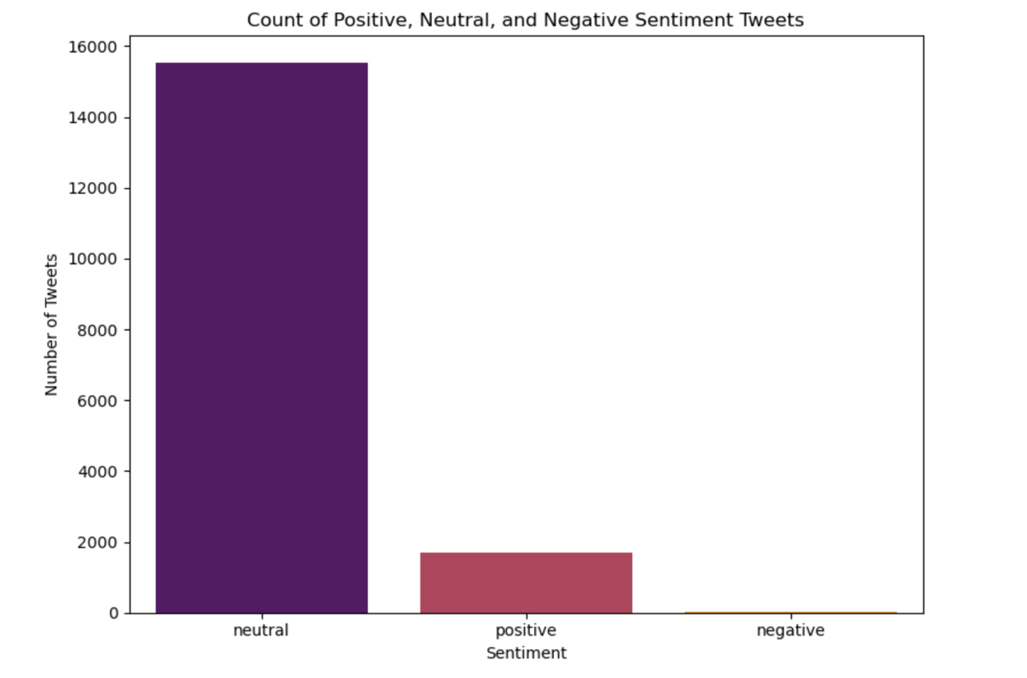

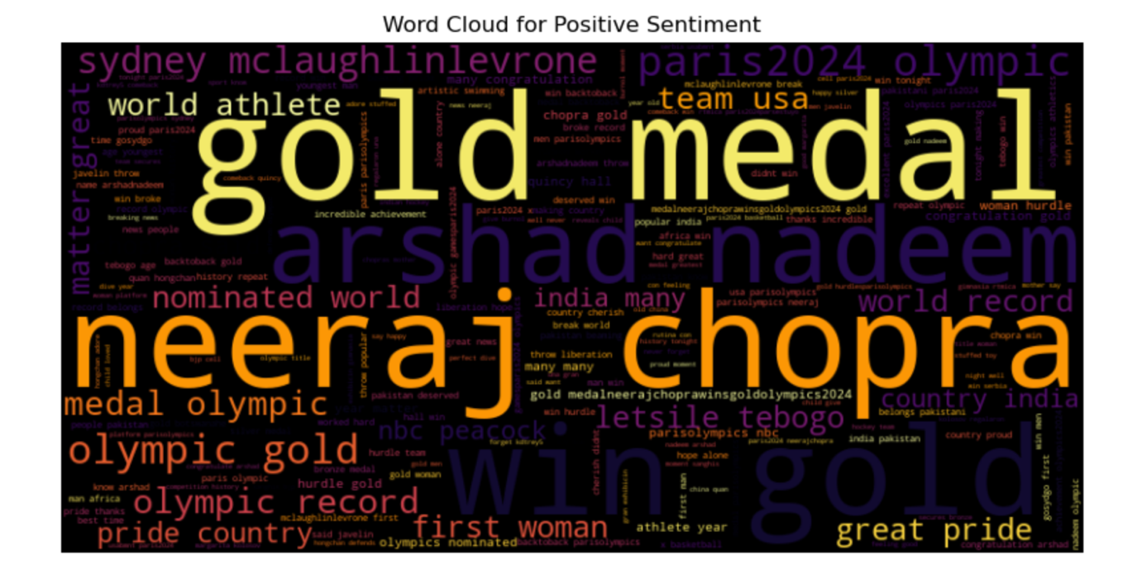

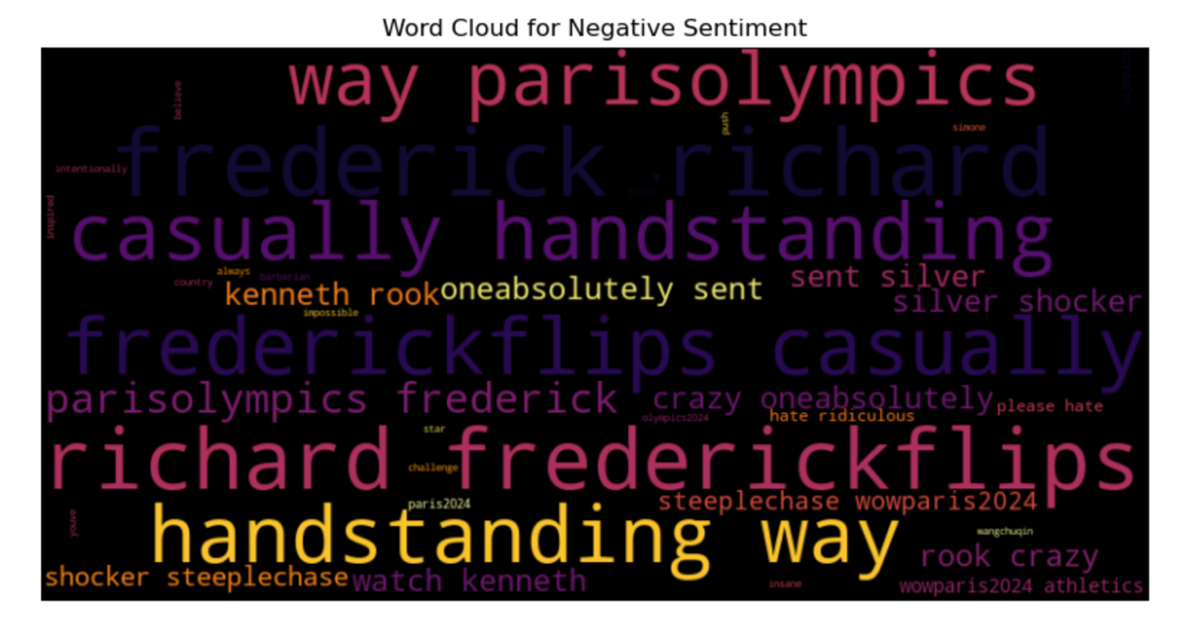

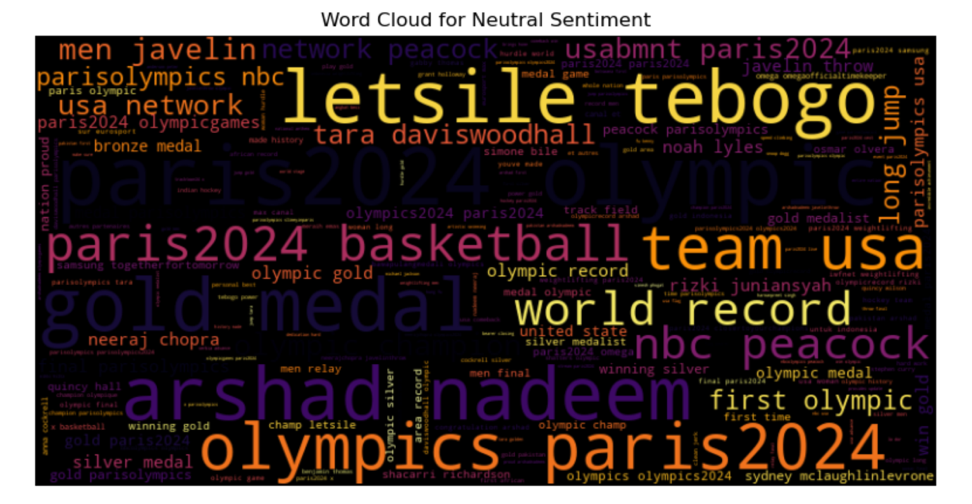

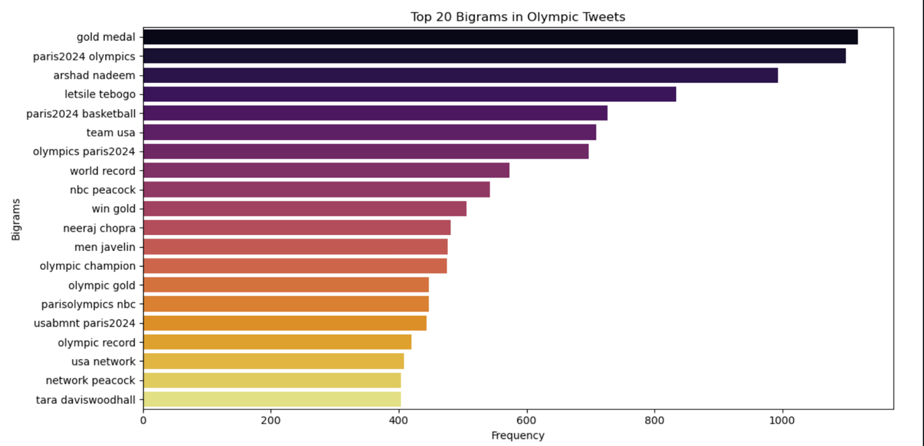

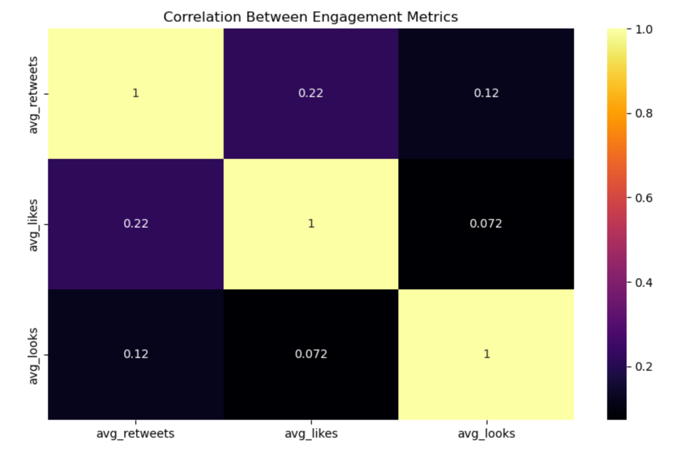

# MODELING

The modeling process began by preprocessing the data which included cleaning tweets and applying sentiment analysis using VADER. To address class imbalance we employed SMOTE (Synthetic Minority Over-sampling Technique). We then evaluated several machine learning models including Logistic Regression, Support Vector Machine, Random Forest and Naive Bayes using a pipeline approach. Each model was trained and evaluated based on accuracy. The Random Forest model emerged as the best performer with an accuracy of 0.809. Further hyperparameter tuning was performed on this model using GridSearchCV which slightly improved its performance. The final tuned Random Forest model and the TF-IDF vectorizer were saved for future use. Pre-trained models namely VADER and DistilBERT were evaluated and saved for potential deployment.

Results of the modeling process:

* The Random Forest model performed best with an accuracy of 0.809.
* SMOTE effectively addressed the class imbalance issue.
* The tuned Random Forest model showed strong performance in classifying Neutral and Positive sentiments.
* Pre-trained models like VADER and DistilBERT provided alternative approaches to sentiment analysis.
* The models struggled more with accurately classifying Negative sentiments compared to Neutral and Positive sentiments.

# CONCLUSION

The sentiment analysis project for the 2024 Paris Olympics successfully developed robust models for classifying public sentiment. The hyperparameter-tuned Random Forest model demonstrated strong performance particularly in identifying Neutral and Positive sentiments. The incorporation of pre-trained models like VADER and DistilBERT provided additional tools for sentiment analysis offering flexibility in approach. While the models showed good overall accuracy, there's room for improvement especially in classifying negative sentiments.

# RECOMMENDATIONS

To enhance the project's impact, several steps were suggested. Firstly, recognizing and rewarding loyal fans and influential retweeters with exclusive content could strengthen relationships and encourage ongoing support. Secondly, maintaining engagement with audiences post-Olympics through sharing highlights and follow-up content would help keep the Olympic spirit alive. Thirdly, analyzing retweet patterns across different regions and customizing messaging accordingly could improve resonance with local audiences. Lastly, using insights gained from this analysis to inform strategies for future Olympic Games or large-scale events would be valuable. Additional steps like feature engineering, identifying trending topics and influencers, and setting up mechanisms for continuous learning and model updates could further improve the sentiment analysis capabilities and its practical applications.

1. Implement a real-time sentiment tracking dashboard for organizers and media partners, allowing them to respond quickly to shifts in public opinion.
2. Develop a multi-lingual sentiment analysis capability to cater to the international nature of the Olympics, using language-specific versions of VADER where available.
3. Create a sentiment-based alert system for potentially controversial or viral topics, enabling rapid response from the communications team.
4. Integrate sentiment analysis results with other data sources (e.g., ticket sales, TV ratings) to provide a comprehensive view of public engagement.
5. Use sentiment trends to guide content creation and social media strategies, focusing on themes and athletes that generate positive engagement.
6. Provide regular sentiment reports to sponsors, helping them optimize their Olympic-related marketing campaigns.
7. Collaborate with local Paris businesses to use sentiment data for improving visitor experiences during the Olympics.

# NEXT STEPS

1. Enhance Feature Engineering: Incorporate Olympics-specific features such as mentions of specific sports, athletes, or events to improve classification accuracy.
2. Develop Custom Olympic VADER Lexicon: Create a specialized lexicon for VADER that includes Olympic-specific terms and their sentiment associations.
3. Implement Cross-Platform Analysis: Extend the sentiment analysis to multiple social media platforms and news sources for a more comprehensive view.
4. Create Interactive Visualizations: Develop user-friendly, interactive dashboards for stakeholders to explore sentiment data in real-time.
5. Establish Benchmarking System: Set up a system to compare sentiment trends with previous Olympic events to identify unique characteristics of the Paris Olympics.
6. Automate Insight Generation: Develop algorithms to automatically identify and report on significant shifts in sentiment or emerging trends.
7. Conduct Stakeholder Training: Offer training sessions for various stakeholders on how to interpret and act upon the sentiment analysis results.
8. Plan for Long-Term Analysis: Set up infrastructure for continued analysis post-Olympics to track the event's lasting impact on public sentiment towards Paris and the Olympic movement.