**SCRIBBLES**

**TO DO LIST APP**

APP DESCRIPTION

In this fast paced world, it is becoming harder and harder for people to remember and manage daily tasks. The creation of to-do list app makes it easier for users to create and manage daily tasks.

GOALS

* To improve the memory of the user.
* To improve the memory of the user through prioritization.
* To motivate the user by dividing long term goals into smaller achievable long term goals. Ticking them off the list improves the user’s confidence
* To improve the organization of the user.
* To enhance the management of the user’s time as less time is spent trying to remember the tasks to be done.

FEATURES

The user can be able to:

* Add a new To Do to the list.
* Remove a To Do or mark it as done.
* Reorder tasks.

**UML DIAGRAM SYMBOLS**

1. Actor

An entity that performs a role in a given system.

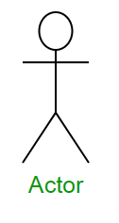

1. System

It sets the boundary of the system in relation to the actors who use it and the features it must provide.

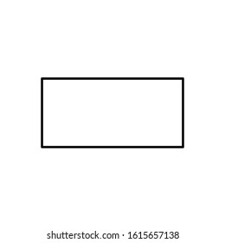

1. Initial State

The starting stage before an activity takes place.

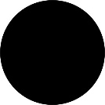

1. Final State

It represents the end of a system.

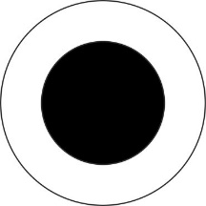

1. Decision Box

It makes sure the control flow or object follows only one path.

1. State or activity box

It represents the set of actions to be performed.

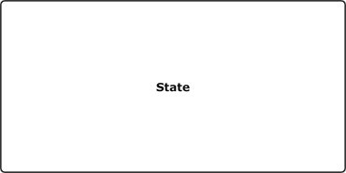

1. Use Case

Identifies a key feature of the system, which fulfill the actor requirements.

1. Association

Identifies an interaction between actors and use cases.

1. Dependecy

A relationship in which one element, the client, uses or depends on another element, the supplier.

1. Generalization

This is a relationship in which on model element is based on another model element.

1. Action Flow

Shows the transition from one activity state to another.

1. Fork

It is control node that splits a flow into multiple concurrent flows.

1. Merge

It is a node in which several flows are merged into a single flow.

It has an arbitrary number of in incoming edges and exactly one outgoing edge.

1. Join

This is a control node that synchronizes multiple flows.

It has multiple incoming edges and one outgoing edge.

control flow or object flow will follow only one path