|  |  |  |  |  |
| --- | --- | --- | --- | --- |
|  |  |  |  |  |
|  |  |  |  |  |
|  |  |  |  |  |
|  |  |  |  |  |
|  |  |  |  |  |
|  |  |  |  |  |
|  |  |  |  |  |
|  |  |  |  |  |
|  |  |  |  |  |
|  |  |  |  |  |
|  |  |  |  |  |











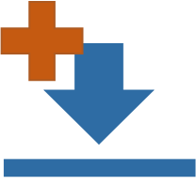



[This Photo](https://commons.wikimedia.org/wiki/File:Simpleicons_Interface_link-symbol-of-two-chains-links-linked.svg) by Unknown Author is licensed under [CC BY-SA](https://creativecommons.org/licenses/by-sa/3.0/)

