

RISC-V Pipeline Processor
Tracer Assignment

Submitted by:
Muhammad Atif

Date: 25-Sep-2024
NUST Chip Design Centre (NCDC), Islamabad, Pakistan
Test Case 1
Assembler Code:
addi x2, x0, 5 # x2 = 5
addi x3, x0, 12 # x3 = 12
addi x4, x0, 0 # x4 = 0
addi x5, x0, 20 # x5 = 20
addi x6, x0, 30 # x6 = 30
addi x7, x3, -9 # x7 = (12 - 9) = 3

or x8, x2, x5 # x8 = 5 | 20 = 21
and x9, x6, x5 # x9 = 30 & 20 = 20
xor x10, x9, x7 # x10 = 20 ^ 3 = 23
sll x11, x2, x3 # x11 = 5 << 12
srl x12, x6, x2 # x12 = 30 >> 5 = 0
sra x13, x6, x2 # x13 = 30 >> 5 (arithmetic)

slt x14, x3, x5 # x14 = (12 < 20) = 1
beq x14, x0, skip1 # Branch if x14 == 0 (not taken)
addi x15, x0, 7 # x15 = 7
skip1: addi x15, x15, 1# x15 = x15 + 1 = 8

sw x5, 100(x0) # MEM[100] = 20
lw x16, 100(x0) # x16 = MEM[100] = 20
sw x6, 104(x0) # MEM[104] = 30
lw x17, 104(x0) # x17 = MEM[104] = 30

add x18, x2, x5 # x18 = 5 + 20 = 25
sub x19, x6, x2 # x19 = 30 - 5 = 25
bne x18, x19, skip2 # Branch if x18 != x19 (not taken)
addi x20, x0, 50 # x20 = 50
skip2: sub x21, x20, x5 # x21 = 50 - 20 = 30

jal x1, target
addi x22, x0, 99
target: addi x23, x0, 42 # x23 = 42
jalr x24, x1, 0

done: beq x0, x0, done

Pipeline Instructions:
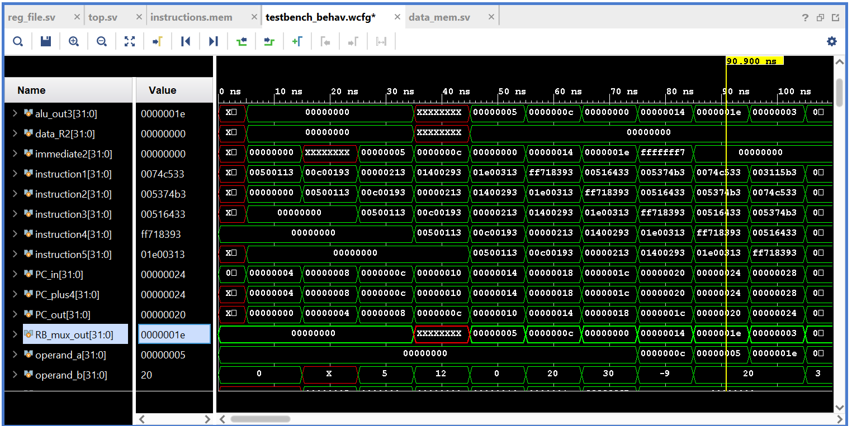
Register File:
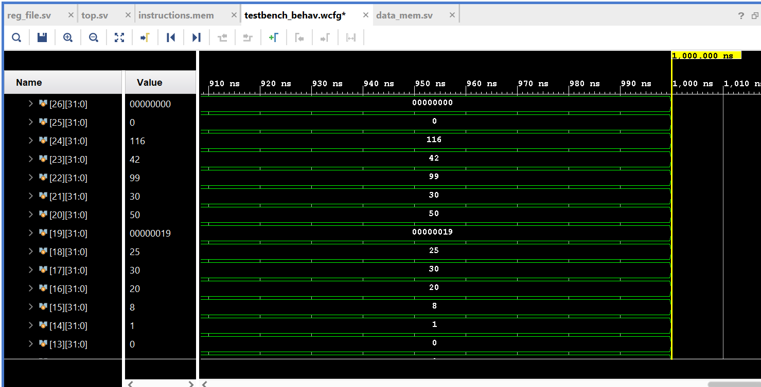
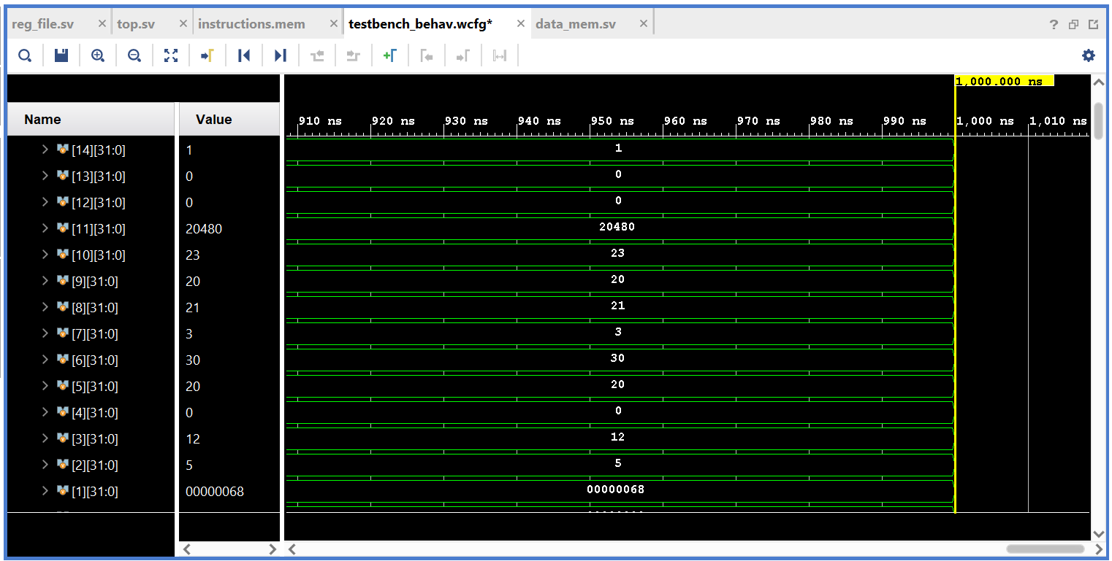

Data Memory:
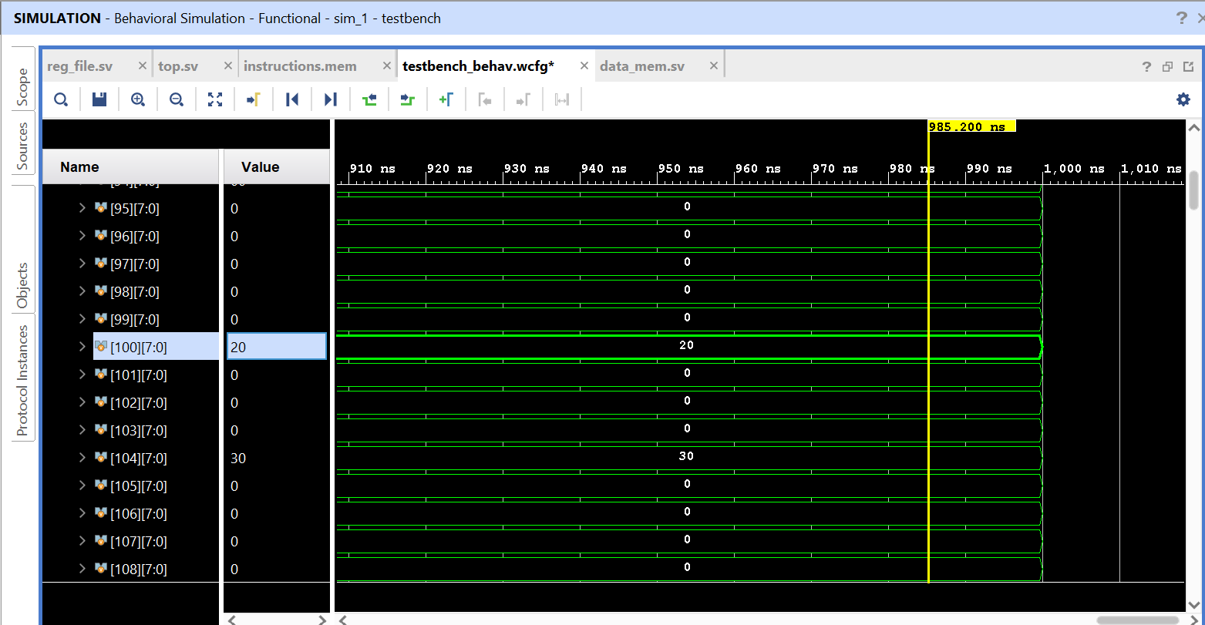

Test Case 2
Assembly Code:
main: addi x2,x0,5
addi x3,x0,12
addi x7,x3,-9
or x4,x7,x2
and x5,x3,x4
add x5,x5,x4
beq x5,x7,end
slt x4,x3,x4
beq x4,x0,around
addi x5,x0,0
around: slt x4,x7,x2
add x7,x4,x5
sub x7,x7,x2
sw x7,84(x3)
lw x2,96(x0)
add x9,x2,x5
jal x3,end
addi x2,x0,1
end: add x2,x2,x9
sw x2,0x20(x3)
done: beq x2,x2,done

Machine Code:
0x00500113
0x00C00193
0xFF718393
0x0023E233
0x0041F2B3
0x004282B3
0x02728863
0x0041A233
0x00020463
0x00000293
0x0023A233
0x005203B3
0x402383B3
0x0471AA23
0x06002103
0x005104B3
0x008001EF
0x00100113
0x00910133
0x0221A023
0x00210063

Pipeline Instructions:
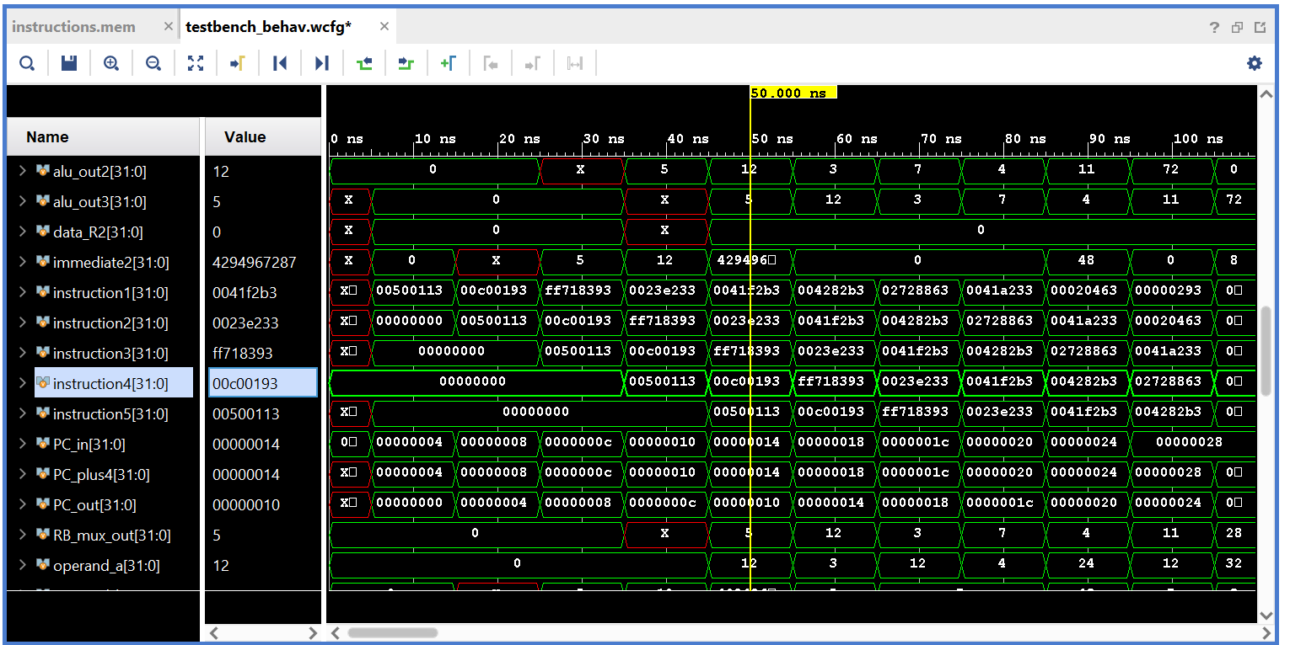
Register File:
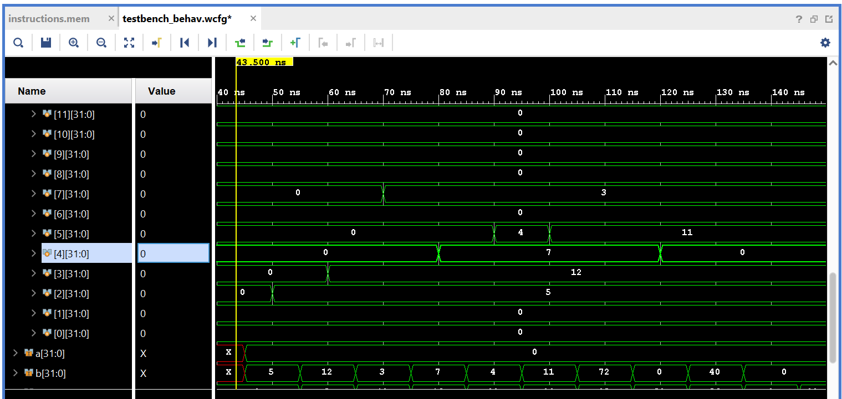
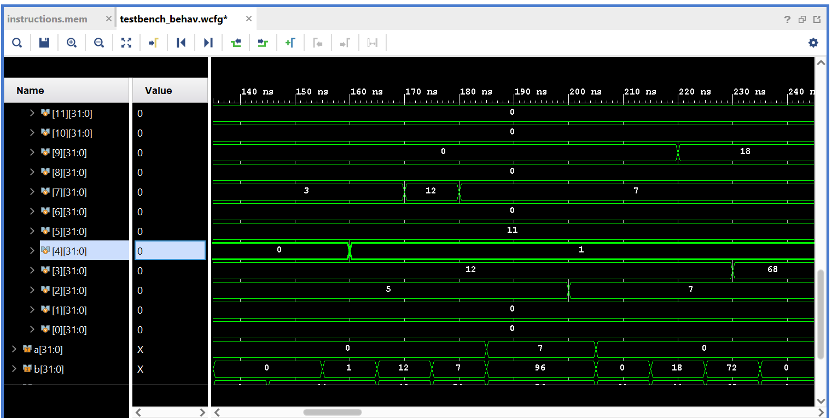
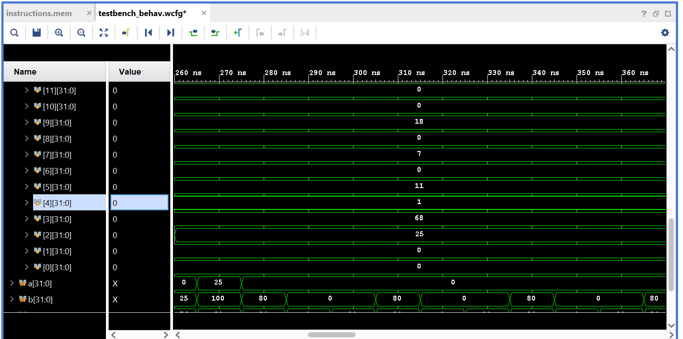

P.T.O

Data Memory:
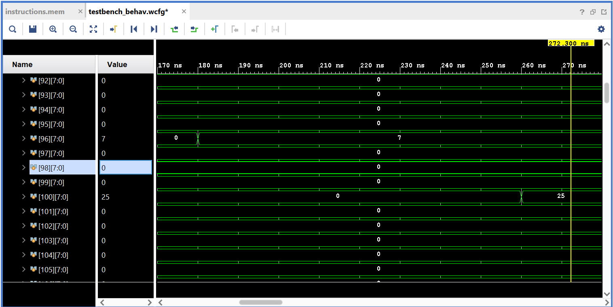

Tracer Task
Terminal Output:
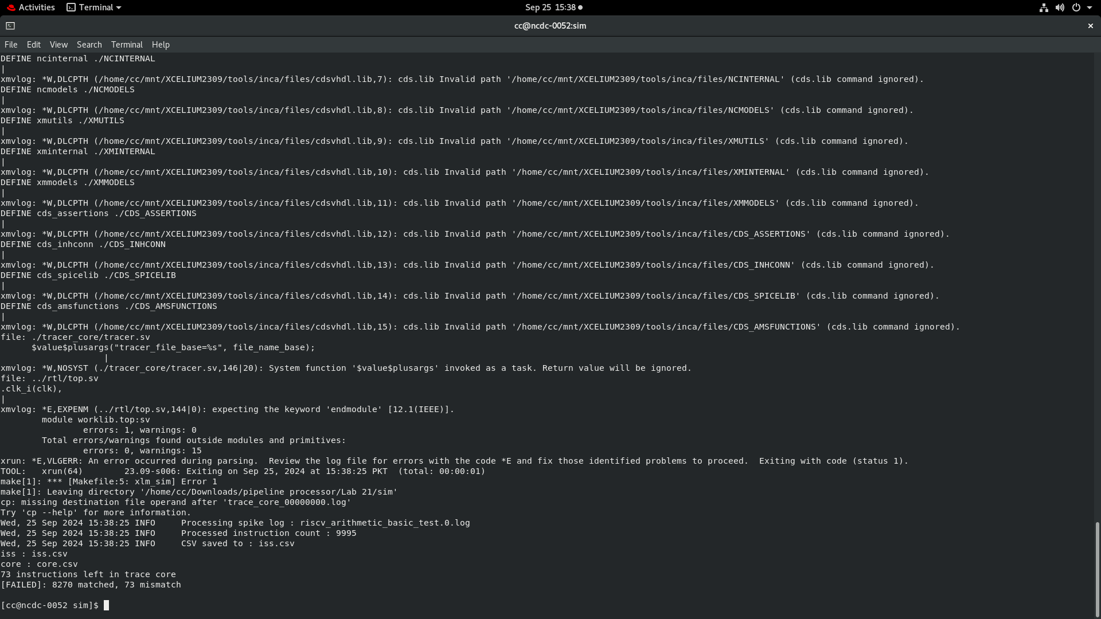
Core.csv File:
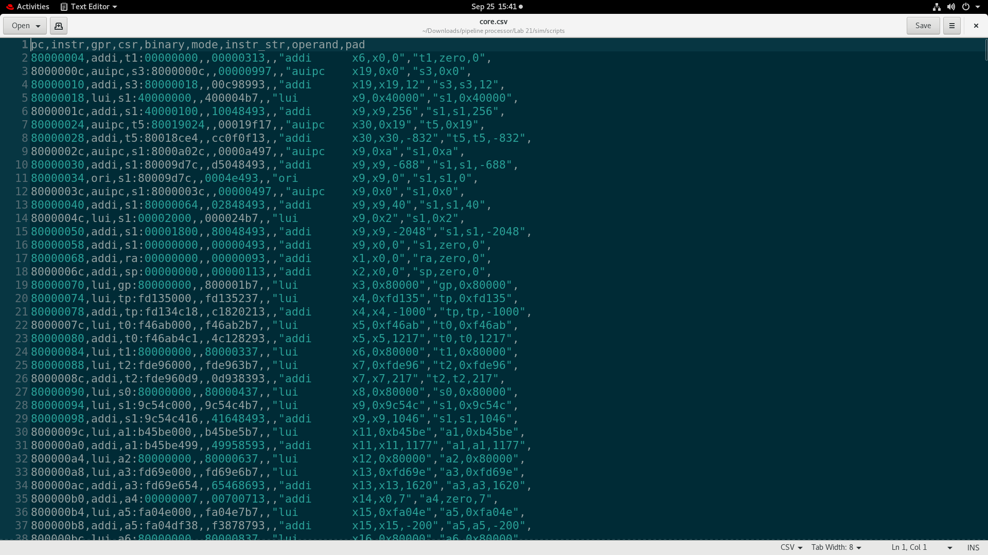

THE END

