Architecture Overview
Overtone - Meeting Join & Live Grounding
Audience: Technical partnership discussion
Prepared by: Muhammad Atif, Founder - Visions Craft (Overtone)
Date: August 2026
Status: Active development - demo / architecture stage
Classification: Confidential - partner review
1. Framing
Overtone is a live meeting layer: a bot joins Google Meet, Zoom, or Teams as a participant, presents a deck, listens with realtime speech-to-speech, and answers from indexed session sources - with a design goal to abstain or escalate when grounding is weak (not invent).
It is not a finished “zero-hallucination guarantee” product. The honest framing is: traceable, source-bound outputs plus a hard stop when the source cannot support an answer.
2. System context
Operator uses the Dashboard to upload decks and launch bots. The Backend (FastAPI) creates a Recall.ai bot that joins the meeting room and opens the Presenter UI as the bot camera. The Presenter connects to the Backend over WebSocket for audio and tools. The Backend bridges to realtime voice (Gemini Live preferred, OpenAI Realtime as fallback) and retrieves grounded slide text from pgvector, with artifacts in GCS and session state in Postgres.
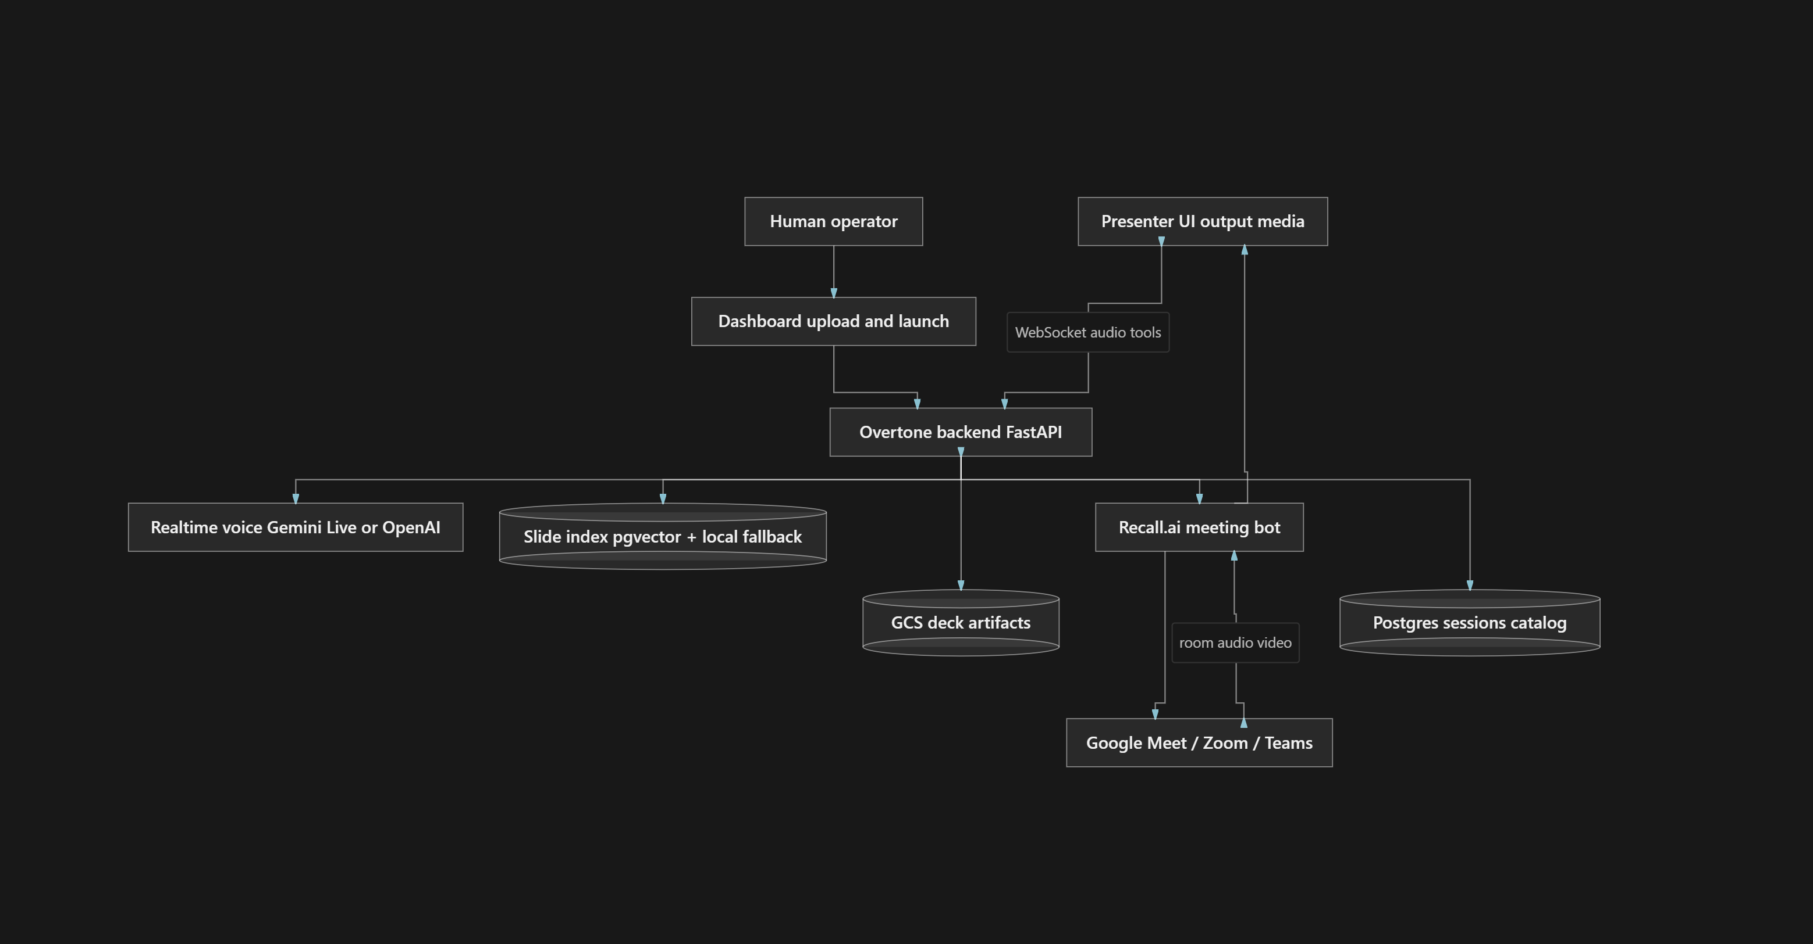
Component | Role
Dashboard | Upload decks, configure agents, launch bots into meetings
Recall.ai | Meeting participant join; virtual camera / audio path
Presenter UI | Deck display as bot camera; mic capture; play spoken audio
Backend relay | Session state, tool execution, voice bridge
Realtime voice | Speech-to-speech + function / tool calling
pgvector + Vision | Per-page extract, embed, retrieve grounded slide text
GCS + Postgres | Artifacts and durable session catalog
3. Session lifecycle
- Upload PDF / PPTX → store → Vision extract per page → quality gate → embeddings → pgvector
→ status ready
- Launch with meeting URL + knowledge base → create session → Recall bot with output-media presenter URL
- Bot joins room → Presenter WebSocket → Live voice session
- Participant audio → relay → model; model tool calls → navigate / get_slide_details / search → spoken answer from tool results only
4. Platform layers
Layer | Function | Current technology
Capture / join | Enter call as participant; camera shows slides | Recall.ai
Presenter | Deck UI, mic, bot audio playback | React (output-media page)
Realtime voice | Speech-to-speech + tools | Gemini Live / OpenAI Realtime
Orchestration | State, tools, mute, page position | FastAPI relay + executor
Grounding | Per-slide retrieval | Vision → embeddings → pgvector
Persistence | Files, catalog, session extras | GCS + Postgres

5. Grounding path
User question → tool routing (navigate / get_slide_details / search) → indexed slide text + session page. Enough evidence → spoken answer. Insufficient evidence → abstain / clarify → escalate path (roadmap).
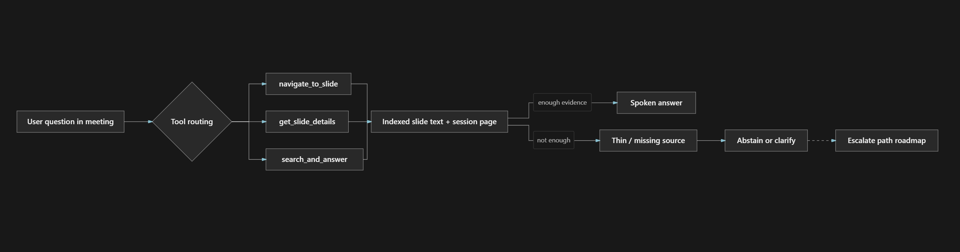
Design principles (escalate-don’t-guess)
- Prefer the currently visible slide for “explain this / what’s on this.”
- Search the deck index before any external lookup.
- If retrieval is empty or stub-thin → do not invent; clarify or state not in source.
- Human escalate (expert as ground truth) is the intended next architectural step — not claimed as fully shipped today.
6. Indexing pipeline
Upload → store (GCS / local) → render page images → Vision per page → title / body / searchable_content → quality gate (reject stub pages) → embeddings → pgvector → presentation status ready. Vision stubs such as title-only “Slide 4” must not be marked ready.
7. Realtime tools
Tool | Role
navigate_to_slide | Jump to a page; persist current_page
get_slide_details | Narrate current or specified page from index
search_and_answer | Hybrid retrieve over slides; stay or navigate
mute_self / unmute_self | Hard silence path
leave_call | Explicit exit only
fetch_external_data | Last resort; not for on-deck questions

Spoken answers are instructed to come from tool results (slide_content / brief_content), not model memory.
8. Maturity
Solid enough to demonstrate | Explicit next (roadmap)
Join Meet via Recall; present deck as bot camera; realtime voice; tool-grounded slide Q&A; index quality gate | First-class escalate-to-human queue; stronger abstention at tool boundary; multi-instance WS fan-out; claim→source audit trail

9. Fit with a digital protégé product
Protégé concern | Overtone role
Join Meet / Zoom as participant | Meeting adapter (focus of current demos)
Follow conversation without guessing | Session + deck grounding + abstain
Respond when addressed | Realtime voice + tools
Escalate when unsure | Architectural fit — align with expert KB / human handoff

Overtone is best understood as a live meeting adapter + grounding shell, not a replacement for an expert-judgment knowledge system.
This document describes current engineering architecture as of the date above. Capabilities labeled roadmap are intentional design direction, not production guarantees.
Contact: Muhammad Atif - ranaatif1299@gmail.com

