ATIFDATA

Commerce Intelligence
Omnichannel Retail Data Modernization & Analytics
Solution Architecture • Data Model • Business Rules • Executive Analytics
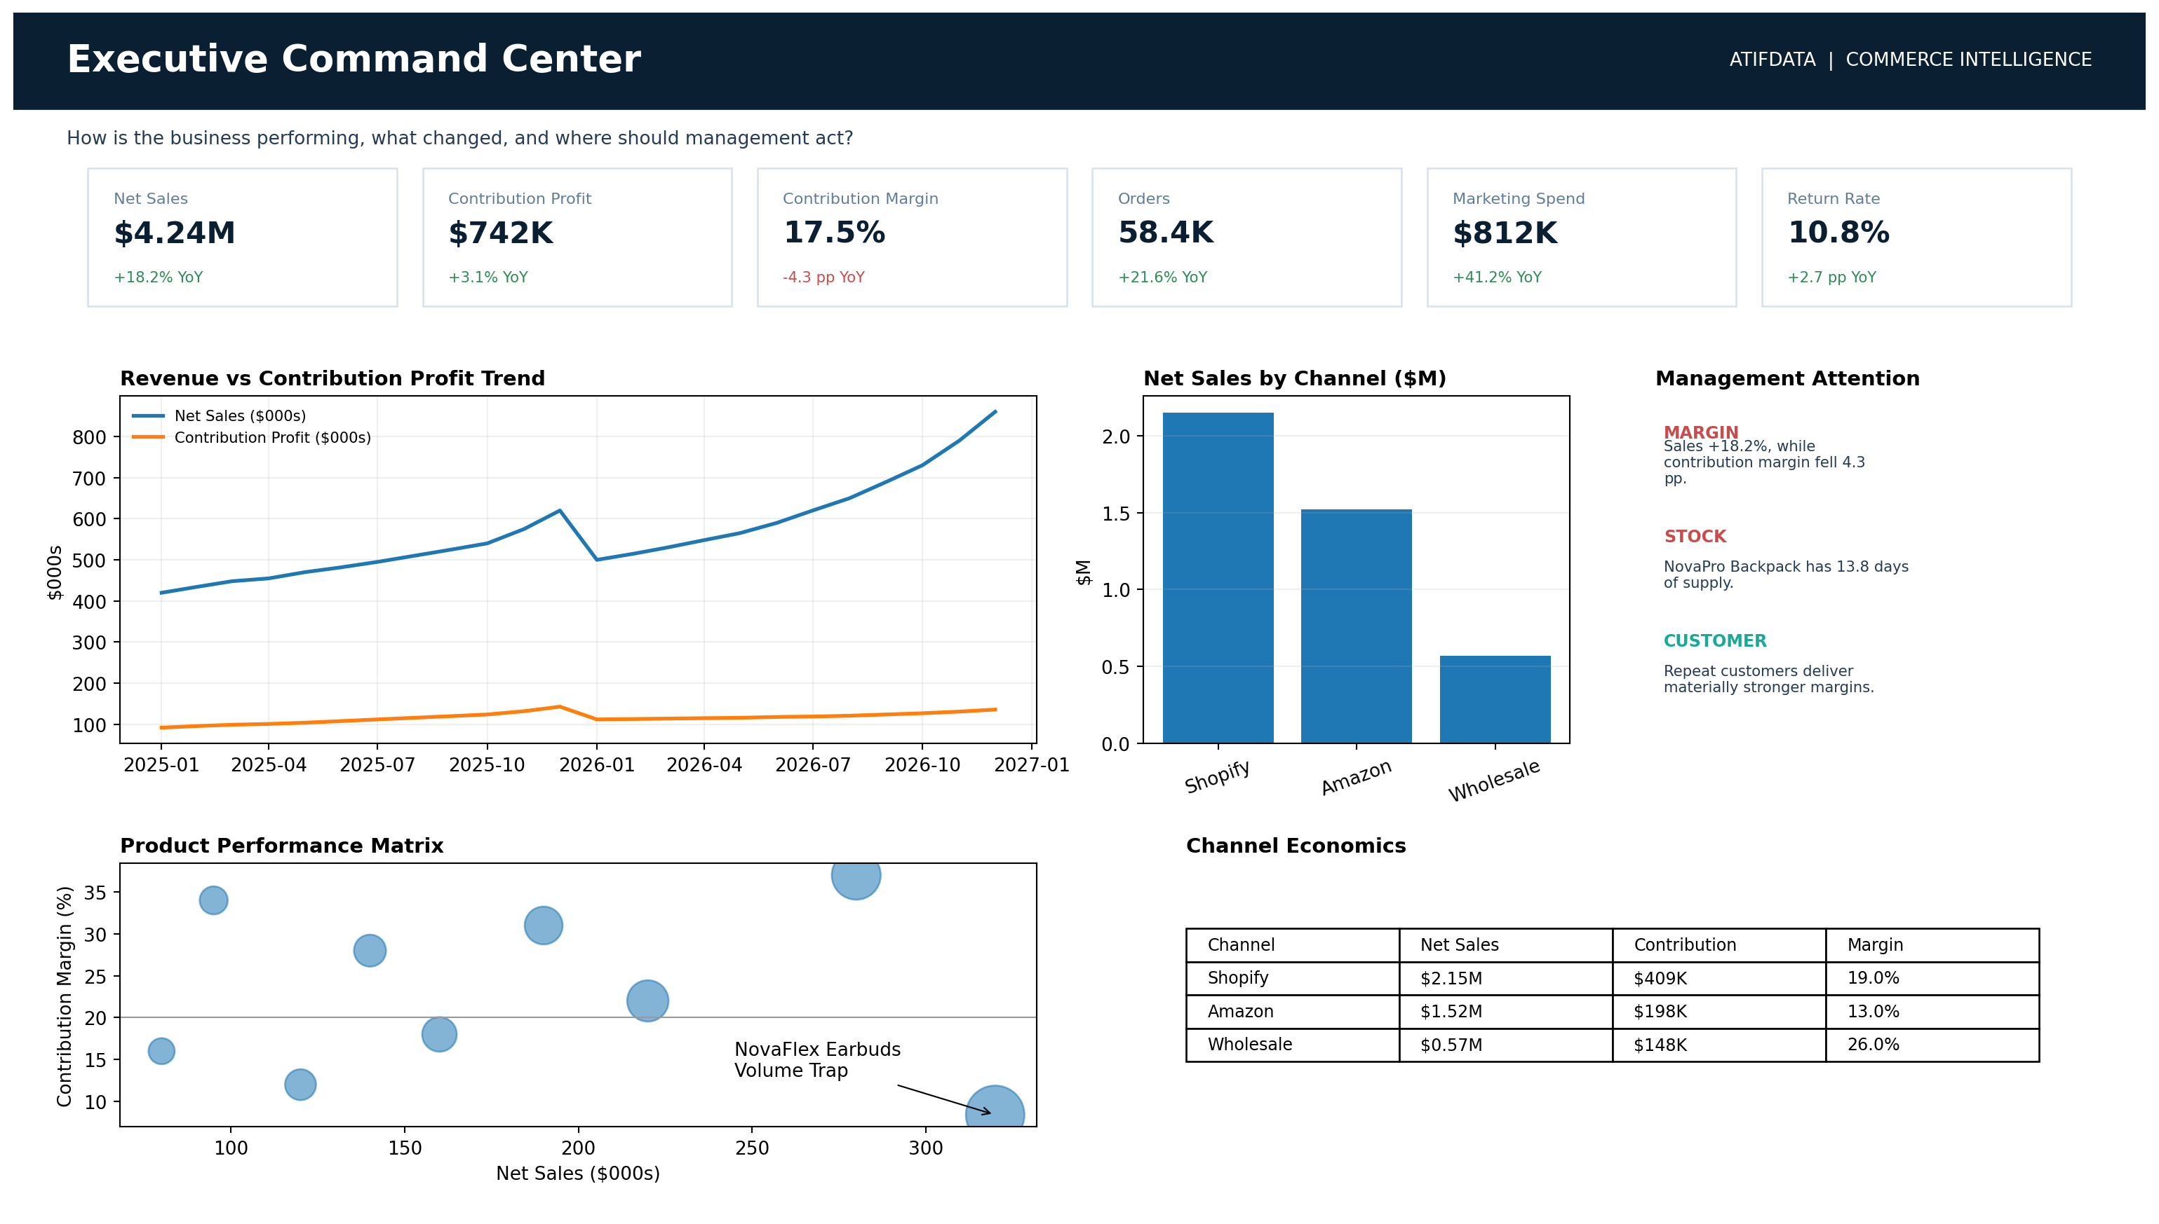
AtifData | Data Modernization & Analytics Solutions

Contents
1. Executive Summary
2. Business Context and Management Challenges
3. Solution Objectives
4. Source Systems
5. Data Quality, Crosswalks and Standardization
6. Gold Analytical Model
7. Business Rules and Profitability
8. Power BI Experience
9. Business Impact & Management Outcomes
10. Executive Insight Layer
11. Implementation Approach
12. Technology Stack
Appendix A. KPI Catalogue
Appendix B. Source-to-Target Summary
Appendix C. Power BI Page Gallery

1. Executive Summary
Commerce Intelligence is an end-to-end data modernization and analytics solution for omnichannel retail - a retail operating model in which sales and customer interactions span multiple connected channels such as an ecommerce website, online marketplaces and wholesale channels. The solution unifies fragmented sales, marketing, customer, inventory and financial data into a governed analytical model for management decision-making.
The architecture combines Microsoft Fabric, layered Bronze/Silver/Gold processing, a conformed multi-fact star schema, a Power BI semantic model and an executive insight layer. The objective is to move beyond isolated platform reporting and show where economic value is being created or lost.
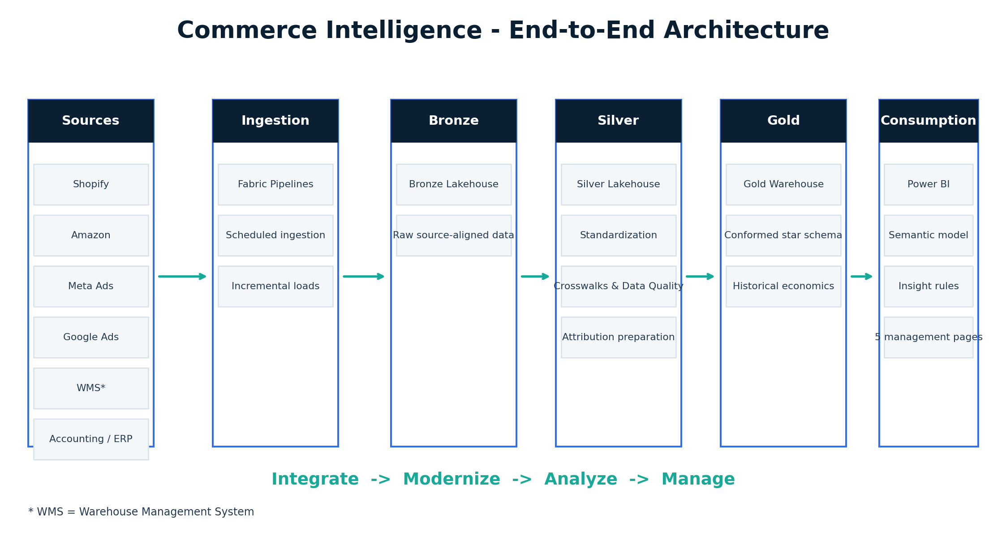

2. Business Context and Management Challenges
Nova Retail Group operates across Shopify, Amazon and wholesale channels while acquiring customers through Meta and Google advertising. Inventory is managed through a Warehouse Management System (WMS) across multiple locations, while product costs and operating expenses are maintained separately in accounting systems.
Management can see sales in individual platforms, but cross-functional questions are harder: Which products remain profitable after returns and acquisition costs? Which marketing channels acquire valuable customers? Which high-margin products are at risk of stockout? Are rising revenues translating into stronger contribution profit?

3. Solution Objectives
Create a single, reliable analytical foundation across commerce, marketing, inventory and finance; standardize inconsistent identifiers and business definitions; preserve historical product economics; support auditable attribution and profitability logic; deliver management-ready Power BI analytics; and surface actionable signals rather than isolated KPIs.

4. Source Systems
Shopify provides orders, order lines, customers, products, discounts, refunds and attribution fields. Amazon provides orders, items, marketplace fees, returns and ASIN/SKU mappings. Meta Ads and Google Ads provide daily campaign spend, impressions, clicks, conversions and platform-attributed revenue. The Warehouse Management System (WMS) provides daily inventory snapshots and movements. Accounting/ERP provides effective-dated product costs and monthly operating expenses.

5. Data Quality, Crosswalks and Standardization
A crosswalk is a mapping table used to reconcile different identifiers for the same business entity across source systems. For example, Shopify SKU NRG-WB-001, Amazon identifier B0NRG1024, WMS code WB001 and ERP code PROD-WB01 can all resolve to one governed MasterSKU. Data Quality (DQ) controls cover deduplication, missing required fields, invalid dates, unmapped products, status standardization, currency conversion, late-arriving returns and source-to-target reconciliation.
Silver-layer processing standardizes these inconsistencies before publishing governed analytical entities to Gold. Operational controls capture rows received, accepted, rejected, duplicated, unmapped and reconciled.
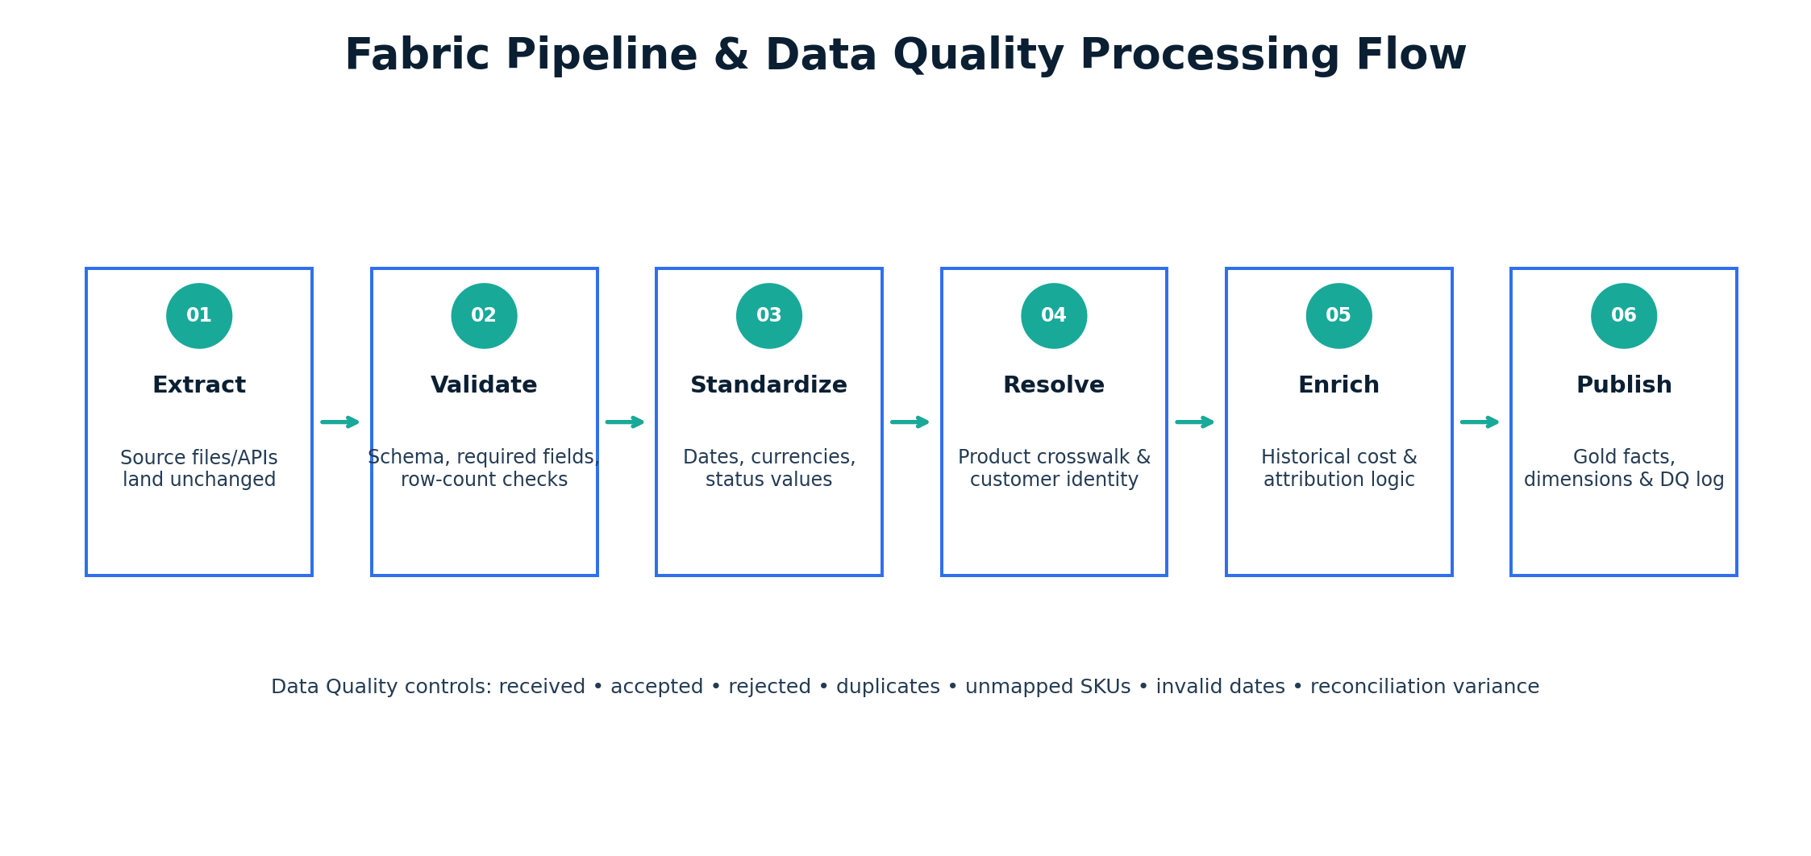
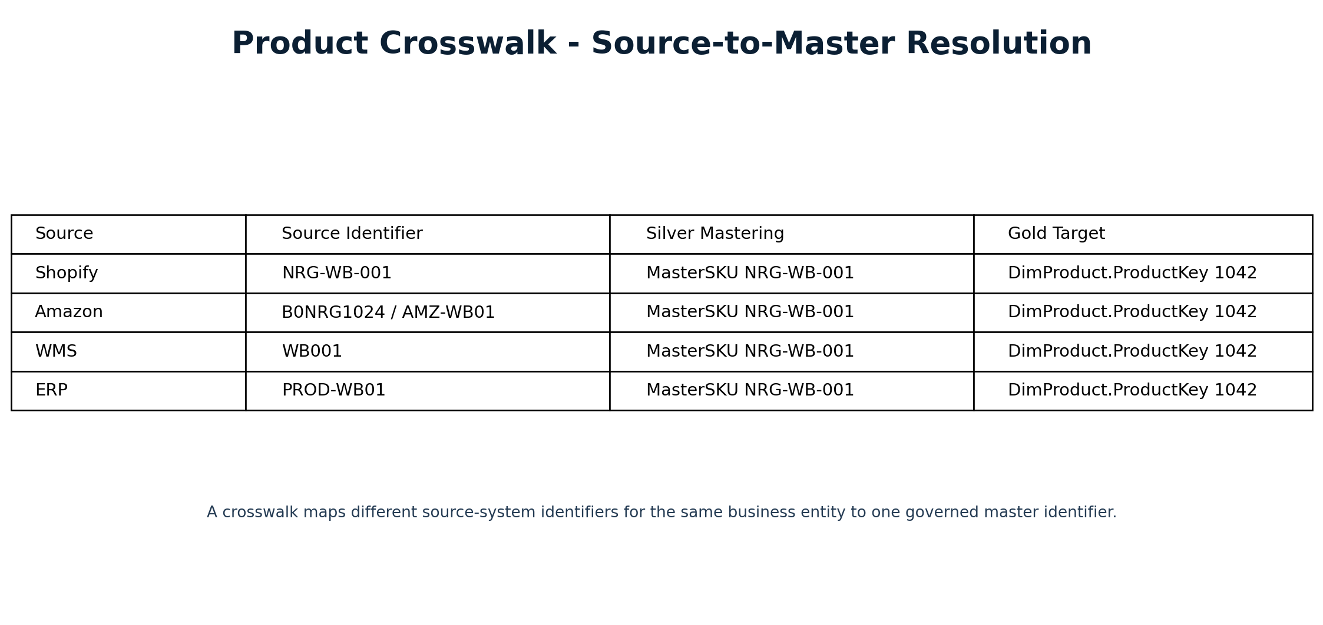

6. Gold Analytical Model
The Gold layer uses conformed dimensions with multiple facts at explicit grains. Core dimensions are Date, Product, Customer, Channel, Campaign, Warehouse and Geography, with Expense Category where required. Core facts are Sales, Returns, Marketing Spend, Inventory Snapshot, Inventory Movement, Product Cost and Operational Expense.
FactSales is one row per order line. FactReturns records return events on their actual return date. FactMarketingSpend is campaign-platform-day. FactInventorySnapshot is SKU-warehouse-day. Product cost is effective-dated so historical COGS is not recalculated using current costs.
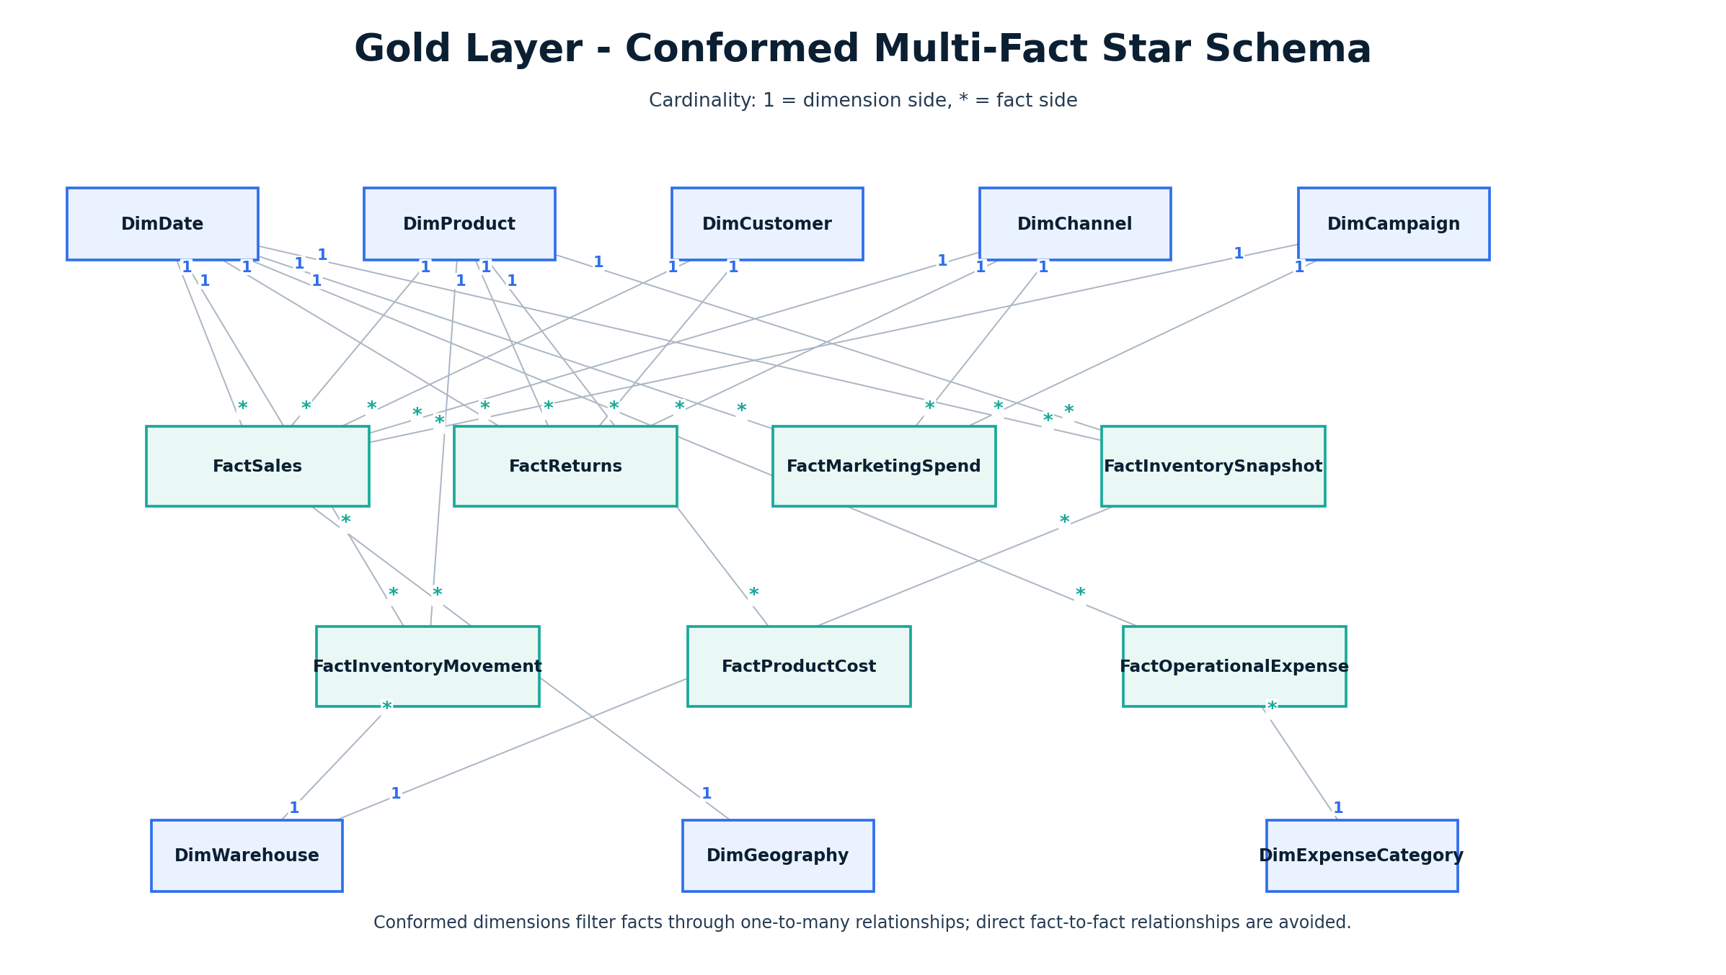

7. Business Rules and Profitability
Gross Sales equals quantity multiplied by original unit price. Net Revenue deducts discounts and refunds. COGS uses the unit cost effective on the transaction date. Contribution Profit deducts COGS, marketplace fees, payment fees, fulfillment costs and allocated marketing cost from Net Revenue. General operating expenses remain separate for company-level operating profitability.
Marketing attribution uses a 30-day last non-direct-touch rule for the core analytical view while retaining platform-reported attribution for comparison. Product-level marketing allocation is proportional to attributed net sales where campaigns map to products or categories.

8. Power BI Experience
The reporting experience is organized into five decision-focused pages: Executive Command Center, Product & Profit Intelligence, Customer Intelligence, Marketing Intelligence and Inventory Intelligence. Each page answers a specific management question and supports navigation from enterprise-level signals to underlying commercial drivers.
In the acquisition cohort visual, M0 represents the customer's acquisition or first-purchase month; M1 is one month after first purchase, continuing through M5 at five months after first purchase. Rows represent acquisition cohorts, while columns represent elapsed months since first purchase.

Executive Command Center


Product & Profit Intelligence
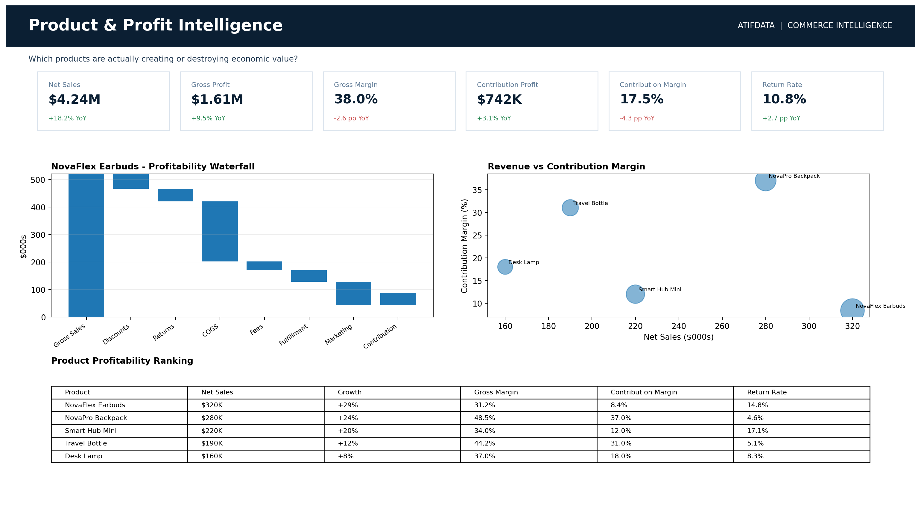

Customer Intelligence
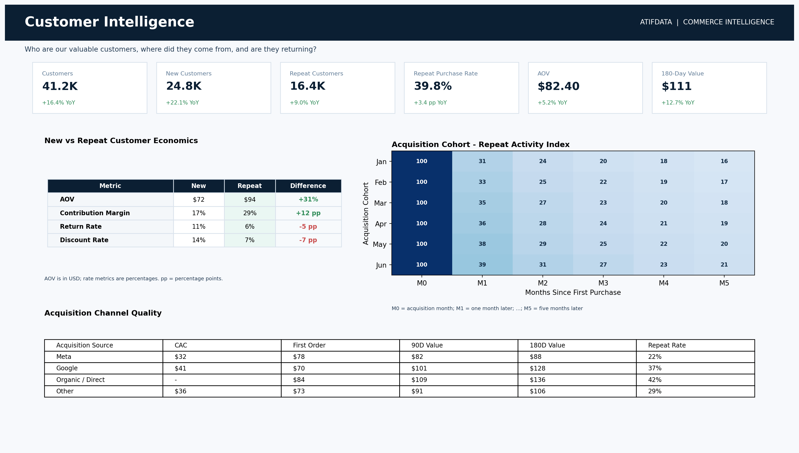

Marketing Intelligence
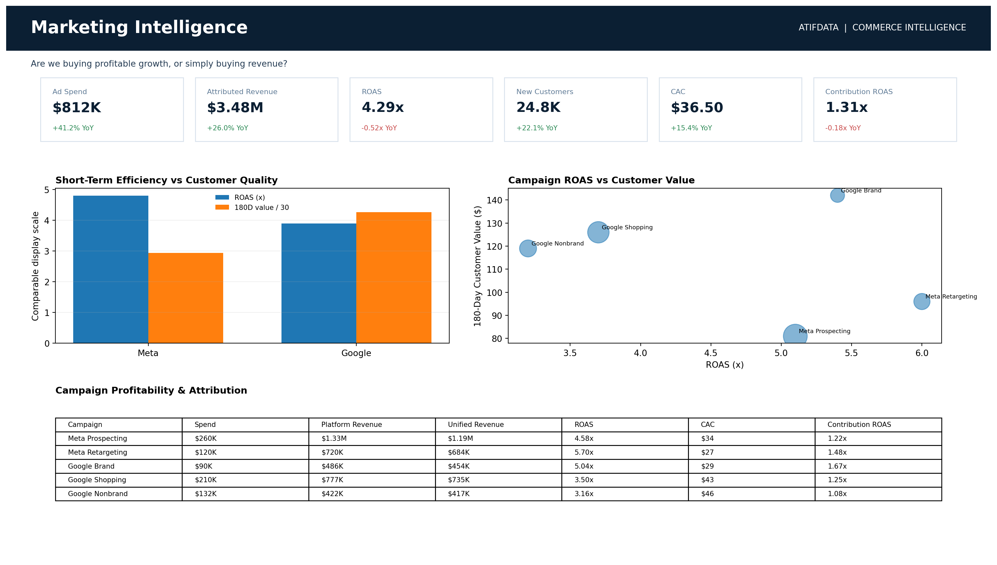

Inventory Intelligence
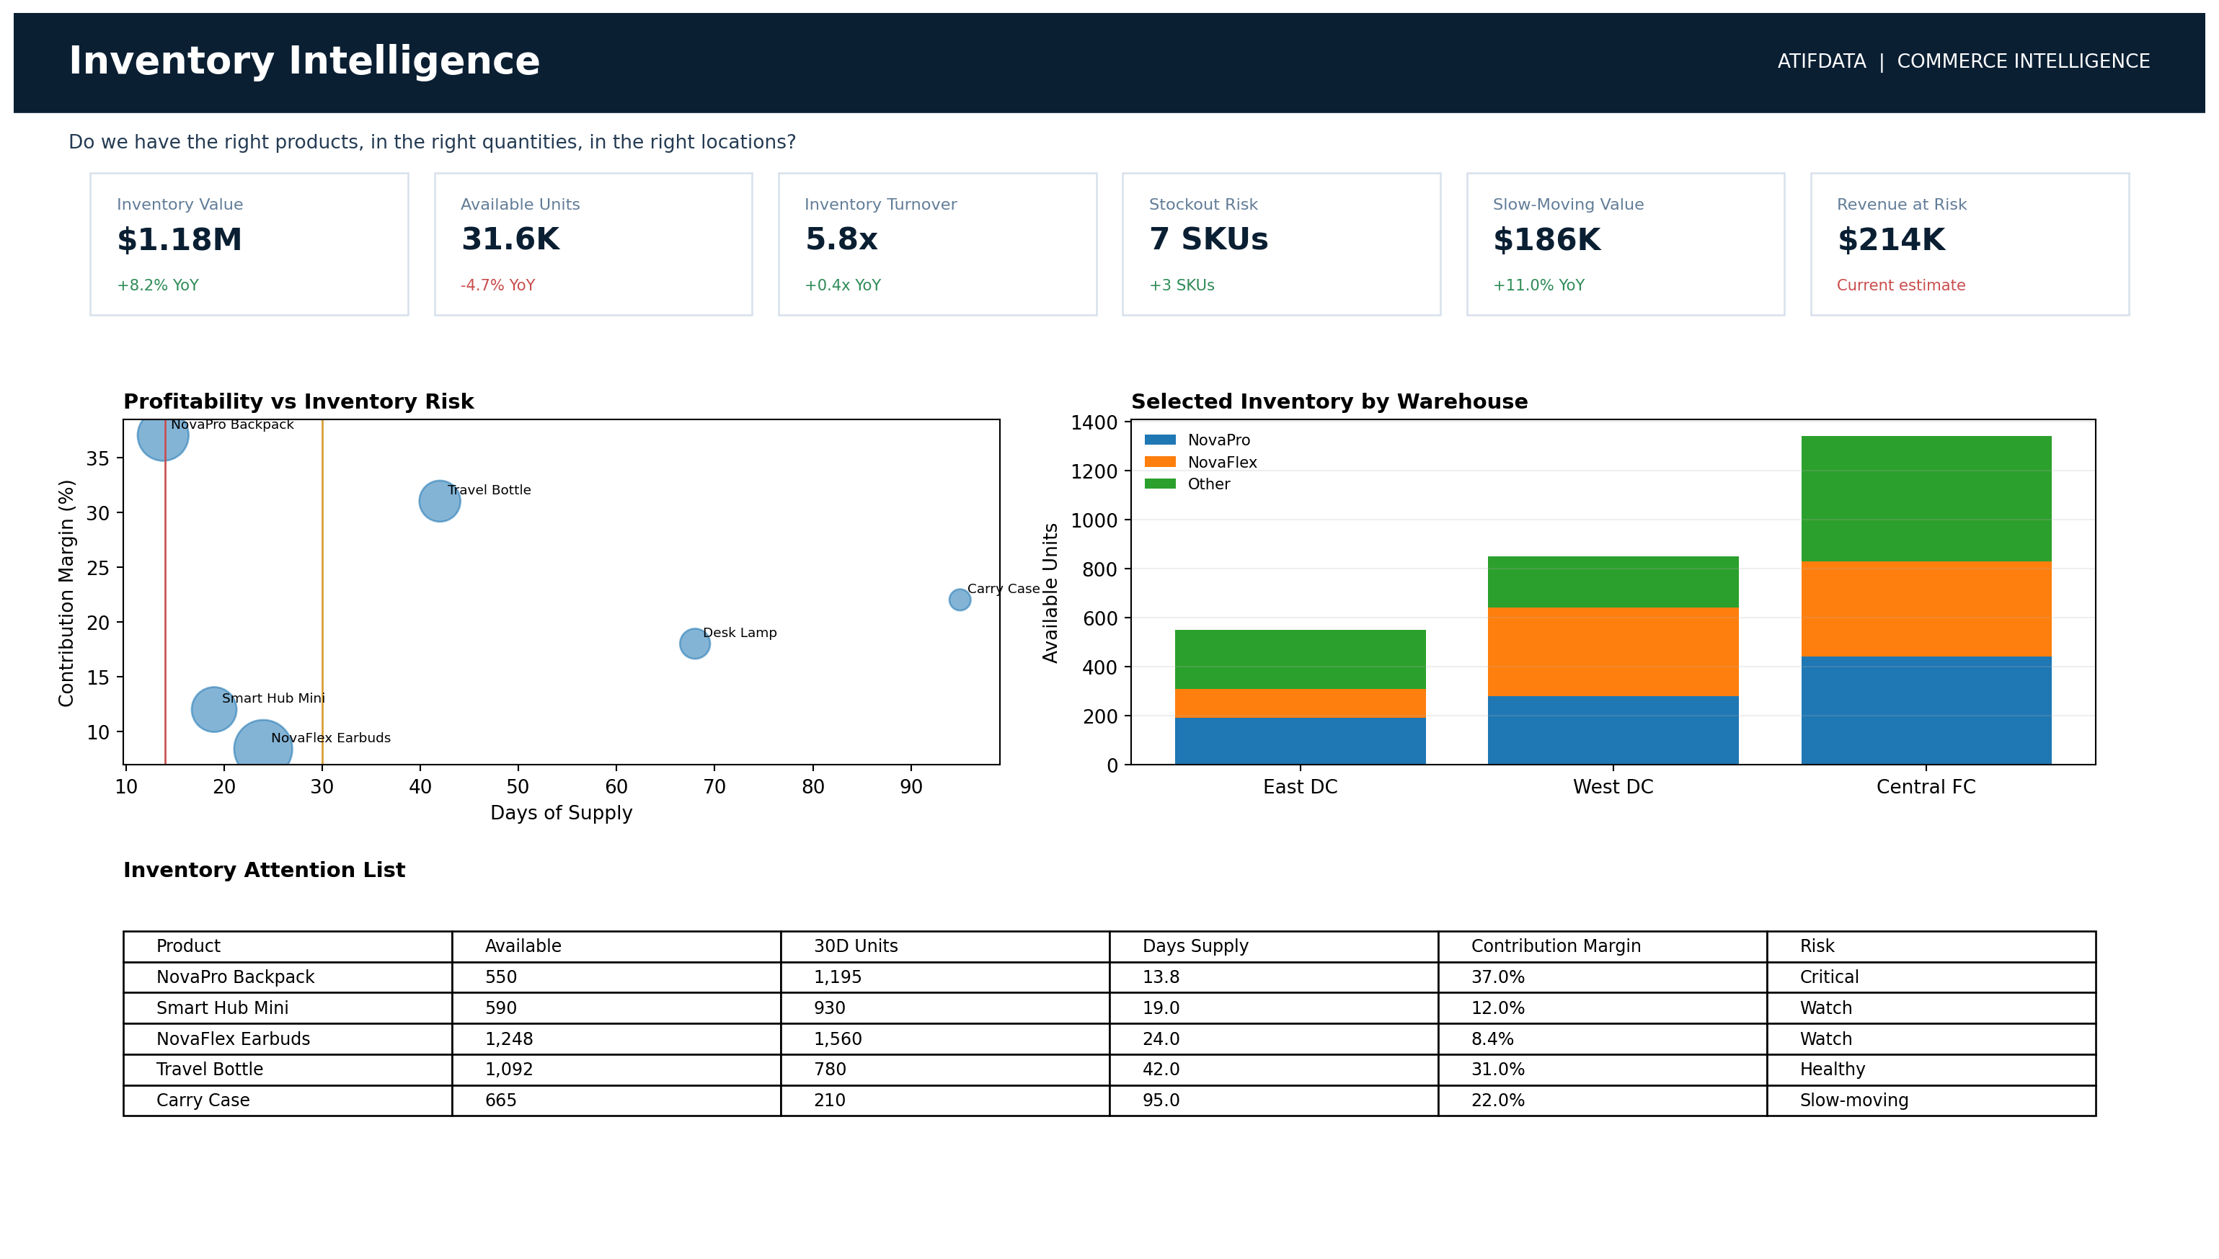

9. Business Impact & Management Outcomes
The integrated analytical view surfaces quantified management outcomes across growth, profitability, customer quality and inventory. Net Sales increased 18.2%, while Contribution Margin declined 4.3 percentage points, exposing a gap between top-line growth and economic value creation. NovaPro Travel Backpack delivered a 37.0% contribution margin but had only 13.8 days of supply, highlighting a replenishment priority.
Google-acquired customers showed $128 of 180-day value versus $88 for Meta-acquired customers - approximately 45% higher - despite Meta's stronger short-term ROAS. Smart Hub Mini reached a 17.1% return rate, exposing a concentrated product issue. Repeat customers delivered a 29% contribution margin versus 17% for new customers, a 12 percentage-point advantage that supports greater focus on retention economics.
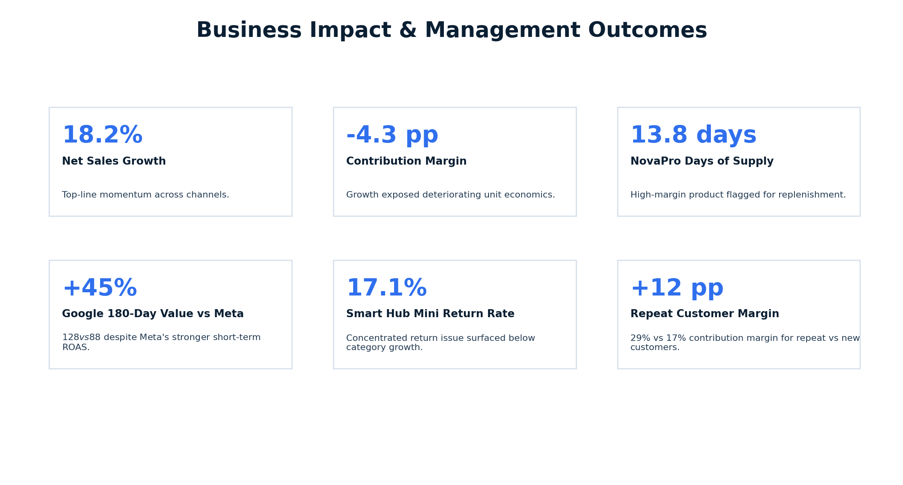

10. Executive Insight Layer
Semantic measures feed deterministic insight rules. Examples include revenue growth above 10% combined with contribution-margin deterioration greater than two percentage points; high-margin products with fewer than 14 days of supply; and cases where short-term channel ROAS conflicts with 180-day customer value. This creates an auditable KPI-to-insight-to-action pattern.

11. Implementation Approach
1. Ingest source-aligned data through Fabric pipelines into Bronze. 2. Validate, standardize and reconcile in Silver. 3. Resolve product identifiers and customer references. 4. Apply historical cost and attribution logic. 5. Publish conformed Gold facts and dimensions. 6. Build the Power BI semantic model and measures. 7. Configure insight rules and management pages. 8. Operationalize refresh monitoring, data-quality controls and enhancement processes.

12. Technology Stack
Microsoft Fabric Data Factory / Pipelines; Fabric Lakehouse and Warehouse; SQL and Python for transformation and validation where appropriate; Power BI semantic modeling and DAX; governed dimensional modeling; scheduled data-quality and reconciliation controls.

Appendix A. KPI Catalogue
Domain | Core KPIs
Executive / Sales | Gross Sales; Net Revenue; Orders; Units Sold; AOV; Revenue Growth; Units per Order
Profitability | COGS; Gross Profit; Gross Margin %; Contribution Profit; Contribution Margin %; Operating Profit
Customer | New Customers; Repeat Customers; Repeat Purchase Rate; Purchase Frequency; 90-Day Value; 180-Day Value; CAC; LTV:CAC
Marketing | Spend; Impressions; Clicks; CTR; CPC; Conversion Rate; ROAS; CAC; Contribution ROAS
Product | Net Sales; Units; ASP; Gross Margin; Contribution Margin; Return Rate; Sales Growth; Profit Growth
Inventory | Stock on Hand; Available Units; Inventory Value; Sales Velocity; Days of Supply; Inventory Turnover; Stockout Risk; Slow-Moving Value

Appendix B. Source-to-Target Summary
Source | Primary Gold Targets
Shopify | FactSales, FactReturns, DimCustomer, DimProduct, DimChannel, DimCampaign
Amazon | FactSales, FactReturns, DimProduct, DimChannel
Meta Ads | FactMarketingSpend, DimCampaign
Google Ads | FactMarketingSpend, DimCampaign
WMS | FactInventorySnapshot, FactInventoryMovement, DimWarehouse
Accounting / ERP | FactProductCost, FactOperationalExpense, DimExpenseCategory

Appendix C. Power BI Page Gallery

Executive Command Center


Product & Profit Intelligence


Customer Intelligence


Marketing Intelligence


Inventory Intelligence


