Practical No 8:
Competitive Coding Link:
https://www.geeksforgeeks.org/problems/m-coloring-problem-1587115620/1
Name:- Mo Atif Azmi
Batch:- A4_B4_51
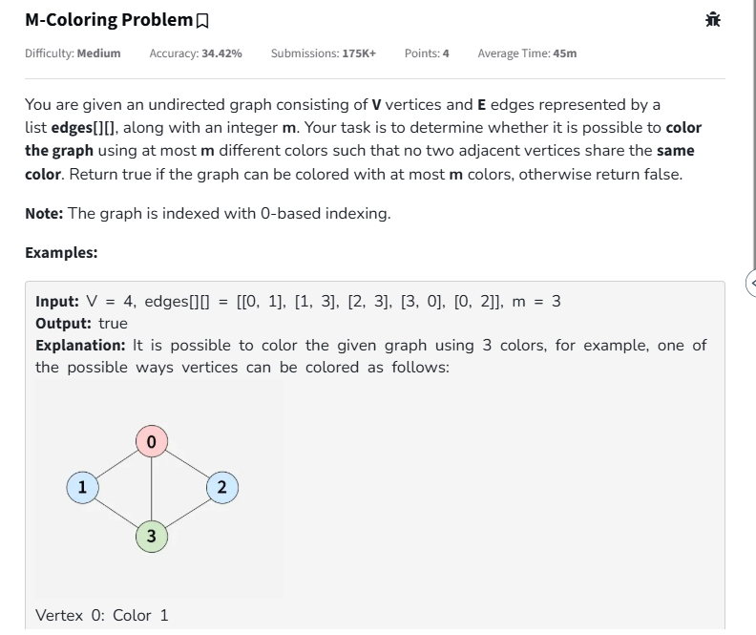

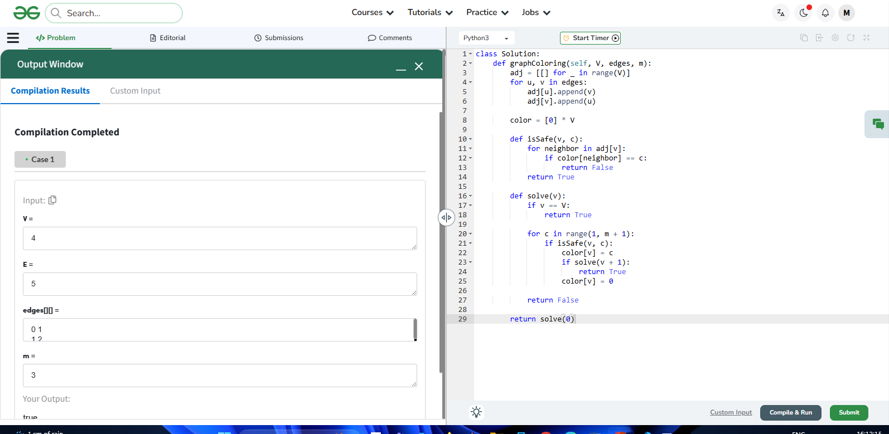
Submission link:- https://www.geeksforgeeks.org/problems/m-coloring-problem-1587115620/1

