practical No 7:
Competitive Coding Link:
https://www.geeksforgeeks.org/problems/hamiltonian-path2522/1
Name:-Mo Atif Azmi
Batch :-A4_B4_51
Date:-29-0-2025
PS:-
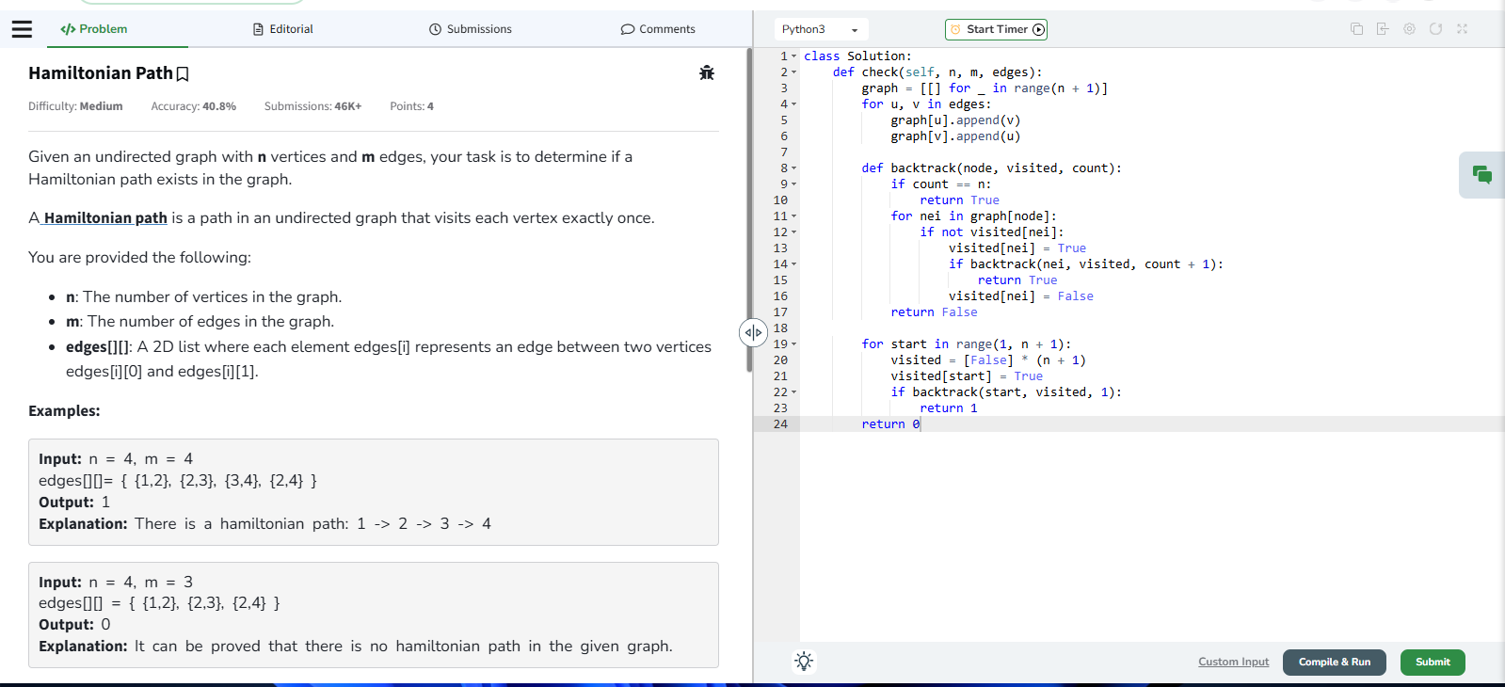
Output:-
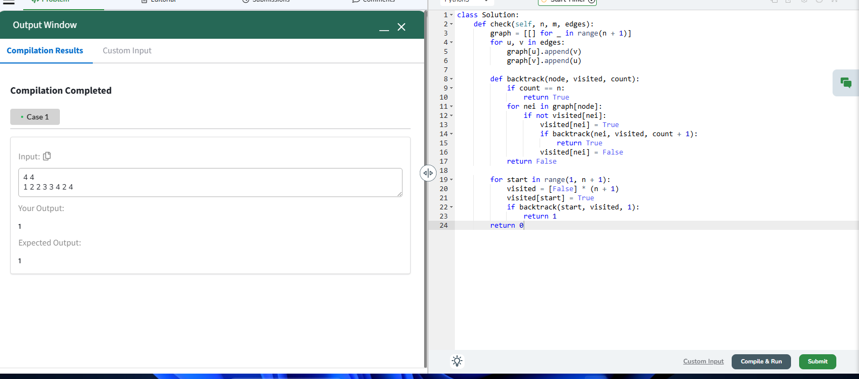
Submission link:- https://www.geeksforgeeks.org/problems/hamiltonian-path2522/1

