**Methodology**



**Dataset Discription**

The Fruits and Vegetables Leaves Dataset is divided into training and validation directories. The training set contains 33 unique leaf types, each with 1680 images per class. The validation set also has 33 leaf types, with 420 images per class. Furthermore, there is a test directory with 33 images for each leaf type.

**1.Train Dataset**

0: {'Apple___Apple_scab': 1680},

1: {'Apple___Black_rot': 1680},

2: {'Apple___Cedar_apple_rust': 1680},

3: {'Apple___healthy': 1680},

4: {'Cherry_(including_sour)___Powdery_mildew': 1680},

5: {'Cherry_(including_sour)___healthy': 1680},

6: {'Corn_(maize)___Cercospora_leaf_spot Gray_leaf_spot': 1680},

7: {'Corn_(maize)___Common_rust_': 1680},

8: {'Corn_(maize)___Northern_Leaf_Blight': 1680},

9: {'Corn_(maize)___healthy': 1680},

10: {'Grape___Black_rot': 1680},

11: {'Grape___Esca_(Black_Measles)': 1680},

12: {'Grape___Leaf_blight_(Isariopsis_Leaf_Spot)': 1680},

13: {'Grape___healthy': 1680},

14: {'Peach___Bacterial_spot': 1680},

15: {'Peach___healthy': 1680},

16: {'Pepper,_bell___Bacterial_spot': 1680},

17: {'Pepper,_bell___healthy': 1680},

18: {'Potato___Early_blight': 1680},

19: {'Potato___Late_blight': 1680},

20: {'Potato___healthy': 1680},

21: {'Strawberry___Leaf_scorch': 1680},

22: {'Strawberry___healthy': 1680},

23: {'Tomato___Bacterial_spot': 1680},

24: {'Tomato___Early_blight': 1680},

25: {'Tomato___Late_blight': 1680},

26: {'Tomato___Leaf_Mold': 1680},

27: {'Tomato___Septoria_leaf_spot': 1680},

28: {'Tomato___Spider_mites Two-spotted_spider_mite': 1680},

29: {'Tomato___Target_Spot': 1680},

30: {'Tomato___Tomato_Yellow_Leaf_Curl_Virus': 1680},

31: {'Tomato___Tomato_mosaic_virus': 1680},

32: {'Tomato___healthy': 1680}

**2.Validation Dataset**

0: {'Apple___Apple_scab': 420},

1: {'Apple___Black_rot': 420},

2: {'Apple___Cedar_apple_rust': 420},

3: {'Apple___healthy': 420},

4: {'Cherry_(including_sour)___Powdery_mildew': 420},

5: {'Cherry_(including_sour)___healthy': 420},

6: {'Corn_(maize)___Cercospora_leaf_spot Gray_leaf_spot': 420},

7: {'Corn_(maize)___Common_rust_': 420},

8: {'Corn_(maize)___Northern_Leaf_Blight': 420},

9: {'Corn_(maize)___healthy': 420},

10: {'Grape___Black_rot': 420},

11: {'Grape___Esca_(Black_Measles)': 420},

12: {'Grape___Leaf_blight_(Isariopsis_Leaf_Spot)': 420},

13: {'Grape___healthy': 420},

14: {'Peach___Bacterial_spot': 420},

15: {'Peach___healthy': 420},

16: {'Pepper,_bell___Bacterial_spot': 420},

17: {'Pepper,_bell___healthy': 420},

18: {'Potato___Early_blight': 420},

19: {'Potato___Late_blight': 420},

20: {'Potato___healthy': 420},

21: {'Strawberry___Leaf_scorch': 420},

22: {'Strawberry___healthy': 420},

23: {'Tomato___Bacterial_spot': 420},

24: {'Tomato___Early_blight': 420},

25: {'Tomato___Late_blight': 420},

26: {'Tomato___Leaf_Mold': 420},

27: {'Tomato___Septoria_leaf_spot': 420},

28: {'Tomato___Spider_mites Two-spotted_spider_mite': 420},

29: {'Tomato___Target_Spot': 420},

30: {'Tomato___Tomato_Yellow_Leaf_Curl_Virus': 420},

31: {'Tomato___Tomato_mosaic_virus': 420},

32: {'Tomato___healthy': 420

**Preprocessing**

The preprocessing script cycles through 33 directories of train directory, each representing a unique leaf

type in the dataset. It accesses the path of each directory, gathers a list of image paths, and processes them by converting them to arrays and resizing them to a set target size. Normalization is applied by dividing

the arrays by 255 to maintain pixel values between 0 and 1. Concurrently, labels are assigned to images according to the directory index to enable supervised learning. To maintain dataset balance during training,

the script limits the number of images per class to 650.

The data is split into a 75-25 ratio for training and testing respectively.

**CNN Model Architecture**

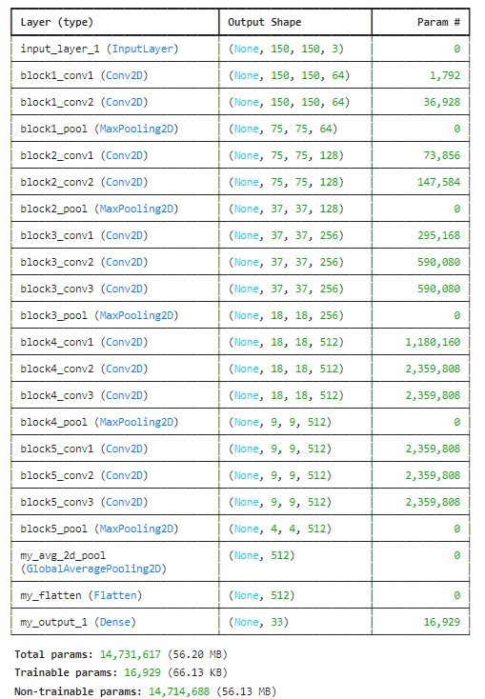

Table for 10 Epochs Result

|  |  |  |
| --- | --- | --- |
| **CNN Model** | **Train Accuracy** | **Test Accuracy** |
| VGG16 | 87.2% | 81.2% |

**Loss – Epoch Graph Accuracy – Epoch Graph**

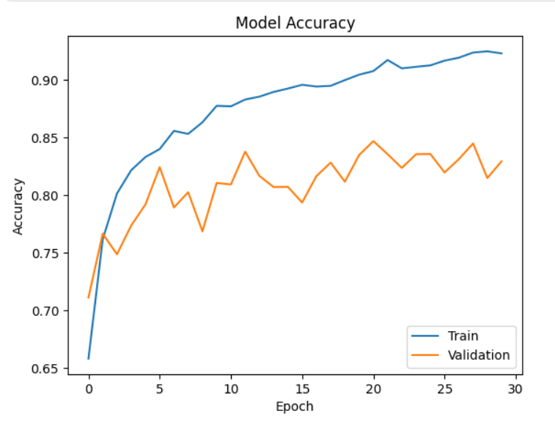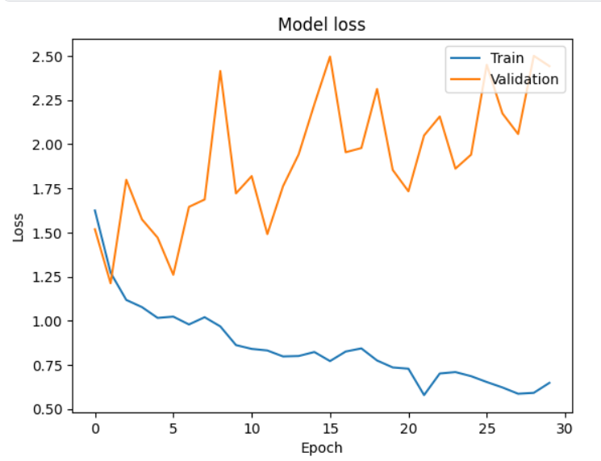

**Results** (y –axis:True label , x-axis:Predicted label)

