LAB -5

NAME: ATIF MEHRBAN

COMPUTER NETWORK

Configuring DHCP server on a Router

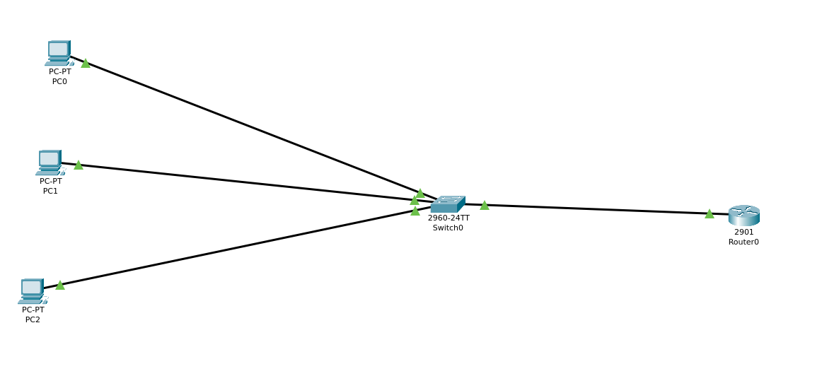

TASK 02

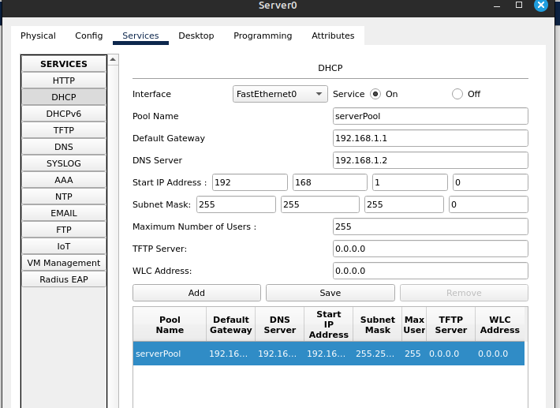

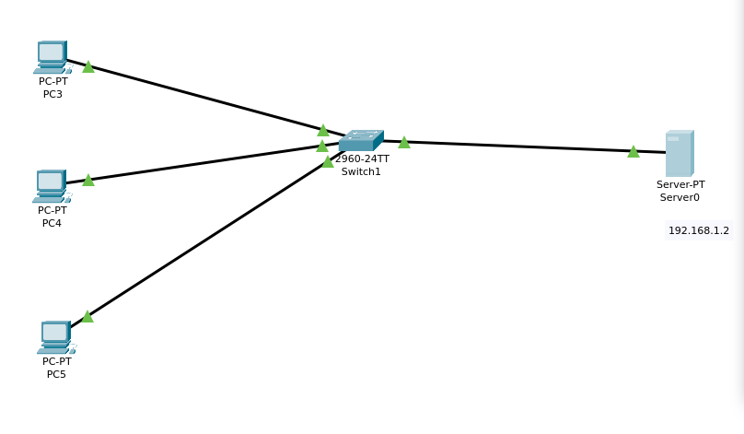

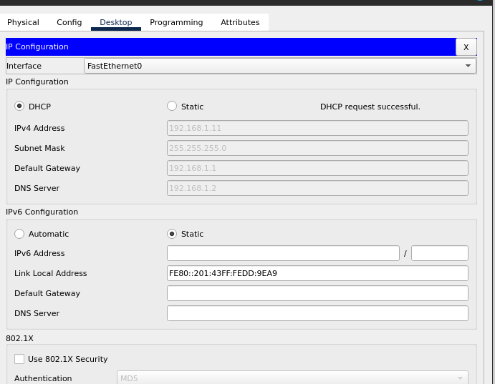

IP Helper-Addresses
The ip helper-address command is generally used to configure a DHCP Relay Agent on a Layer 3 interface
on a Cisco IOS device. Broadcast messages are not forwarded from one subnet to another by a router.
In order for DHCP clients on each subnet to receive their IP configuration via DHCP, we would need to
deploy a DHCP server on each subnet. This could quickly become expensive and cumbersome to manage
as the number of subnets grows.

