LAB -3

NAME: ATIF MEHRBAN

COMPUTER NETWORK

STRAIGHT-THROUGH CABLE
A straight-through network cable is just what the name suggests, a cable that passes data straight
through from one end to another end. These cables are used for a variety of connections, for
instance, connecting a computer to a hub or switch, connecting a computer to a cable/ISDN/DSL
modem, and linking switches and hubs together.

Tools Required
The tools required to do this lab are:
• CAT 6 network cable
• RJ-45 Connectors
• Cable Cutter
• Crimping tool, &
• Cable tester.

Procedure
Well, the wire has two sides. Let’s call one side ... Side A and the other side ... Side B. Do the
following steps with Side A of the wire.
1. Remove the plastic cover from the cable up to two inches. You will see 4 twisted pairs
(total 8 wires). In each twisted pair, one wire will be colored and the other will be white.
For example, one will be Green and the other will be White having Green marks. The

latter is called Green-White. Similarly there will be Brown wire twisted with Brown-
White, Blue wire twisted with Blue-White, Orange twisted with Orange-White. This can

2. Untwist the wires and make them smooth (don’t remove the plastic covers from the metal
wires).
3. Arrange the wires in the order: Orange-White, Orange, Green-White, Blue, Blue-White,
Green, Brown-White, and Brown. The order is important since there is a wiring standard
defined by the Telecommunications Industry Association (TIA) .
5. Cut the wires in straight fashion and insert in the RJ-45 Jack.
6. Using the Crimping tool, punch it properly. Perform Step 1-5 for Side B.

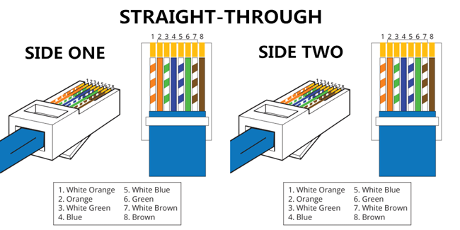

CROSS-OVER CABLE
A cross-over network cable is used to connect two computers directly. It is also used when you
connect two hubs/Switches with a normal port on both hubs/Switches. (In other words, the cross
cable is used relatively in a rare case.). It is used to connect similar devices.
Tools Required
Same as used for making Straight-Through Cable.
Procedure
Side A
Perform Steps 1-5 mentioned above for making straight-through cable.
Side B
Arrange the wires as: green-white, green, orange-white, blue, blue-white, orange, brown-white,
and brown. And punch it properly.

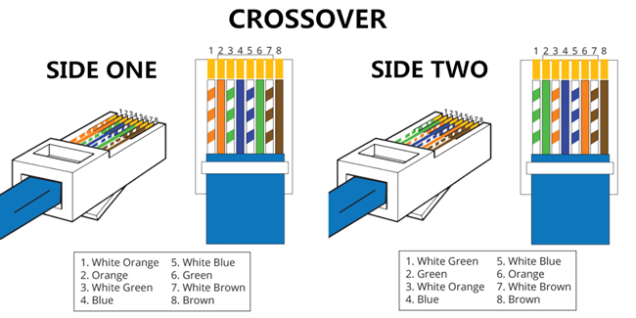

TESTING CABLES
Once both cables are ready, test it to make sure it works by means of a cable tester. Insert the two
ends of the cable into the jacks on the tester and watch the lights. If they all light up, wire has a
good connection and ready to use.

