LAB -4

NAME: ATIF MEHRBAN

COMPUTER NETWORK

Inter LAN Communication in CPT

Design the following topologies and perform simulation in packet tracer.
• Assign IP Address of Class C
• Transfer packet between them.

TASK 01

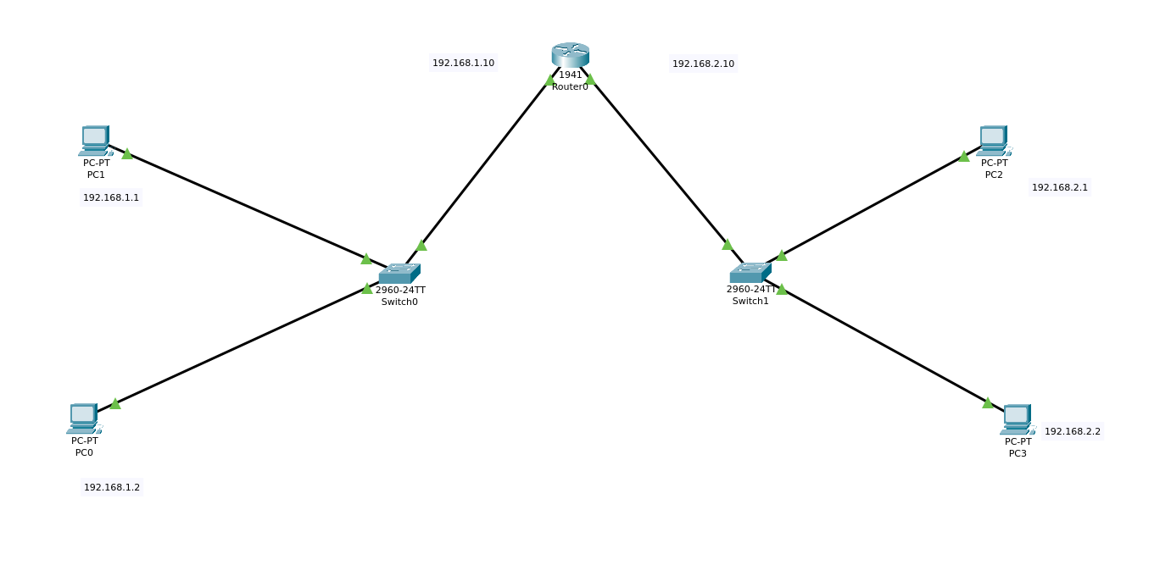

TASK 02
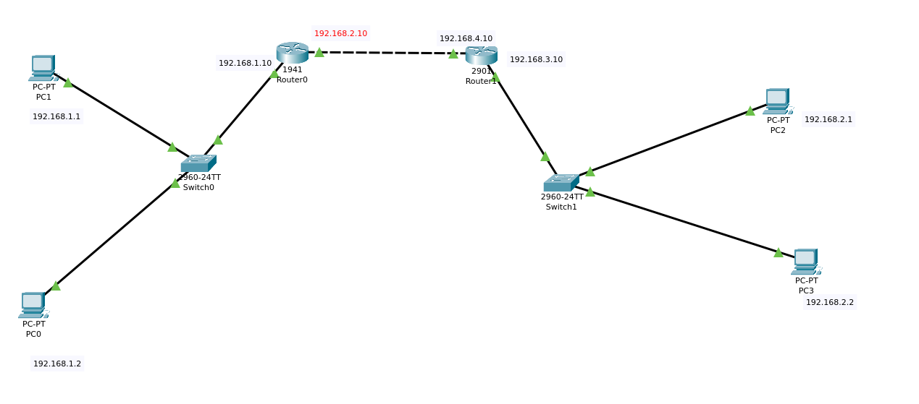

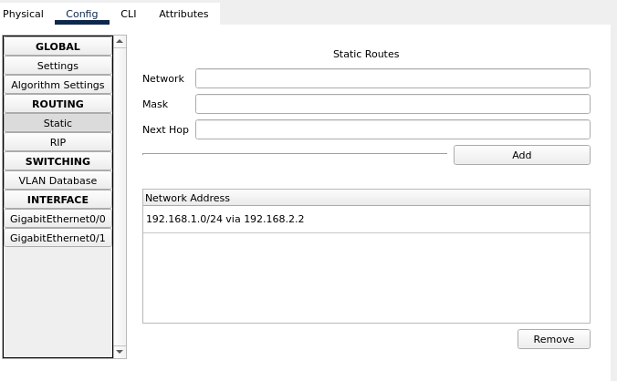

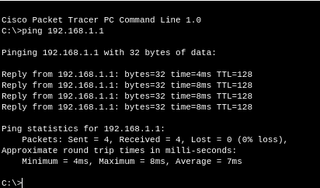

TASK 03

