PROJECT :
THE BREAKER GAME

GROUP MEMBERS:
HAMMAAD AHMAD KHALID
(P20-0626)

HUZAIFA KAMAL
(P20-0009)

DESCRIPTION:
A game developed using Assembly Language. We will implement a simple game in which you will have a layers of colored bricks and a ball which is tossed up to break the bricks. When the tossed ball hit a break it will break up and then the brick is gone. When the ball comes down and the paddle misses it you will lose one of three lives. The game pad or arrow keys are used to control the paddle.

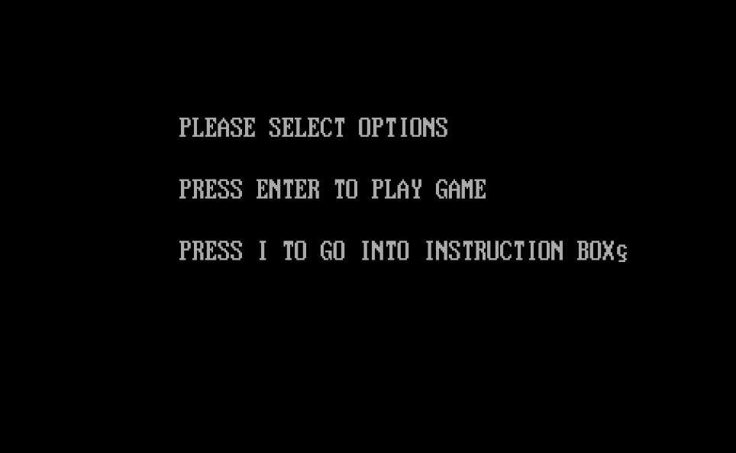
PROTOTYPE:

