PROJECT STEP 2

P20-0626
(HAMMAAD AHMAD KHALID)
P20-0009
(HUZAIFA KAMAL)

The attached code file contain the code for WELCOME page of the game and one of the next page after that I.E. INSTRUCTION page.

The program when started will show the welcome interface .
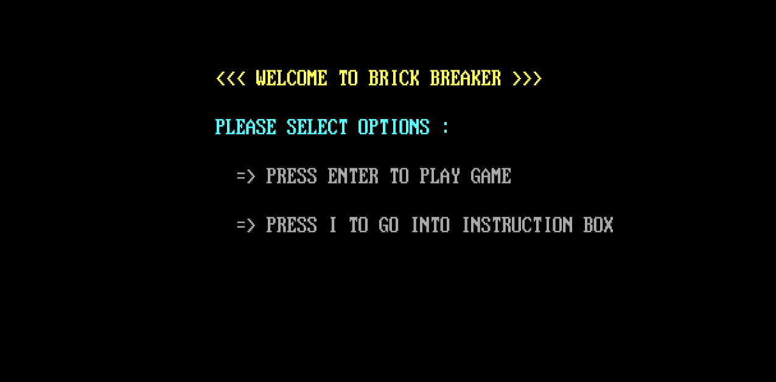
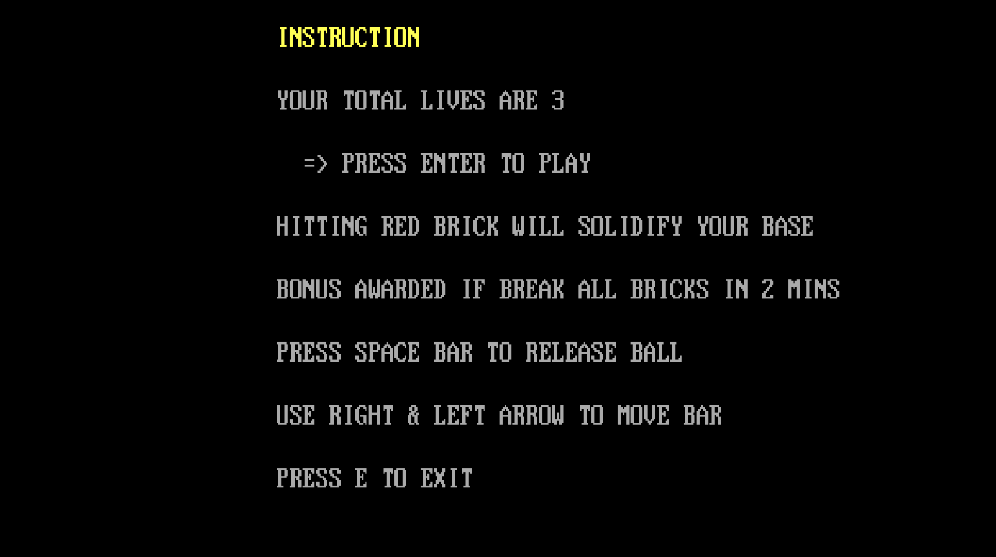
When I is pressed it will shift to INSTRUCTION interface.

