Git vs. GitHub in Simple Terms

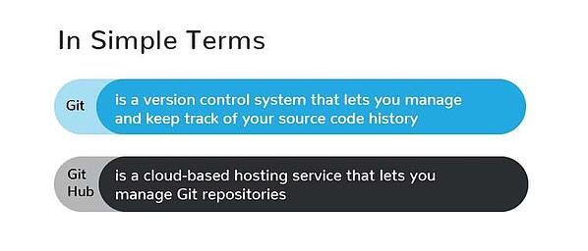

So, taken all together: Git vs. GitHub… what’s the difference? Simply put, Git is a version control system that lets you manage and keep track of your source code history. GitHub is a cloud-based hosting service that lets you manage Git repositories. If you have open-source projects that use Git, then GitHub is designed to help you better manage them.

After all, in the world of programming, naming conventions aren’t always intuitive. That’s why it’s worth recognizing the connections and the differences in the similarly named *Git* and *GitHub*. Both Git and GitHub give programmers valuable version-control functionality so that they can build ongoing coding projects without being afraid of messing everything up. GitHub just takes things a little bit further than Git, offering more functionality and resources, as well as a place online to store and collaborate on projects.

Reference: <https://blog.devmountain.com/git-vs-github-whats-the-difference/#:~:text=GitHub%E2%80%A6-,what's%20the%20difference%3F,help%20you%20better%20manage%20them>.