Workout Tracker
Project Overview:
The Workout Tracker is a basic web application built to help the user log and track their workouts. The purpose of this application is to relieve the burden of remembering what was trained, how long it was trained, and any additional notes on workouts for future reference. Instead of writing workouts on paper or in a random note on the phone, this app platform makes it easy to structure workouts in a simple list format. Each workout entry consists of a name, type, duration, date, intensity, and any additional comment available for that entry. The purpose of the project is to provide a clear demonstration of a basic CRUD application using the knowledge learnt in class

Purpose of the application:
The purpose of this application is to provide the user with an easy way to maintain their workout information without the use of an overly complicated fitness app. Most individuals frequently forget what the last workout session consisted of, its intensity/time, or even what day they trained. This creates difficulty in following a consistent workout routine. But this project works to eliminate that factor by providing a clean user interface to add, view, edit, and delete workouts. It creates a successful way to keep organized info in one consolidated spot to allow the user to quickly review their information and easily begin tracking their progress over weeks or months.

Key features:
This app has all four main CRUD operations: Create, Read, Update, and Delete. Users can create a new workout by completing a form with workout name, type, duration, date, intensity, and notes. All workout entries that are saved are shown on a clean list page, and each workout is presented in an organized card layout containing the information. Each workout can be edited to overwrite the existing workout or deleted completely. When in edit mode, the app loads the data that the user had previously entered for quick and easy updates. When in delete mode, the app explicitly confirms the deletion of a workout item to be sure that a user wants to proceed with the action. Overall, the features were built with a focus on usability, simplicity, and keeping the user’s workout history easily manageable.

Target Users and Goals:
The Workout Tracker is intended for anyone who wants a straightforward way to log their workouts. This may include beginners who absolutely only need a simple log, students who just want a simple entry point, and a person who goes to the gym often and wants a clean webpage without any of the bloat of having a full fitness application. The essence of the project is to offer the user a way to have an organized area to accurately input the details of their workout, easily and securely edit or delete if they want, and to keep it minimalistic and simple so anyone can learn to utilize the application without instruction. The primary focus for the application is that it should be functional, approachable, and dependable for typical users who are working to track their workouts.

Technology Stack:
The project was created using the main tools and technologies mentioned in class and required for this assignment. The backend is built using Node.js with the Express framework for handling routing and application logic. The database is a MongoDB Atlas cloud database, and the user-defined schema and model layer for structuring the workout data is done using Mongoose. The user interface uses EJS templates to run dynamic content on each page, and basic styling is included using Bootstrap classes and custom CSS written for the specific pages. Nodemon was used during development to automatically restart the server whenever files were updated.

Technologies used:
- Node.js - Backend runtime
- Express.js - Routing and controller handling
- MongoDB Atlas - Cloud database
- Mongoose - Schema + model for workout data
- EJS - Template engine for generating views
- Booststrap - Layout and basic UI styling
- Nodemon - Auto-reload during development

Data Model (Workout Schema):
The application contains just one data model named Workout. A workout, or workout session, is a single record that encompasses all the information about a user and their workout for the session. The Workout object is defined using Mongoose and has the following fields that hold data: workout name, workout type, duration, date, intensity level, and any optional notes. Each field is validated to ensure that the data is meaningful. For example, the duration must be at least 1 minute, and all main fields are required. This structure for the data keeps it useful and orderly with MongoDB.

Field Name | Type | Example | Description
workoutName | String | Shoulders & Arms | Name of the workout (required)
workoutType | String | Strength training | Category or type of workout (required)
durationMinutes | Number | 60 | Workout duration in minutes (required)
date | Date | 2025-11-21 | Date the workout was completed (required)
intensity | String | High | Intensity level (required)
notes | String | Focused on biceps today | Optional additional comments
Screenshots of Website:

Home page
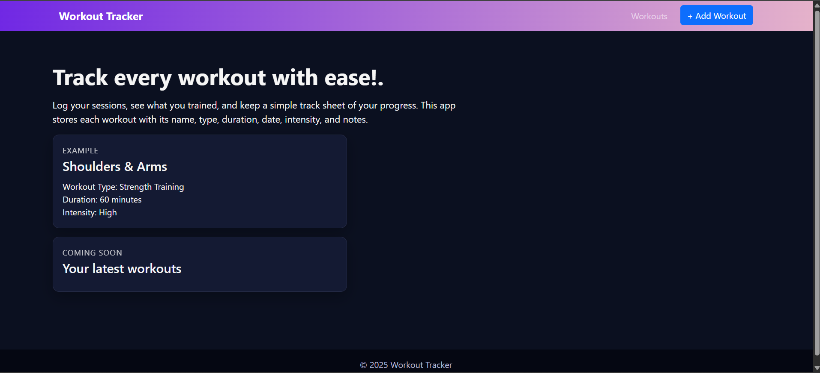

Workout list (Empty due to nothing being added)
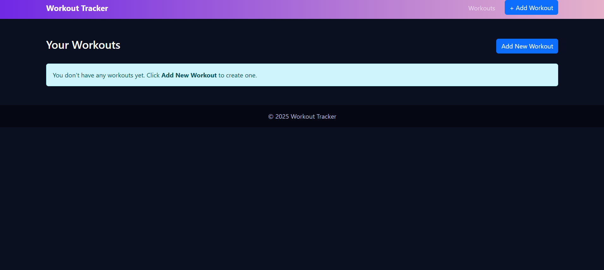

Add Workout
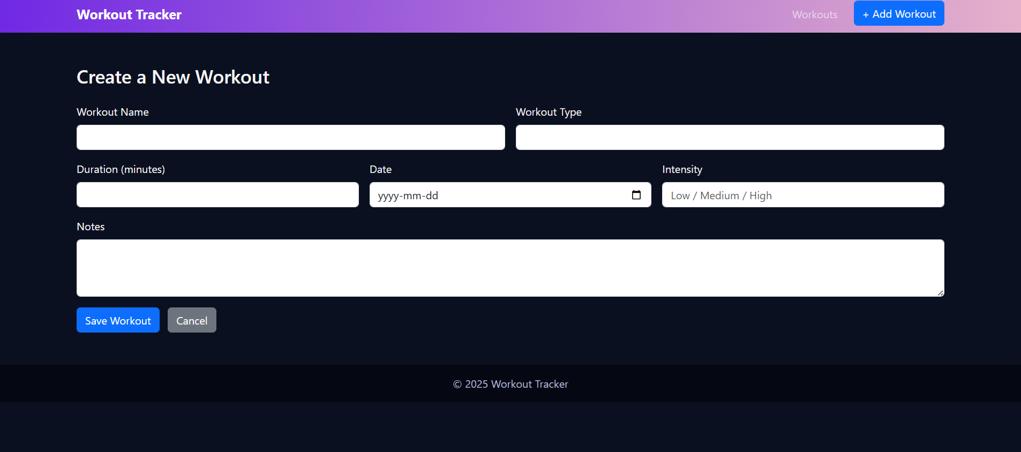

Edit Workout
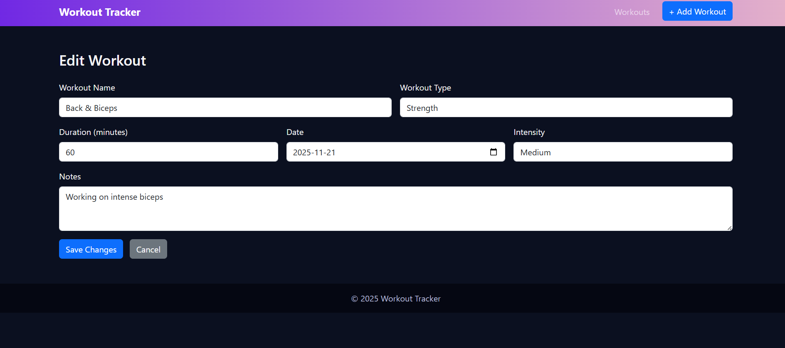

Delete confirmation page
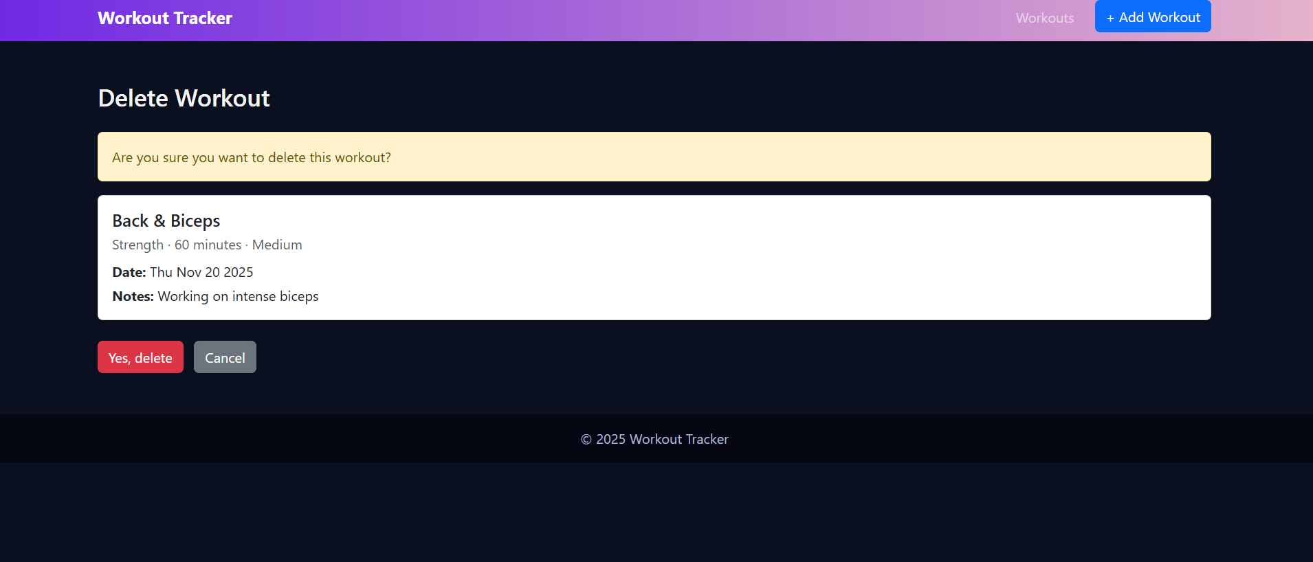

The screenshots above display how the user interacts with the system and how what is said above regarding the functionality matches with the visuals.

