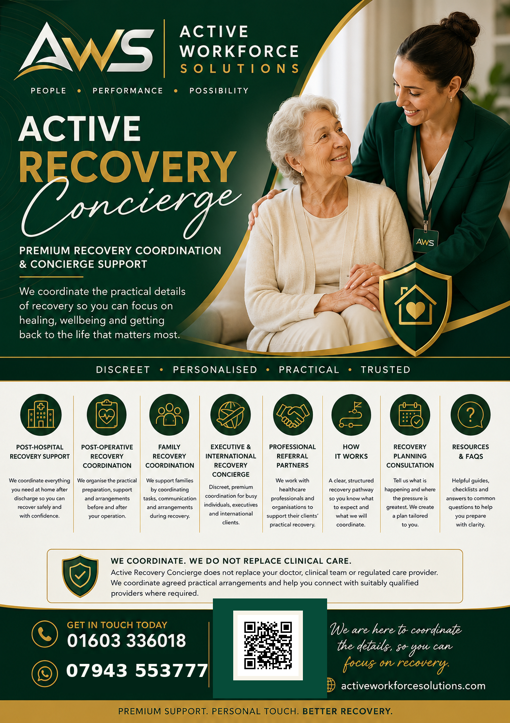
2 | POST-HOSPITAL RECOVERY SUPPORT  A safer, calmer transition from hospital to home.

Hospital discharge can happen quickly, while the practical arrangements needed at home may still be evolving. We help turn a discharge plan into an organised practical transition - reducing uncertainty for the client and family.
HOW WE CAN HELP
✓ Pre-discharge practical planning and action checklists.
✓ Home-readiness arrangements and essential logistics.
✓ Appointments, transport and diary coordination.
✓ Agreed family communication and practical updates.
✓ Identification of practical gaps after discharge.
✓ Connection with appropriately qualified regulated or specialist providers where required.
IDEAL FOR
Individuals returning home after hospital treatment and families who want one organised point of practical coordination.
You focus on recovery. We help coordinate the details.
READY WHEN YOU ARE  01603 336018 | WhatsApp 07943 553777  activeworkforcesolutions.com |   Scan to visit

3 | POST-OPERATIVE RECOVERY COORDINATION  Preparation before surgery. Organisation after it.

A successful recovery journey begins before the operation. We help clients prepare for the practical realities of recovery so important arrangements are considered before the day of surgery and reviewed as recovery progresses.
HOW WE CAN HELP
✓ Pre-surgery practical planning and personalised checklists.
✓ Home preparation and recovery logistics.
✓ Transport, appointments and diary coordination.
✓ Agreed family or representative communication.
✓ Practical recovery reviews as circumstances change.
✓ Onward connection to clinical, regulated or specialist providers where required.
IDEAL FOR
Planned surgery, elective procedures and clients who want a structured, discreet recovery experience.
Good preparation today can support a smoother recovery tomorrow.
READY WHEN YOU ARE  01603 336018 | WhatsApp 07943 553777  activeworkforcesolutions.com | Scan to visit

4 | FAMILY RECOVERY COORDINATION  Let family be family - not the full-time coordination team.

When someone you care about is recovering, families can quickly become organisers, communicators and problem-solvers. We bring structure to the practical journey so loved ones can focus more on being present.
HOW WE CAN HELP
✓ A shared practical recovery plan and action list.
✓ Clarification of agreed responsibilities and key contacts.
✓ Coordination of appointments, transport and logistics.
✓ Agreed updates for nominated family members.
✓ Help identifying appropriate external services where needed.
✓ Ongoing practical review as needs change.
IDEAL FOR
Families supporting a parent, spouse, relative or loved one through recovery or a change in independence.
Less organising. More time to care.
READY WHEN YOU ARE  01603 336018 | WhatsApp 07943 553777  activeworkforcesolutions.com | Scan to visit

5 | EXECUTIVE & INTERNATIONAL RECOVERY CONCIERGE  Discreet coordination for recovery that must fit around a demanding life.

For clients managing demanding schedules, international travel, multiple locations or a high need for privacy, recovery can require an additional level of discretion, flexibility and organisation.
HOW WE CAN HELP
✓ Discreet recovery planning around professional and personal commitments.
✓ Coordination across appointments, locations and providers.
✓ Travel and non-clinical recovery logistics.
✓ Communication with authorised representatives or family offices.
✓ International and cross-location practical coordination.
✓ One trusted point of coordination for agreed arrangements.
IDEAL FOR
Executives, entrepreneurs, international clients and families seeking a highly discreet concierge experience.
Discreet. Seamless. Personal.
READY WHEN YOU ARE  01603 336018 | WhatsApp 07943 553777  activeworkforcesolutions.com | Scan to visit

6 | PROFESSIONAL REFERRAL PARTNERS  A practical bridge between treatment and everyday recovery.

Active Recovery Concierge complements professional treatment and support by coordinating agreed non-clinical arrangements around the client. We provide a clear, professional pathway without replacing clinical or regulated responsibilities.
HOW WE CAN HELP
✓ Hospitals and discharge teams.
✓ Consultants, surgeons and private clinics.
✓ GP practices and allied health professionals.
✓ Case managers and social work professionals.
✓ Insurers, employers and wellbeing programmes.
✓ Other professional referrers supporting a client's recovery journey.
WHY REFER
A structured non-clinical coordination option for suitable clients who need practical organisation, continuity and onward connection.
Reliable. Professional. Collaborative.
READY WHEN YOU ARE  01603 336018 | WhatsApp 07943 553777  activeworkforcesolutions.com | Scan to visit

7 | HOW IT WORKS  A simple pathway designed to replace confusion with clarity.

Our structured recovery pathway helps clients understand what will happen, what information is needed and how agreed practical arrangements will be coordinated.
HOW WE CAN HELP
✓ 1. Initial conversation - understand your situation, priorities and pressure points.
✓ 2. Define the scope - agree what we coordinate and what sits with other professionals.
✓ 3. Recovery plan - create practical actions, responsibilities and key dates.
✓ 4. Coordination - organise agreed non-clinical arrangements and track progress.
✓ 5. Review - adapt practical arrangements as recovery changes.
✓ 6. Transition - make outstanding responsibilities clear when intensive coordination ends.
OUR PROMISE
Clear expectations, respectful communication and practical coordination shaped around the person - not a generic package.
Simple. Structured. Supportive.
READY WHEN YOU ARE  01603 336018 | WhatsApp 07943 553777  activeworkforcesolutions.com | Scan to visit

8 | RECOVERY PLANNING CONSULTATION  Your first step towards a calmer, clearer recovery journey.
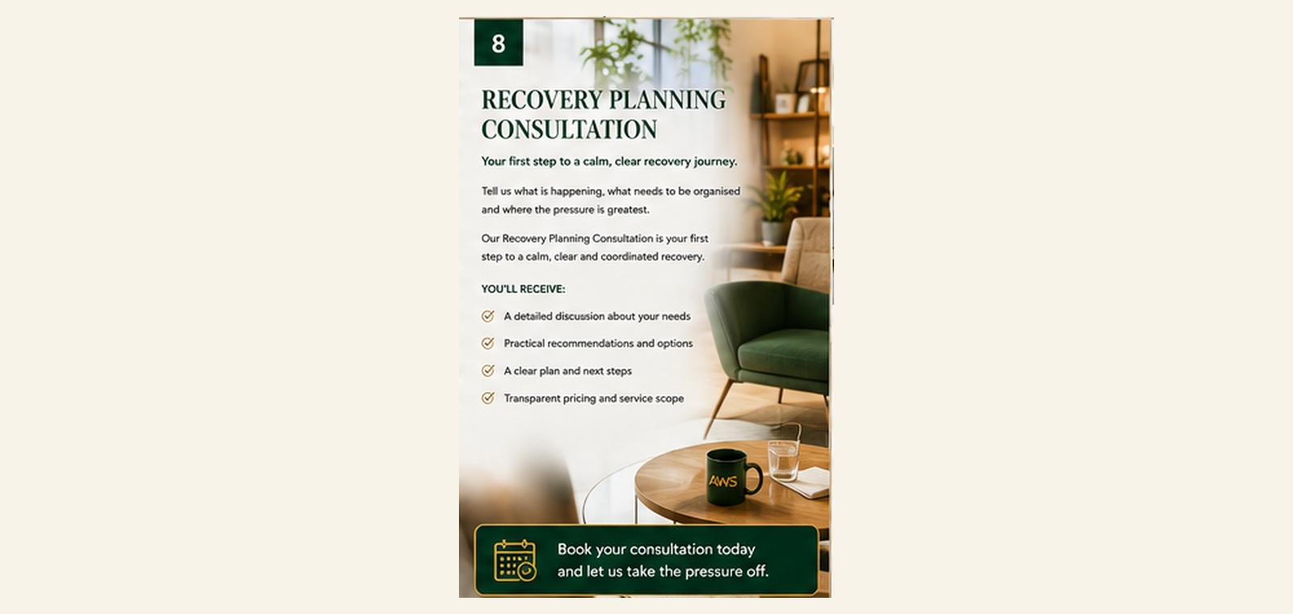
Tell us what is happening, what needs to be organised and where the pressure is greatest. The consultation helps us understand your circumstances, identify practical gaps and agree sensible next steps.
HOW WE CAN HELP
✓ A detailed discussion about your needs and priorities.
✓ Review of existing arrangements and practical gaps.
✓ Clarification of what we can coordinate and what sits with other providers.
✓ Practical recommendations and agreed next steps.
✓ A tailored coordination plan where ongoing support is appropriate.
START HERE
Ideal if you are unsure where to begin, preparing for surgery or discharge, or simply want an organised plan before making further arrangements.
Start with clarity. Leave with a plan.
READY WHEN YOU ARE  01603 336018 | WhatsApp 07943 553777  activeworkforcesolutions.com | Scan to visit

9 | RESOURCES & FAQs  Useful information for better-prepared recovery.
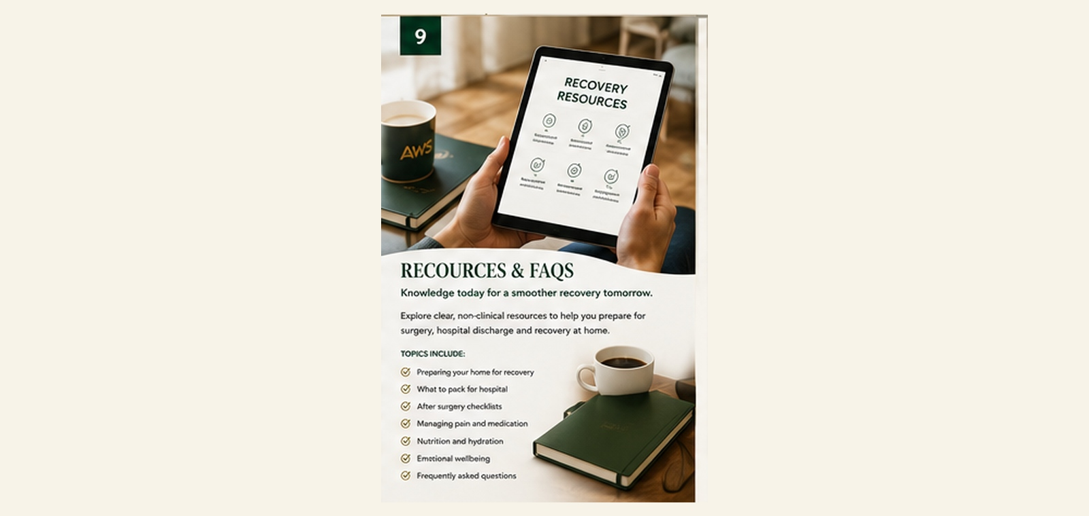
Clear information can reduce uncertainty. Our non-clinical resources help clients and families prepare, organise and understand the practical recovery journey.
HOW WE CAN HELP
✓ Practical preparation and home-readiness checklists.
✓ Questions to consider before hospital discharge.
✓ Guidance on organising family communication and responsibilities.
✓ Information explaining what our concierge service does and does not provide.
✓ Frequently asked questions about referrals, confidentiality and coordination.
✓ Practical prompts to help prepare for a Recovery Planning Consultation.
DESIGNED TO HELP
Clients and families feel more prepared, ask better questions and understand who is responsible for each part of the recovery journey.
Knowledge today for a smoother recovery tomorrow.
READY WHEN YOU ARE  01603 336018 | WhatsApp 07943 553777  activeworkforcesolutions.com | Scan to visit

10 | YOUR RECOVERY. THOUGHTFULLY COORDINATED.  One trusted point of practical coordination.

You do not need to organise every practical detail alone.
Whether you are preparing for surgery, coming home from hospital, supporting someone you love or managing recovery around a demanding lifestyle, we are here to bring clarity, structure and continuity to the practical journey.
WHY CLIENTS CHOOSE ACTIVE RECOVERY CONCIERGE
✓ One organised point of contact for agreed practical arrangements.
✓ Personalised coordination shaped around individual circumstances.
✓ Discretion, continuity and respectful communication.
✓ Practical support without blurring clinical or regulated responsibilities.
✓ Help connecting with appropriately qualified providers where required.
✓ A calmer, clearer recovery experience for clients and families.
IMPORTANT
Active Recovery Concierge is a coordination and concierge service. We do not replace doctors, nurses, therapists, clinical teams or regulated care providers. We do not diagnose, give medical advice or provide regulated personal care through this concierge service. Where regulated or specialist services are required, we help clients identify and connect with appropriately qualified providers, who remain responsible for the services they deliver.
READY WHEN YOU ARE  01603 336018 | WhatsApp 07943 553777  activeworkforcesolutions.com | Scan to visit

