**Figma design:** Login and Registration page

<https://www.figma.com/design/AGDRk2CMUJHydyOCkVsILg/Untitled?node-id=0-1&t=XWukpLAWVLRm3rM6-1>

**Login Page**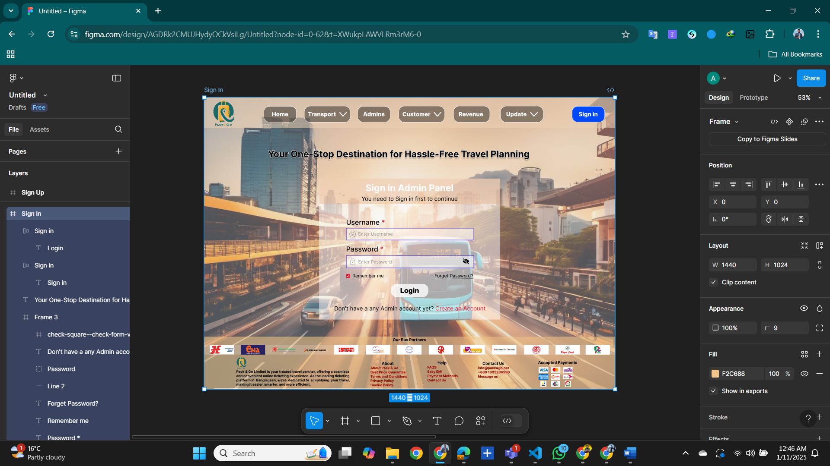

**Registration Page:**

