Atika Mughal

SAP ID: 5000000280

Computer Networking Lab-2

Task 1:
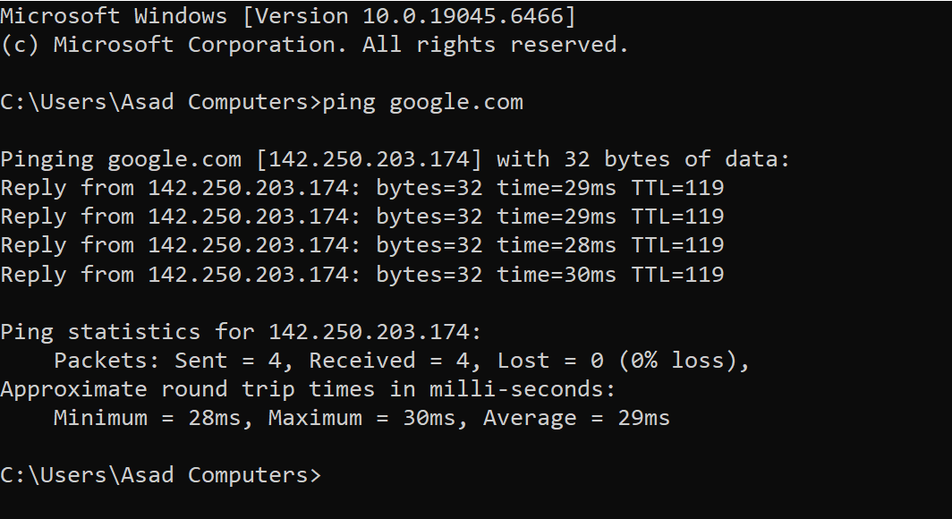

Task 2:
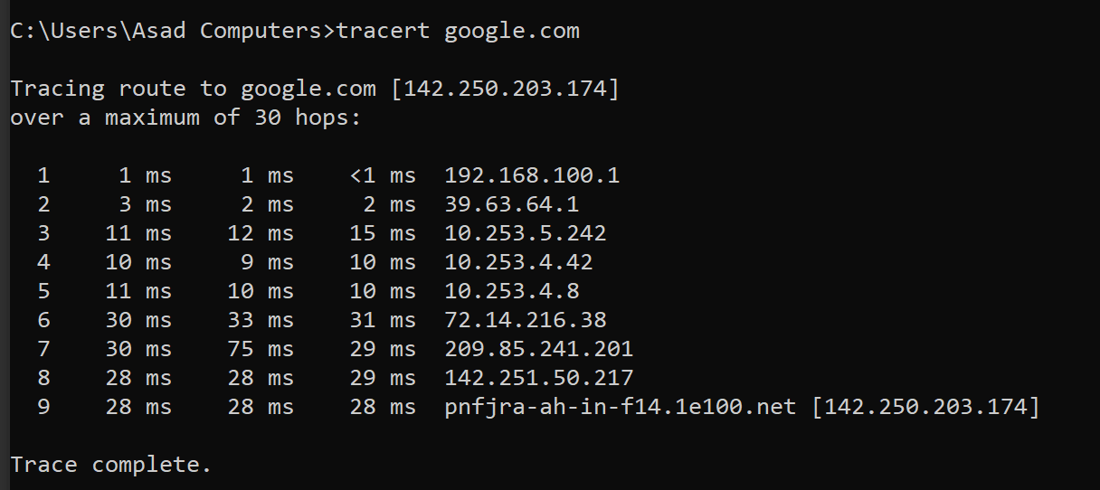

Task 3: Identify Hop1.
- Hop 1 is the first device your computer sends the data to.
- Hop 1 represents the default gateway (local router) that connects the host computer to the network.

Task 4: Identify the ISP router from tracert.
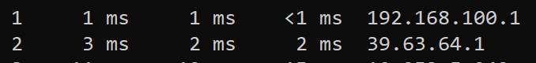
The ISP router is identified at Hop 2 with IP address 39.63.64.1. It represents the first router of the Internet Service Provider that connects the local network to the wider internet.
- Hop 2 is the ISP router.
- Hop 1 (192.168.100.1) is a private IP (local router)
- Hop 2 (39.63.64.1) is a public IP address

Task 5:
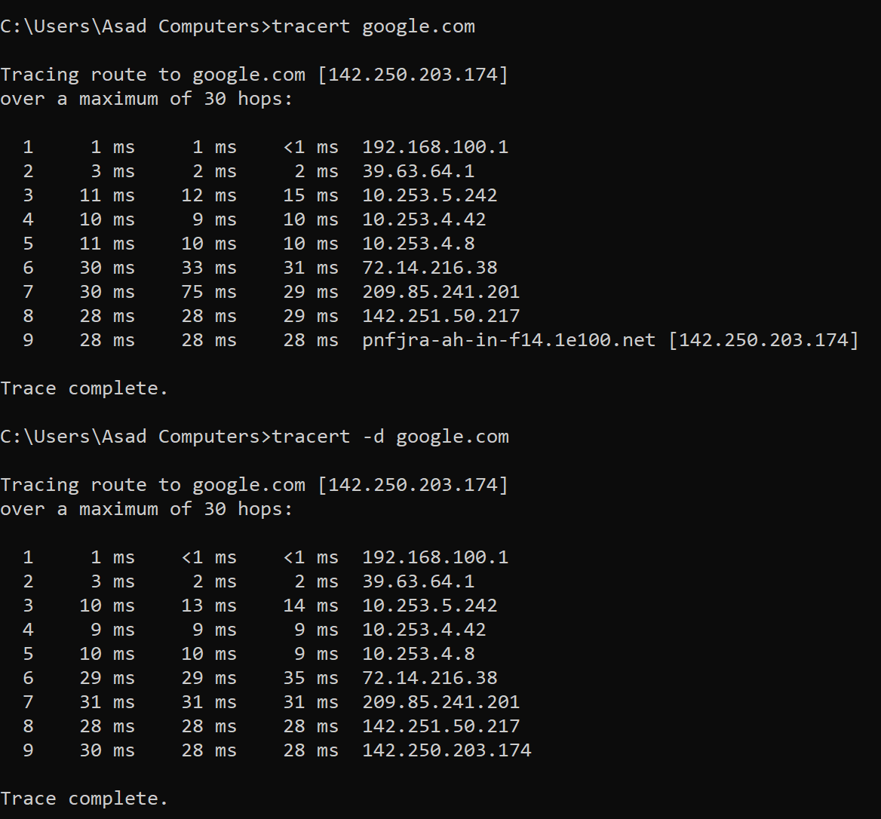
tracert | tracert -d
Displays IP addresses + domain | Only displays IP addresses
Uses DNS lookup to resolve IP address into names | Does not perform DNS resolution
It takes more time because DNS resolution is involved | Faster than tracert
e.g. pnfjra-ah-in-f14.1e100.net [142.250.203.174] | e.g. 142.250.203.174

Task 6: What does * * * mean in tracert output? Is it always an error?
* * * in tracert indicates that the router did not respond within the timeout period. It is not always an error, as some routers block ICMP requests for security reasons. If the destination is reached later, the network path is functioning correctly.
In the given tracert output, no * * * entries were observed. This indicates that all intermediate routers responded within the timeout period, and there was no packet loss or ICMP blocking along the route.

Task 7: Visit an HTTP and an HTTPS website. Identify which uses TLS and explain.
- HTTP (Hypertext Transfer Protocol) → Not secure. Data is sent in plain text. If it starts with http://, it does not use TLS.
- HTTPS (HTTP Secure) → Secure. Data is encrypted using TLS (Transport Layer Security). If the website URL starts with https://, it uses TLS.
Visit Websites:
http://neverssl.com
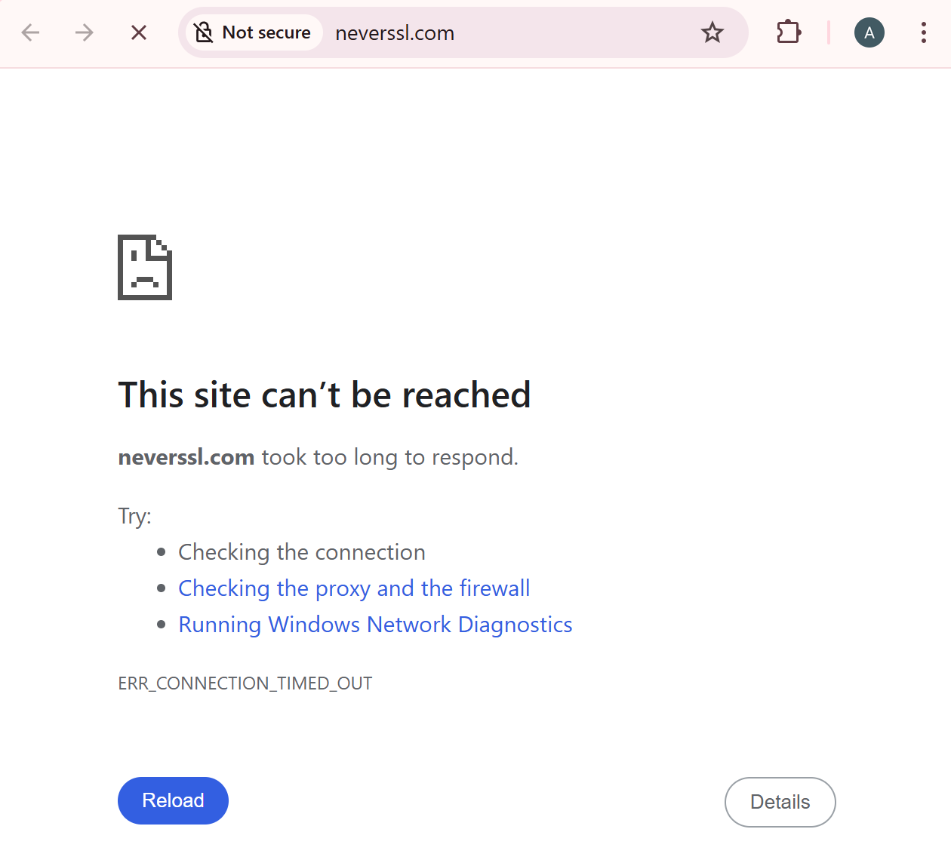
https://www.google.com


Task 8: Define hop and explain its importance.
A hop is a single step that a data packet takes as it travels from one network device, like a router, to another on its way from the source to the destination. It is important because the number of hops helps measure the distance between devices in a network, assists routers in choosing efficient paths, and allows network administrators to identify delays or failures using tools like traceroute. More hops can increase latency, so understanding hops is essential for efficient data transmission and troubleshooting.

Task 9: Explain TTL and its role in packet transmission.
TTL (Time To Live) is a number in a data packet that tells the network how long the packet can travel. Every time the packet passes through a router (a hop), this number goes down by one. If it reaches zero, the packet is thrown away. TTL’s role is to stop packets from getting stuck in the network forever and keep data moving smoothly.

Task 10: Write a short note on the importance of TLS.
TLS (Transport Layer Security) is important because it keeps data safe when it travels over the internet. It encrypts information like passwords, messages, and credit card details, so no one can read or steal it. TLS also verifies websites, ensuring you are connecting to the right site and not a fake one. Overall, it protects privacy, prevents hacking, and makes online communication secure.

Task 11: Wireshark.
Capturing Packets.
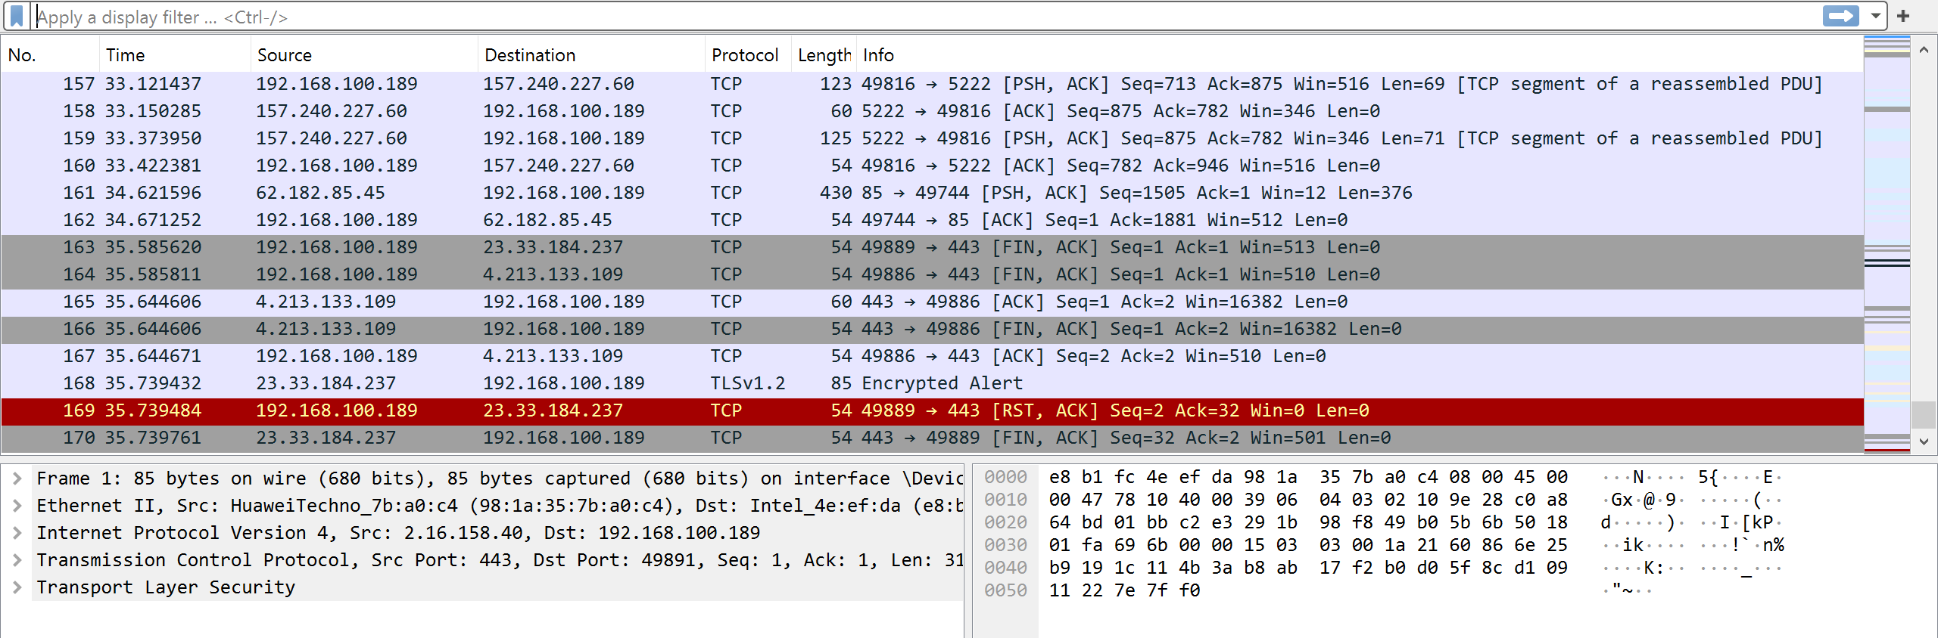

Task 12: Apply a Filter (HTTP).
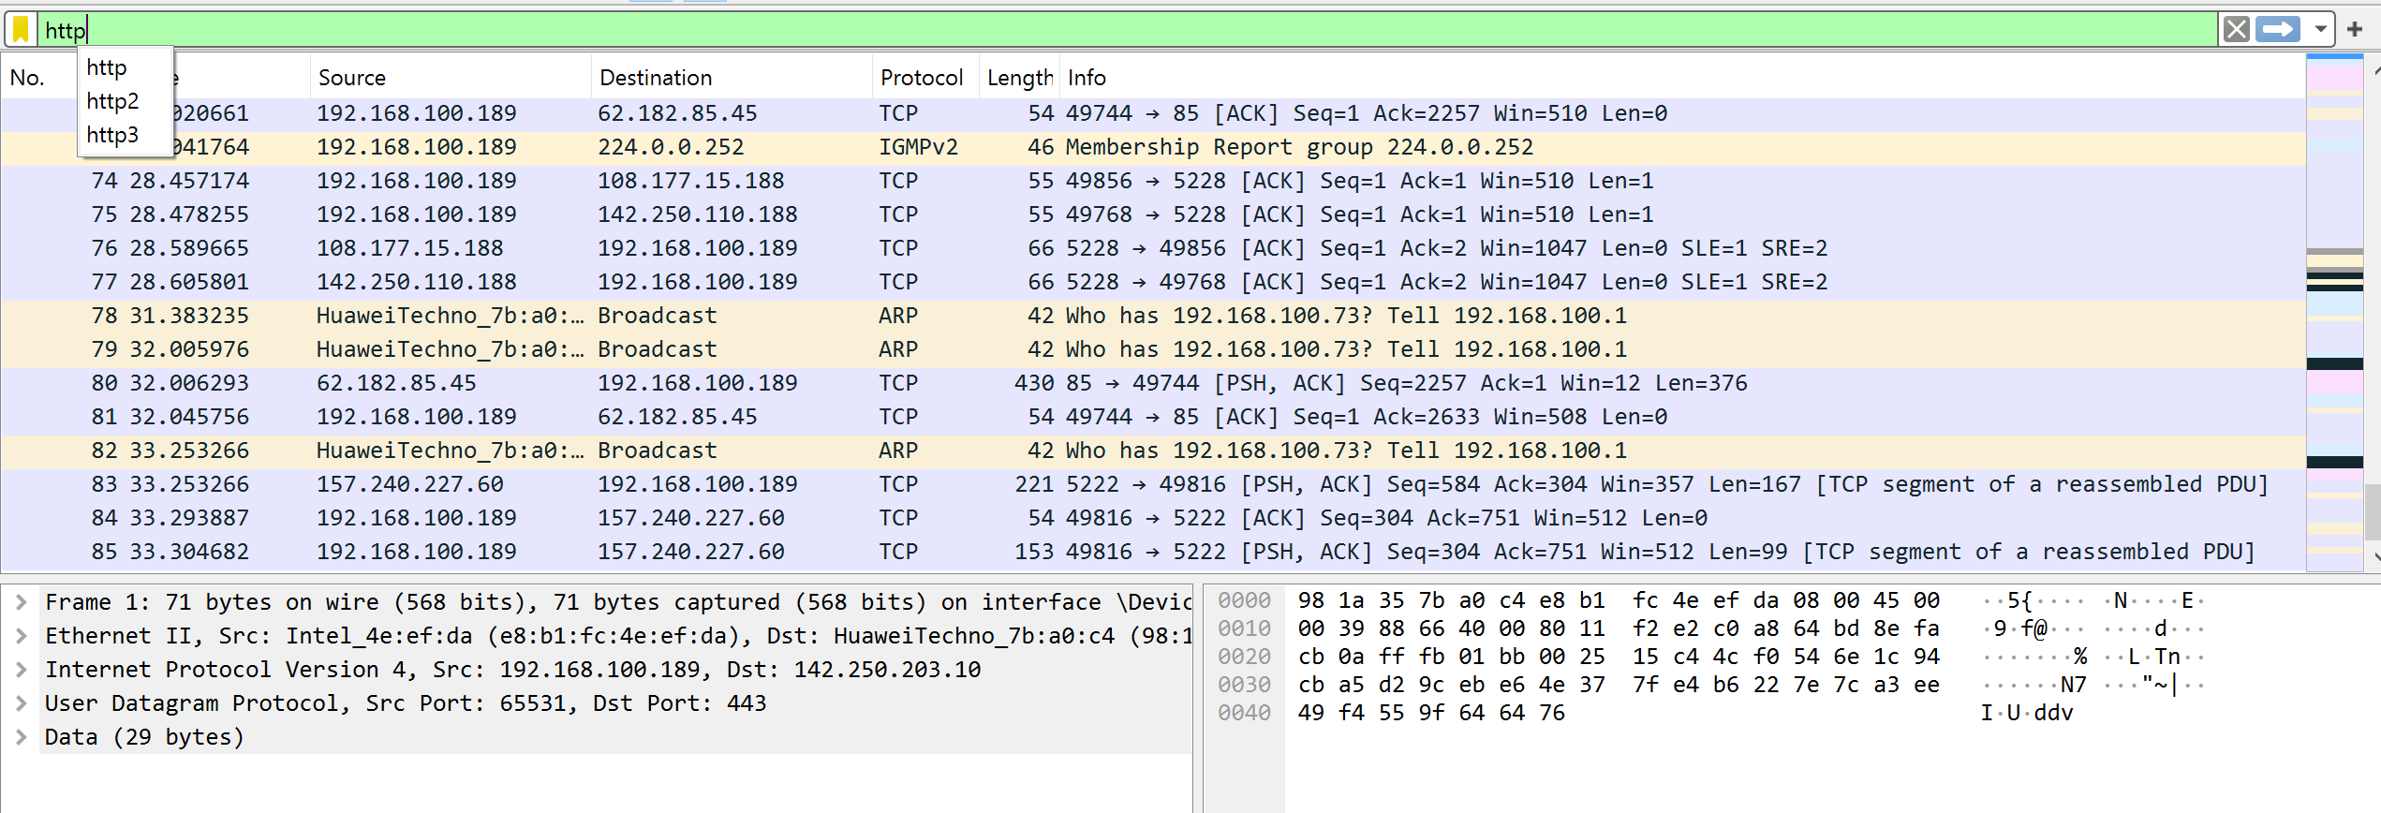

Task 13: HTTPs/TLS.
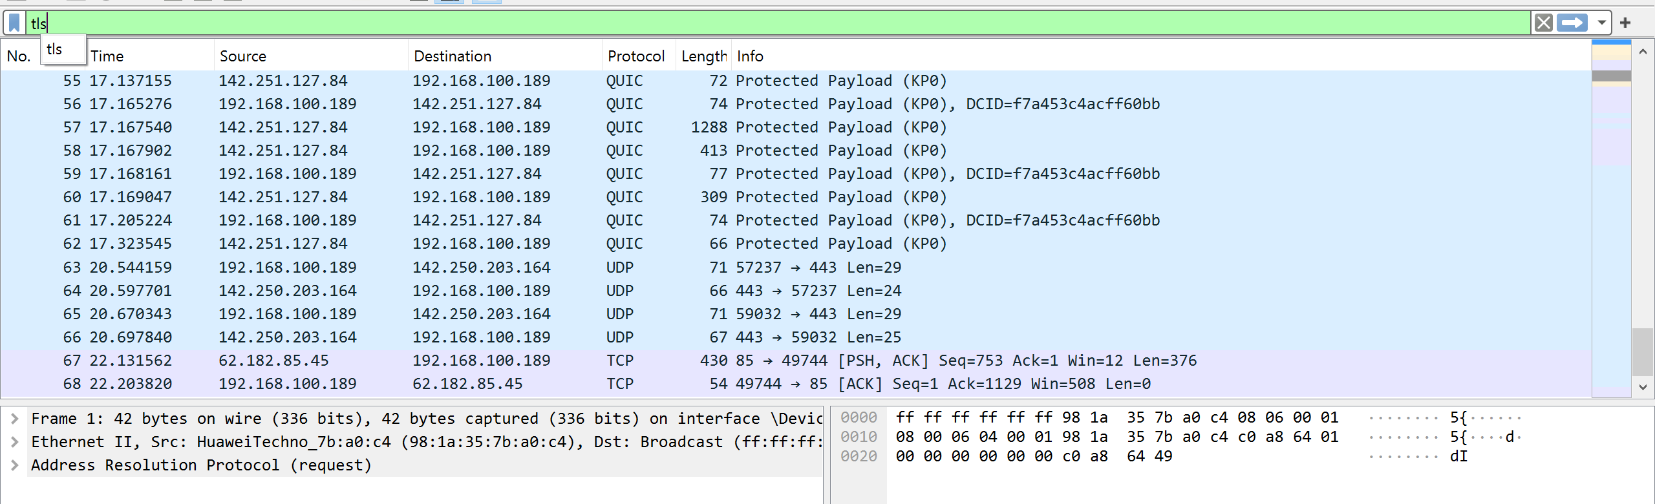

Task 14: Identify source and destination IP addresses from a captured packet.
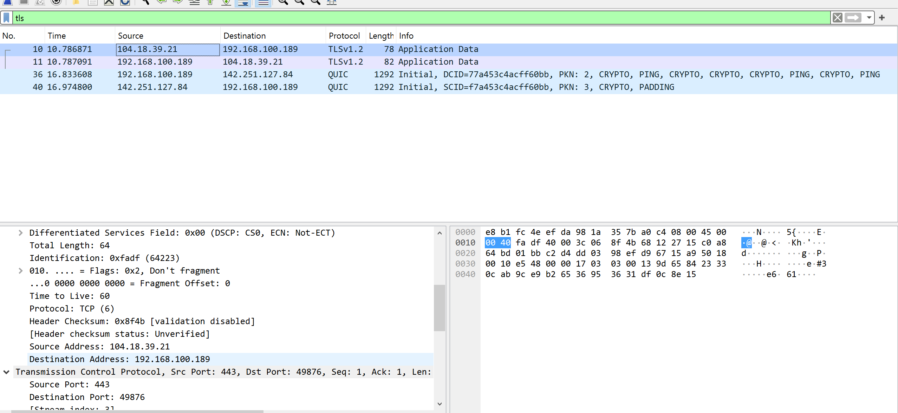
Source Address: 104.18.39.21
Destination Address: 192.168.100.189

Task 15: Explain one difference between HTTP and HTTPS packets observed in Wireshark.
In Wireshark, HTTP packets show readable data such as website names and text because they are not encrypted, while HTTPS packets appear as TLS/SSL packets and their data is encrypted and cannot be read. Therefore, HTTP traffic is visible in plain text but HTTPS traffic is secure and hidden.

