Atika Mughal

SAP ID: 5000000280

Computer Networking Lab-3

Cisco Packet Tracer

- Bus Topology.
A network in which all computers are connected to a single main cable called the backbone, and every device shares the same communication line to send and receive data.
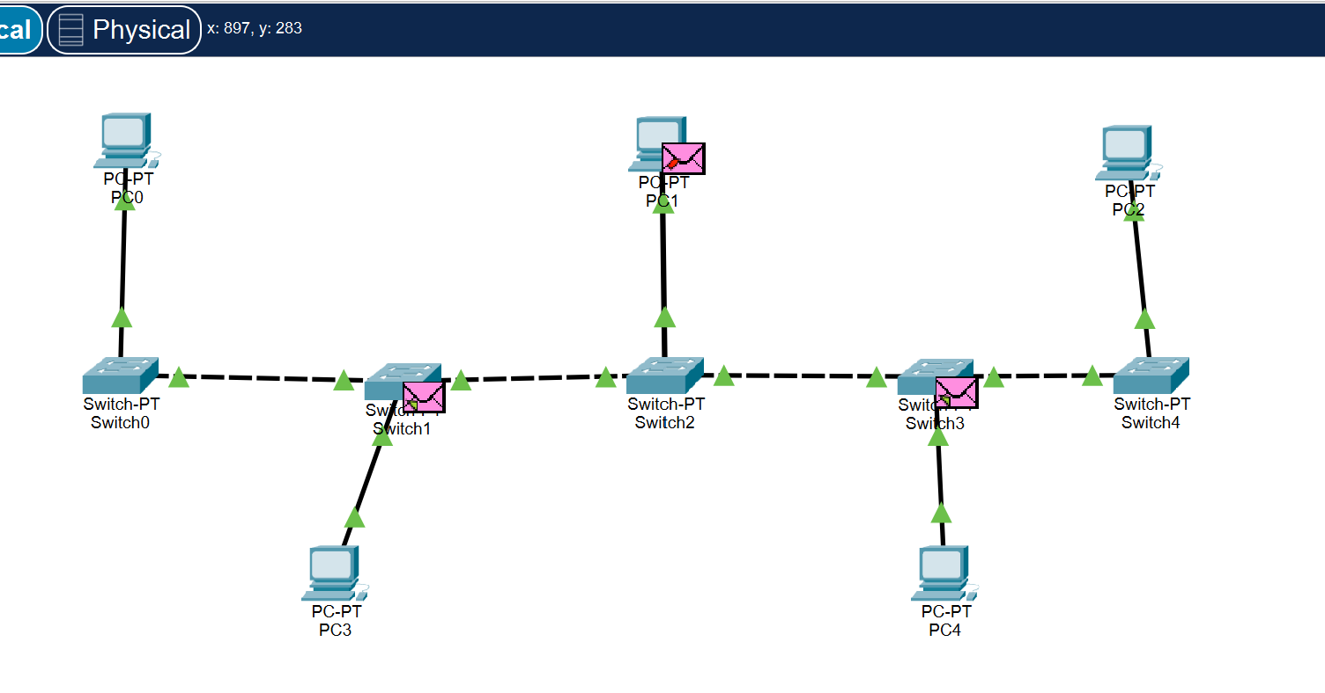
- Star Topology.
Star topology is a network in which all computers are connected to a central device (like a switch or hub), and all communication passes through that central point.
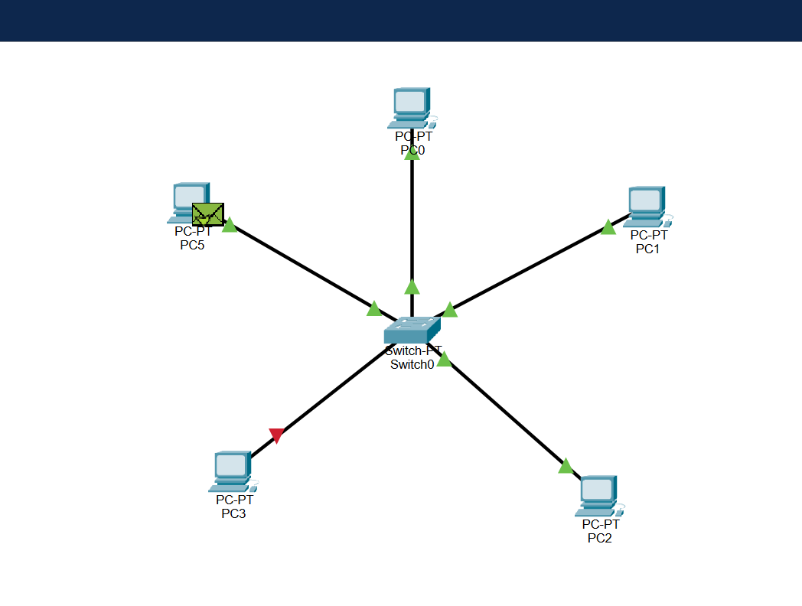
- Ring Topology.
Ring topology is a network where each device is connected in a closed loop and data travels around the circle.
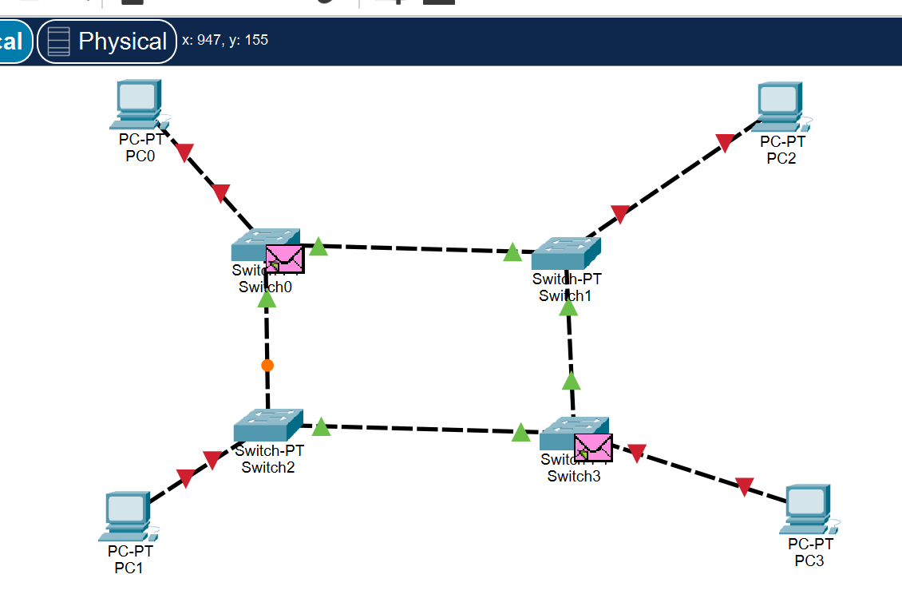
- Mesh Topology.
A mesh topology is a network where every device is connected directly to every other device.
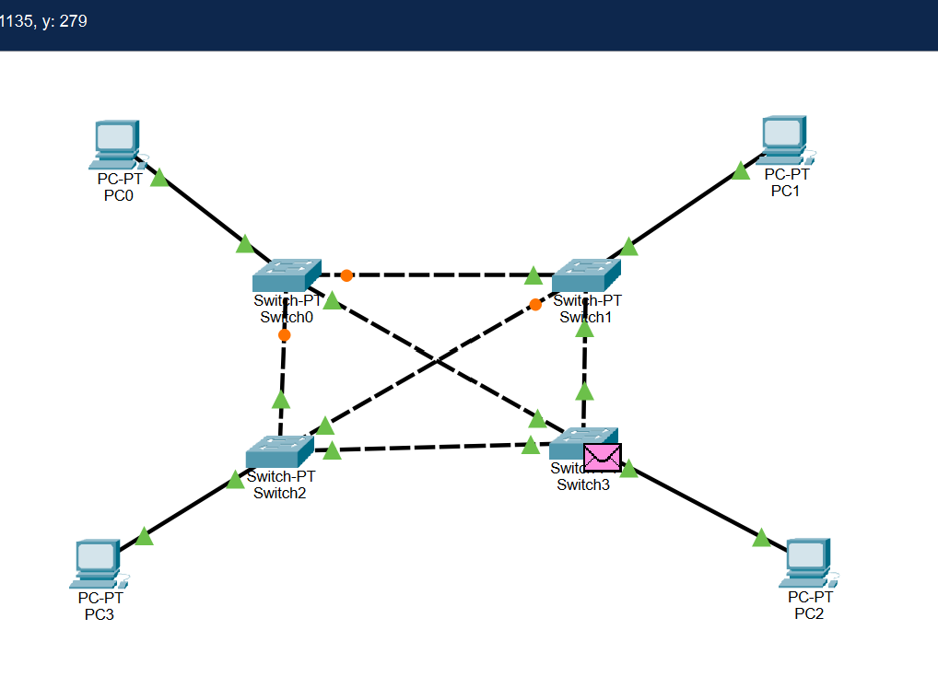
- Tree Topology.
Tree topology is a network structure where nodes are arranged like a tree, with a root node connected to one or more levels of child nodes.
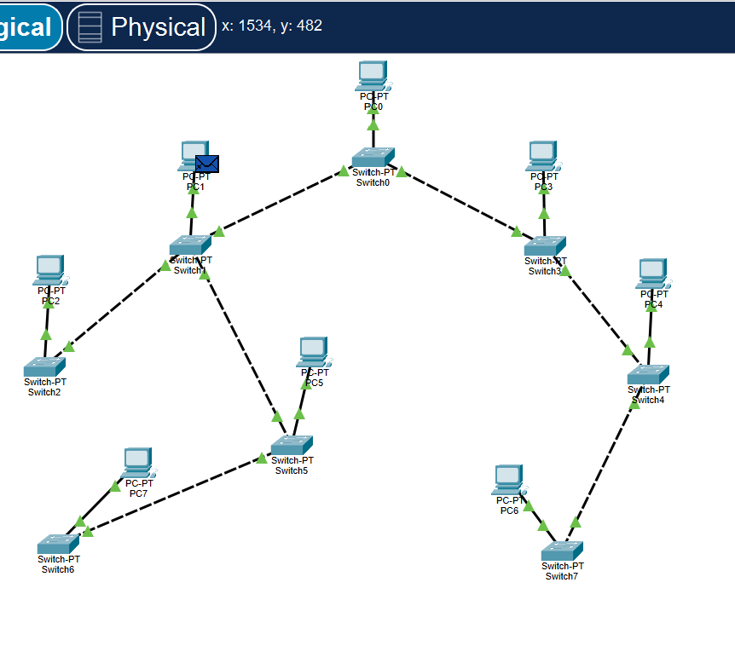

Part B: Creating Basic LAN in Cisco Packet Tracer.
- Open Cisco Packet Tracer.

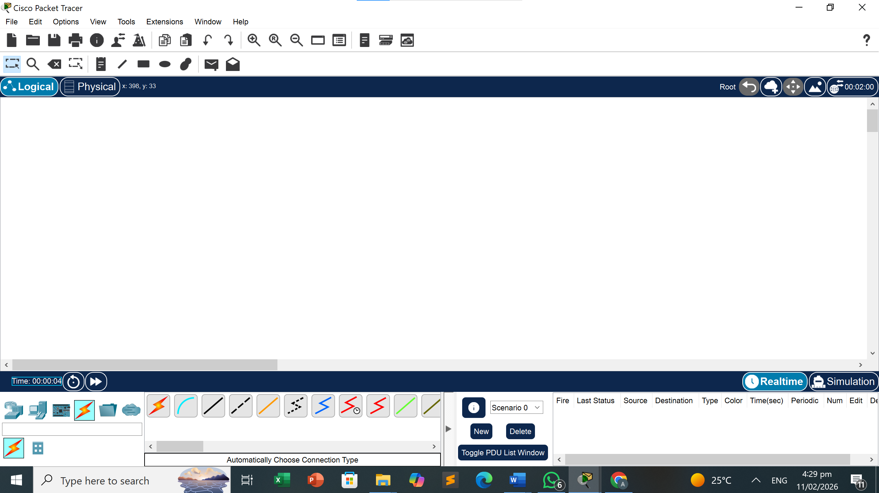
- Drag 2 PCs from End Devices.
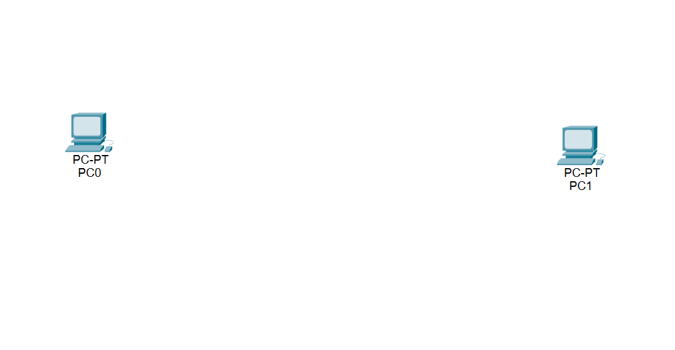
- Drag 1 Switch (2960 model).
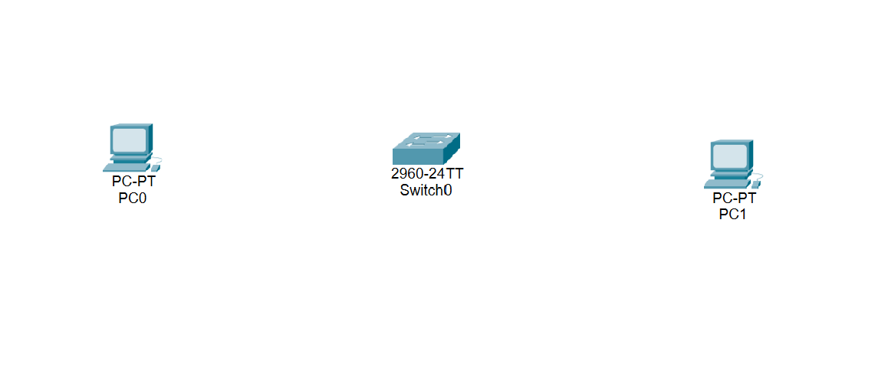
- Connect PCs to switch using Copper Straight Through cable.
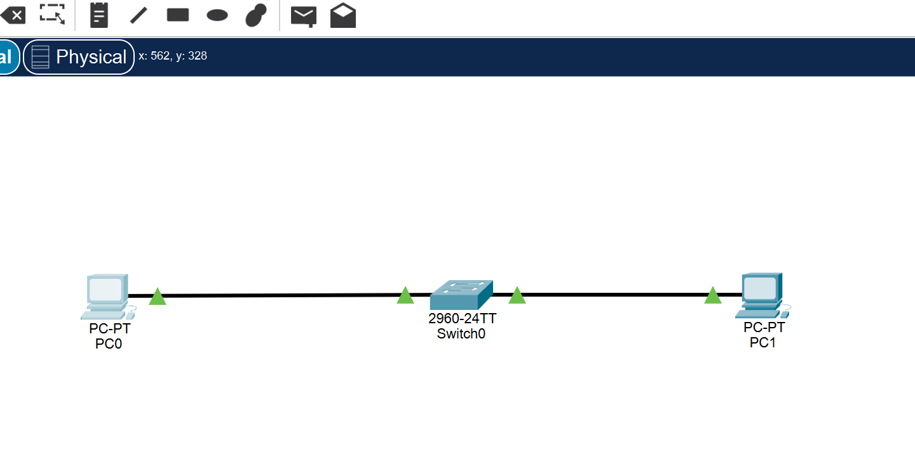

- Assign IP Address 192.168.1.1 to PC0.
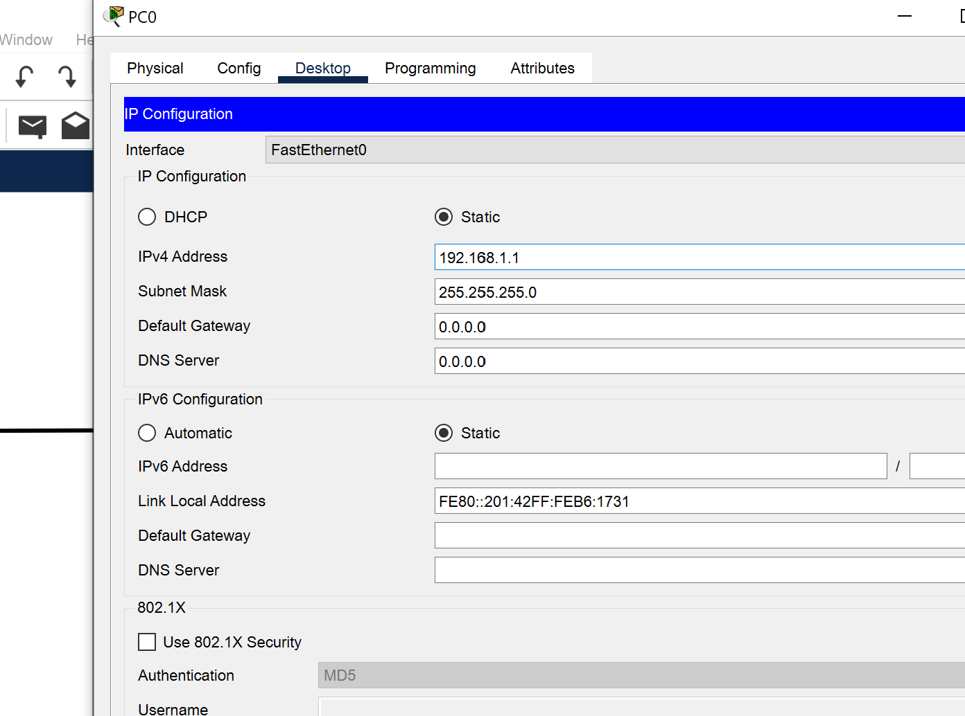

- Assign IP Address 192.168.1.2 to PC1.
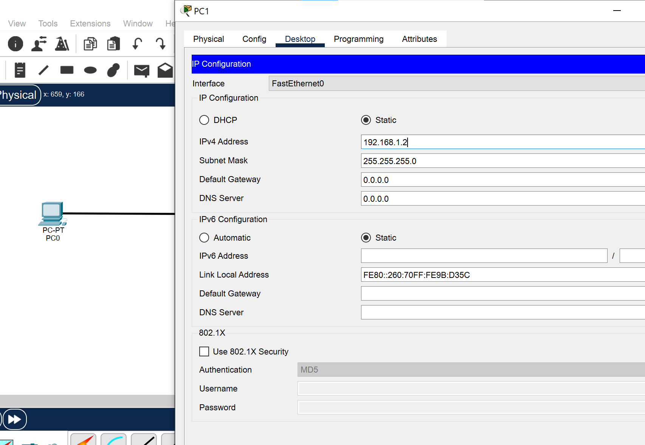

- Set Subnet Mask 255.255.255.0 for both PCs.


- Test connectivity using command: ping 192.168.1.2.
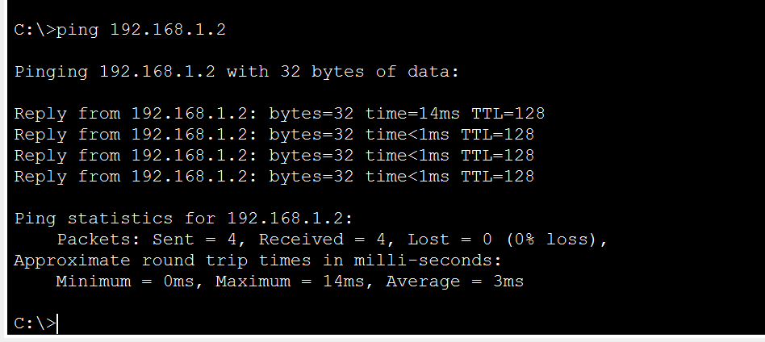
Result: Success.

Part C: Error Demonstration Activity
Change PC1 IP address to 192.168.2.2 and repeat ping command. Observe the result.
- Intentionally breaking the network.
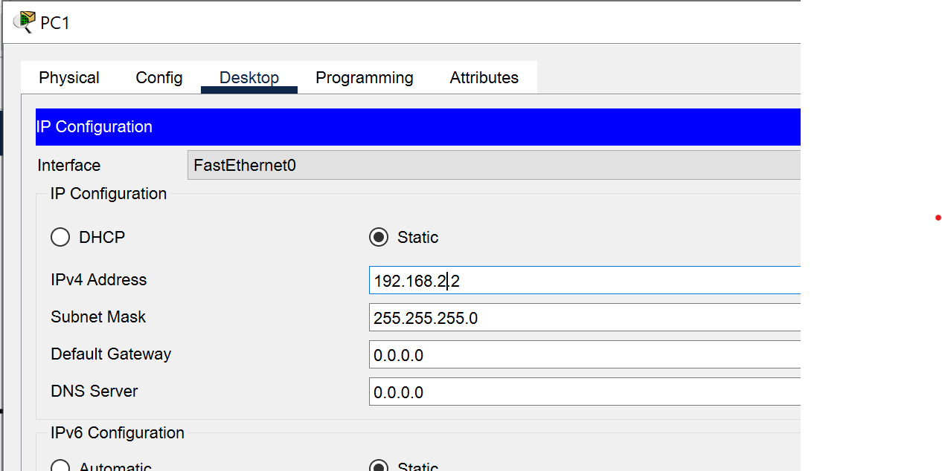

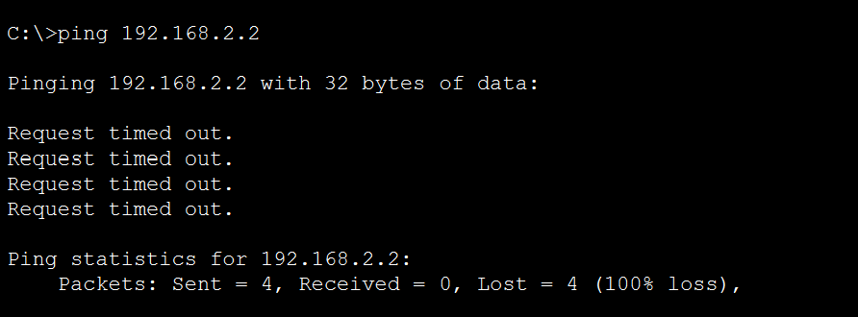
When PC1’s IP address is changed to 192.168.2.2, it moves to a different subnet than PC0 (192.168.1.1). Devices in different networks require a router to communicate, but the topology only contains a switch, which cannot perform routing. Because no default gateway exists to forward the packets to another network, the ping request cannot reach PC1 and the communication fails.

Analytical Questions:
- What happens if two devices have the same IP address?
The two devices cannot have the same IP Address, if they have the same address, it will show some conflicts. Message will not send to the other device.
- Can devices communicate without a switch? Explain.
Yes. Device can communicate without a switch through the ethernet wire. If we are connecting two devices with wire, the data will share.
- Why must subnet mask be same in a LAN?
In a LAN, all devices must use the same subnet mask so they can agree on which IP addresses belong to the local network and which belong to another network.

