Atika Mughal

SAP ID: 5000000280

Computer Networking Lab-5

Task 1: Connect to FTP server from PC.
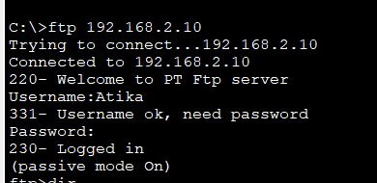
Task 2: Create a text file and upload it.
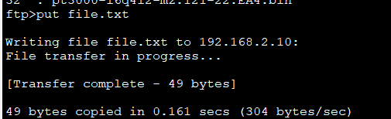
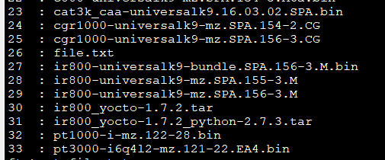
Task 3: Rename file on server.
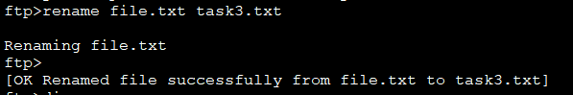
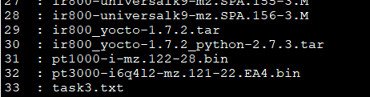
Task 4: Download file from another PC.
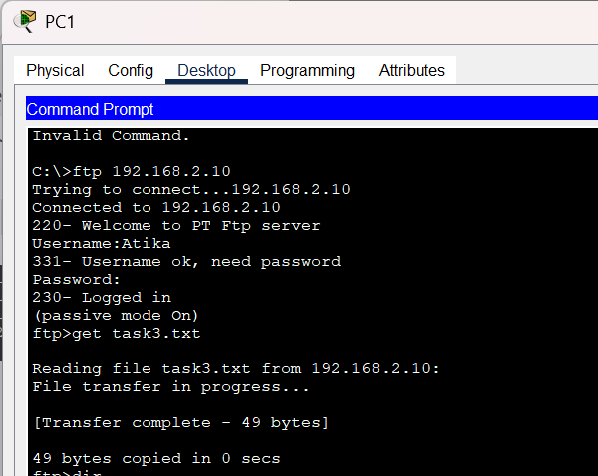

Task 5: Test permission restrictions (rename/delete/upload).
Rename:

Upload:

Delete:
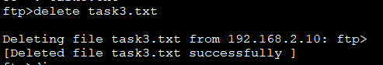
Questions:
- What is FTP?
FTP (File Transfer Protocol) is a standard method used to transfer files between computers over a network (usually the internet).
- Difference between put and get?
In FTP, PUT and GET are commands used to transfer files, but in opposite directions.
- PUT → “I am sending a file to the server”
- GET → “I am receiving a file from the server”
- Why permissions are important?
Permissions are important because they control who can access, read, write, or modify files and resources in a system.
- Why gateway is important and what happens if gateway is wrong?
A gateway (usually the default gateway) is the device that connects your local network to other networks, especially the internet.

