Atika Mughal

SAP ID: 5000000280

Operating System Lab-1

Task 1:
Ubuntu lies in the Debian family of Linux. Here is the comparison with examples according to their usage.
- Debian:
Debian is a free and open-source Linux distribution known for its high stability and reliability, widely used for servers and long-term systems. It does not update very frequently, so systems remain safe and consistent for a long time.
Example:
A university website server running 24/7 uses Debian because it rarely crashes and updates do not break the system.

- RedHat:
Red Hat is used in enterprise and corporate environments where security, support, and reliability are very important. It is a paid Linux distribution with official technical support. It is used in banks, large companies, and Data centres.
Example:
A banking database server uses RedHat to securely manage customer data with guaranteed professional support.

- SUSE:
SUSE is commonly used in enterprise systems, especially where easy system management is needed. It provides a graphical tool called YaST for configuration. It is used in Enterprise servers, SAP Applications, and Corporate IT environments.
Example:
A company running SAP business software uses SUSE because it integrates well and is easy to manage.

- Arch Linux:
Arch Linux is used by advanced users and developers who want full control over their system. Users install and configure everything manually. It is used in Developer systems, Learning Linux internals, and Custom setups.
Example:
A software developer installs Arch Linux to create a lightweight, customized environment with only required tools.

- Gentoo:
Gentoo is used when maximum performance and customization are needed. Software is compiled from source, allowing optimization for specific hardware. It is used in Performance-critical systems, Advanced Linux users, and Custom hardware systems.
Example:
A performance-focused server is built using Gentoo to optimize speed for specific hardware.

Task 2: Type 1 Hypervisor vs Type 2 Hypervisor
Type 1 (Bare Metal Hypervisor):
A Type 1 hypervisor runs directly on the physical hardware without any host operating system. It controls the hardware itself. It is used in Data centres, Cloud computing, and Enterprise servers.
Real-Life Example:
Think of Type 1 hypervisor like a school principal who directly manages all teachers (virtual machines) without any middle person.
Example Scenario:
A cloud provider runs many virtual servers for different customers using VMware ESXi on a single powerful server.
Well-Known Examples:
- VMware ESXi
- Microsoft Hyper-V (Server)
- Xen / Citrix Hypervisor
Type 2 (Hosted Hypervisor):
A Type 2 hypervisor runs on top of a host operating system (like Windows or Linux). It depends on the host OS to access hardware. It is used in Personal computers, Learning and testing, and Software development.
Real-Life Example:
Think of Type 2 hypervisor like a class monitor who works under a teacher (host OS).
Example Scenario:
A student uses VirtualBox on Windows to run Ubuntu for learning Linux.
Well-Known Examples:
- Oracle VirtualBox
- VMware Workstation
- Parallels Desktop

Task 3: Linux Commands
- Create a folder with your name.
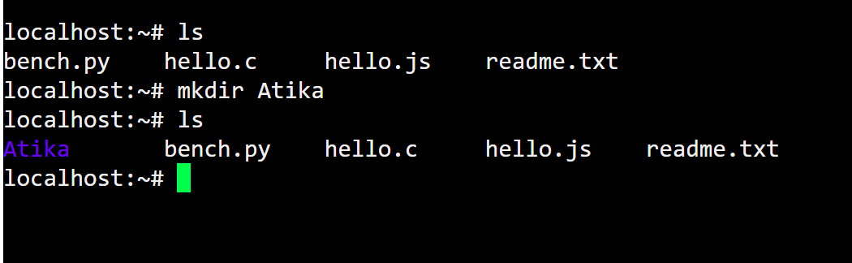

- Create one sample python and one text file.
Text File:
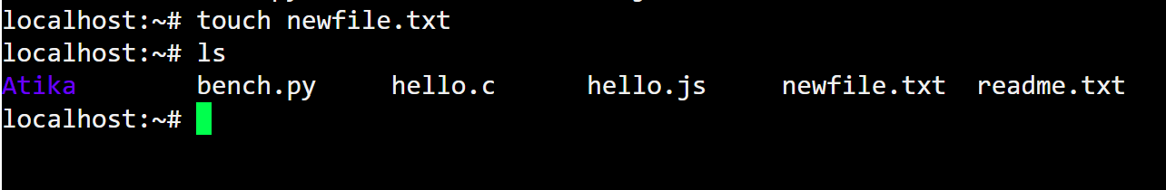

Python File:
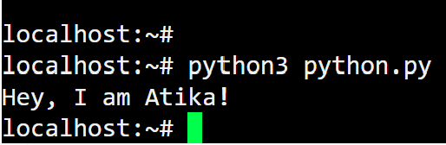
- Add some content in both files and run the program.
Python File:
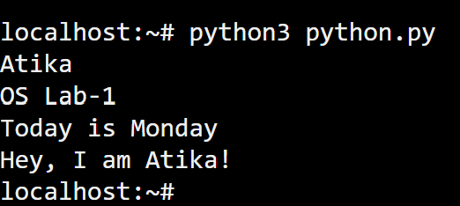

Text File:
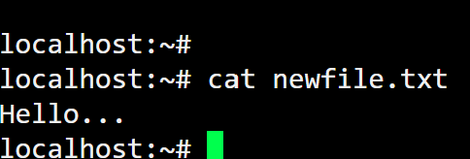

Task 4:
