Atika Mughal

SAP ID: 5000000280

Operating System Lab-2

Task 1: Compare file hierarchy system of Windows, Linux and MacOS.
A file hierarchy system is the way an operating system organizes and manages files and folders on storage devices. It follows a tree-like structure, where files are stored inside directories (folders), starting from a main root location.
Different operating systems use different file hierarchy structures, and directory organizations to store system files and user data efficiently.
File Hierarchy in Different Operating Systems.
1. Windows:
Windows uses a drive-based hierarchy system. Each storage device is assigned a drive letter such as C:, D:, etc.
The main system files are usually stored in the C:\Windows directory, and user data is stored in C:\Users.
Example path:
C:\Users\Atika\Documents
2. Linux:
Linux uses a single root directory represented by /. All files and folders are organized under this root. There are no drive letters.
Each directory has a specific purpose, such as system configuration, user files, or executable programs.
Example path:
/home/atika/Documents
3. macOS:
macOS also follows a Unix-based file hierarchy similar to Linux. It uses a single root directory /.
System files, applications, and user data are stored in well-defined directories.
Example path:
/Users/Atika/Documents

Comparison Table:
Feature | Windows | Linux | macOS
Root Directory | Drive letters (C:, D:) | Single root / | Single root /
File system type | NTFS (New technology File System) | ext4 (Extended Fourth File System) | APFS (Apple File System)
User Home Directory | C:\Users\Username | /home/username | /Users/Username
Drive Naming | Uses letters | Mounted as Folders | Mounted as Folders
Command Line | Command prompt/ Powershell | Terminal | Terminal

Task 2: Package Manager Tools in Ubuntu.
Ubuntu uses APT (Advanced Package Tool) as its default package manager.
Besides APT, Ubuntu also supports other package management tools that help users install, remove, update, and manage software packages in different ways (command-line or graphical).
- Aptitude:
Aptitude is a command-line based package manager that works on top of APT.
It provides better dependency handling than apt.
Features:
- Text-based interface
- Automatically resolves dependencies
- Can be used interactively or with commands

- Snap:
Snap is a modern package management system developed by Canonical.
Snap packages include all dependencies, so they work the same on all systems.
Features:
- One command installs everything
- No dependency problems
- Same command for all systems

- Dpkg:
Dpkg (Debian Package) is a low-level package manager.
It directly installs .deb files but does not handle dependencies automatically.
Features:
- Does NOT fix dependencies
- Used only for .deb files
- One mistake can cause errors

- Synaptic:
Synaptic is a graphical package manager based on APT.
It is suitable for beginners who prefer GUI instead of terminal.
Features:
- Easy to use graphical interface
- Search, install, remove software easily
- Shows package details and dependencies
EASIEST → HARDEST (Student-friendly order):
Synaptic -> Snap -> Aptitude -> Dpkg

Task 3: Compiling and running a C Program.
Step 1: Create a C file:
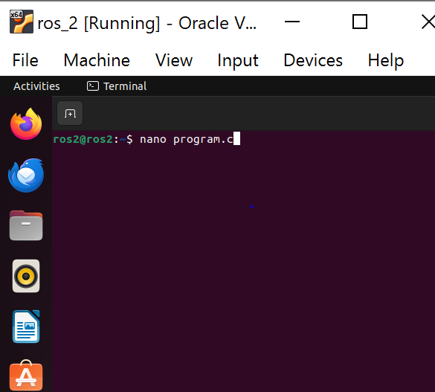
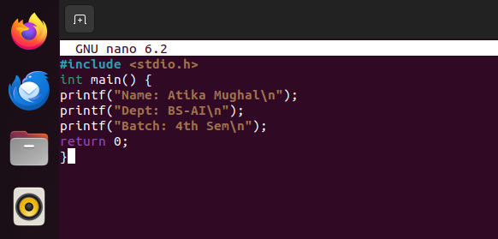
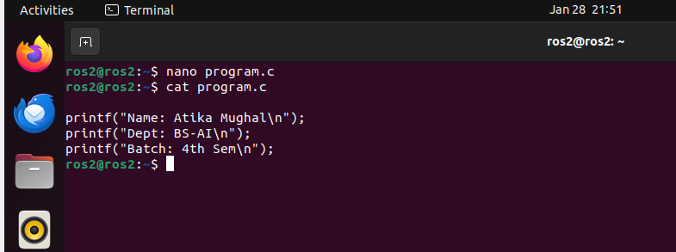

Step 2: Check File Permissions:
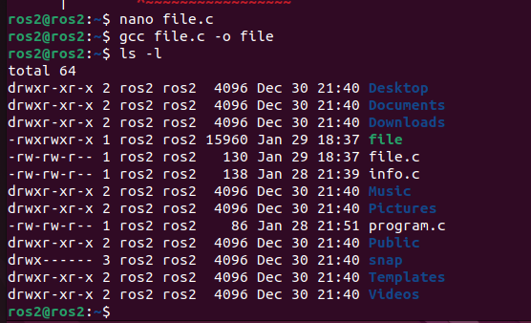
Step 3: Compile the Program and create it’s executable:
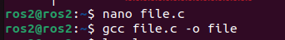
Step 4: Execute the C program:
