Atika Mughal

SAP ID: 5000000280

Operating System Lab-3

Creating User:
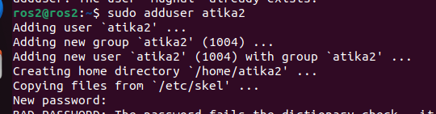
Checking ID of the User:
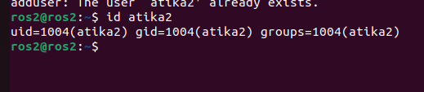
Changing ownership of a file:
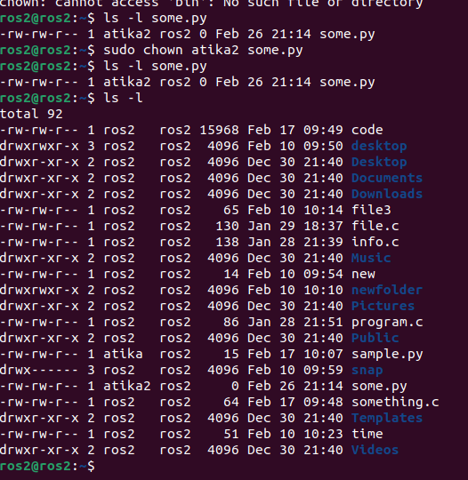
Adding User in a Sudo group:
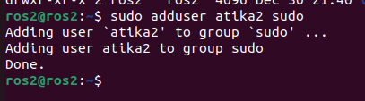

Login to user:
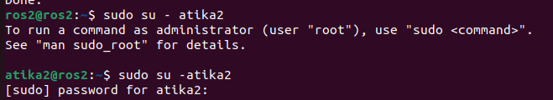
Usage:
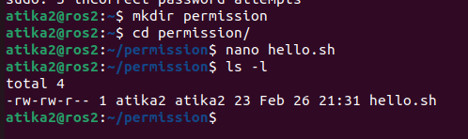
Execution Permission:
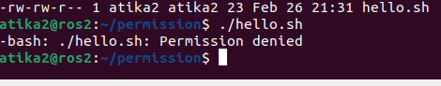
Change Permission:
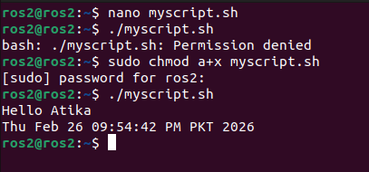
Compiling a C Code:
