Atika Mughal

SAP ID: 5000000280

Operating System Lab-4

Task 1: Explore the following commands with examples.
- Pstree:
The pstree command in Linux is used to display the running processes in a tree-like structure. It shows the relationship between parent and child processes, which helps users understand how processes are connected.
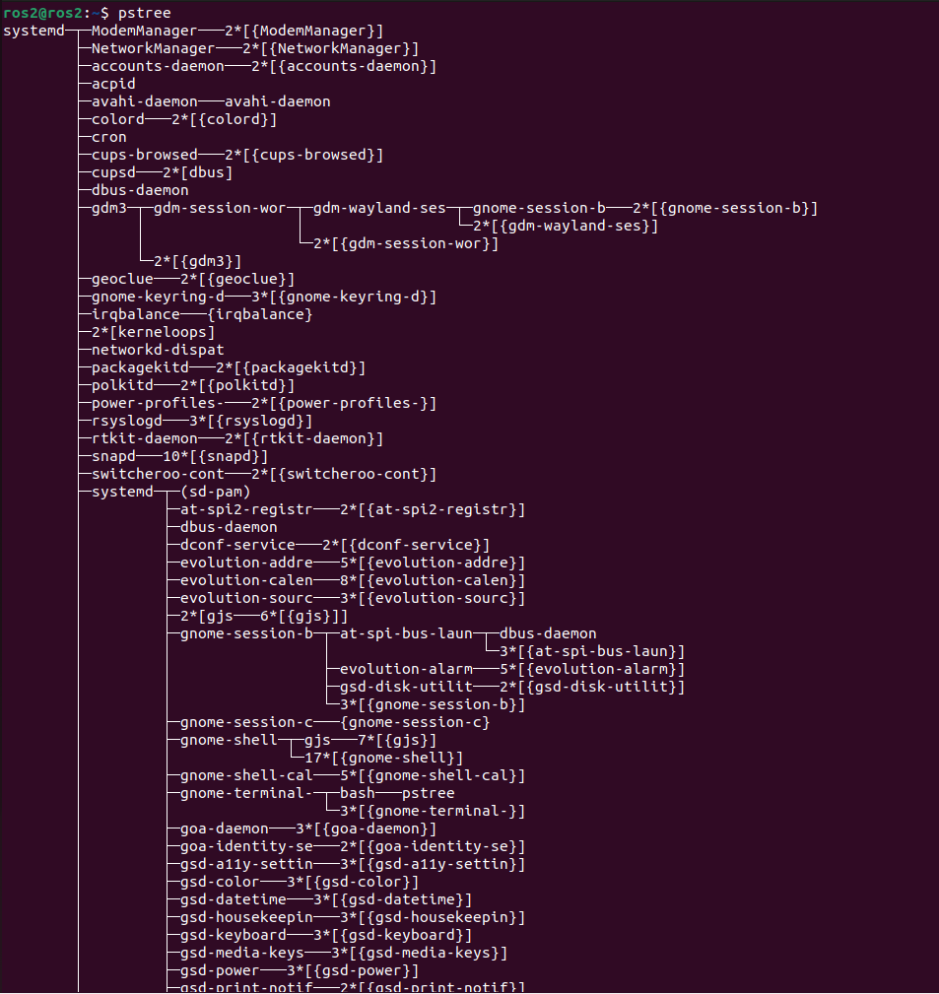

- Lsof:
The lsof command stands for “List Open Files.” In Linux, everything is treated as a file, including devices and network connections. The lsof command shows which files are currently opened by which processes. When we run lsof, it displays a list of open files and the processes using them. If we want to check a specific file, we can use lsof filename.txt.
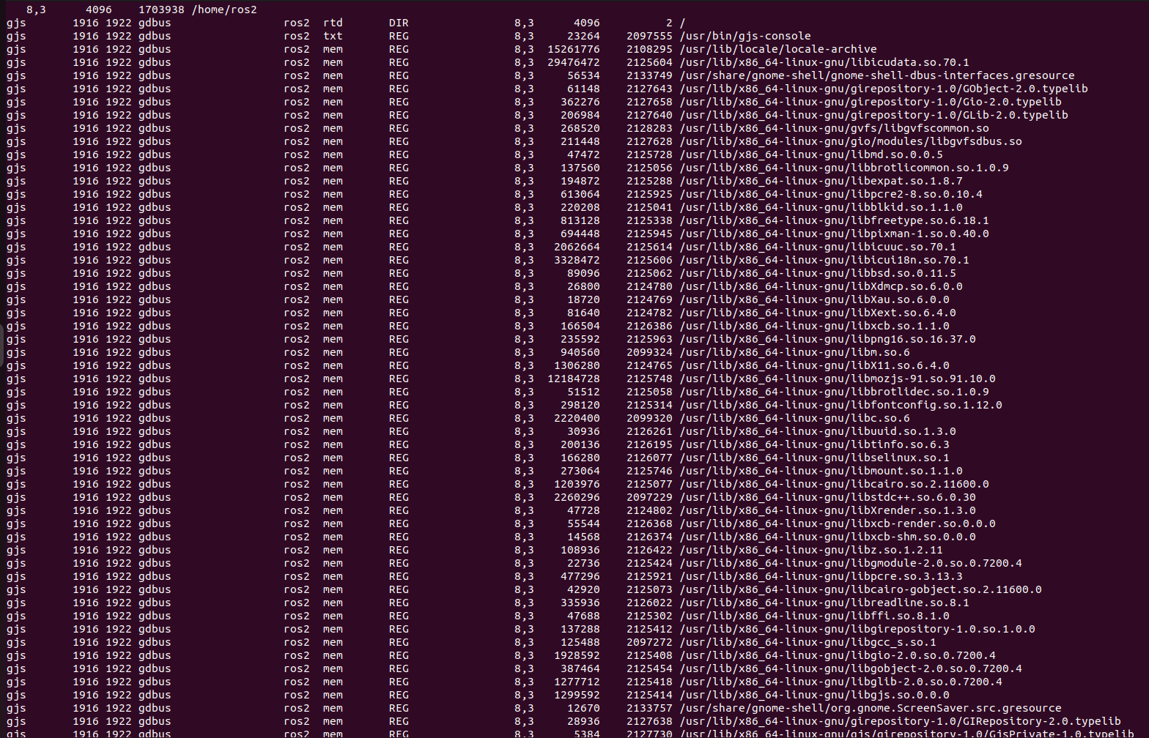
- Watch:
The watch command is used to run a command repeatedly at fixed time intervals. By default, it updates the output every two seconds. For example, if we run watch date, the system will continuously display the updated date and time. The watch command is useful for monitoring system changes in real time.
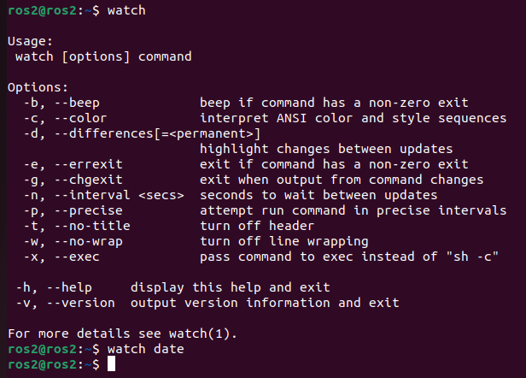
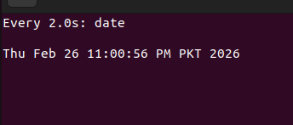

- Free:
The free command is used to display information about system memory usage, including RAM and swap space. When we type free, it shows total memory, used memory, and free memory. If we want the output in a human-readable format, we use free -h, which displays the values in KB, MB, or GB. This command is important for checking whether the system has enough available memory.
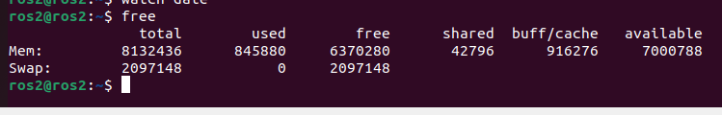
- Df:
The df command stands for “Disk Free” and is used to check disk space usage of file systems. When we run df, it displays the total disk space, used space, available space, and usage percentage. For better readability, we use df -h, which shows the sizes in KB, MB, or GB. This command helps users monitor storage space and avoid disk full errors.
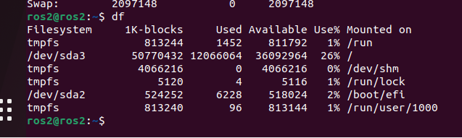
- Strace:
The strace command is used to trace system calls and signals made by a program. It is mainly used for debugging and troubleshooting. For example, running strace ls shows all system calls made by the ls command. We can also trace a running process using strace -p PID, where PID is the process ID. The strace command helps in identifying errors related to file access, permissions, or system-level problems.
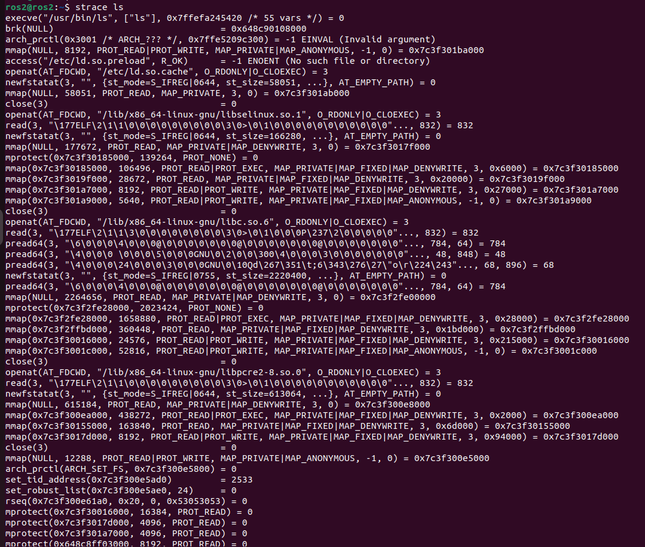
Task 2: Write a simple script.sh file. Print some information, add delay (sleep) and track the process and its PID of script and sleep process using any tool.
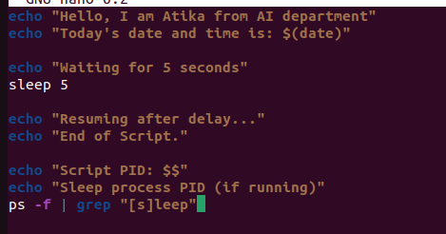

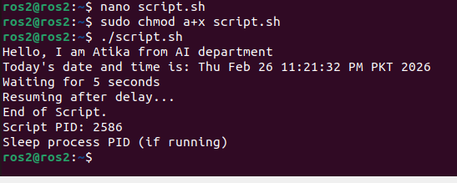
Task 3: Write a simple python or C code, add delay, kill it before it gets completed and report the process.
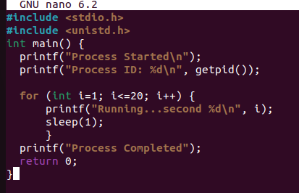
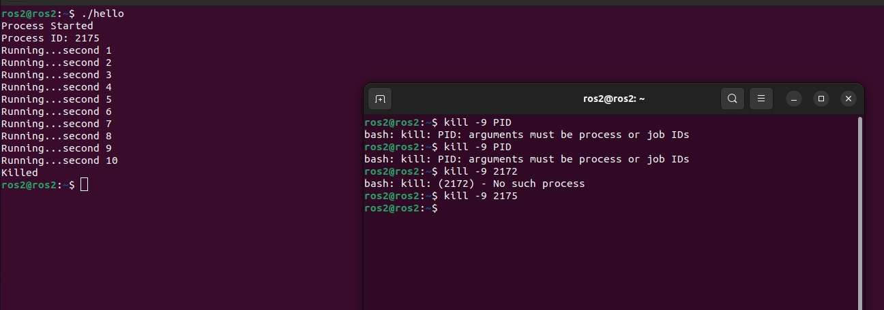
Task 4: Write one simple script file and python file, check their NI and PRI, change them using nice and renice and report the process.
