Atika Mughal

SAP ID: 5000000280

Operating Systems Lab-5

Task 1:
- Writing a script file, directory with my name, and 3 files inside that folder.
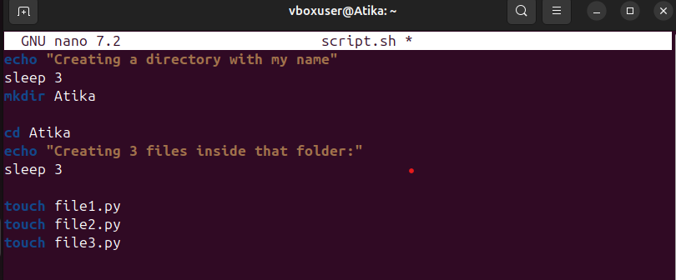
- Checking the directory and files:
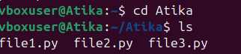
- Checking permissions:
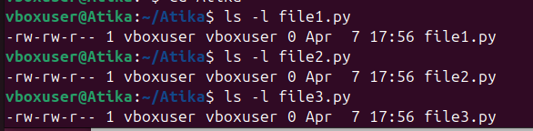
- Giving permissions to three files:
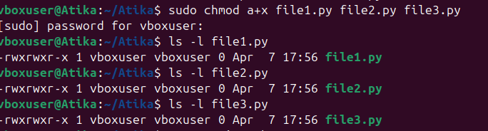

Task 2:
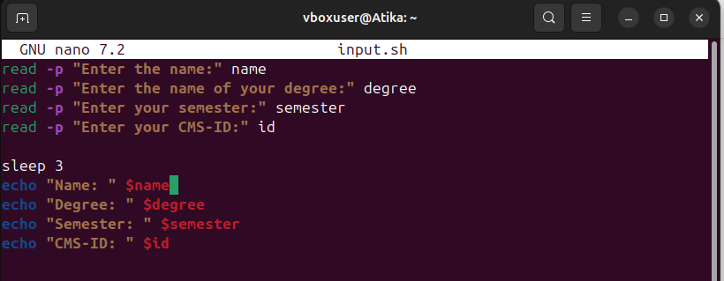
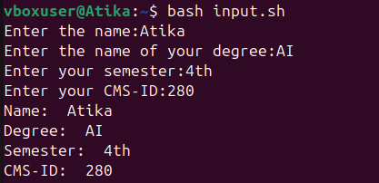

Task 3:
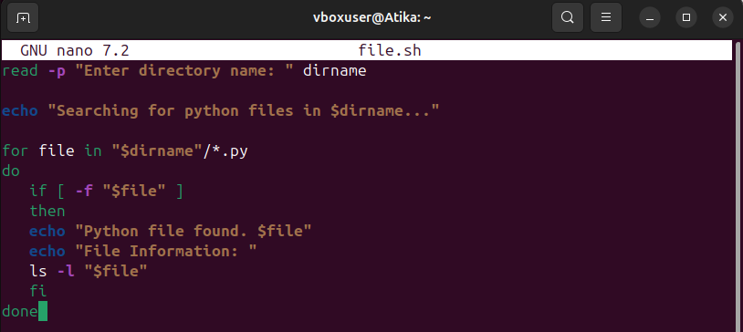
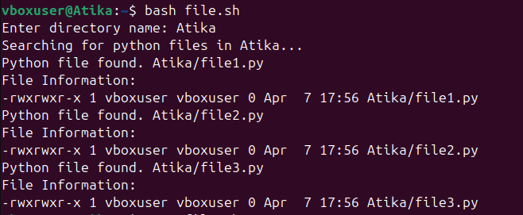
Task 4:
