Atika Mughal

SAP ID: 5000000280

Operating Systems Lab-6

Task 1: Write a Code which should name the parent and child processes as parent process and child
process respectively.
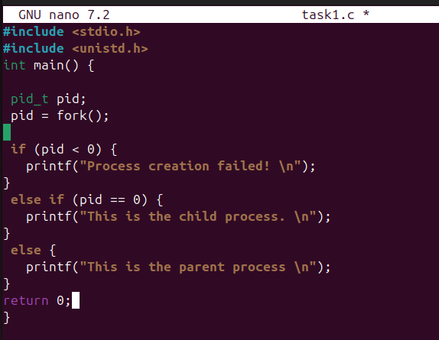
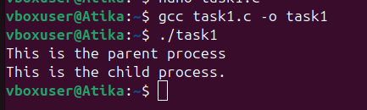

Task 2: Create 3 processes with names; A, B and C respectively, where A should be parent of B and C. Show it using pstree and their PIDs.
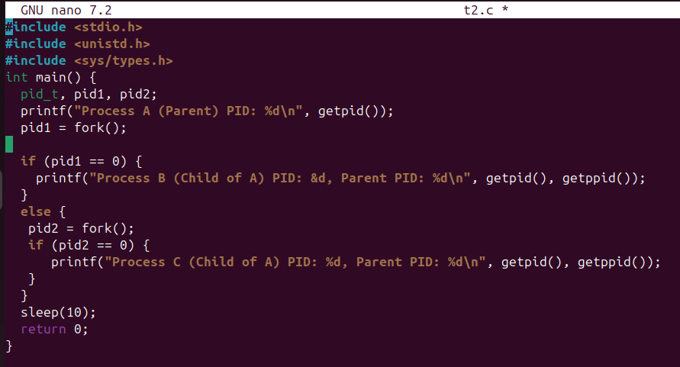
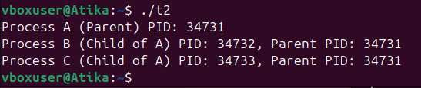
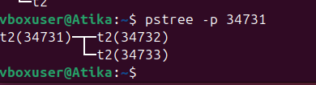

Task 3: Explore exec() function and use it in a simple C program.
What is exec()?
exec() replaces the current process with a new program.
After exec() runs:
- The old code is gone
- New program starts executing
- PID remains the same
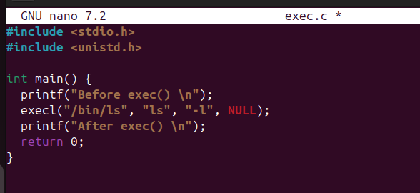
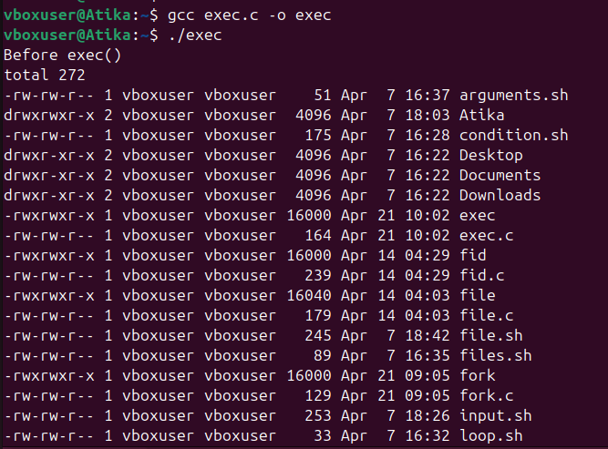

Task 4: Use fork in real-life example and explain it.
