Atika Mughal

SAP ID: 5000000280

Operating Systems Lab-7

Task 1: Write the C code which should pass data to 3 threads.
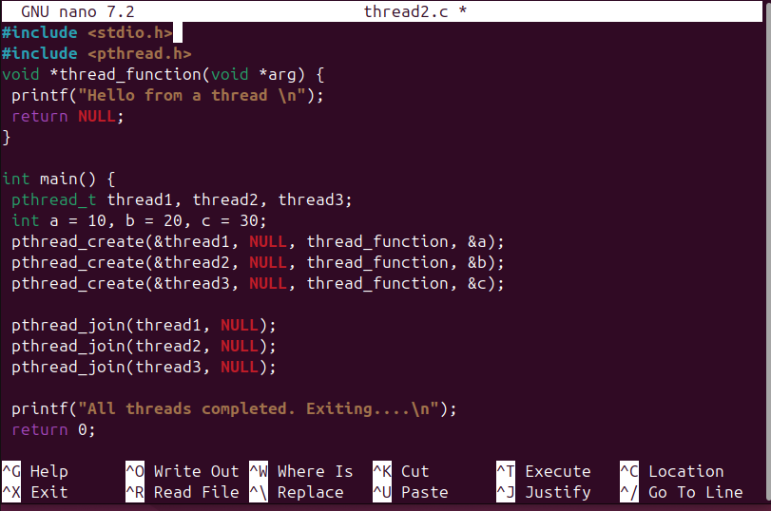
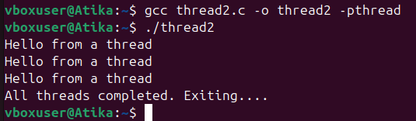
Task 2: Write C code which should take two integers from the users in the start and create three
threads for addition, multiplication and subtraction.
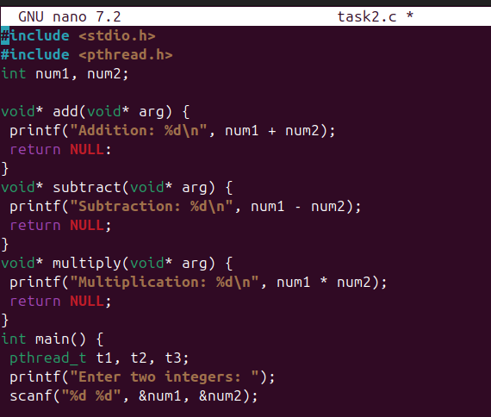
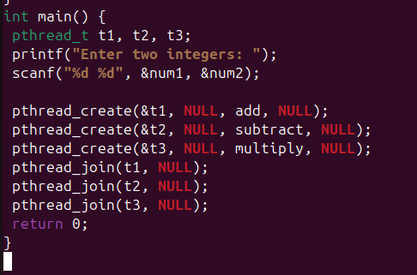
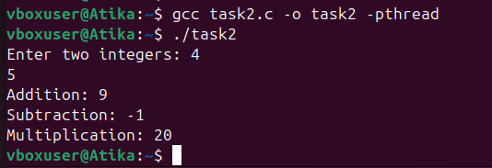
Task 3: Write C code in which a client-server code in which a thread (server) listens to
another thread (client).
