Atika Mughal

SAP ID: 5000000280

Operating Systems Lab-8

Task 1: Implement the producer-consumer problem using mutex.
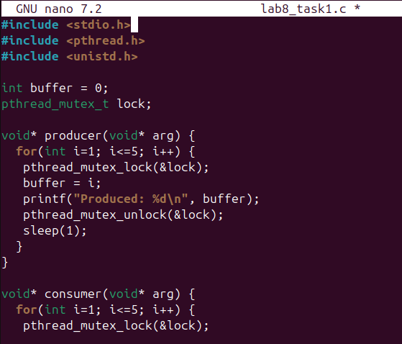
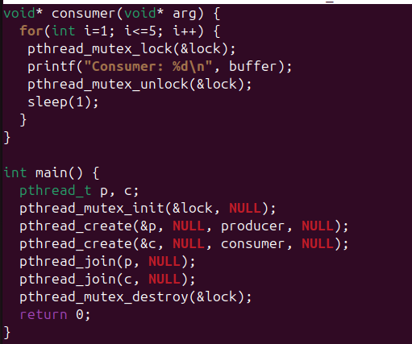

Output:
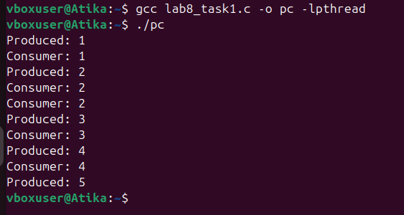
Task 2: Write a single code which implements increment problem in both ways (with
and without mutex) and calculate the time overhead at the end of the code.
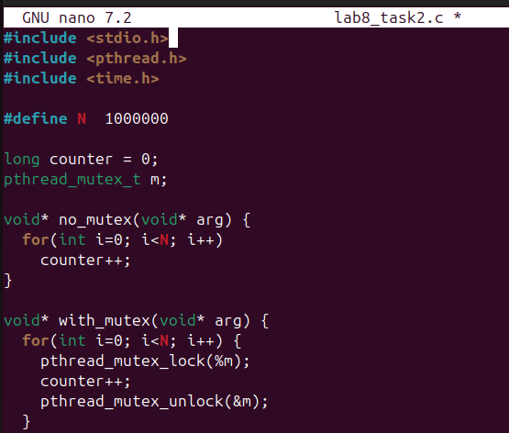
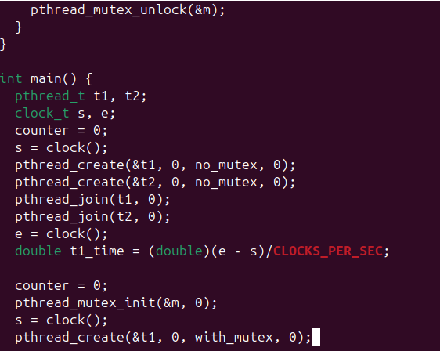
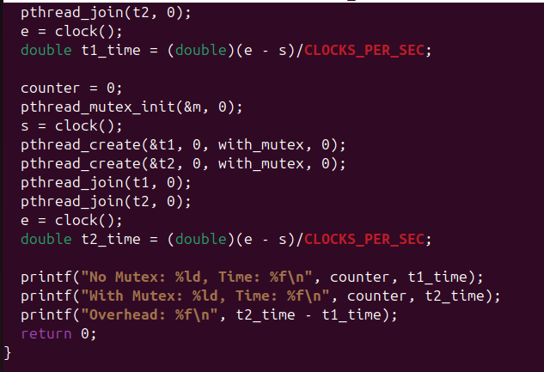
Output:
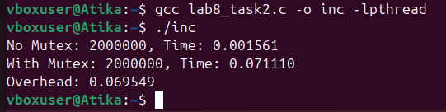
Task 3: Calculate the time overhead of semaphore implemented above.
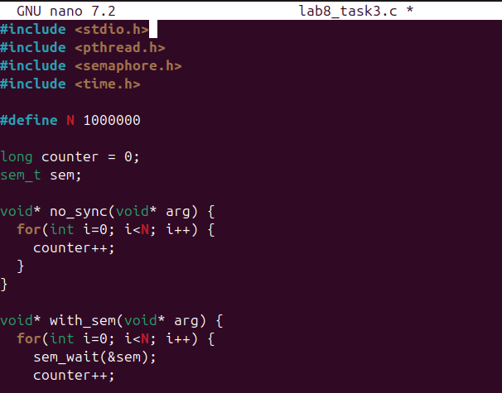
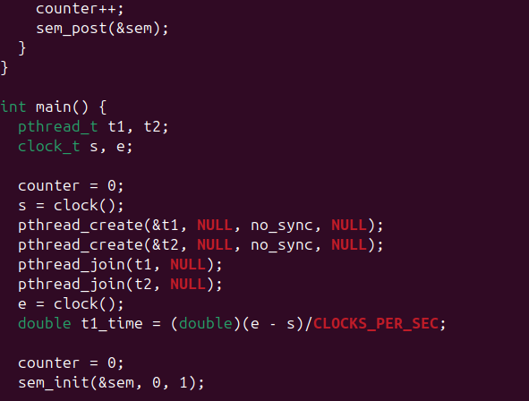
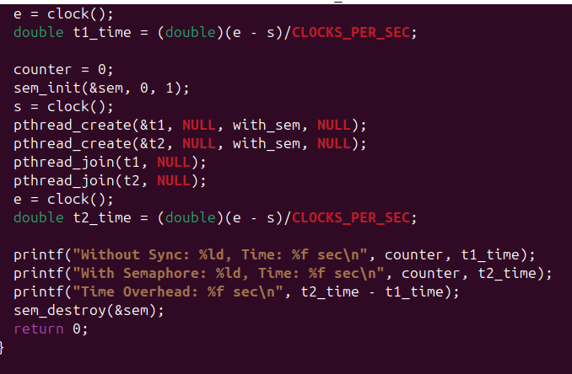
Output:
