Atika Mughal

SAP ID: 5000000280

Database Systems Assignment-1

- Three-level (ANSI/SPARC) Database Architecture:
- ANSI/SPARC = American National Standards Institute / Standards Planning and Requirements Committee.
The Three-Level Database Architecture separates database into three layers so that users and applications are independent of how data is stored. It improves data security, flexibility, and data independence.

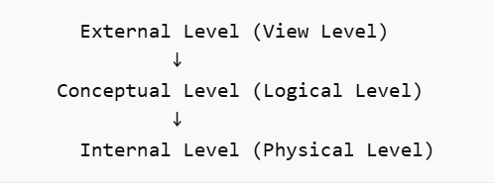

External Level (View Level):
This is the top layer where users interact with the database. Different users can see different views of data according to their needs. For example, a student may see only his marks, while an administrator can see all records. This level hides unnecessary details from users.

Conceptual Level (Logical Level):
This middle layer defines the structure of the database. It contains tables, relationships, and constraints but does not describe how data is physically stored. For example, a student table may contain columns like ID, name, and marks, but it does not show storage details.

Internal Level (Physical Level):
This is the lowest layer where data is actually stored on disk. It defines how data is stored, indexed, and organized in files. Users and programmers do not interact with this level directly.

Advantages of Three level Database Architecture:
- Data security
- Data independence
- Easy modification of database structure

- Centralized vs Client–Server vs 3-Tier architecture:
Database architectures define how data and processing are distributed. The three main types are centralized, client-server, and 3-tier architecture.

Centralized Architecture:
In centralized architecture, everything is stored on a single server. Users connect to that server to access data. The server handles both data storage and processing.
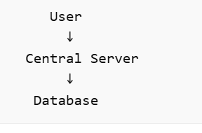

Advantages:
- Easy management
- Data consistency

Disadvantages:
- If server fails, system stops
- Not suitable for large systems

Client–Server Architecture:
In client-server architecture, tasks are divided between client and server. The client provides the user interface, while the server handles data storage and processing.
For example, in a banking system, users request data through a client application, and the server retrieves data from the database.
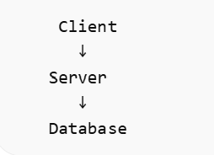
Advantages:
- Faster processing
- Distributed workload

Disadvantages:
- Network dependency
- Server load may increase

3-Tier Architecture:
3-tier architecture divides system into three layers:
- Presentation Layer → User interface
- Application Layer → Business logic
- Database Layer → Data storage
This separation improves security and scalability. For example, a web application uses a UI (presentation), server logic (application), and database.

Advantages:
- Secure and scalable
- Easy maintenance

Disadvantages:
- More complex design

