Atika Mughal

SAP ID: 5000000280

Database Systems Lab-1

Task 1:
Step 1: Accessing Oracle APEX:
Step 2: Understanding the Oracle APEX Interface:
Step 3: Creating a Workspace:
Step 4: Creating an application:
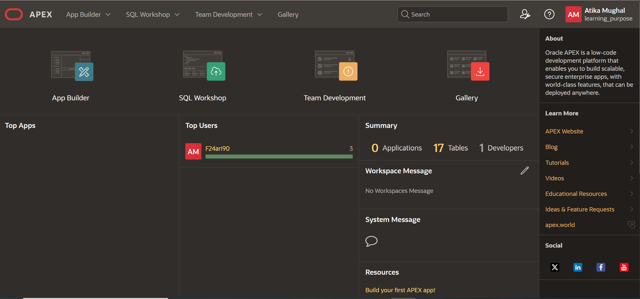
After selecting App Builder:
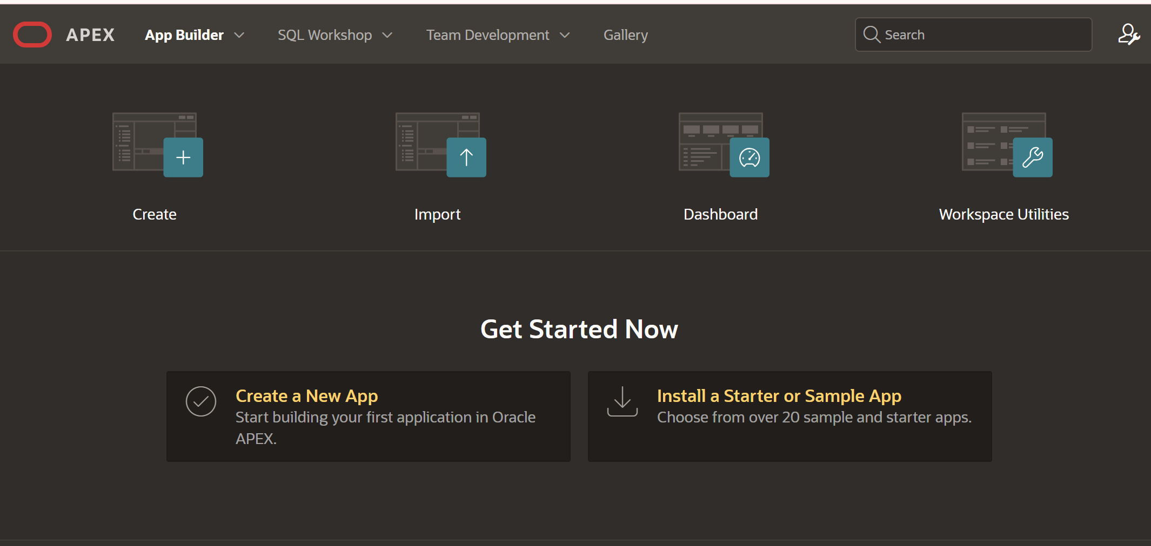

Application Name:
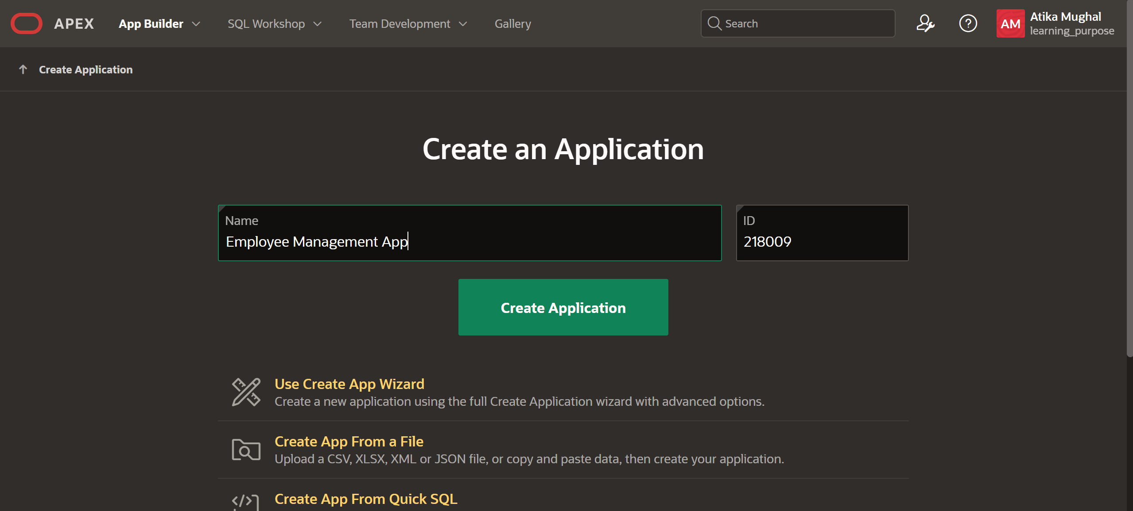
Create pages:
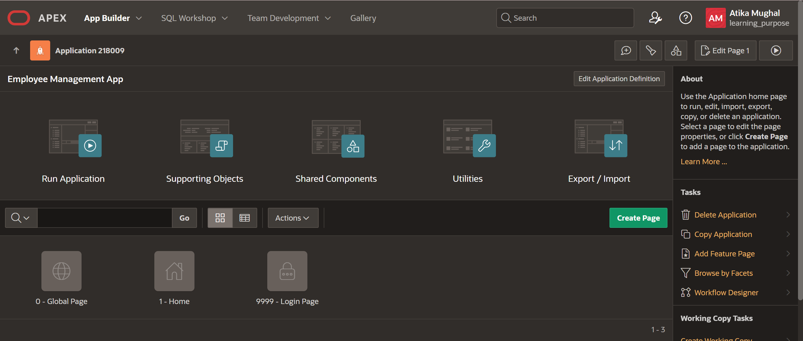
1.Home page
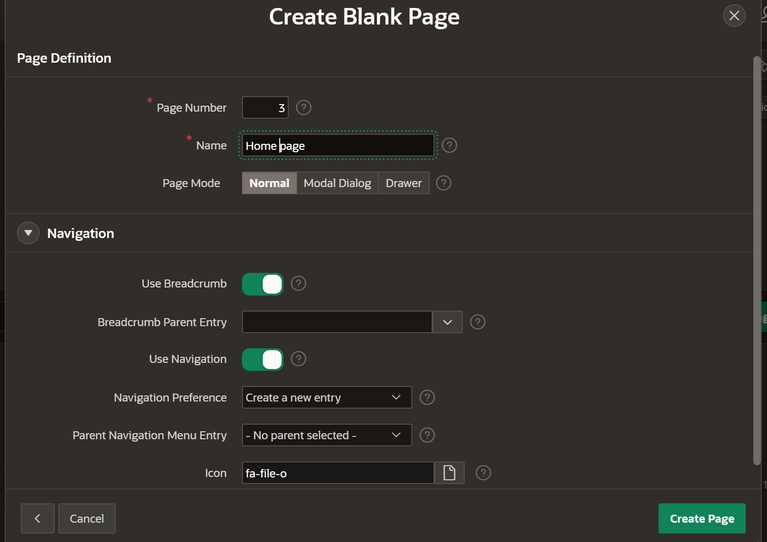

Home Page Output:
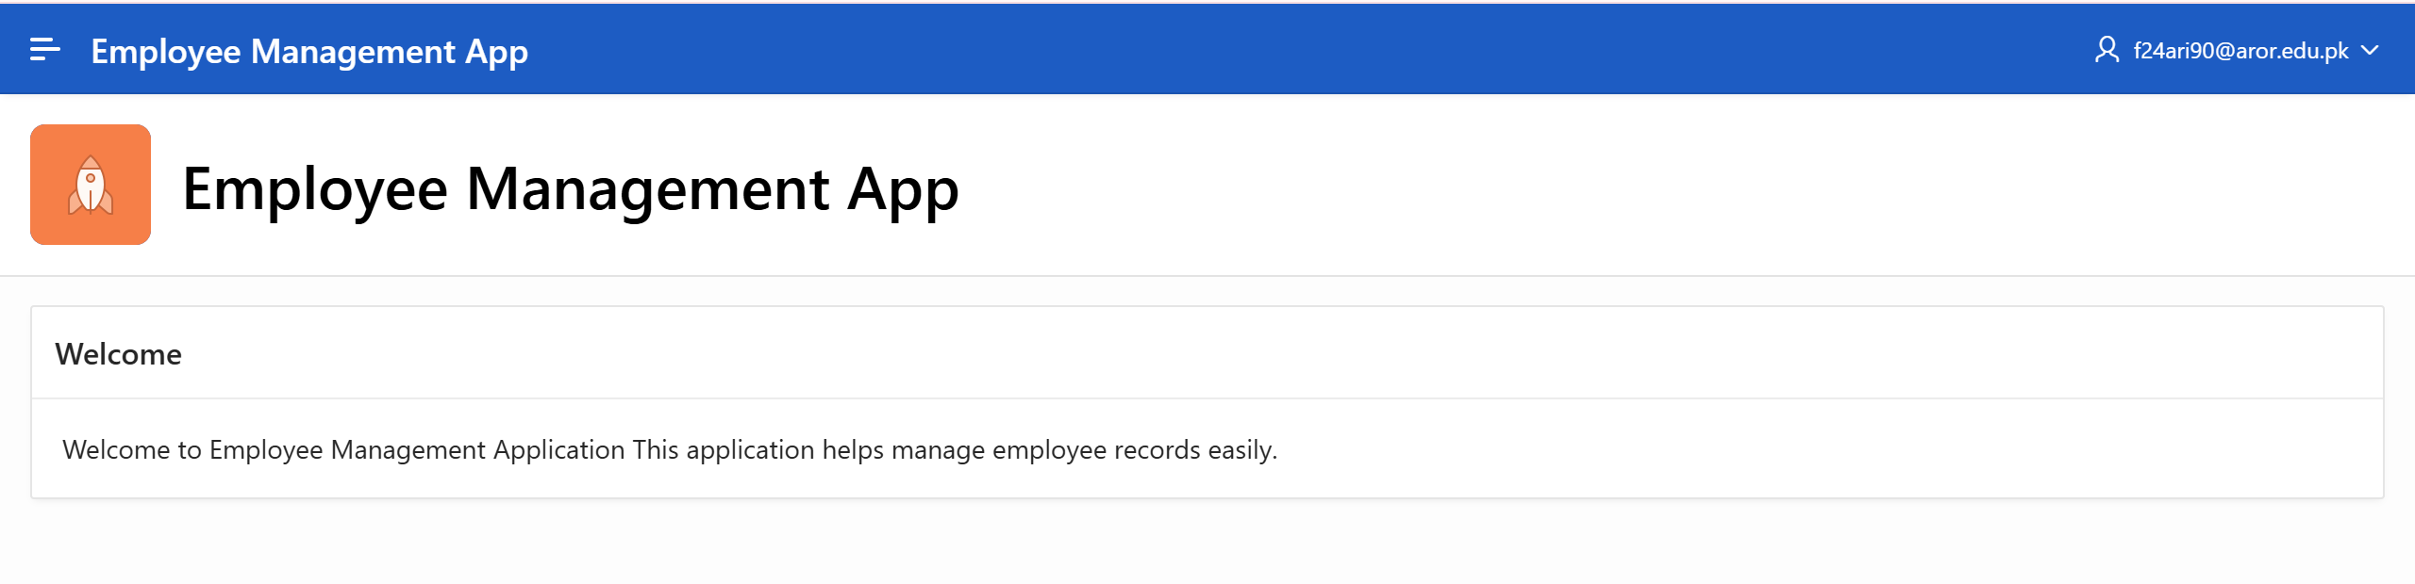
Page 2. Interactive Report
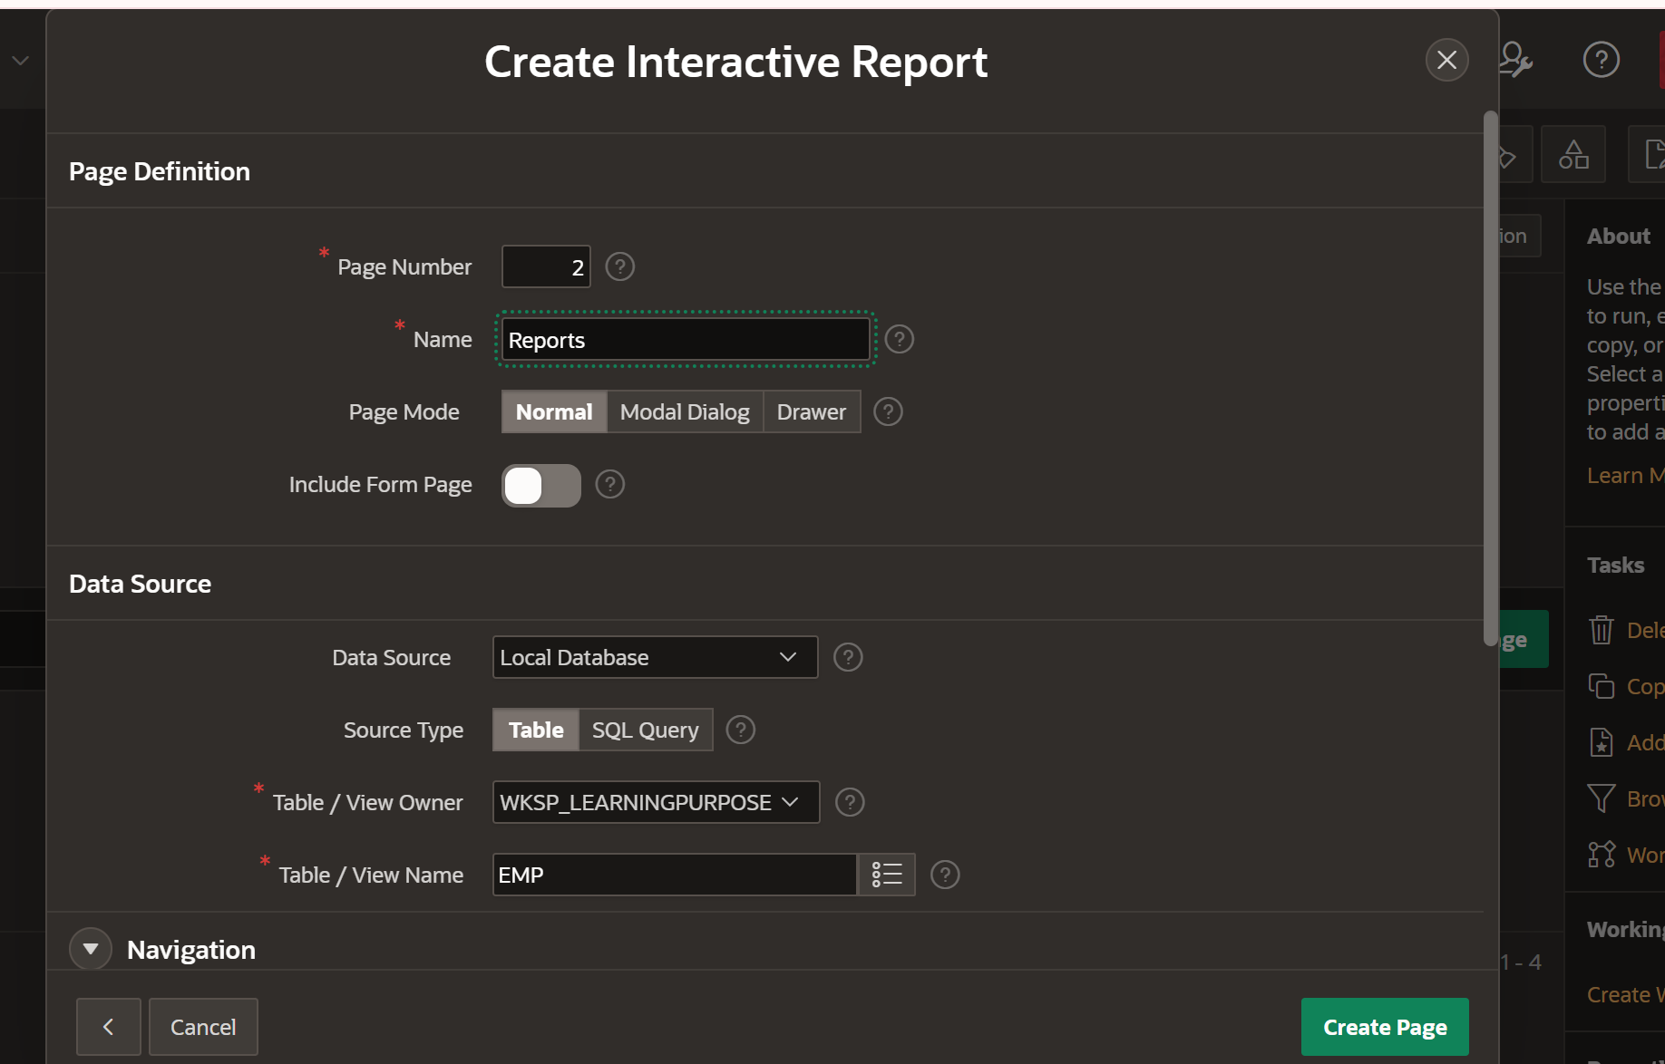
Output:
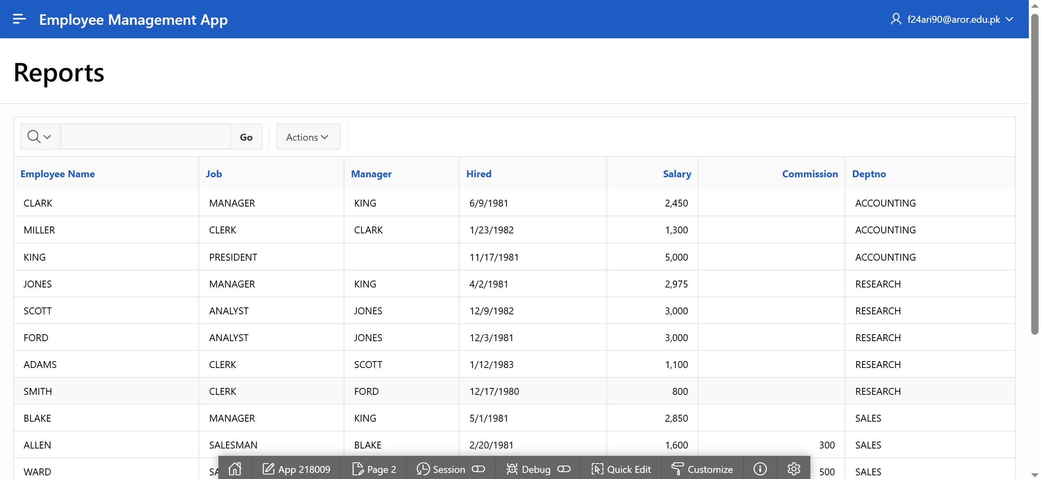

Page 3. Form
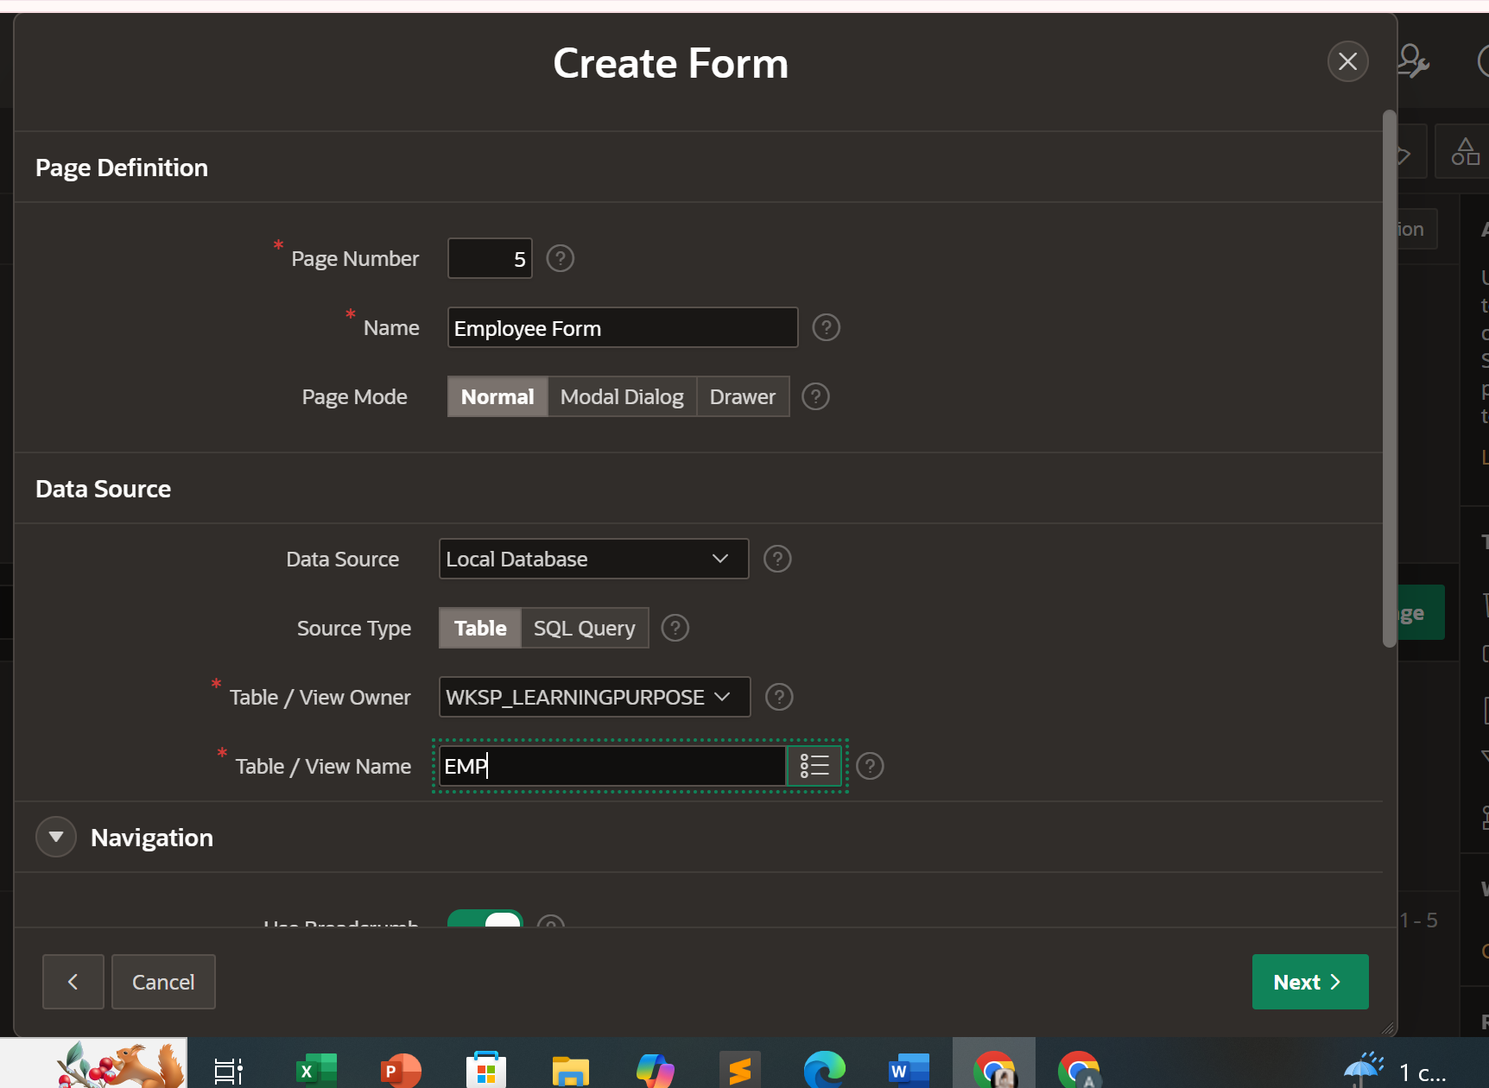
Output:
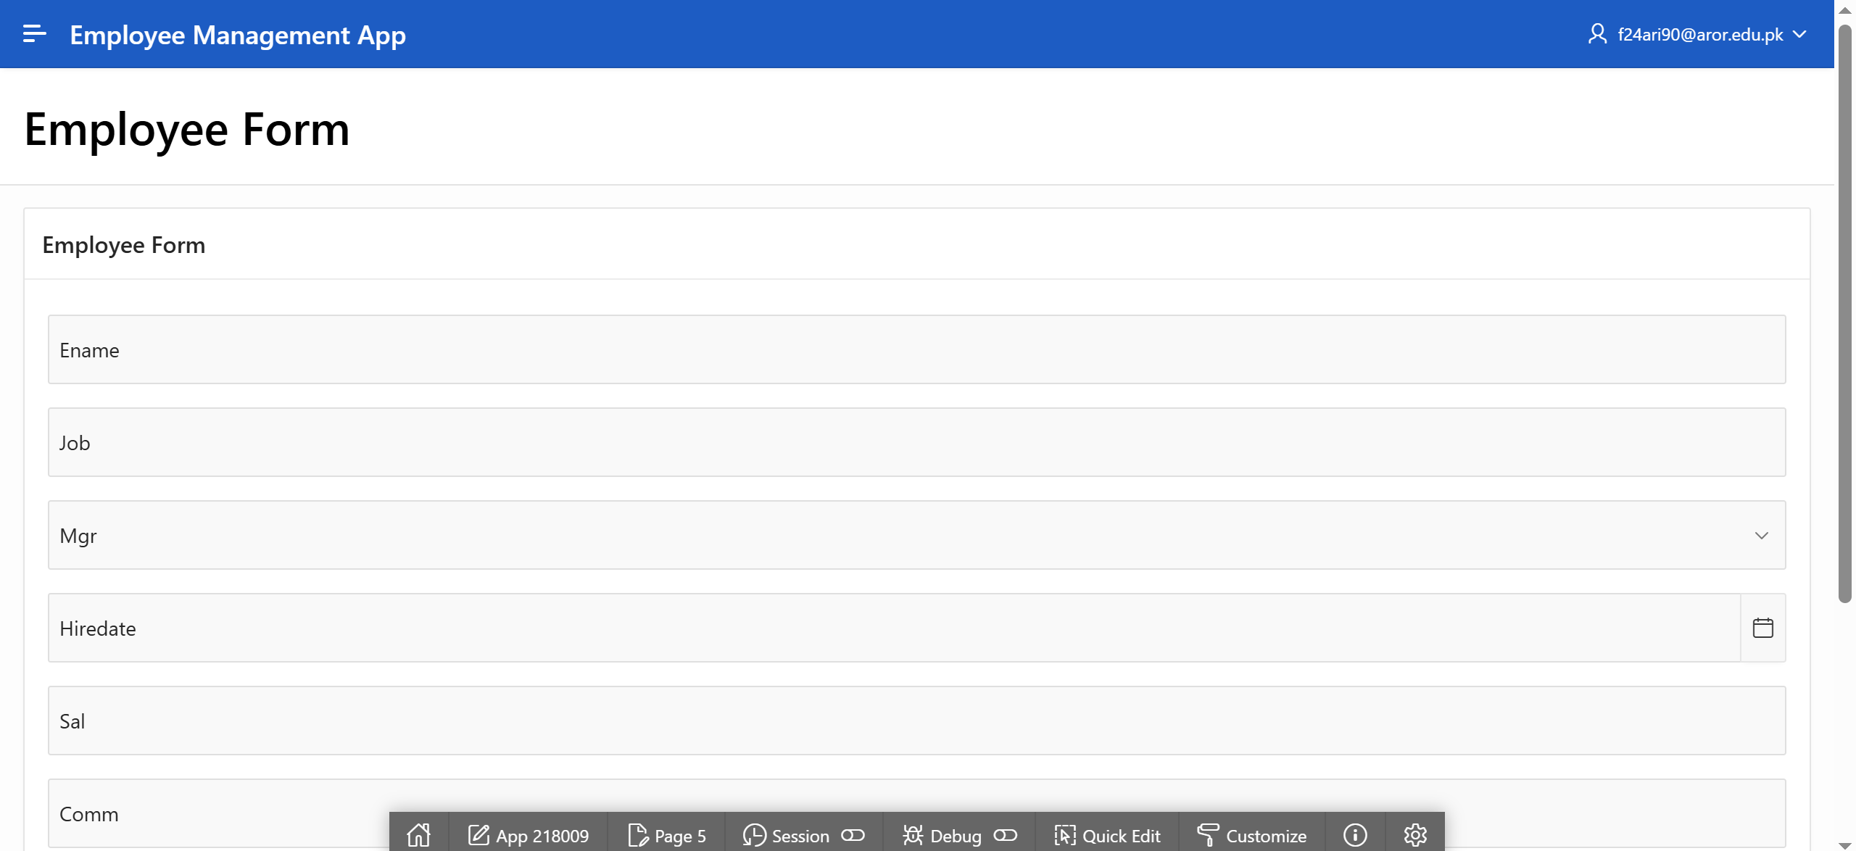
Step 5: Running the Application:
Application Interface:
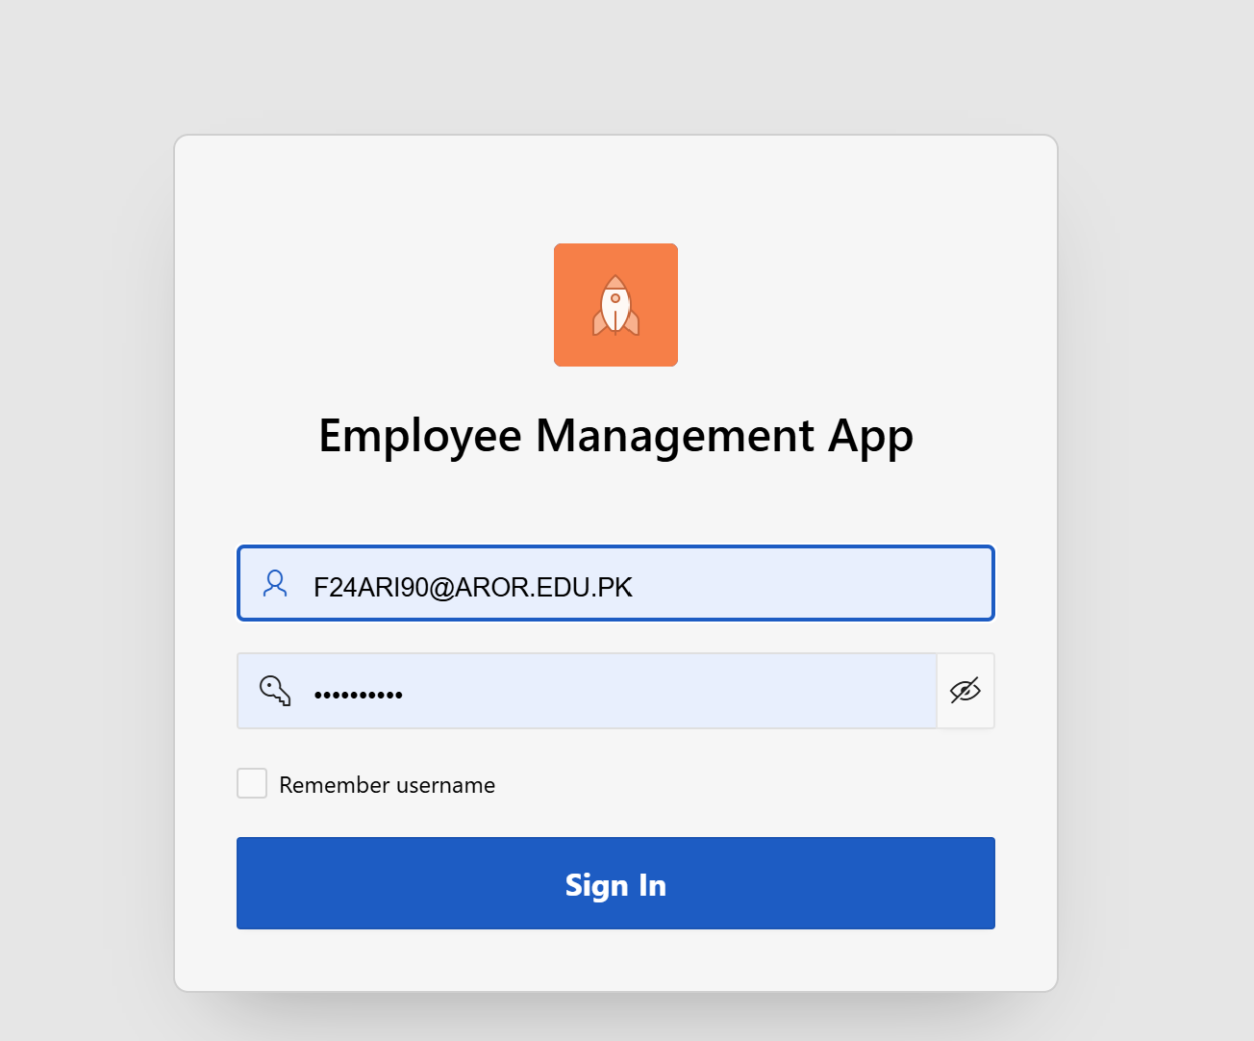
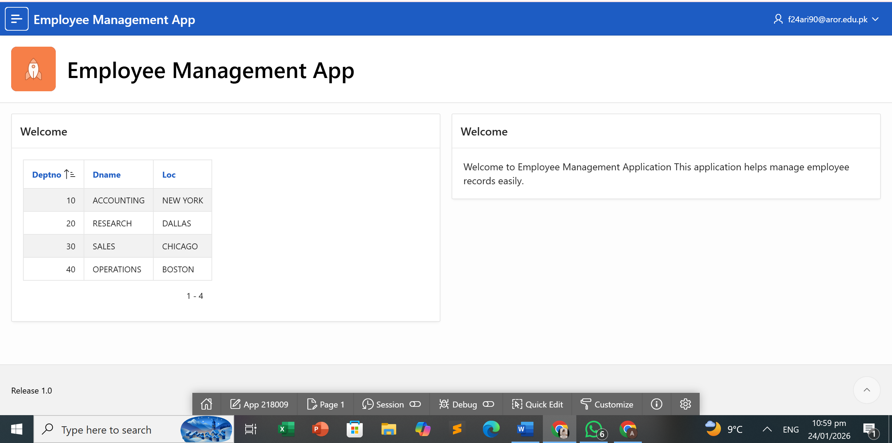
Step 6: Modifying the Pages:
Adding Items:
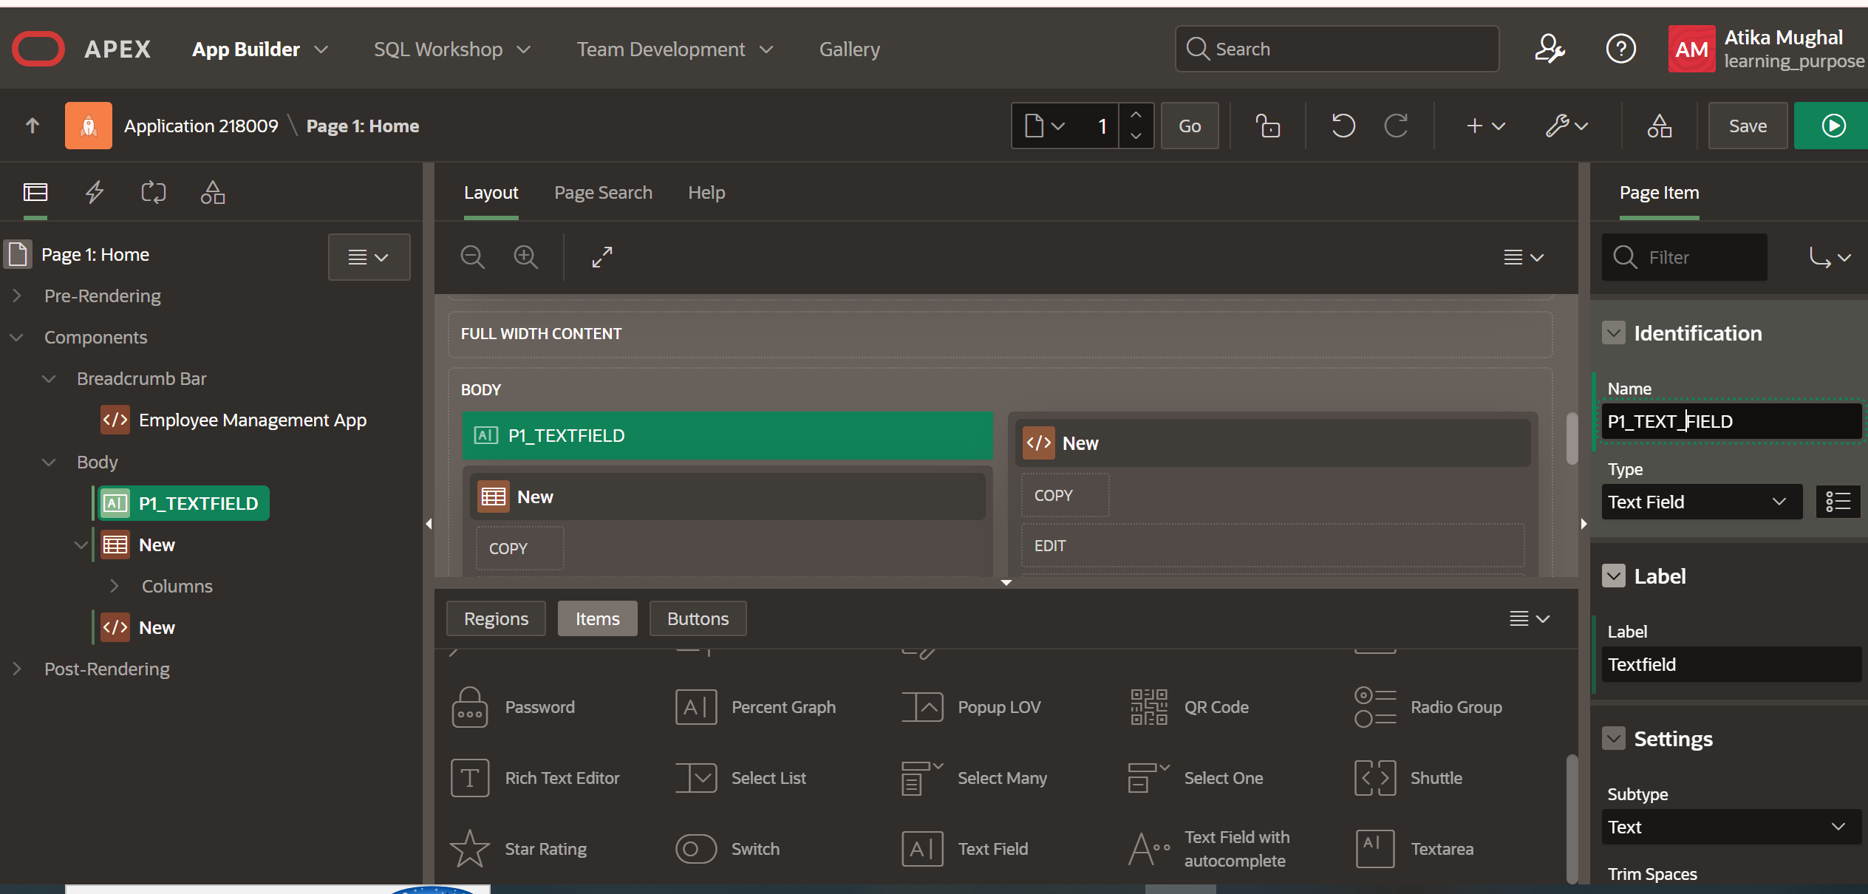
Step 7: Exploring SQL Workshop:
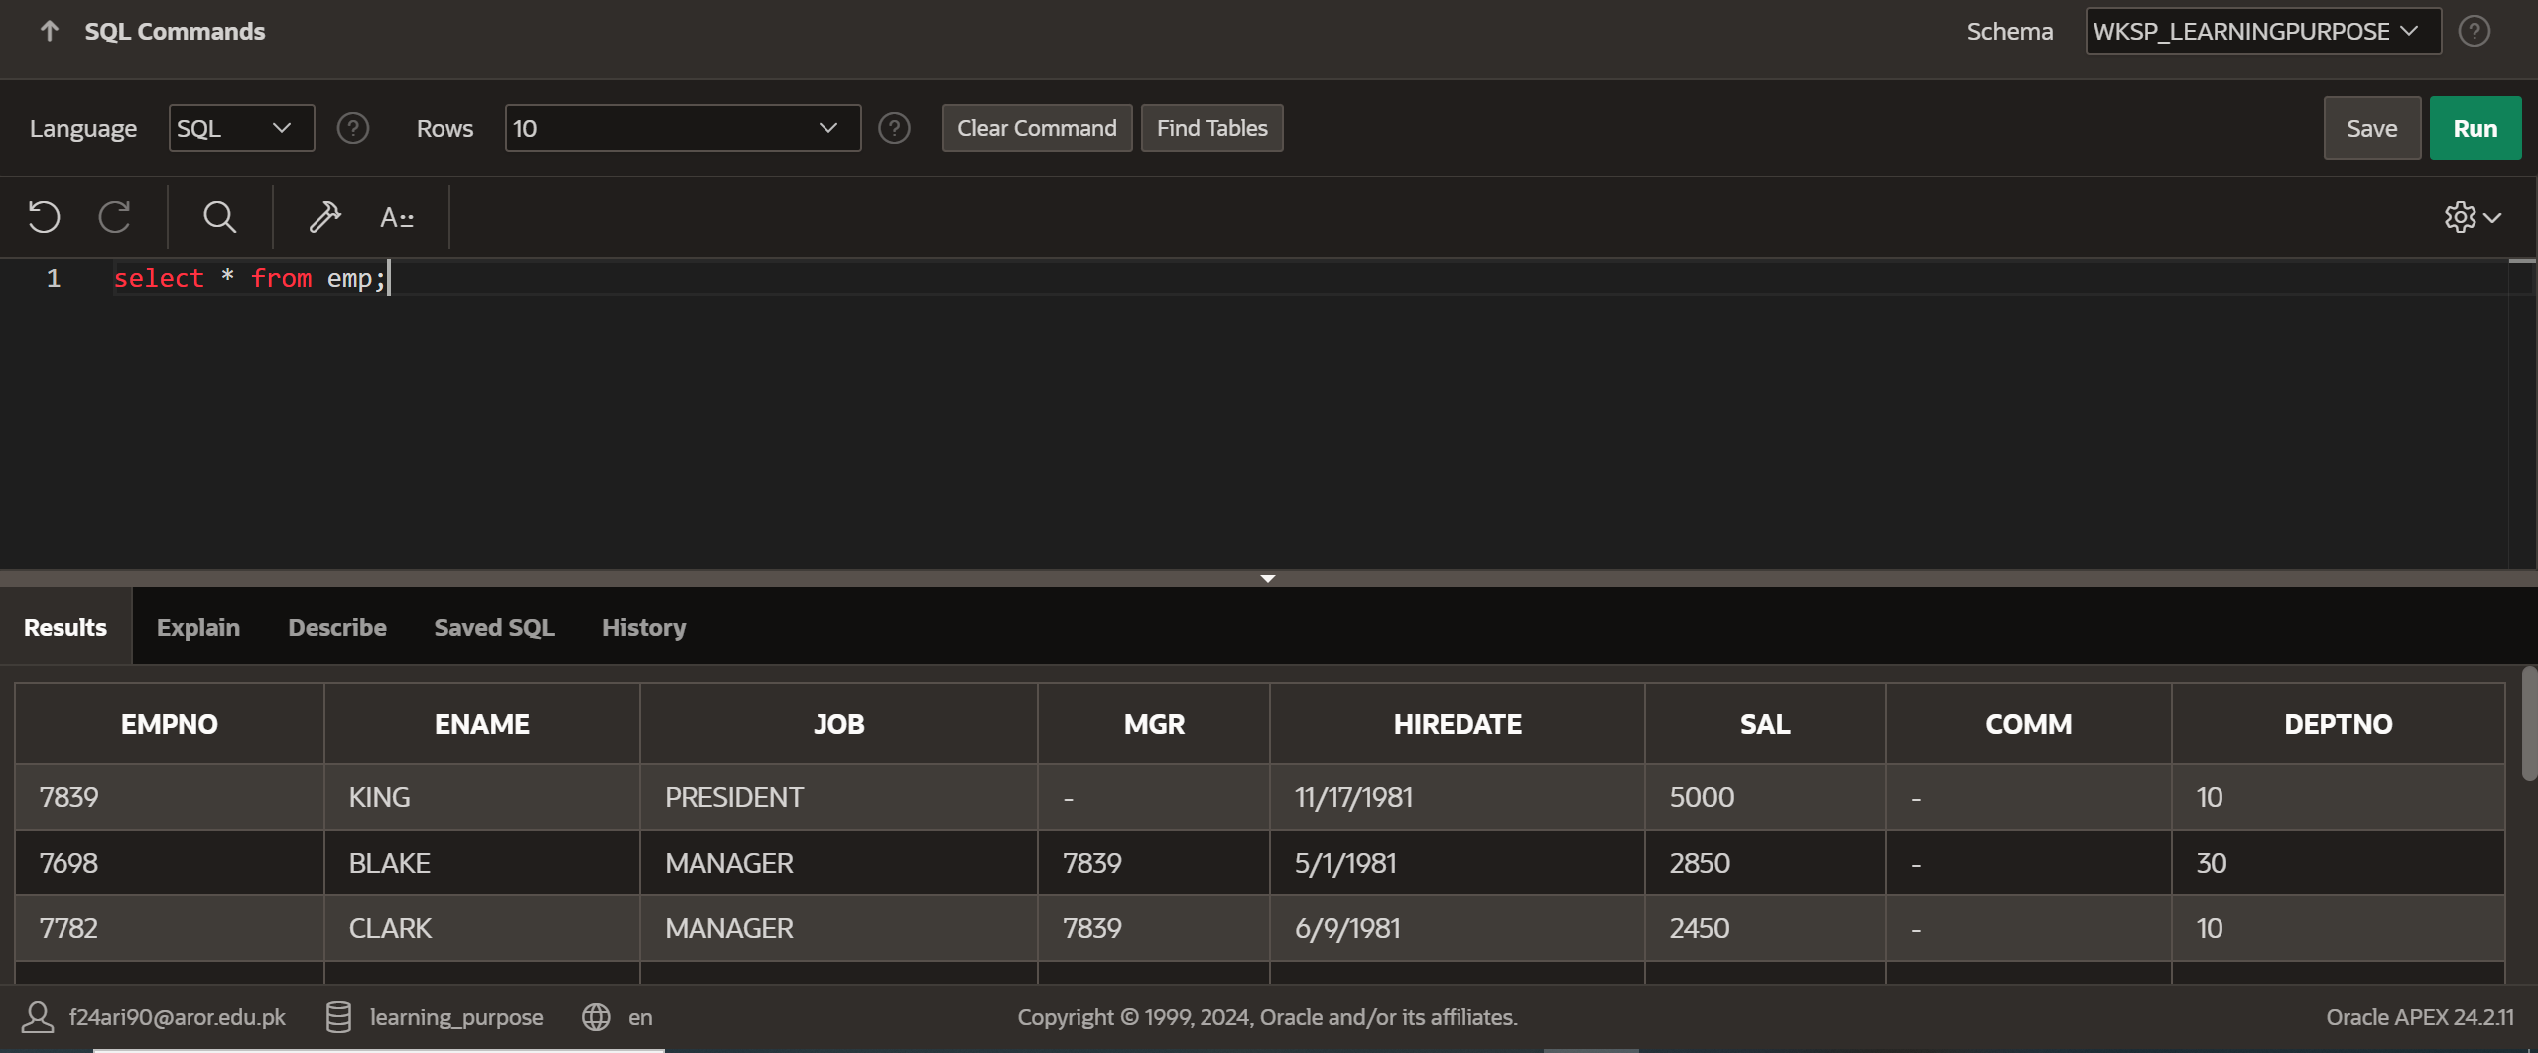

Step 8: Creating an Interactive Report:
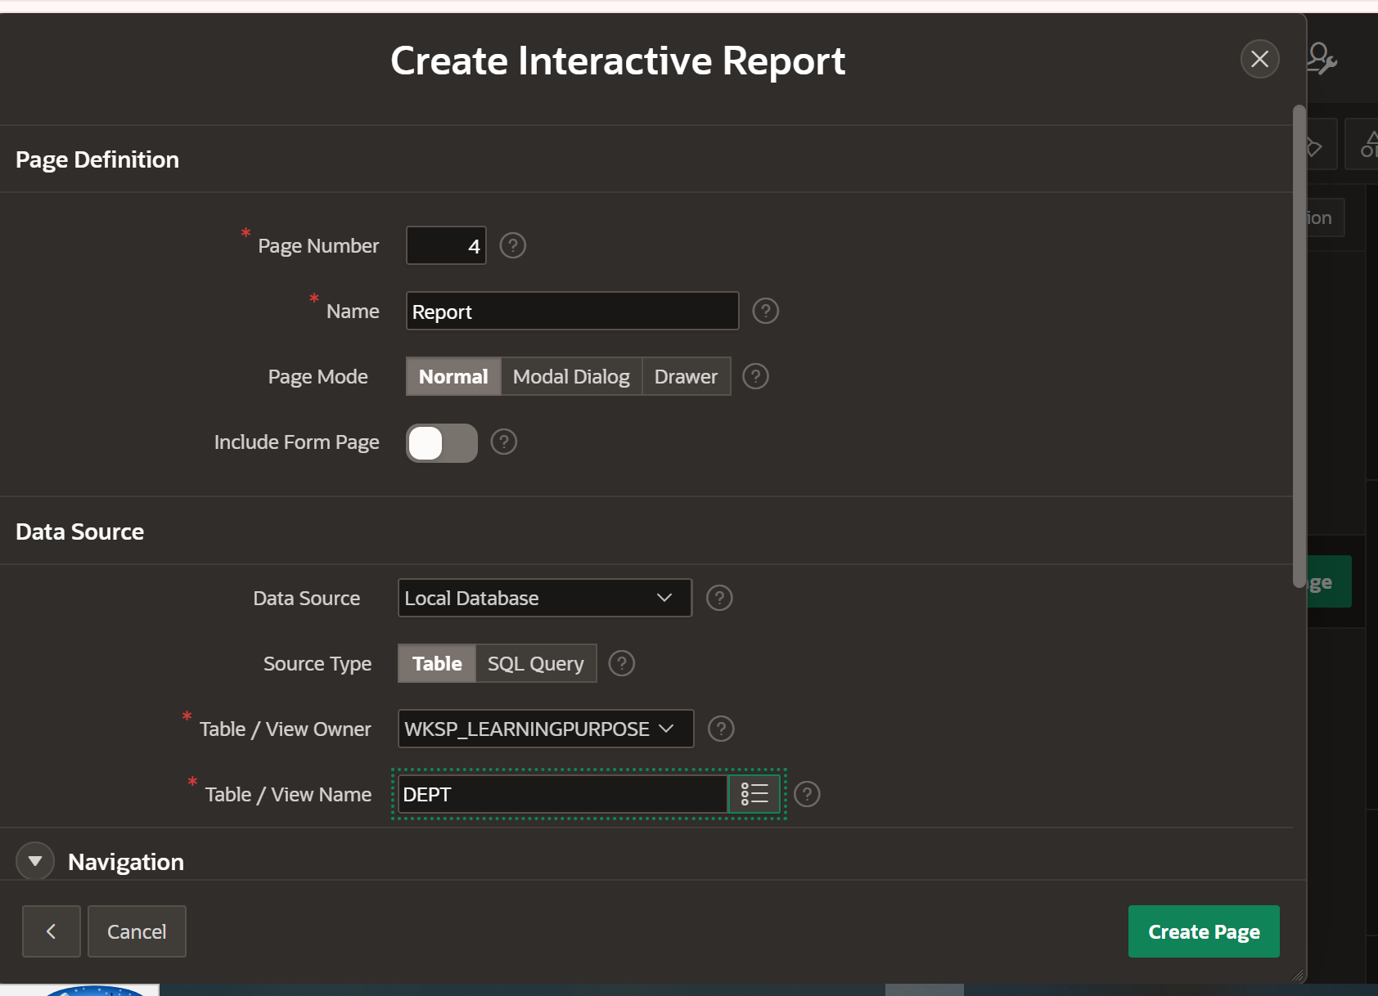
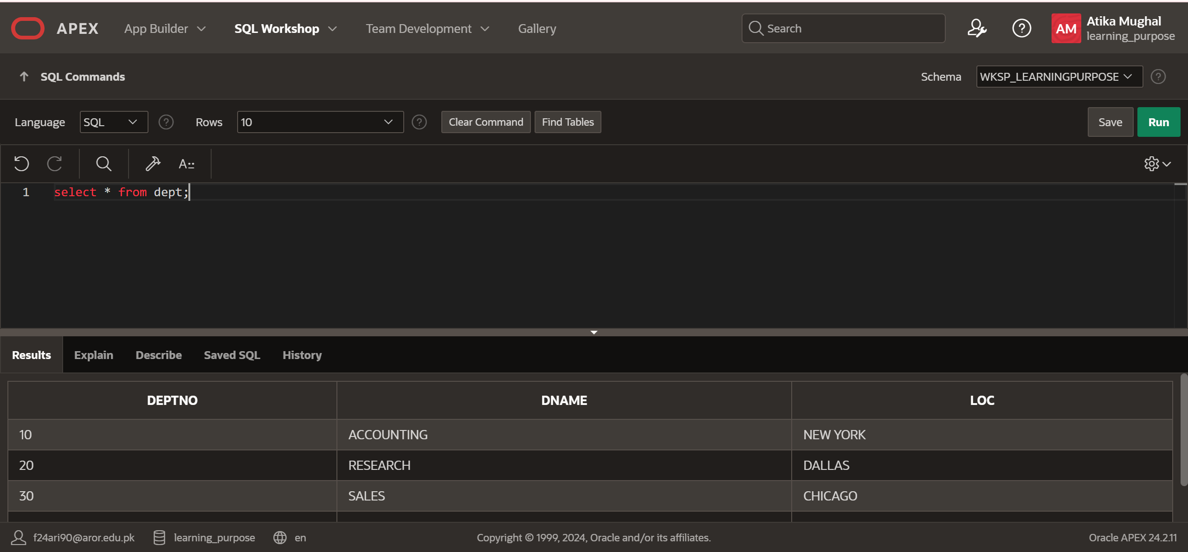
Output:
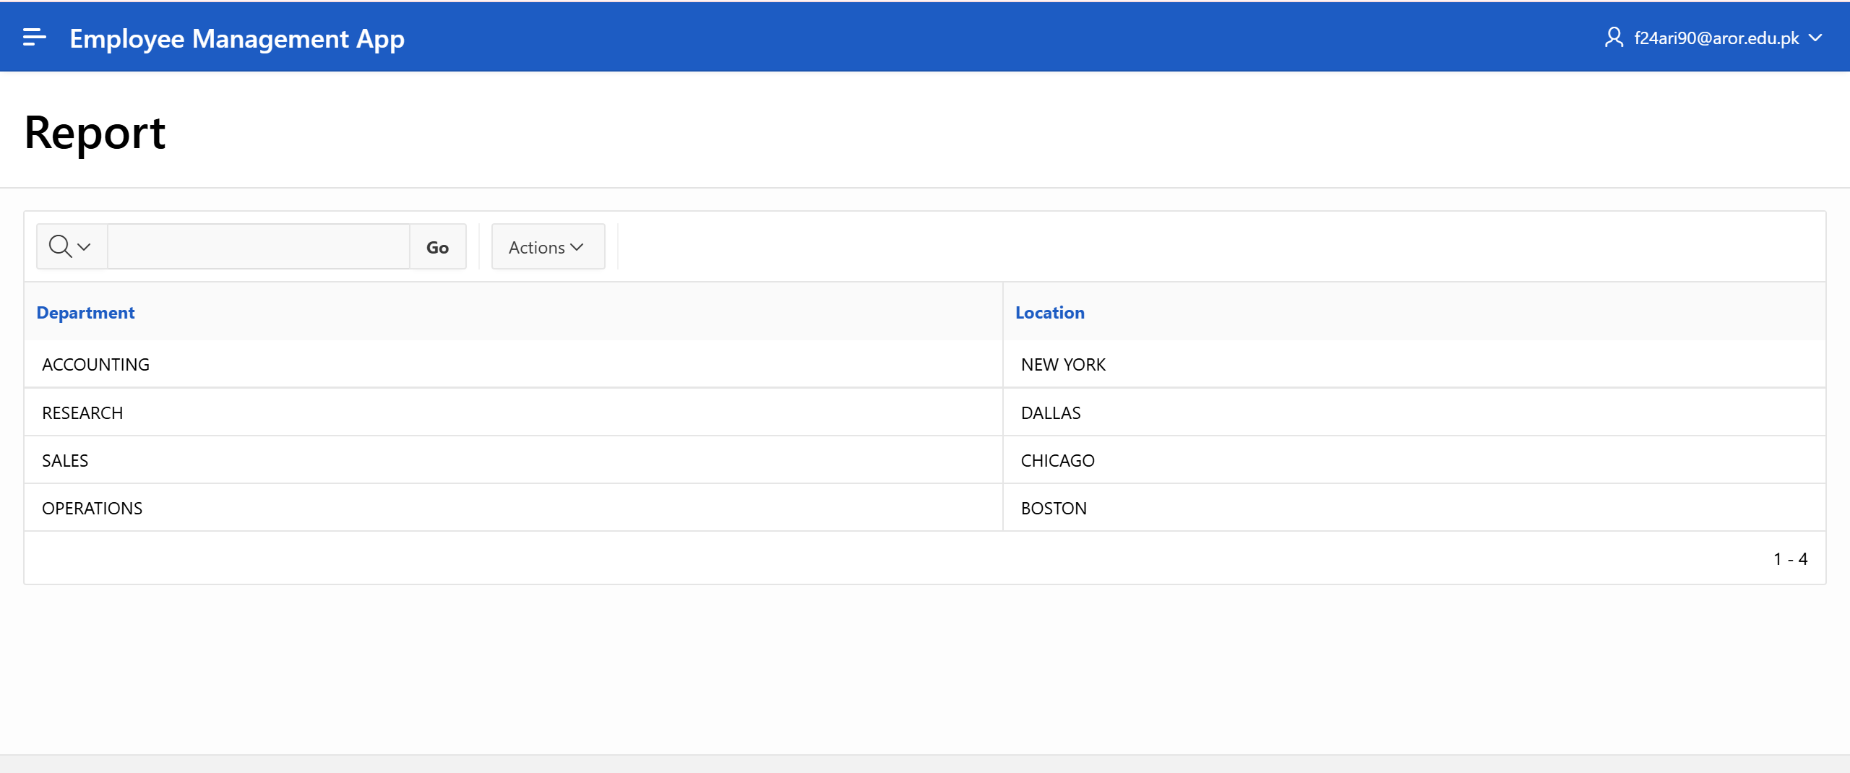

Task 2:
1: Navigating Oracle APEX:
During my experience with Oracle APEX, I found the platforms very interesting and helpful for learning database management and application development. In Oracle APEX, I was able to create a simple application, add pages, regions, forms, and interactive reports. The drag-and-drop interface made it easy to design pages without writing too much code, which helped me focus on understanding the database structure.
2: Oracle SQL Live:
Using Oracle SQL Live, I practiced writing SQL queries to retrieve, update, and manage data. It gave me a good understanding of how to interact with databases and test my queries in real-time.

