Atika Mughal

SAP ID: 5000000280

Database Systems Lab-10

Task 1: Write step-by-step procedure for Backup and recovery of your database (with screenshot).
- Open MySQL Workbench and connect to your MySQL server.
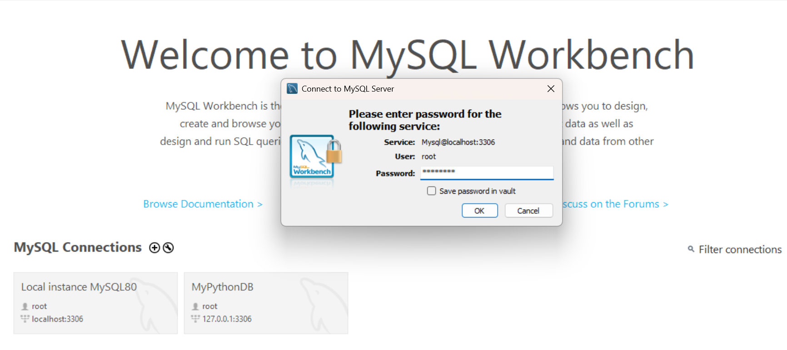
- Navigate to the "Administration" tab in the bottom-left panel.
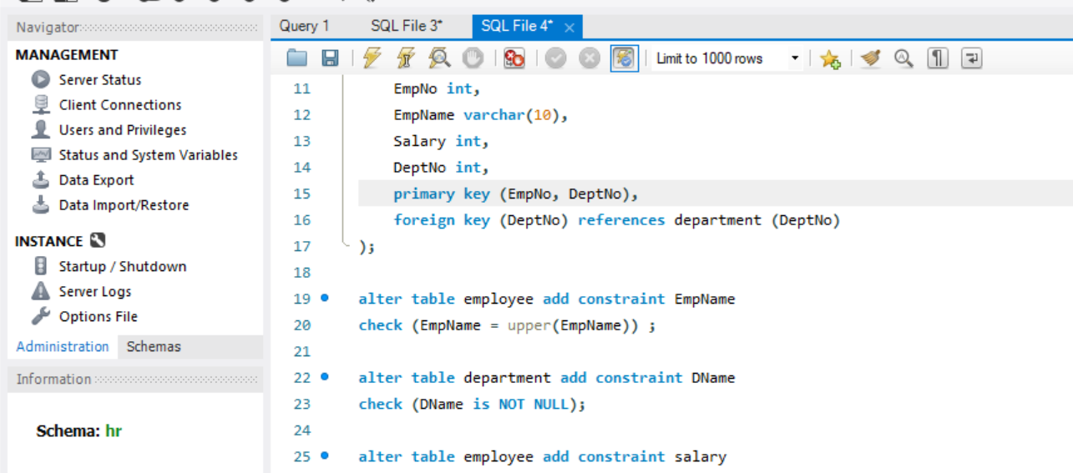

- Click on "Data Export" under the "Management" section.
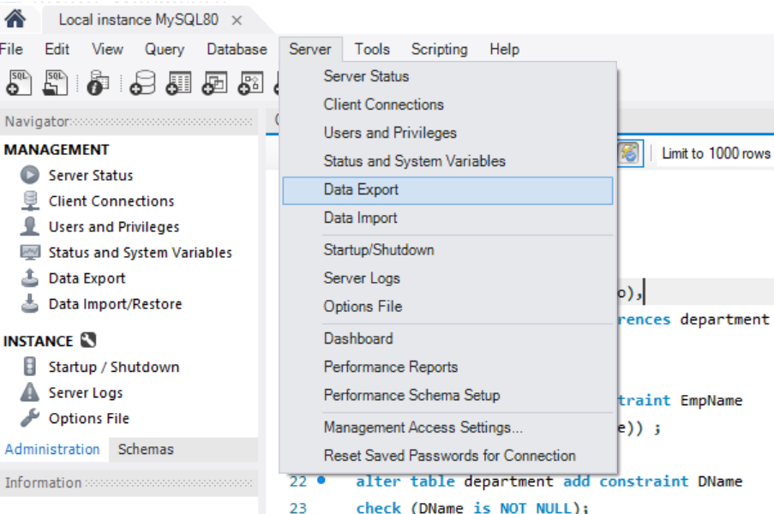

- Select the database(s) you want to back up from the list.
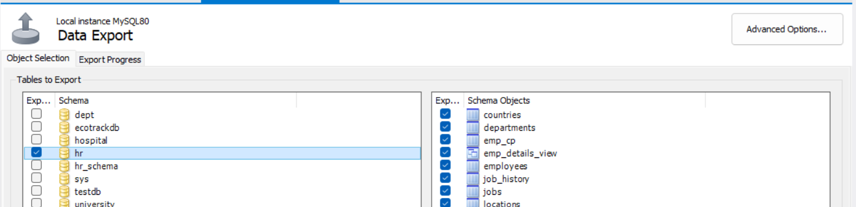

- Choose export options:
Export to Self-Contained File: Saves the entire database as a single .sql file.
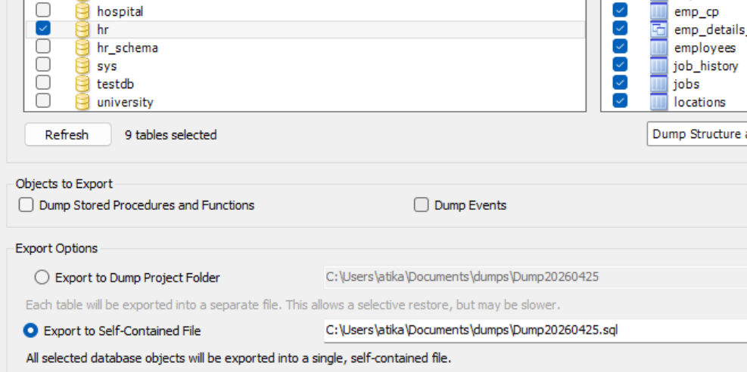

- Click "Start Export" and wait for the process to complete.
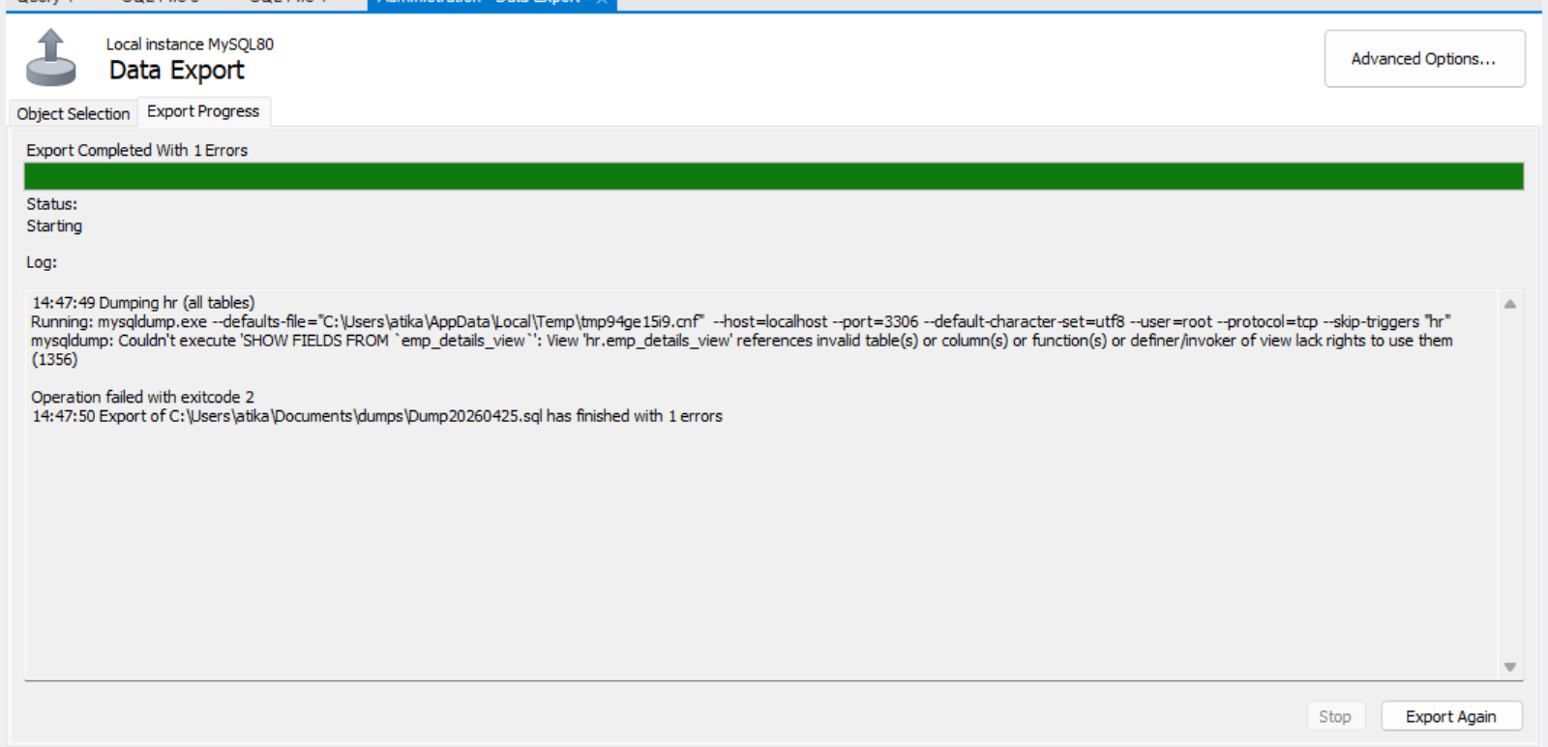

- Verify the backup file in the specified location.
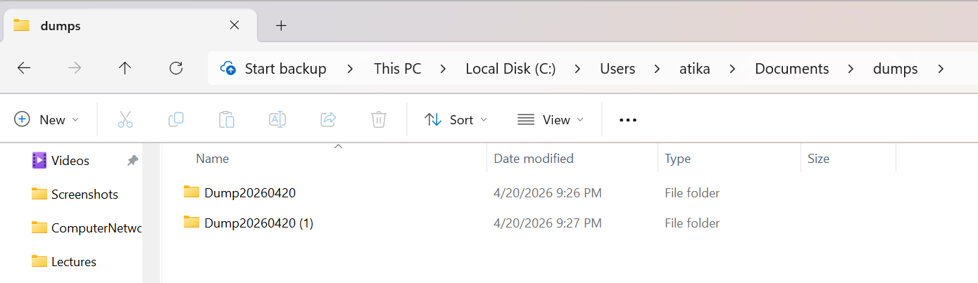
Restoring Database:
- Open MySQL Workbench and connect to your MySQL server.


- Navigate to the "Administration" tab.


- Click on "Data Import/Restore" under the "Management" section.
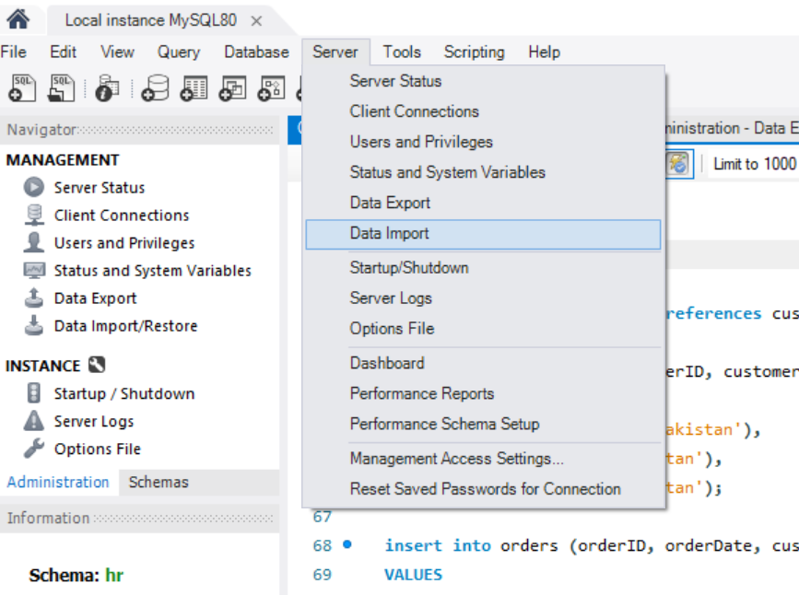

- Select "Import from Self-Contained File" and browse to your backup file (.sql).
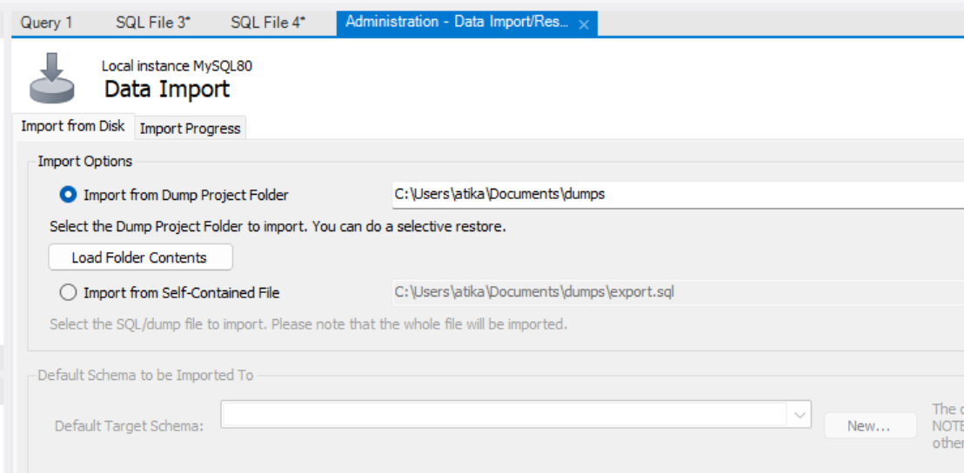

- Choose the target database:
New Schema: Create a new database for the restored data.
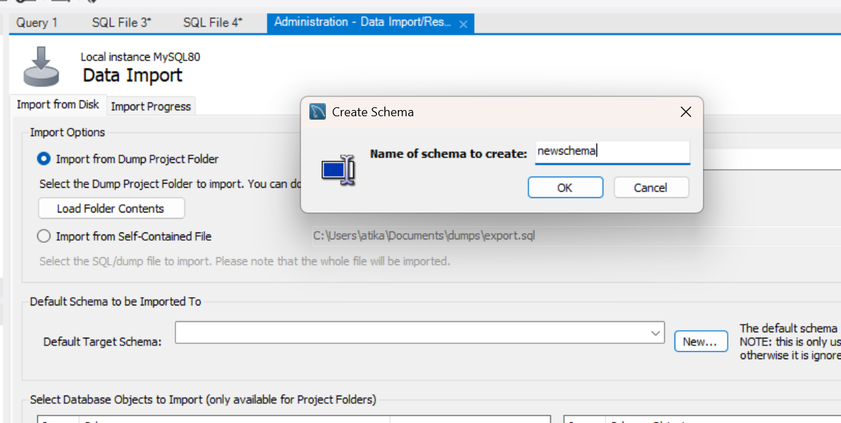

- Click "Start Import" and wait for the process to complete.
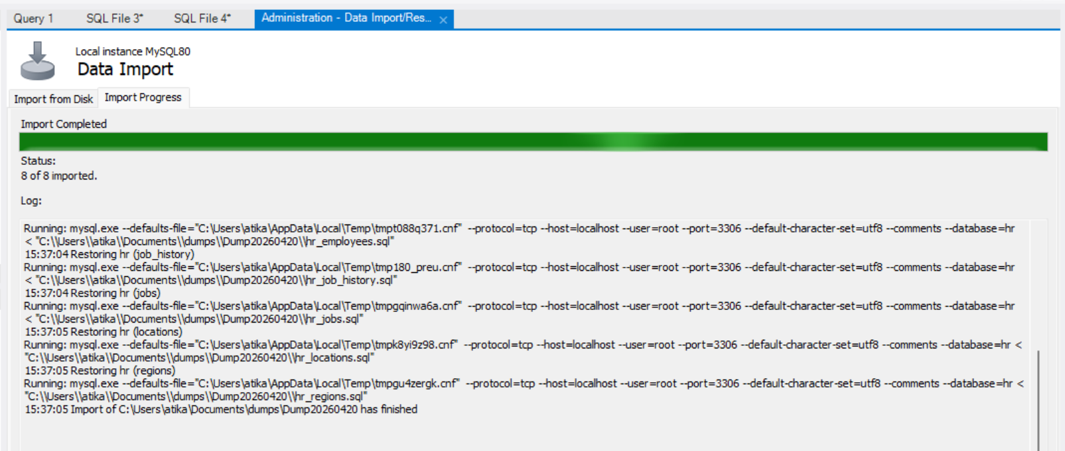

Task 2: Design an ER diagram for a University Database (Students, Courses, Enrollments).
Step 1: Problem Statement Analysis
Scenario: Design a database for a School System with:
- Students (student_id (PK), name, email)
- Enrollments (: enrollment_id (PK), student_id (FK), course_id (FK))
- Courses (course_id (PK), course_name, credits)

Step 2: Draw the ER Diagram
Use a tool like draw.io or MySQL Workbench ERD:
- Goto File -> New Model and add followings:
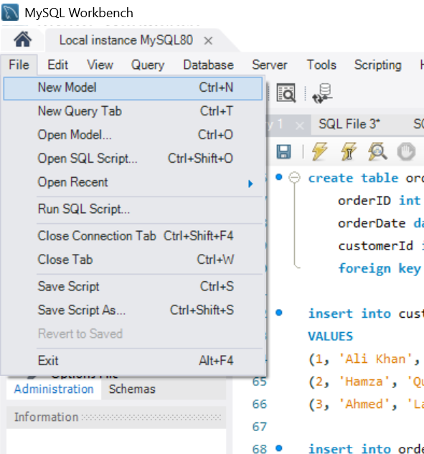
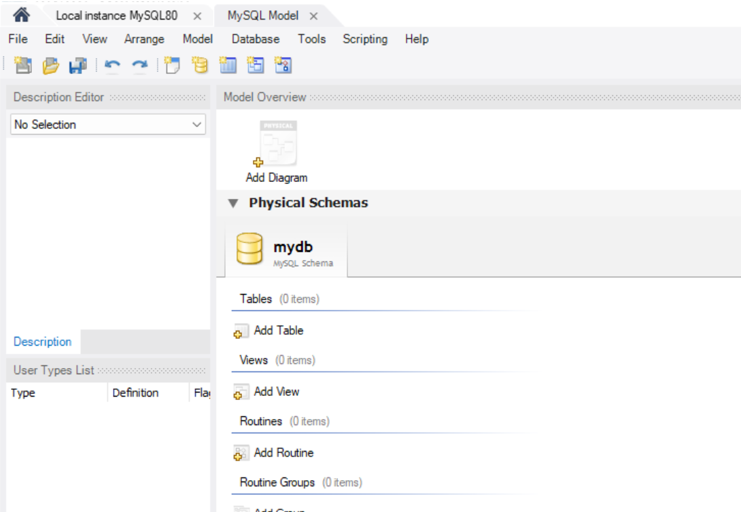

- Entities: Represented as rectangles.

· Students, Courses, Enrollments

- Attributes: Listed as ovals connected to entities.
  - Students: student_id (PK), name, email
  - Courses: course_id (PK), course_name, credits
  - Enrollments: enrollment_id (PK), student_id (FK), course_id (FK)
- Relationships: Shown as diamonds with cardinality.
  - Students → Enrollments (1:M)
  - Courses → Enrollments (1:M)
  - Students ↔ Courses (M:N)
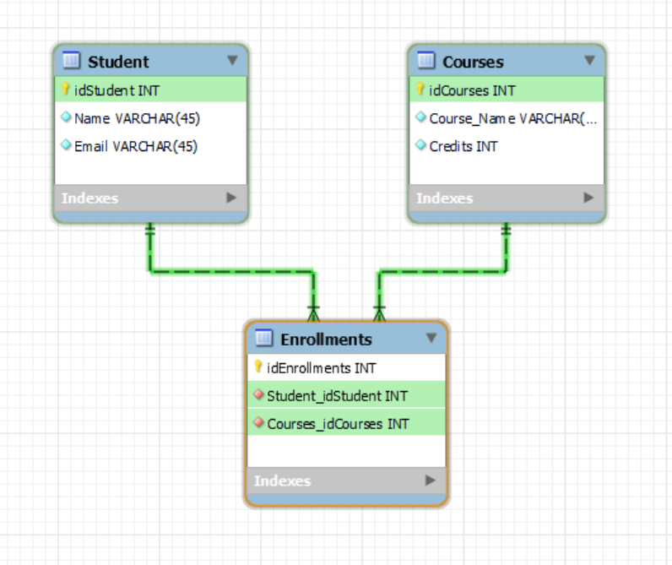
Step 3: Convert ER Diagram to MySQL Schema
Create SQL script via:
- Goto Database -> Forward Engineer.
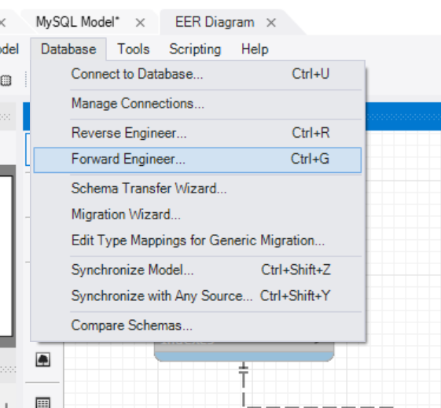
- Run the SQL Script: Paste and execute the CREATE TABLE statements.
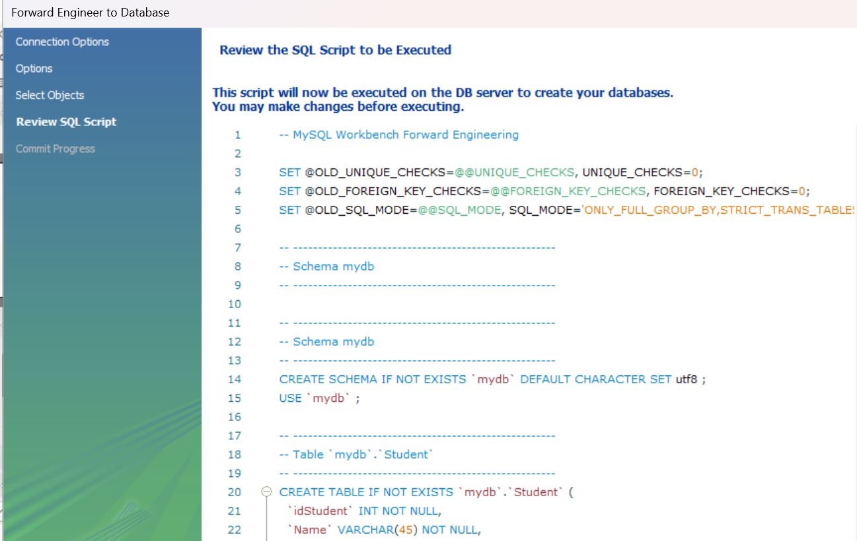
Task 3: Write SQL to create the schema.
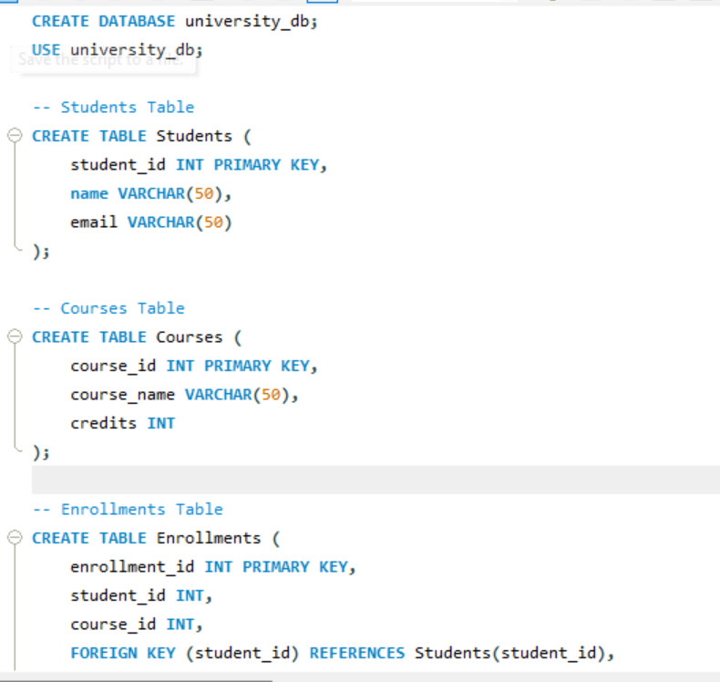

Task 4: Insert sample data and run queries.
